

AWS EKS nginx ingress

# Date: 01/09/2022

**Prerequisite setup**

1. **Install aws cli**
2. **Install ekstctl**
3. **Install kubectl**
4. **Create user and knowledge about IAM user**

**Ref link for installation:** [**https://github.com/DeepchainLabs/aws_eks**](https://github.com/DeepchainLabs/aws_eks)

**Login Aws in Command**

$ aws configure

Give access key, secret key, and zone code then hit enter .

**Configure cluster**

create cluster file name as **cluster.yml**

Example:

$nano cluster.yml

apiVersion: eksctl.io/v1alpha5

kind: ClusterConfig

metadata:

name: deepchain

region: ap-south-1

version: '1.21'

* create_cluster:

$ eksctl create cluster -f cluster.yaml

**Create node group under this cluster**

Go to the inside cluster then select compute and click add node group. Then configure the node group as necessary.

**If node role node not created before create node role**

Like this below pic and have permission policy given this below pic:

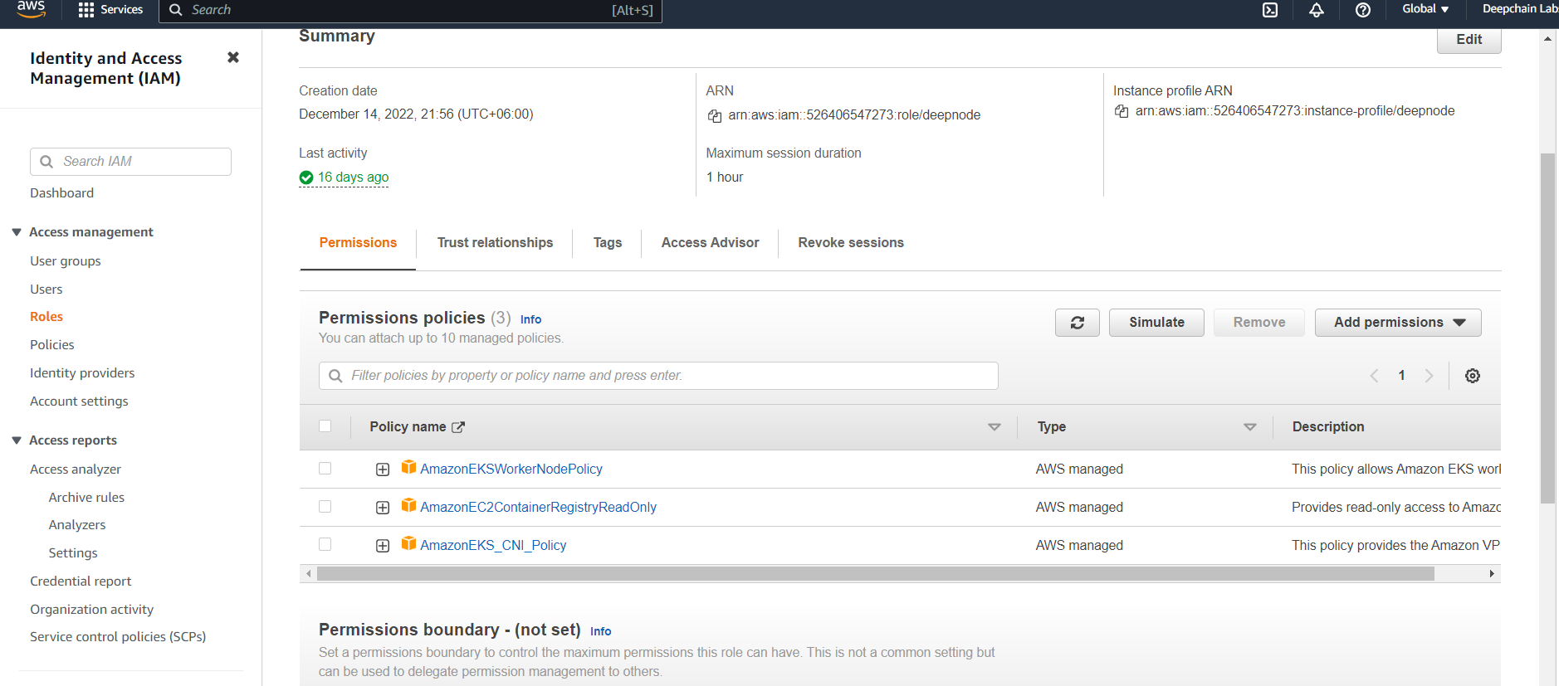

* Check node ready or not $ kubectl get nodes

**Now install nginx ingress**

Use this command

kubectl apply -f https://raw.githubusercontent.com/kubernetes/ingress-nginx/controller-0.32.0/deploy/static/provider/aws/deploy.yaml

For more information visit this link: <https://aws.amazon.com/blogs/opensource/network-load-balancer-nginx-ingress-controller-eks/>

**Configure ingress for your app**

apiVersion: networking.k8s.io/v1

kind: Ingress

metadata:

name: chatbot-server-ingress

namespace: ct-2

annotations:

kubernetes.io/ingress.class: nginx **#target nginx class**

spec:

rules:

- host: ct.nftvast.com **# your domain address name**

http:

paths:

- pathType: Prefix

backend:

service:

name: chatbot-server **#selected your service**

port:

number: 80

path: /

**Example Of Application**

---

apiVersion: v1

kind: Namespace

metadata:

name: ct-2

---

apiVersion: apps/v1

kind: Deployment

metadata:

name: chatbot-server

namespace: ct-2

spec:

replicas: 2

selector:

matchLabels:

app: chatbot-server

template:

metadata:

labels:

app: chatbot-server

spec:

containers:

- name: ct

image: shihab24/testapp:latest

# env:

# - name: TZ

# value: Asia/Dhaka

ports:

- containerPort: 3000

# imagePullPolicy: Always

---

apiVersion: v1

kind: Service

metadata:

name: chatbot-server

namespace: ct-2

spec:

type: NodePort

selector:

app: chatbot-server

ports:

- port: 80

targetPort: 3000

---

apiVersion: networking.k8s.io/v1

kind: Ingress

metadata:

name: chatbot-server-ingress

namespace: ct-2

annotations:

kubernetes.io/ingress.class: nginx

spec:

rules:

- host: ct.nftvast.com

http:

paths:

- pathType: Prefix

backend:

service:

name: chatbot-server

port:

number: 80

path: /

**Configure dns**

You will get load balancer address like this



Add this address in cname record

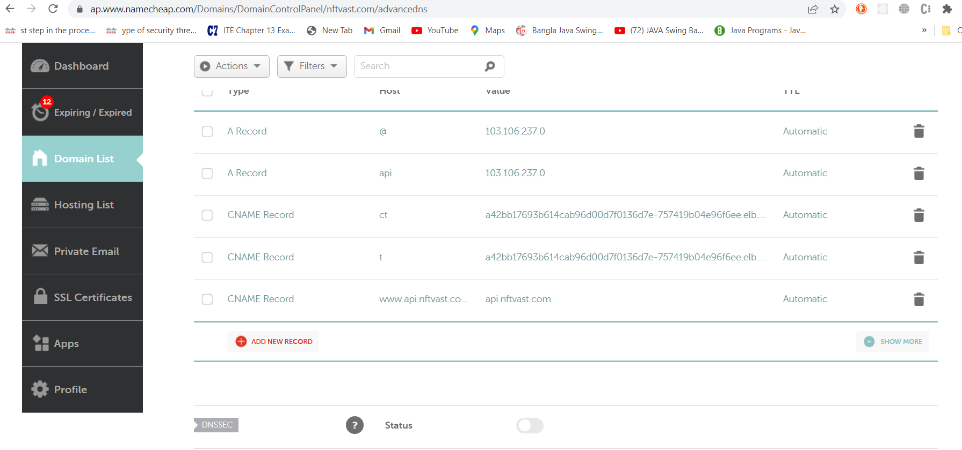

**More Information**

<https://aws.amazon.com/blogs/opensource/network-load-balancer-nginx-ingress-controller-eks/>

<https://kubernetes.github.io/ingress-nginx/deploy/>

<https://docs.aws.amazon.com/eks/latest/userguide/create-kubeconfig.html>

<https://github.com/DeepchainLabs/aws_eks>

<https://kubernetes.io/docs/tasks/tools/install-kubectl-linux/>

<https://aws.amazon.com/premiumsupport/knowledge-center/eks-api-server-unauthorized-error/>