**Cloud Computing Foundation**

**Lab10 – Assignment**

**Name: Deepchand Jagdish Prajapati**

**Roll No.: - 310**

**Batch: CCF1**

**Question:** Create Internet Gateway, attach to your VPC, configure IG with route table.

1. In VPC dashboard, in ‘Virtual private cloud’ section on the left side of the window, click on ‘Internet gateways’. In the Internet gateways menu, click on ‘Create internet gateway’.

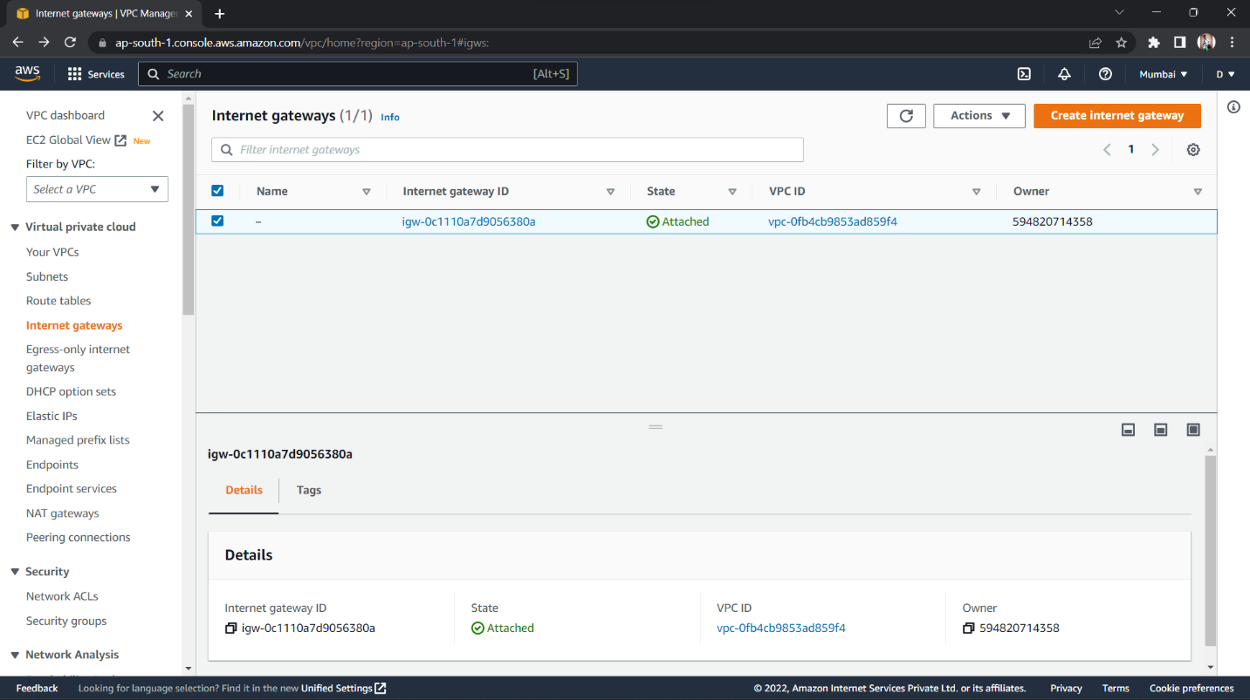

1. Choose and type a name for the Internet gateway, then click on ‘Create internet gateway’. Internet gateway will be created.

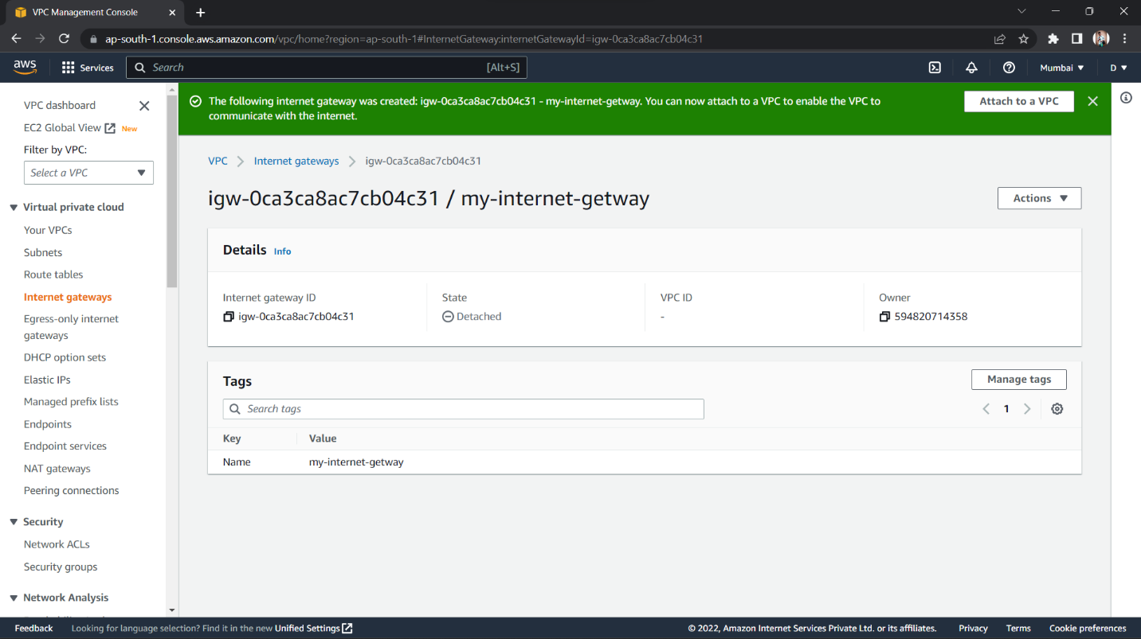

1. With the gateway selected, click on ‘Actions’ dropdown menu, and select ‘Attach to VPC’. Click in the ‘Available VPCs’ text box and when the VPC you created should appear automatically select the VPC and click on ‘Attach internet gateway’. The Internet gateway should be successfully attached to the selected VPC.

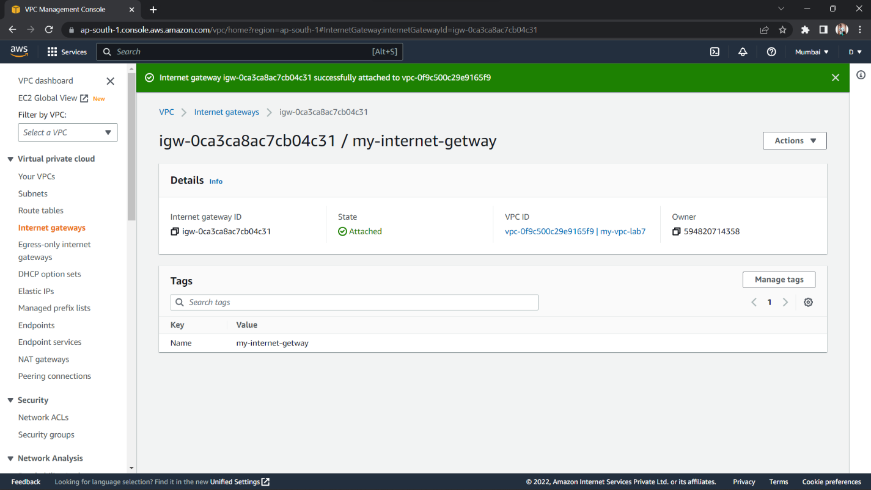

1. Now, navigate to the Route tables menu and go to the ‘Routes’ section. Click on ‘Edit routes’. Click on ‘Add route’, and select Destination ‘0.0.0.0/0’ and in the Target list select ‘Internet gateway’ and the internet gateway you created should appear automatically, select it and click on ‘Save changes’. This should enable the internet access from the internet gateway through the route table.

