**Cloud Computing Foundation**

**Lab11 – Assignment**

**Name: Deepchand Jagdish Prajapati**

**Roll No.: - 310**

**Batch: CCF1**

**Question:** Create windows [EC2](http://moodle.mitaoe.ac.in/mod/resource/view.php?id=44884) instance in public subnet and access it using RDP client.

1. In EC2 dashboard, navigate to ‘Instances’ section and click on ‘Launch Instance’. Choose a name for your instance, then select Windows in ‘Application and OS Images’ section. Select ‘t2.micro’ Instance type, then select/create a key pair. Now, in ‘Network settings’ section, click on ‘Edit’.

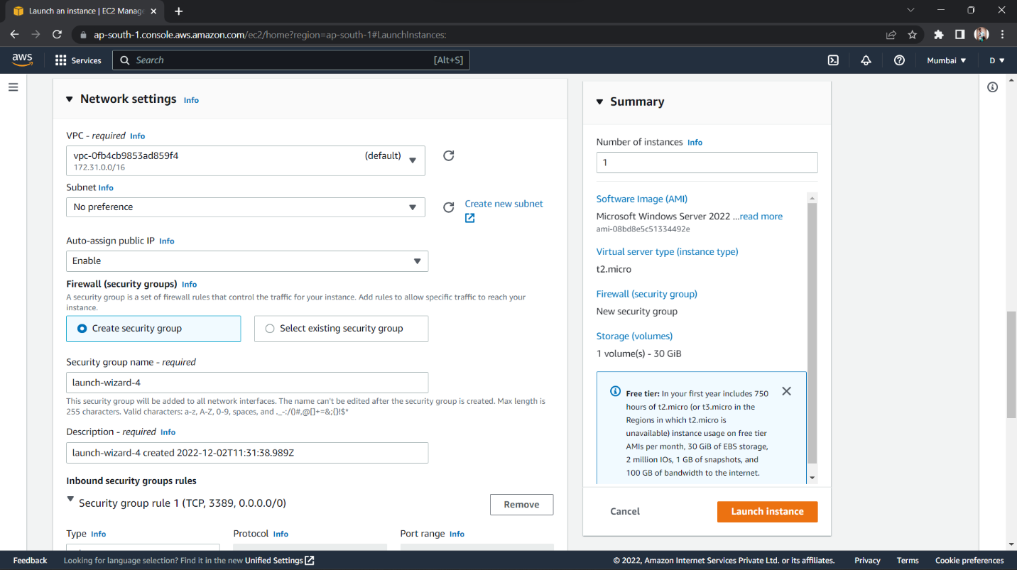

1. In the expanded ‘Network settings’ section, select the VPC and the Public subnet you created and enable ‘Auto-assign public IP’. Create a new security group with default configuration, select a storage type and click on ‘Launch instance’.

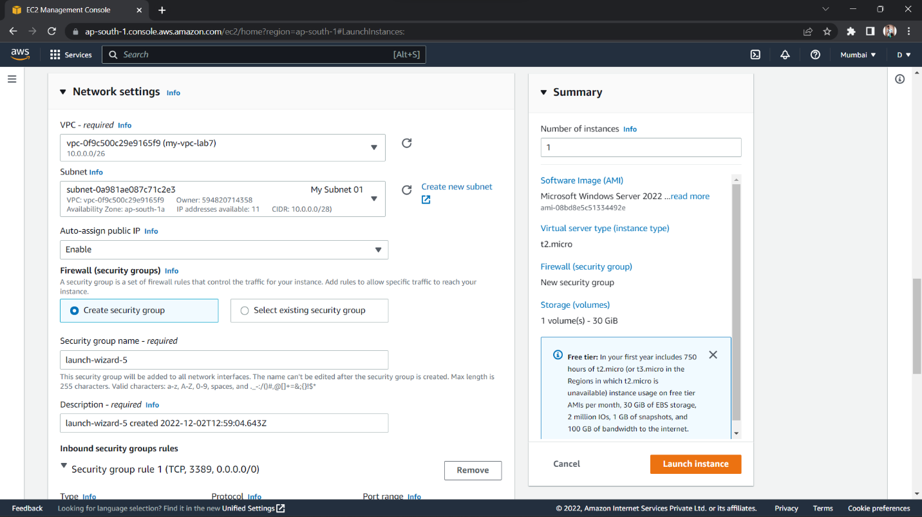

1. With the created instance selected, click on ‘Connect’ and then select ‘RDP client’. In the ‘Password’ section click on ‘Get password’, upload the private key file, click on ‘Decrypt password’ to obtain login password. Use the given Public IP, User name and generated Password to connect to the instance using Remote Desktop Connection Application. *(EC2 instance is now connected to RDP client)*

