**Cloud Computing**

**Lab3 – Assignment**

**Name: Deepchand Jagdish Prajapati**

**Roll No.: - 310**

**Batch: CCF1**

**Question:** Create [S3](http://moodle.mitaoe.ac.in/mod/resource/view.php?id=44885) bucket add 5 Objects in the given bucket.

**Step 1:** First log in to your AWS console account and search **S3** in the search bar and then click on the **Create Bucket** button after that give the appropriate name to the bucket and finally click on the create button.

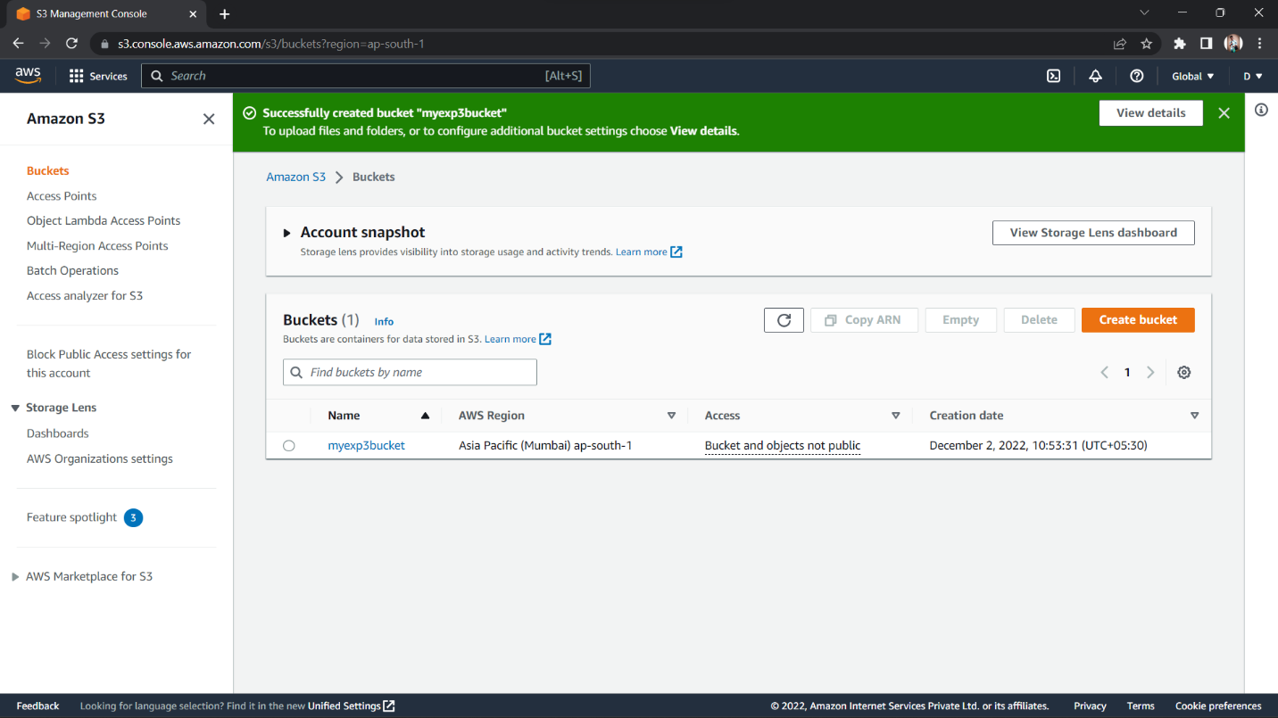

**Step 2:** Click on the **Upload** button simply drag and drop the file that you want to upload.

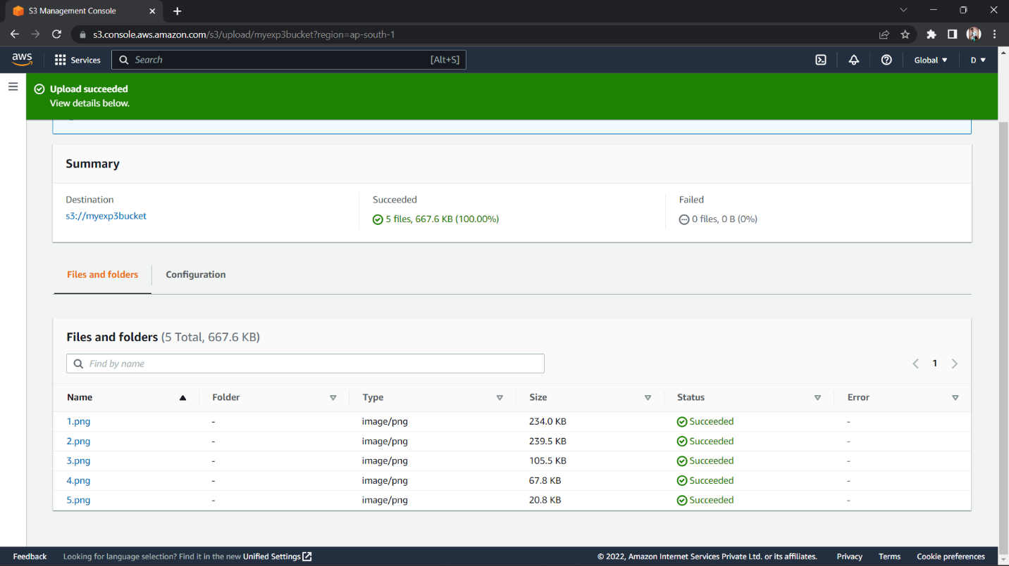

**(Uploaded Files)**

