**Cloud Computing**

**Lab4 – Assignment**

**Name: Deepchand Jagdish Prajapati**

**Roll No.: - 310**

**Batch: CCF1**

**Question:** Create [S3](http://moodle.mitaoe.ac.in/mod/resource/view.php?id=44885) bucket copy 5 Objects from first created bucket to the newly create bucket.

**Step 1:** Select previous bucket open it and in actions button there you will get **copy** option then select the objects that you want to copy. After give the destination where you want to copy that object.

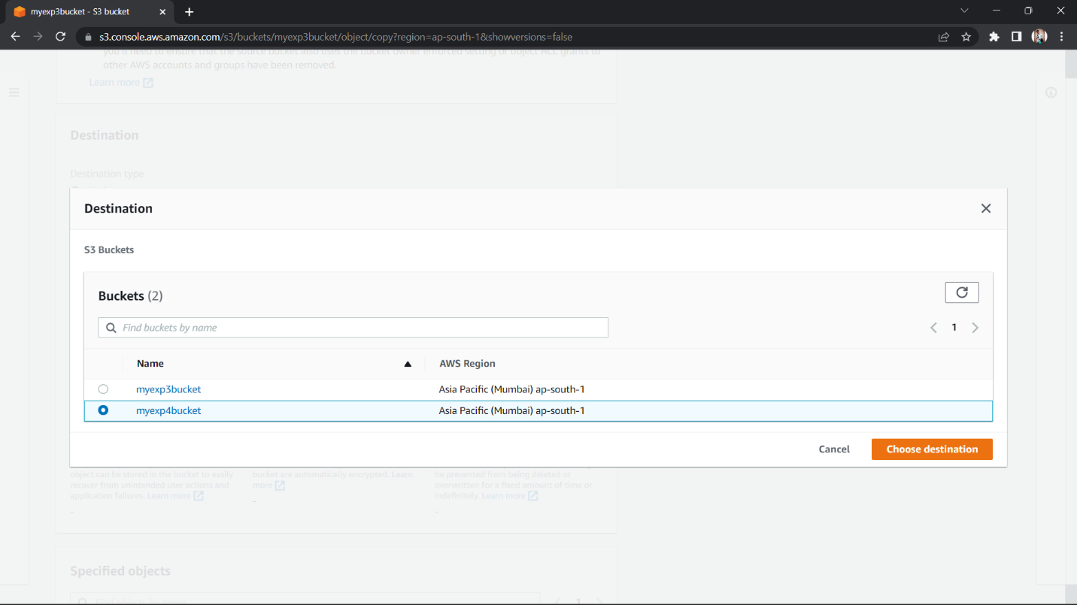

**Step 1:** Click on Copy Objects now you will get Successfully copied objects.

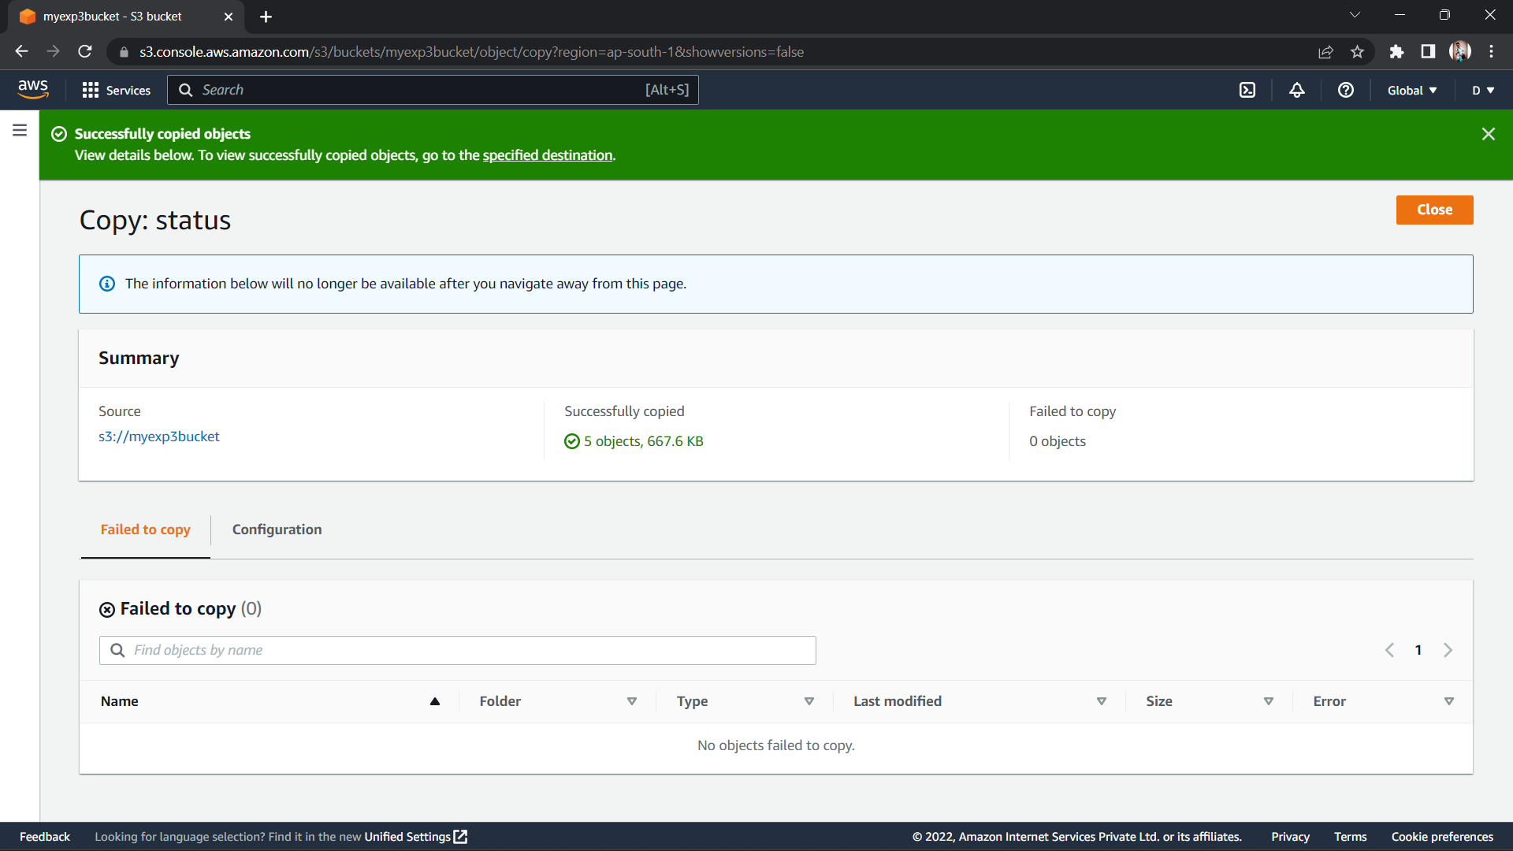

**(Copied Objects)**

