**Cloud Computing**

**Lab5 – Assignment**

**Name: Deepchand Jagdish Prajapati**

**Roll No.: - 310**

**Batch: CCF1**

**Question:** Create [S3](http://moodle.mitaoe.ac.in/mod/resource/view.php?id=44885) bucket add 2 Objects and show versioning.

**Step 1:** First log in to your AWS console account and search **S3** in the search bar and then click on the **Create Bucket** button after that give the appropriate name to the bucket, make sure that you have check show versioning **Enable** and finally click on the create button.

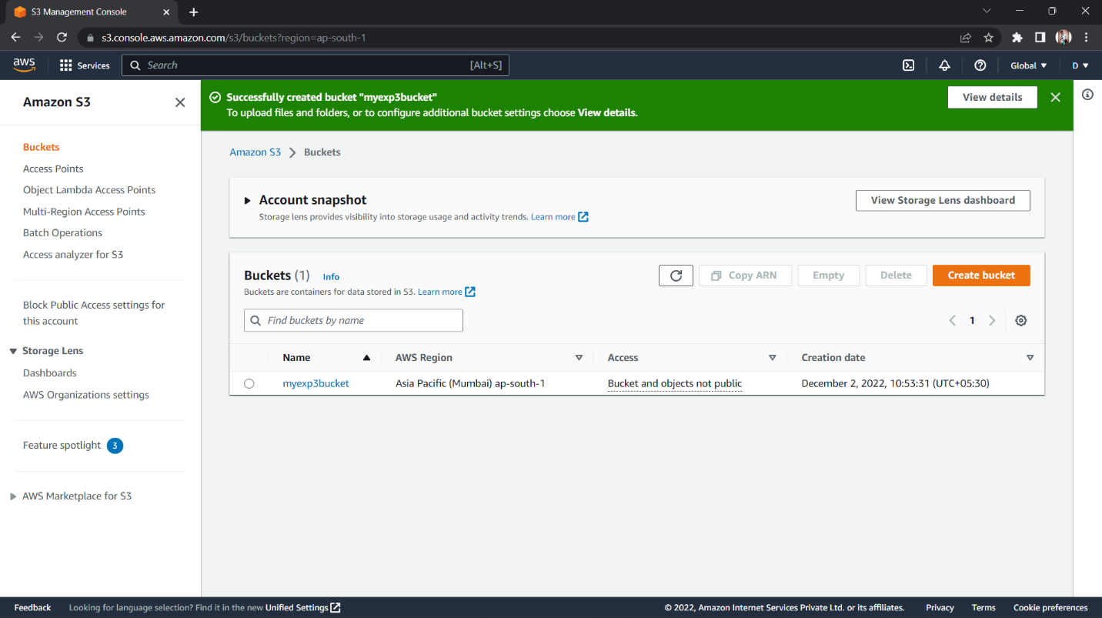

**Step 2:** Go inside the created bucket and there you will find all the uploaded objects on the top there is one button called show versions click on that it will display show versioning.

