**Cloud Computing**

**Lab6 – Assignment**

**Name: Deepchand Jagdish Prajapati**

**Roll No.: - 310**

**Batch: CCF1**

**Question:** Create [S3](http://moodle.mitaoe.ac.in/mod/resource/view.php?id=44885) bucket delete 2 Objects from bucket and show delete marker.

**Step 1:** First log in to your AWS console account and search **S3** in the search bar and then click on the **Create Bucket** button after that give the appropriate name to the bucket, make sure that you have check show versioning **Enable** and finally click on the create button.

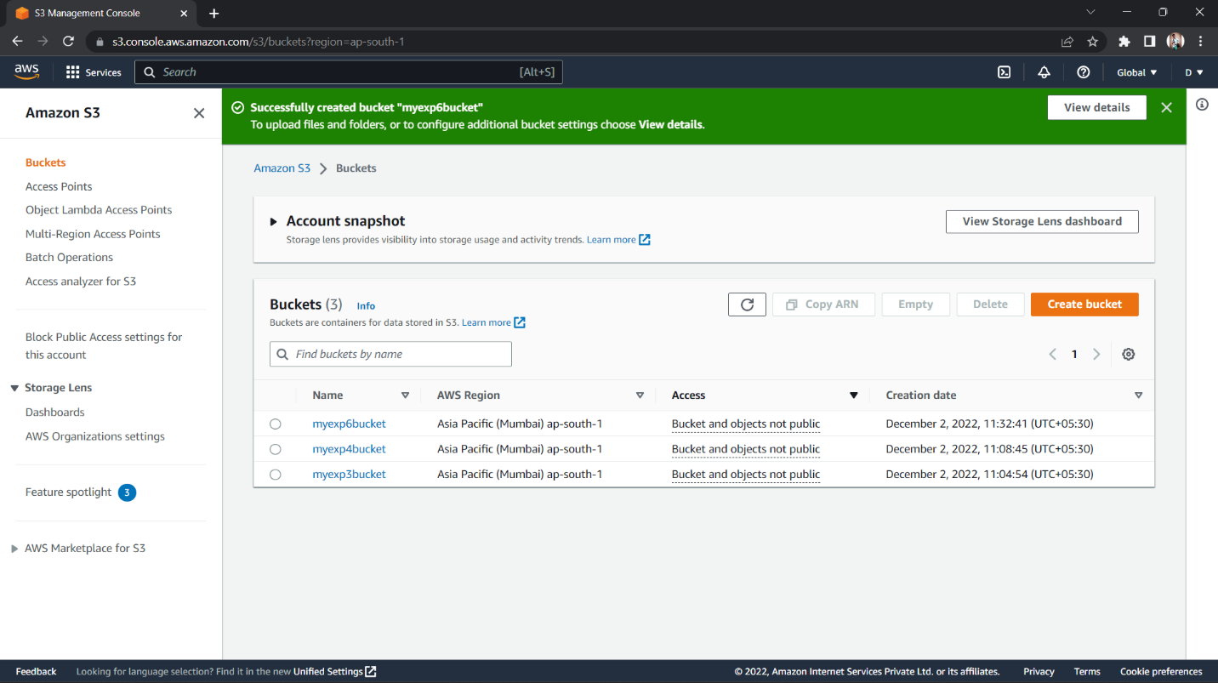

**Step 2:** Go inside the bucket and select the objects that you would like to delete now in the Actions options you will find the Delete option click on it and type ‘*delete’* then click on **delete** button.

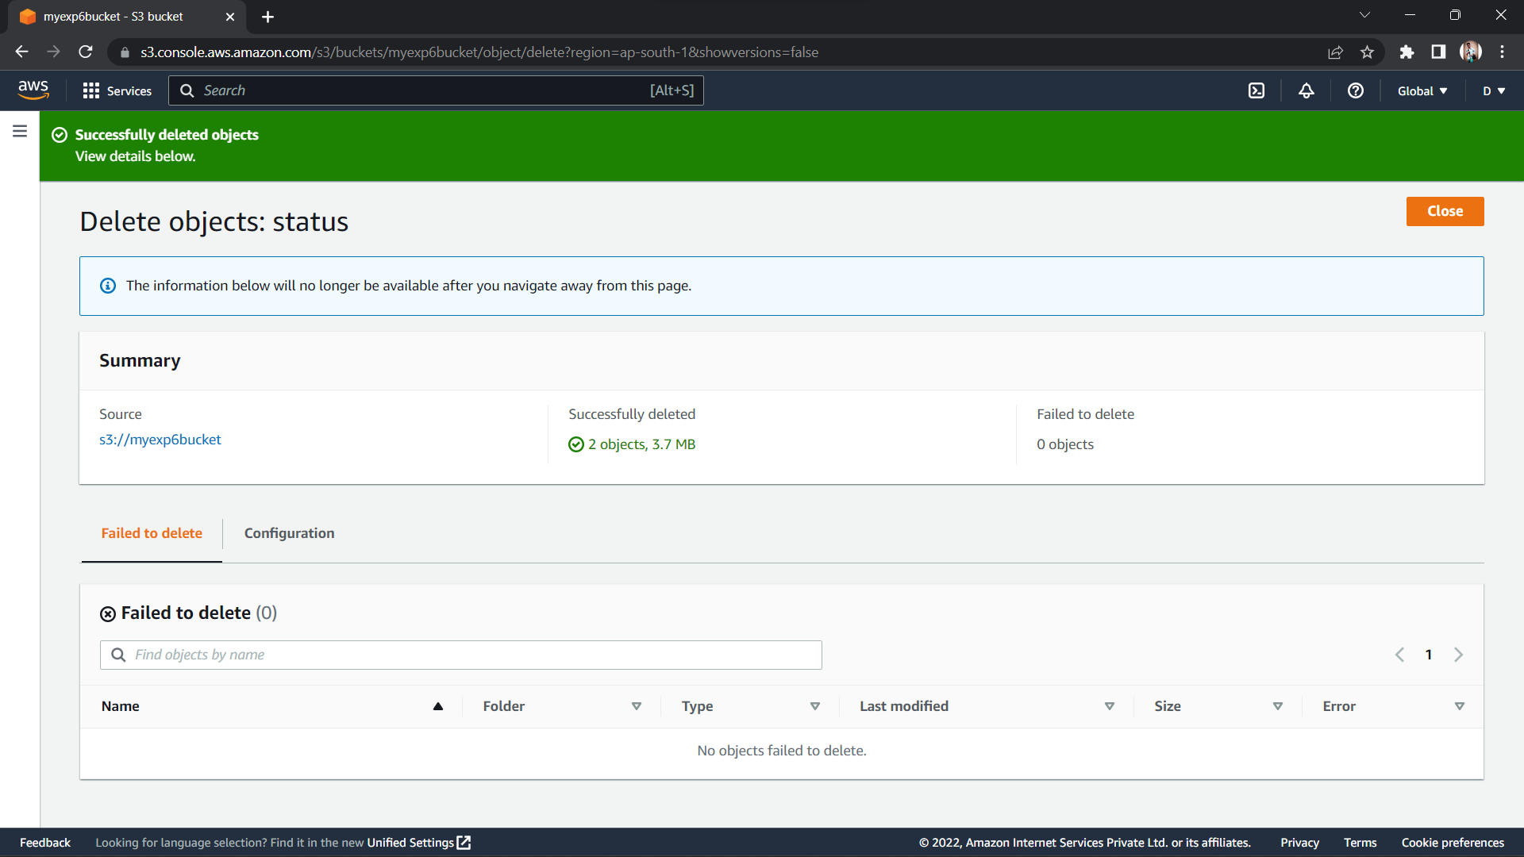

**Step 3:** Go inside the created bucket and there you will find all the uploaded objects on the top there is one button called show versions click on that it will display ***Delete Marker.***

