**Cloud Computing**

**Lab7 – Assignment**

**Name: Deepchand Jagdish Prajapati**

**Roll No.: - 310**

**Batch: CCF1**

**Question:** Create VPC for 64 IP's.

1. Click on ‘Create VPC’ in the VPC dashboard.

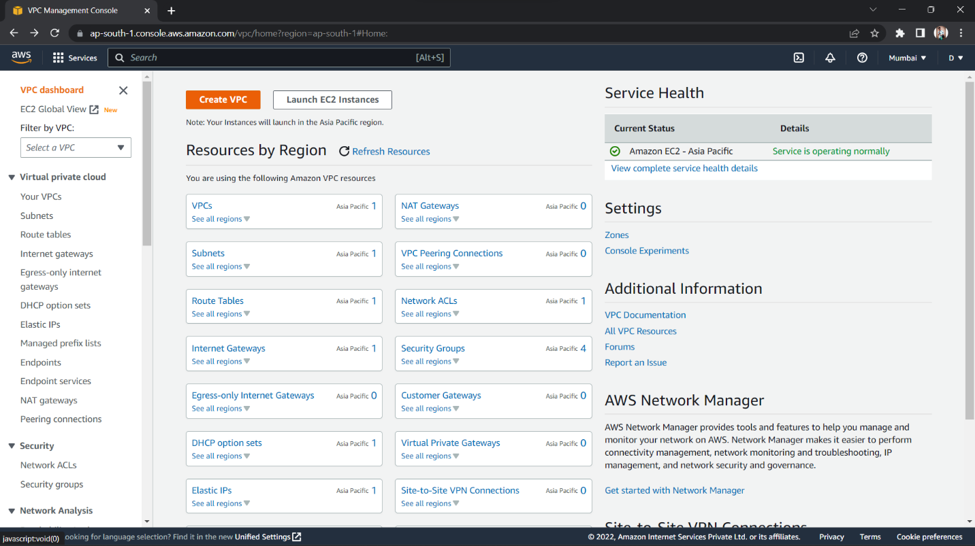

1. Select ‘VPC only’ and choose a VPC name. Select ‘IPv4 CIDR manual input’. Type in IPv4 CIDR ‘10.0.0.0/26’ (‘/26’ for 64 IPs), then click ‘Create VPC’. Your VPC should be created

