**Cloud Computing Foundation**

**Lab8 – Assignment**

**Name: Deepchand Jagdish Prajapati**

**Roll No.: - 310**

**Batch: CCF1**

**Question:** Create 2 subnets one Public and one private with 16 IP's each.

1. In VPC dashboard, in ‘Virtual private cloud’ section on the left side of the window, click on ‘Subnets’. In the subnet menu, click on ‘Create subnet’.

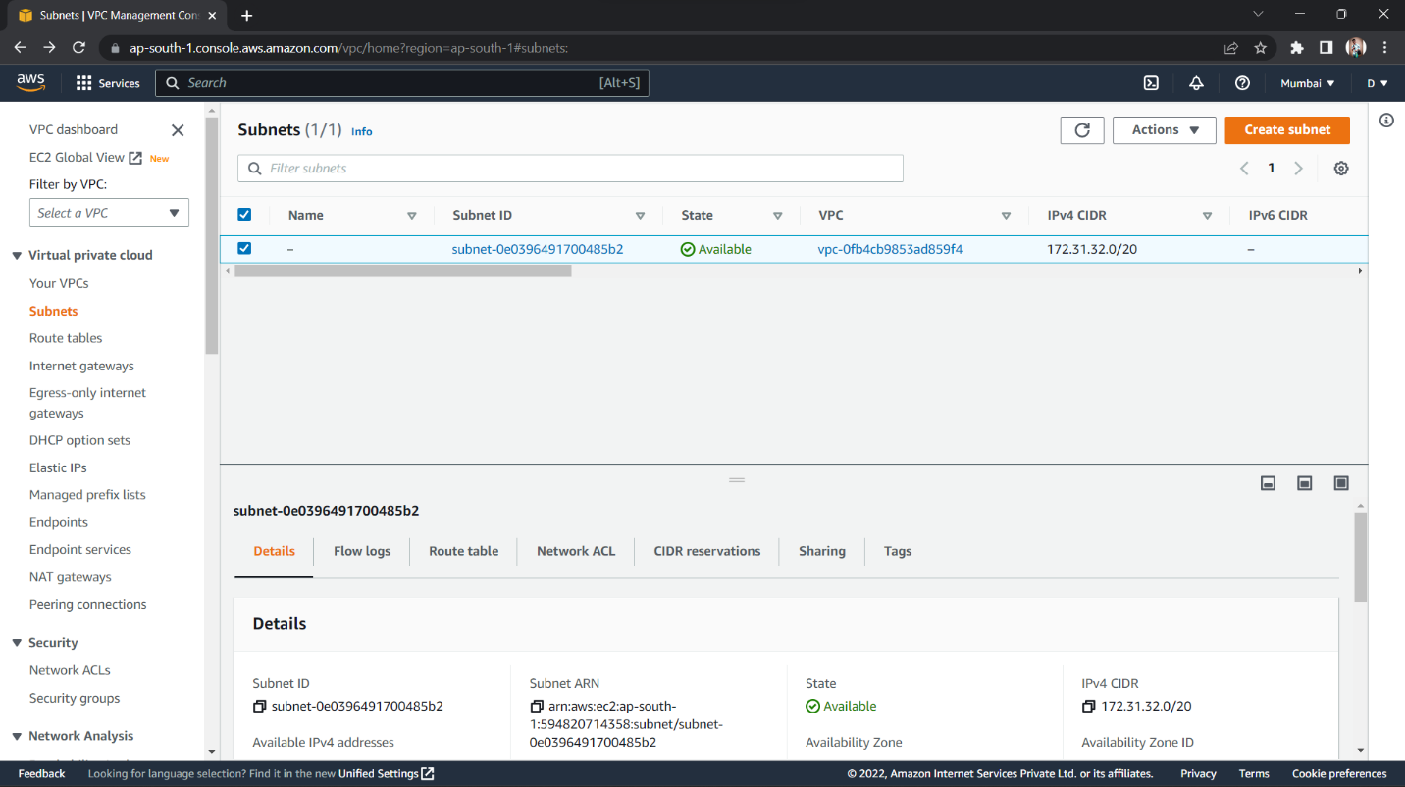

1. In the VPC ID, select the VPC that you created and its IPv4 CIDRs will appear below. In the Subnet settings, choose a subnet name, select an Availability zone of your choice. Type in ‘10.0.0.0/28’ (‘/28 for 16 IPs’, i.e. 10.0.0.0 – 10.0.0.15) IPv4 CIDR block for the subnet.

(Optional): You can simultaneously create another VPC by clicking on ‘Add new subnet’. Type in IPv4 CIDR block for the subnet different from the previous one, like ‘10.0.0.16/28’, keeping ‘/28’ same (for 16 IPs). Click on ‘Create subnet’.

