**Cloud Computing Foundation**

**Lab9 – Assignment**

**Name: Deepchand Jagdish Prajapati**

**Roll No.: - 310**

**Batch: CCF1**

**Question:** Create Route table and add newly created subnets in Route table.

1. In VPC dashboard, in ‘Virtual private cloud’ section on the left side of the window, click on ‘Route tables’. In the Route tables menu, click on ‘Create route table’.

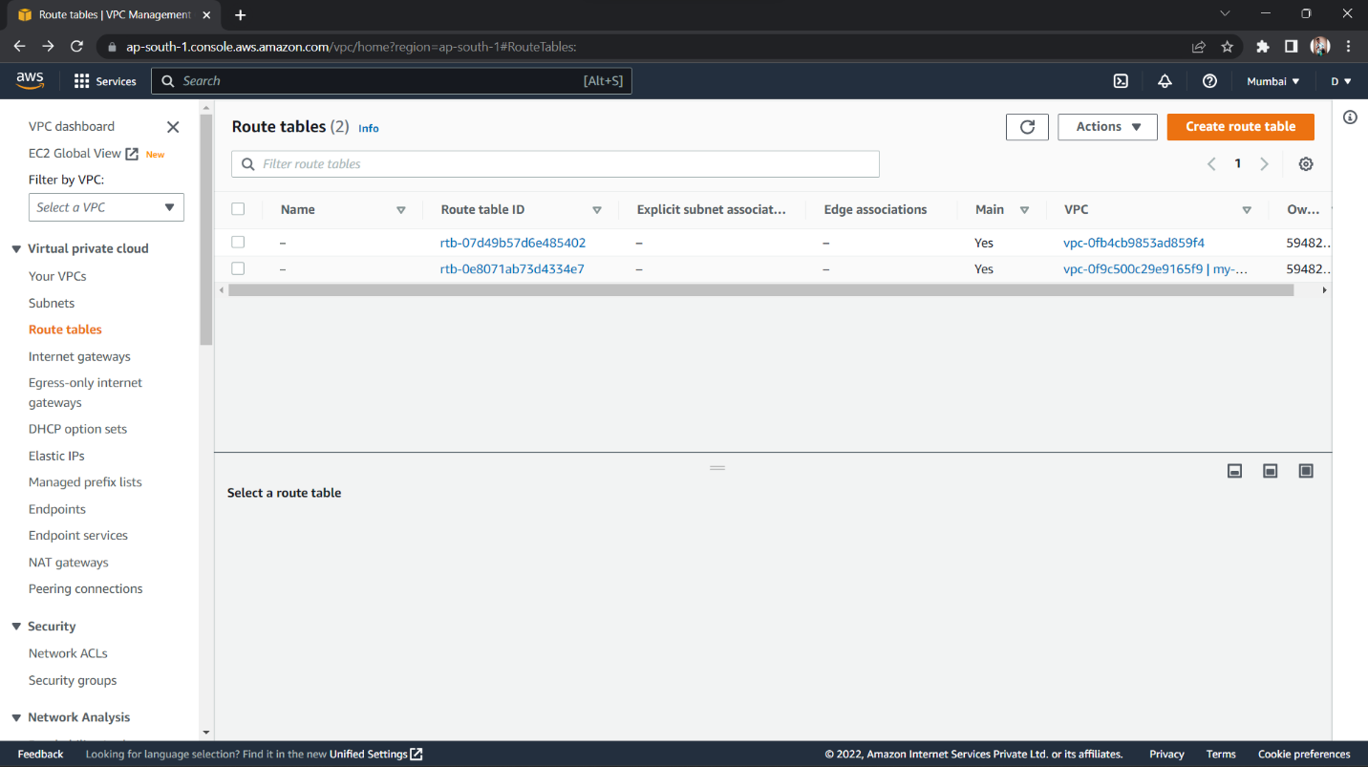

1. Choose and type a name for your Route table, then select the VPC that you created. This will specify the VPC to use for this route table. Click on ‘Create route table’. Your Route table will be created.

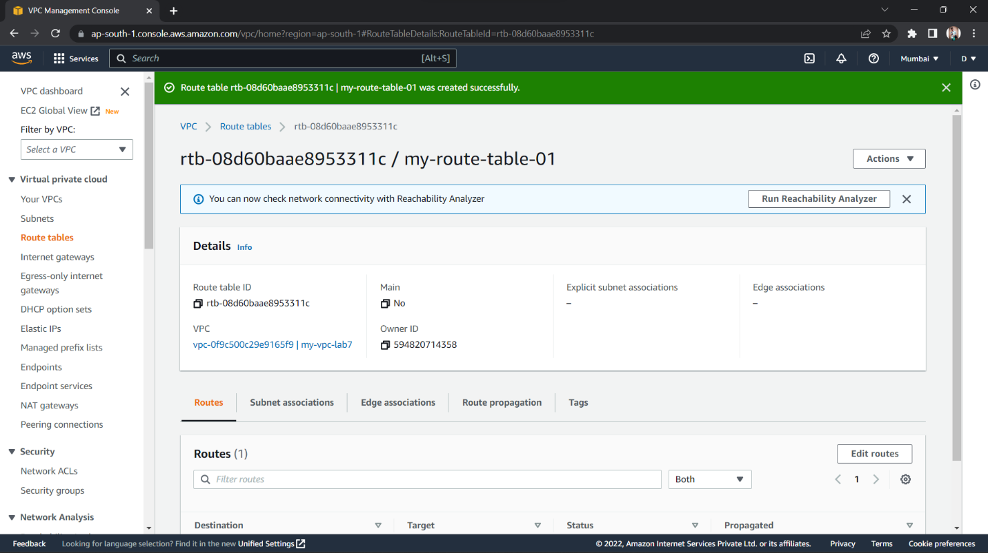

1. Once the Route table is created, select the created route table and navigate to ‘Subnet associations’ section. In the ‘Explicit subnet associations’ list, click on ‘Edit subnet associations. Here, select the subnets you created that you want to associate with the Route table, and click on ‘Save associations.

