**Understanding Covid-19**

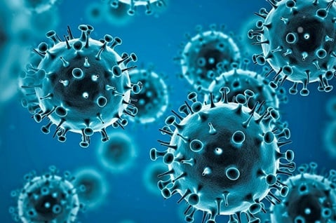

Note: The data is extracted from World Health Organization (WHO), Centers for Disease Control and Prevention (CDC), Mayo Clinic, and others. I don’t claim any right on these data

### About COVID-19

COVID-19 is primarily spread through respiratory droplets when an infected person coughs, sneezes, talks, or breathes. It can also spread by touching surfaces contaminated with the virus and then touching the face. The virus can cause a range of symptoms and complications, particularly in older adults and those with underlying health conditions.

### Home Remedies

While COVID-19 often requires medical attention, particularly in severe cases, these home remedies and supportive measures can help manage mild symptoms:

* **Hydration**: Drink plenty of fluids such as water, herbal teas, and clear broths to stay hydrated and help loosen congestion.
* **Rest**: Get plenty of rest to help your body recover and strengthen the immune system.
* **Nutrition**: Eat a balanced diet rich in fruits, vegetables, whole grains, and lean proteins to support overall health.
* **Steam Inhalation**: Inhale steam from hot water to help relieve nasal congestion and soothe irritated airways.
* **Saltwater Gargle**: Gargle with warm salt water to soothe a sore throat.

### Do's and Don'ts

**Do's:**

* **Follow Medical Advice**: Adhere to the treatment plan prescribed by your healthcare provider, including any medications or therapies.
* **Isolate**: Stay isolated from others to prevent the spread of the virus. Follow local guidelines on quarantine and isolation.
* **Wear a Mask**: Wear a mask when around others to reduce the spread of respiratory droplets.
* **Practice Hygiene**: Wash hands frequently with soap and water for at least 20 seconds or use hand sanitizer with at least 60% alcohol.

**Don'ts:**

* **Avoid Crowds**: Avoid crowded places and close contact with people who are not in your household.
* **Don't Ignore Symptoms**: Monitor your symptoms closely and seek medical attention if they worsen or if you have difficulty breathing, persistent chest pain, confusion, or bluish lips or face.
* **Don't Share Personal Items**: Avoid sharing dishes, drinking glasses, towels, or bedding with others in your household.

### Dietary Recommendations

A balanced diet can help support your immune system and overall health during recovery from COVID-19:

|  |  |  |  |  |  |
| --- | --- | --- | --- | --- | --- |
| | **Meal** | | --- |  |  | | --- | |  |  |  | | --- | |  | | | **Recommended Foods** | | --- | |
| Breakfast | |  | | --- | |  |  |  | | --- | | - Whole grain cereal with fresh fruits and low-fat yogurt  - Oatmeal with berries and nuts | |
| Lunch | |  | | --- | |  |  |  | | --- | | - Chicken or vegetable soup with whole grain bread  - Salad with leafy greens, beans, and olive oil dressing | |
| Dinner | - Baked fish with sweet potatoes and steamed broccoli  - Stir-fried tofu with brown rice and mixed vegetables |