Portfolio Optimisation Using R

Abstract: In this paper, we will be using R to analyze the returns of various stocks and commodities market. Based on the sectors in the link below <https://www.moneycontrol.com/india/stockmarket/sector-classification/marketstatistics/nse/banks.html?classic=true>..

Based on the sectors given below: we have taken top 2-3 stocks in the sector for analysis purpose and also 8 commodities in Indian Rupees (Gold Silver, Aluminium, Copper, Lead, Zinc, Crude oil and natural gas). We have taken commodities prices from MCX

https://www.mcxindia.com/market-data/spot-market-price

The reason for choosing the choosing the commodities is to find out if the price of commodities affects the raw materials of an organisation and hence it affects the price and profit of the organisation. For example, as coper is used in electrical components, the rise in prices may affect the stock prices Polycab (which manufactures copper wires).

First, we import the data and find out daily returns and based on daily returns we find out corelation matrix. The corelation matrix is an important table which shows the price percentage movements between different stock. Based on this some corelation strategies are discussed below:

* Empirical Corelation Trading: In this empirical corelation trading attempts to exploit historically significant corelations within or between markets for instance if global markets are rising for a few days then we try to predict whether Sensex will rise or fall
* Pair Trading: In this trading strategy, we match long position with short position having high corelation. It is based on historical corelation of 2 securities (which have a high corelation between them) and one stock should be lagging behind the other. This generally happens in stocks of the same sector. For example, if we find that HDFC and SBI is intercorrelated and SBI lags behind HDFC price change then we will monitor HDFC price to profit from SBI trade.
* Mult Asset Options (Corelation Options/Rainbow Options): They depend partially on corelation between two or more underlying assets in the option. It has various types like Option on the better of two, option on the worse of two, call of the maximum of two, exchange option, spread option, Option on better of two or cash, Dual strike option or basket option. We also have quanto option which is related to multi asset options
* Structured Products: are designed to provide the investors with a relatively high return and low risk due to diversification. It contains multiple assets, is sometimes tranched and includes derivative.
* Corelation Swaps: In a corelation swaps, one party pays a fixed corelation rate in exchange for realized stochastic corelation rate
* Dispersion Trading
* Hedging: We also find out which stocks are negatively corelated and try to price movement between them for example, we have found stock prices are negatively corelated between commodity prices and make positions accordingly.

Deviation: Based on the deviation, we may determine whether we need to take options in commodity market, for example if we have to purchase steel on regular basis, and if we find steel prices is very volatile, then we may hedge steel prices to purchase steel prices at low prices.

Variance Covariance Matrix. We calculate variance and covariance matrix f the stock prices.

Based on this we calculate sharpe ratio and efficient portfolio of the stock. Weights of the stocks are attached here

We also calculate efficient frontier for this stock.

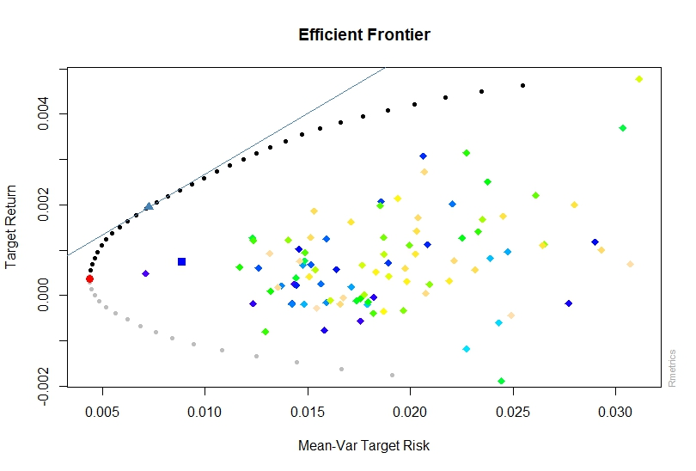

We also calculate risk and returns between various commodities/stocks

