VENDOR SELECTION IN SUPPLY CHAIN MANAGEMENT USING GOAL PROGRAMMING

A project report submitted in partial fulfillment of the requirements for the award of B.Tech degree in mechanical engineering

Submitted By:

Anubhuti Mishra (U04Me615)
Aparna (U04Me704)
Naushir Vora (U04Me682)
Deep Shah (U04Me699)

Guided By
Dr.R.Venkat Rao
Professor

VENDOR SELECTION IN SUPPLY CHAIN MANAGEMENT USING GOAL PROGRAMMING

Students:-
- Anubhuti Mishra
- Aparna
- Naushir Vora
- Deep Shah

These students have carried on their original work under the guidance of

Dr.R.Venkat Rao
Professor

Board of examiners:-

1. Chairman
2. Examiner 1
3. Examiner 2

ACKNOWLEDGMENT

We are deeply indebted to all the people who have guided, inspired, and helped us in the project. We owe a debt of gratitude to all of them, who were so generous with their time and expertise. The expertise in the project belongs to those listed below.

Mr. Yogesh Pandya, Vice President, HR, Reliance Hazira, for granting us the permission to carry out our project jointly at Reliance Hazira.

Mr. L. Santhanam, Head, Purchasing Department, Reliance, Hazira, who will be supervising and guiding us through the project at Reliance, Hazira.

We express our deep gratitude and sincere thanks to Dr.R.V.Rao, professor of mechanical engineering, for his valuable suggestions and unstinted cooperation throughout this project. Despite of his hectic schedule, we cannot forget the hours he has specially spent in discussing our project with us. It is a great pleasure and proud experience to work under his guidance.

CONTENTS

1. Introduction
2. Literature survey
3. Multi criteria decision making
4. Goal programming as a technique for vendor selection
5. Work carried out and future tasks
6. References

1. Introduction

1.1 Supply Chain Management

A supply chain is the system of organizations, people, activities, information and resources involved in moving a product or service from supplier to customer. Supply chains link value chains.
Supply chain management (SCM) is the process of planning, implementing, and controlling the operations of the supply chain as efficiently as possible. It spans all movement and storage of raw materials, work-in-process inventory, and finished goods from point-of-origin to point-of-consumption. The goal of supply chain management is to provide suppliers and customers a window into their supply chain so they can reduce inventory, better utilize plant capacity and cut communications costs. The potential cost savings can be tens of millions of dollars to the bottom line.
The successful operation of any enterprise depends in large measure on procurement of the proper equipment, materials, and supplies of the right quantities, with the right qualities, at the right price, and at the right time. With supply chain synchronization, one can anticipate dramatically improved customer responsiveness. Manufacturers will know exactly where the order is in the process, which operation or activity is next, whether or not any problems exist, and how much time the remaining order fulfillment steps will take. Customers will know with confidence exactly when their orders will be completed and delivered. Supply chain synchronization closes the loop between supply and demand. These systems combine what-if simulation with advanced mathematical methods, such as genetic algorithms, to quickly and effectively assure identification of the best possible course of action. The real-time feedback loop is one of the most important elements of the system design.

1.2 Significance of Vendor Selection

In most industries, purchased material and services comprise the largest class of expenditures. The investment in raw material, parts and supplies inventory in most companies is substantial, and the efficient management of inventory can contribute significantly to profit. Today Manufacturers are purchasing subassemblies rather than piece parts; outsourcing has become prominent in activities ranging from logistics to administrative services, and suppliers are increasingly involved in defining the technical and commercial aspects of the goods and services companies provide. Most importantly, the complexity of purchasing has increased dramatically in terms of the nature of what is purchased. What companies buy has changed significantly. This has implications for how companies buy and translates into highly leverageable opportunities for significant cost reduction and profit enhancement. Procurement is quickly becoming recognized as a priority function that offers high-impact opportunities for improving the bottom line. Manufacturers share production-scheduling and quality control information daily with the principal supplier of raw materials.
Companies need to work with different suppliers to continue their activities. In manufacturing industries the raw materials and component parts can equal up to 70% product cost. In such circumstances the purchasing department can play a key role in cost reduction and supplier selection is one of the most important functions of purchasing management. Several factors may affect a suppliers’ performance. Hence, supplier selection is a multi-criteria problem which includes both tangible and intangible criteria, some of which may conflict.

There are two kinds of supplier selection problems.

- Single Sourcing: Here one supplier can satisfy all the buyer’s needs. Hence the management needs to make only one decision; which supplier is the best.

- Multiple Sourcing: No supplier can satisfy all the buyer’s requirements and the management needs to split order quantities among suppliers for a variety of reasons such as creating a constant environment of competitiveness.

The other axis covers the four different stages in the supplier evaluation process:
- problem definition,
(2) Criteria formulation,
(3) Supplier qualification
(4) Final selection.

Most the decision making methods are applied to the qualification and final selection stage of the buying process, namely supplier selection. Thorough supplier selection is essential to partnership strategy.

1.3 Criteria for Vendor Selection

Vendor selection is based on a various criteria depending upon the policies and the requirements of the concerned organizations. They are also specific to the field of operation and the size of the organization. There are generally two categories of criteria or parameters considered.

- Factors that the company will formulate as its objectives, such as net purchasing costs, net rejections, net late deliveries, etc.

- Factors that will help the company in short-listing the vendors, such as the vendor’s technical capability, financial position, procedural compliance, reputation and position in industry, attitude, flexibility, packaging ability, labour relation record, communication systems, management and organization, geographical location, production facilities and capacity, warranties and claim policies, repair service, environmentally friendly features of the product, etc.

The main objective of this type decision making is minimization of losses and maximization of profits.

2. LITERATURE SURVEY

Many logistics processes involve several supply chain actors, inside and outside the company, and require different skills to be properly managed. Integration, that is collaborative working between supply chain partners in a defined field, has emerged in recent years as a suitable tool to streamline interface operations, which usually cause replicated or poorly performed activities (Romano, 2003), and is recognized as a key dimension of supply chain management (Lee and Ng, 1997; Stock et al., 1998).
The key supply chain processes that need to be integrated can be summarized in demand management, procurement, inbound logistics, internal operations, distribution, new product development (Lambert and Cooper, 2000). Focusing on supplier–customer integration, related benefits have been described and analyzed by several authors (Carr and Pearson, 1999; Ellram, 1995; Kalwani and Narayandas, 1995; Watts and Hahn, 1993), and an exhaustive list of them is provided by Perona and Saccani (2004). Among others, reducing the overall supply chain lead time is recognized as a main outcome of supplier–customer integration. Lead time reduction is particularly relevant due to time based competition (De Toni and Meneghetti, 2000) and its correlation with logistics performances, such as inventory levels and costs, and service level delivered to customers (Womack and Jones, 1996). To achieve the benefits of vendor–buyer integration, in terms of increased internal efficiency and profitability of both players (Davis, 1993), identifying and selecting viable suppliers is a preliminary step to be properly managed (Carter et al., 1998). Moreover, once viable candidates have been chosen, further analyses may be required to determine which purchased items are appropriate for the practical implementation of collaborative processes (i.e. standard items v/s customized ones) (Mukhopadhyay and Kekre, 2002).
Vendor selection or evaluation is a common problem for acquiring the necessary materials to support the outputs of organizations. The problem is to find and to evaluate periodically the best or most suitable vendor(s) for the organizations based on various vendors’ capabilities. This usually happens when the purchase is complex, high-dollarvalue, and perhaps critical [12]. Also, a process of formal vendor evaluation and ranking is necessary. The process for vendor selection is indeed a problem-solving process, which covers the works of problem definition, formulation of criteria, qualification, and choice [13]. However, most articles deal with qualification and choice phases to which operations research related techniques are adapted [5,14]. Due to the fact that the evaluation always involves conflicting performance criteria of vendors, the techniques of MCDM are coherently derived to manage the problem. We can roughly divide these quantitative approaches into four categories: multi-attribute decision making (or a general view of linear weighting models), multi-objective optimization (or a general view of mathematical/linear programming models), statistics/probabilistic approaches, intelligent approaches, and others [5,15,16]. Five categories, each with their own related approaches and examples, are listed in Table 2. Additionally, the first category concentrates on selection activities, which adopt a limited and countable number of predetermined alternatives through multiple attributes or criteria. The alternatives associate with them the level of achievement of the attributes. Though it may still be in doubt whether they are quantifiable or not, those attributes will act as a platform upon which the final choice is to be made [3]. Most approaches utilized, such as AHP, conjoint analysis, the linear weighting (or scoring) method and the outranking method can be classified into this category. The second category involves the design for the best or required alternative by taking into consideration the various interactions within the design constraints that best satisfy the decision maker by way of attaining some acceptable levels of a set of some quantifiable objectives. Its alternatives have been implicitly expressed in the feasible zone of a constraint set, so that the most satisfactory objectives can be obtained [32]. Techniques such as the "-constraint method, data envelopment analysis (DEA), and goal programming contribute to this category.

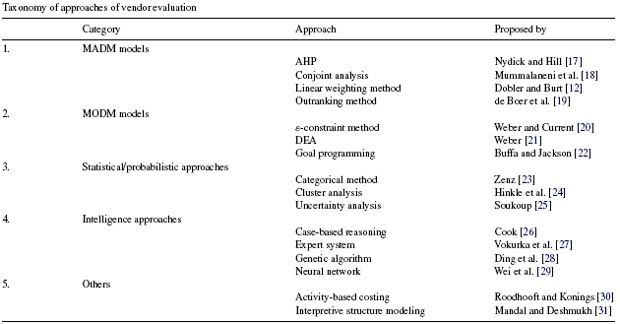

Table2.

3.MULTI CRITERIA DECISION MAKING

Multi Criteria Decision Making (MCDM) techniques are used to identify the optimal vendor selection and distinguish acceptable from unacceptable possibilities. Figure 1 shows the framework for Multi Criteria Decision Making (MCDM).

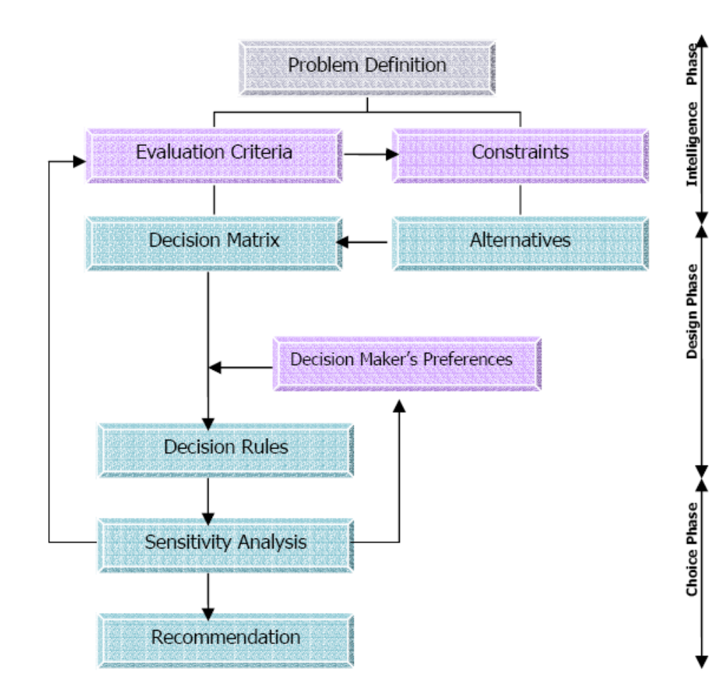

Fig1. Framework for Multi Criteria Decision Making

Multi Criteria Decision Making includes two basic methodologies Multi Attribute Decision Making (MADM) and Multi Objective Decision Making (MODM) techniques. Figure 2 presents the classification of multi criteria decision problems.

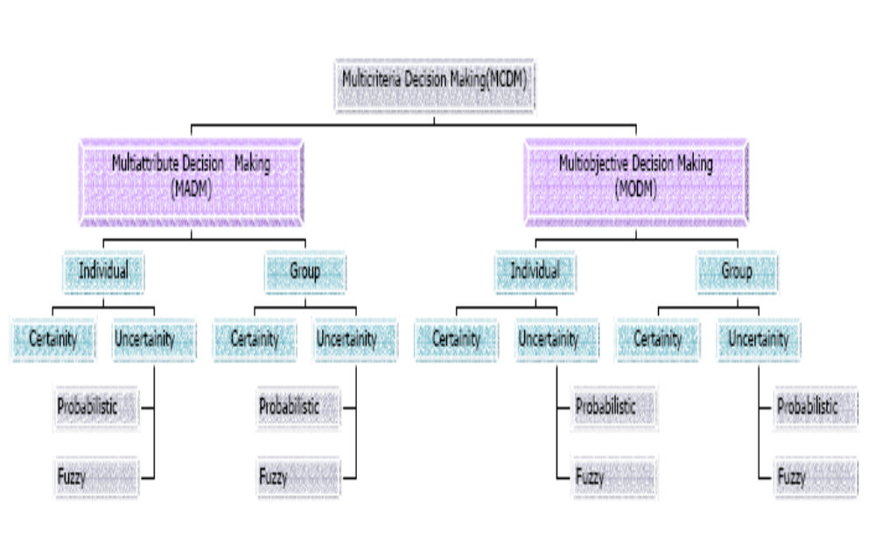

Fig2. Classification of multi criteria decision problems.

The distinction between MADM and MODM is based on the evaluation criteria. MADM problems require that choices be made among alternatives described by their attributes. The set of attributes is given explicitly and multi attribute problems have a finite set of feasible alternatives. Unlike MADM, MODM problems require that means-ends relationships be specified, since they deal explicitly with the relationship of attributes of alternatives to higher level objectives. MODM involves designing the alternatives and searching for the best decisions among an infinite or very large set of feasible alternatives. Each alternative is defined implicitly in terms of the decision variables and evaluated by means of objective functions. Table 1 distinguishes between MODM and MADM based on different aspects.

Table1. Comparison of MODM and MADM Approaches

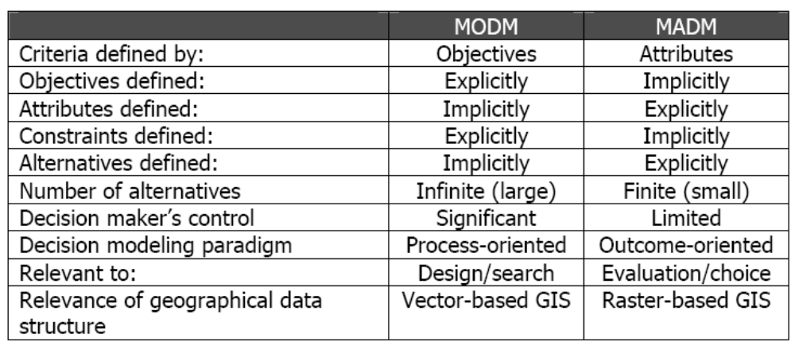

Under MADM methodology there are various techniques like Analytic Hierarchy Process (AHP), DEA, TOPSIS etc. While MODM comprises of techniques such as ANP (Analytic Network Process), Genetic Algorithm, Goal Programming etc.

4. GOAL PROGRAMMING AS A TECHNIQUE FOR VENDOR SELECTION

We will be using goal programming to work on the problems of vendor selection in the industry. Goal Programming is an analytical approach devised to address decision-making problems where targets have been assigned to all the attributes and where the decision maker (DM) is interested in minimizing the non-achievement of the corresponding goals.
Goal Programming (GP), also called linear goal programming (LGP), can be categorized as a special case of linear programming (LP). The origin of GP as a means of resolving infeasible LP problems at-tests to its characterization as a LP methodology
GP is now considered a multi objective decision making (MODM) method; it is used to solve multi-variable, constrained resource and similar problems that have multiple goals.
Goal programming is a technique often used in engineering design activities primarily to find a compromised solution which will simultaneously satisfy a number of design goals.
In solving goal programming problems, classical methods reduce the multiple goal-attainment problems into a single objective of minimizing a weighted sum of deviations from goals.
For example an organization declared that it wanted to optimize both profits and sales. In general, multiple objectives [such as profits and sales taken together] are much easier to handle if they either always increased or decreased together as functions of the decision variables as illustrated in Figure 3.

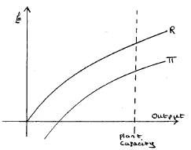

Figure 3

In this case one criterion could be optimized subject to prevailing constraints and the best value of the other measure would follow as a consequence.

But if the two performance measures are, at least beyond a certain point, inversely related - as in the case of profits and sales as shown in Figure 2,

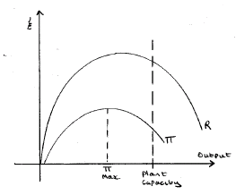

Fig 2.

This is where goal programming comes in - in dealing with multi-criteria decision problems where the goals cannot simultaneously be optimized. Goal programming seeks to obtain an optimal compromise.

4.1 Objective

In vendor selection process a company has to deal with multi-criteria decision problems where the goals cannot simultaneously be optimized. Goal programming seeks to obtain an optimal compromise. Goal programming looks at departures [deviations] from full achievement of the objectives and optimizes a weighted average of these deviations. In this report we pose the goal programming problem as a multi objective optimization problem of minimizing deviations from individual goals. This procedure eliminates the need of having extra constraints needed with classical formulations and also eliminates the need of any user-defined weight factor for each goal. The proposed technique i.e. Goal programming can also solve highly complicated problems having non-convex trade-off region, which are difficult to solve using classical methods. The efficacy of the proposed method is demonstrated by solving a test problem.

4.2 Methodology

The initial structure of GP problem comprises of three parts:
- Decision Variables: Setting the decision variables at a particular level in terms of what to manufacture, how to manufacture and how much to manufacture.

- Objective Function: This function measures what the decision maker is trying to achieve in terms of monetary profits, growth, expansion, maximum utilization of available resources etc. the objective is a criterion which distinguishes a good decision from a bad decision.

- Constraints: every organization aims to achieve the maximum profit, growth and market value and sets objectives in lieu of such targets. But in reality such objectives and decisions are surrounded by restrictions and complications. For example, availability of limited manpower, capital, short supply of resources, market demands and forecasts.

In Linear Programming problems there is a single objective function to be maximized or minimized (subject to constraints). In some problems there may be more than one competing objective (or goal) and we need to trade-off objectives against each other. One way of handling problems with multiple objectives is to choose one of the goals as the supreme goal and to treat the others as constraints to ensure that some minimal ‘satisfying’ level of the other goals is achieved. However, Goal Programming provides a more satisfactory treatment where in many cases problems can still be solved using standard Linear Programming algorithms.

In a Linear Programming problem:
• There is a single objective
• Constraints are absolutely binding In a Goal Programming problem:
• There are multiple objectives (with trade-offs)
• Deviations from constraints are penalized

4.3 GP Modeling

Similar to LP, the GP model has an objective function, constraints (called goal constraints), and nonnegative requirements. The GP objective function is commonly expressed in minimization form as

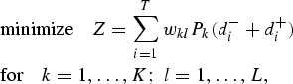

Where;
i = goal constraint index,

k = priority rank index

l = index of the deviation variables within priority rank.

In the objective function;

Z = summation of all deviations

W_{kl =} optional mathematical weights used to differentiate deviation variables
within a kth priority level.

P_{k} = optional rankings of deviation variables within goal constraints.

d⁻_{I} = values are the negative deviational variables,

d⁺_{I =} values are the positive deviational variables.

P_{k} rankings are called preemptive priorities because they establish an ordinal priority ranking (where P₁ > P₂ > P₃ >... etc.) that orders the systematic optimization of the deviation variables.

The fact that the optimization of the variables in the objective function is ordered by the preemptive priority ranking has given rise to the use of the term satisficing. This term results from the fact that a solution in a GP model satisfies the ranking structure while minimizing deviation from goals. One of the best features of GP is that the P_{k} permits the decision makers to rank goals in accordance with their personal preferences, and even weight the importance of those preferences within goals using w_{kl}. The greater the w_{kl} mathematical weighting, the greater the importance attached to its related deviation variable.
The goal constraints in a GP model can be ex-pressed as:

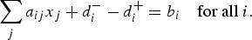

Here, the a_{ij} values are the resource utilization rates representing the per unit usage of the related re-source b_{i}, and the x_{j} are decision variables we seek to determine. The goal constraints in a GP model are used to express goals that we seek to achieve by minimizing deviation (in the form of deviation variables) from their right-hand-side b_{i} goal tar-gets. In essence, this use of deviation variables minimizes the absolute difference between the right-and left-hand sides of each constraint. The d⁻_{i} are termed underachievement variables and the d⁺_{i} are overachievement variables. The non-negativity requirements in a GP model are usually expressed as:

When preemptive priorities are not established, the GP model takes on the form

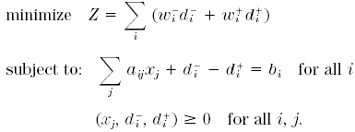

The w_{i}⁻ and w_{i}⁺ are positive, negative or zero weights. A constraint may not be a goal constraint in that we can let d_{i}⁻ = d⁺_{i} = 0 if the condition must be met exactly, as, for example, a fixed budget condition. Such constraints are said to be hard. In contrast, goal constraints are said to be soft, as their goals can be underachieved, overachieved or met exactly, as, for example, a production requirement.

Example:

Linear Programming problem:

Maximize profits subject to a labour and storage constraint

max 2X₁ + 3X₂

Subject to

X₁ + X₂ ≤ 100 (labour constraint) (1)

4X₁ + X₂ ≤ 200 (storage constraint) (2)

The solution to the problem is:

X₁=0, X₂=100, S₁=0, S₂=100; Z (profits) = 300.

The storage constraint is not binding so storage is under used.
Goal Programming Problem

Suppose instead that the firm wants to achieve 3 objectives:

X₁ + X₂ = 100 (Use all available labour) (3)

X₁ + X₂ = 200 (Use all storage) (4)

2X₁ + 3X₂ = 110 (Achieve reasonable profits) (5)

These three goals may be either over- or under- achieved.

We introduce deviation variables to represent the over- or under-achievement of the goals:

D₁A represents the amount of over-achievement of goal (1)
D₁B represents the amount of under-achievement of goal (1)
D₂A represents the amount of over-achievement of goal (2)
D₂B represents the amount of under-achievement of goal (2)

Note that for any goal K:

If the goal is exactly achieved: D_{K}A = 0; D_{K}B = 0
If the goal is over-achieved: D_{K}A > 0; D_{K}B = 0
If the goal is under-achieved: D_{K}A = 0; D_{K}B > 0
And in all cases all deviation variables ≥ 0

Adding pairs of deviation variables to the goals transforms them into a set of constraints:

X₁ + X₂ + D₁B - D₁A = 100 (6)

X₁ + X₂ + D₂B - D₂A = 200 (7)

2X₁ + 3X₂ + D₃B - D₃A = 110 (8)

The objective of the goal programmer is to minimize deviations from the goals given by:

min D₁A + D₁B + D₂A + D₂B + D₃A + D₃B (9)

This problem has now been transformed into a standard Linear Programming problem which can be solved as usual.

The solution to the problem (using the simplex method) is:
X₁ = 49; X₂ = 4; D₁B = 47; Z (deviation from goals) = 47

Note that profits are 110 but labour is under-used.

4.4 Weighting of Goals

min D₁A + D₁B + D₂A + D₂B + D₃A + D₃B (10)

The objective function (10) implies that all deviations are given equal weight. (It also implies that achieving profits above the target is penalized in the same way as underachieving the goal which is silly.)

Goals can be weighted by using different coefficients on the deviations in the objective function.

For example, to modify the goals so that:
(1) Avoiding under-utilization of labour is twice as important as all other objectives
(2) Achieving excess profits is not penalized the resulting objective function would become:

Min 1 D₁A + 2 D₁B + 1 D₂A + 1 D₂B + 0 D₃A + 1 D₃B and the solution to this (weighted) Goal Programming problem is:

X₁ = 33.3; X₂ = 66.7; D₃A = 156.7; Z = 0

All the goals are now achieved with profits = 266.7.

4.4.1 Differential Weighting

X₁ + X₂ + D₁B - D₁A = 100 (6)

X₁ + X₂ + D₂B - D₂A = 200 (7)

2X₁ + 3X₂ + D₃B - D₃A = 110 (8)

Now, to find the weight assigned to D1, D2 and D3:

D1: 1/100
D2: 1/200
D3: 1/110

4.5 Prioritizing Goals

Suppose that the attainment of one (or more) of the goals is considered to be of paramount importance. Then achievement of this goal should be attained before all other goals are considered. More generally, goals can be organized in groups of different priorities. Goals of priority K are only considered when all goals of higher priority have been achieved. This type is known as Preemptive Goal programming, where there is a hierarchy of priority of levels for various goals so that there are goals of primary importance that receive before others which are of secondary importance .
Note that this is different from weighting of goals and cannot be transformed into a standard Linear Programming problem. However, it can be solved by a straightforward modification of the simplex algorithm.

Modified Simplex algorithm:

Step 1: Minimize deviation of all priority 1 goals

Step 2: Minimize deviation of all priority 2 goals subject to 1

Step 3: Minimize deviation of all priority 3 goals subject to 1 & 2 etc.

The algorithm stops when goals of a certain priority cannot be achieved.

Example:

Suppose the priorities are: 1 storage; 2: labour; 3 profits.

Then the sequence of problems to be solved is:

Priority 1: min D2A + D2B

Priority 2: min D1A + D1B (s. t. D2A = D2B = 0)

Priority 3: min D3A + D3B (s. t. D2A = D2B = D1A = D1B = 0)

Solution is: X1 = 33.3; X2 = 66.7; profits = 266.7; D3A = 156.7
Priority 1 and 2 goals are achieved. Excess profits are 156.7.

Note that goal weighting and prioritizing of goals can be combined.

Example 2

Kumar et al. (2004) had presented a fuzzy goal programming approach for vendor selection problem in a supply chain. The vendor source data is given in Table 29.3 and this data relates to a realistic situation of a manufacturing company dealing with auto parts. The approach was developed from requirements espoused by the situation during the initial stages of implementing a formal program for better management of its supply chain which subsequently undertook a vendor certification plan for its purchased items. Those vendors who successfully passed the screening processes were eligible for procurement. Four established vendors for a projected demand of the part had been screened for supplying this purchased item. Table 29.3 represents the data set for the price quoted (p_{i}), the percentage rejections (q_{i}), the percentage late deliveries (d_{i}), vendors’ capacities (U_{i}), vendors’ quota flexibility (f_{i}) on a scale of 0–1, vendor rating (r_{i}) on a scale of 0–1, and the budget allocations for the vendors (B_{i}). The least value flexibility in vendors’ quota and least total purchase value of supplied items were policy decisions and depend on the demand. The least value of flexibility in vendors’ quota was given as F = fD and the least total purchase value of supplied items was given as P = rD. Overall flexibility (f) and the overall vendor rating (r) were considered as 0.03 and 0.92 on a scale of 0 -1, aggregate demand (D) as 20,000, and the least value of flexibility in vendors’ quota (F) and the least total purchase value of supplied items (P) were considered as 600 and 18,400, respectively.

Table 29.3. Vendor source data (from Kumar et al. (2004); reprinted with permission from Elsevier)
__________________________________________________________________________
Vendor p_{i} ($) q_{i} (%) d_{i} (%) U_{i} (units) f_{i} r_{i} B_{i}($)
__________________________________________________________________________
1 5 0.05 0.04 5000 0.02 0.88 25000
2 7 0.03 0.02 15000 0.01 0.91 100000
3 6 0.00 0.08 6000 0.06 0.97 35000
4 2 0.02 0.01 3000 0.04 0.85 5500
__________________________________________________________________________

The mixed integer programming vendor selection problem (MIP_VSP) formulation for three objectives and a set of system and policy constraints formulated by Kumar et al. (2004) are given below:
_{n}
Minimize Z₁= ∑ p_{i}x_{i} (1)
_{i=1}
_{n}
Minimize Z₂= ∑ q_{i}x_{i} (2)
_{i=1}

_{n}
Minimize Z₃= ∑ d_{i}x_{i} (3)
_{i=1}
Subject to:
_{n}
∑ x_{i} = D (4)
_{i=1}

x_{i} ≤ U_{i} for all i =1,2,…, n (5)
_{n}
∑ f_{i}x_{i} ≥ F (6)
_{n}
∑ r_{i}x_{i} ≥ P (7)
_{i=1}
p_{i}x_{i} ≤ B_{i} for all i =1,2,…., n (8)
x_{i} ≥ 0 and integer (9)
x_{i} = quantity purchased from vendor i
D = aggregate demand of the item over a fixed planning period
n = number of vendors competing for selection
p_{i} = price of a unit item of the ordered quantity xi from the vendor i
q_{i} = percentage of the rejected units delivered by the vendor i
d_{i} = percentage of the late delivered units by the vendor i
U_{i} = upper bound of the quantity available with vendor i
f_{i} = vendor quota flexibility for vendor i
F = lower bound of flexibility in supply quota that a vendor should have
r_{i} = vendor rating value for vendor i
P = lower bound to total purchasing value that a vendor should have
B_{i} = budget allocated to each vendor
Objective function 1 minimizes the net cost for all the items.
Objective function 2 minimizes the net number of rejected items from the vendors.
Objective function 3 minimizes the net number of late delivered items from the vendors.
Constraint 4 puts restrictions due to the overall demand of items.
Constraint 5 puts restrictions due to the maximum capacity of the vendors.
Constraint 6 incorporates flexibility needed with the vendors’ quota.
Constraint 7 incorporates total purchase value constraint for all the ordered quantities.
Constraint 8 puts restrictions on budget amount allocated to the vendors for supplying the items.

Solution :-
This is clearly an example of multi-decision problem which can be solved by goal programming.
The problem has three objective functions subject to constraint equations.

Minimize Z₁= ∑ p_{i}x_{i}
From the data we get

5x₁ ₊7x₃+6x₃+2x4₄

Minimize Z₂= ∑ q_{i}x_{i}

0.05x₁ + 0.03x₂ + 0.0x₃ + 0.02x₄

Also
Minimize Z₃= ∑ d_{i}x_{i}

0.04x₁+0.02x₂+0.08x₃+0.01x₄

These are subject to constraints and after substituting their numerical values in the equation we get,

x₁ + x₂+ x₃+x₄=3000

0.02x₁+0.01x₂+0.06x₃+0.04x₄>=600

0.88x₁+0.91x₂+0.97x₃+0.85x₄>=18400

To solve this problem using simplex method, we need to introduce deviational variables in each of these constraints involving goals. They may be defined as follows.
Converting the objective functions by adding deviational variables we get,

5x₁ ₊7x₃+6x₃+2x4₄-d₁⁺+d₁⁻=12,000 assumption

0.05x₁ + 0.03x₂ + 0.0x₃ + 0.02x₄ –d₂⁺+d₂⁻=300

0.04x₁+0.02x₂+0.08x₃+0.01x₄ –d₃⁺-d₃⁻=700

Where
d₁⁺: over achievement of price of a unit item of the ordered quantity

d₁⁻ :under achievement of price of a unit item of the ordered quantity

d₂⁺:over achievement of the rejected units delivered by the vendor

d₂⁻ : under achievement of the rejected units delivered by the vendor

d₃⁺: over achievement of the late delivered units by the vendor

d₃⁻: under achievement of the late delivered units by the vendor

The remaining constraint functions with inequalities are converted into equalities by adding some constraints.

0.02x₁+0.01x₂+0.06x₃+0.04x₄-s₁ =600

0.88x₁+0.91x₂+0.97x₃+0.85 x₄ –s₂=18400

x₁ + x₂+ x₃+x₄ =3000

0< x₁ <= 5000

0< x₂ <= 15000

0< x₃ <= 6000

0< x₄ <= 3000

In this problem we consider all the under achievements to be zero there fore in the problem all the under achieved deviations become zero.

Therefore,
d₁⁻ =0

d₂⁻=0

d₃⁻=0

and the objective function turns out to be

d₁/12000+d₂/300+d₃/700+s₁+s₂

Hence with the available equations simplex method is used to solve the equations.

The same problem when solved using genetic algorithm gives the following results:

S.No. Objective AHP Value of Vendor Order Quantity (units)
weights objective x₁ x₂ x₃ x₄
__________________________________________________________________________
1 Z₁($) 0.3333 115107 2869 8636 5830 2665
Z₂ (units) 0.3333 456
Z₃ (units) 0.3333 781
1.1 Z₁($) 0.3333 120437 0 11437 5813 2750
Z₂ (units) 0.3333 398
Z₃ (units) 0.3333 721
1.2 Z₁($) 0.3333 117100 4585 12669 0 2746
Z₂ (units) 0.3333 664
Z₃ (units) 0.3333 464
1.3 Z₁($) 0.3333 124717 4726 9443 5831 0
Z₂ (units) 0.3333 520
Z₃ (units) 0.3333 844
2 Z₁($) 0.54 115122 2849 8651 5830 2670
Z₂ (units) 0.30 456
Z₃ (units) 0.16 780
3 Z₁($) 0.4 115171 2752 8719 5830 2699
Z₂ (units) 0.3 453
Z₃ (units) 0.3 778
__________________________________________________________________________

References

- Quantitative techniques in management by N.D.VOHRA by TATA McGRAW HILL publication
- Operations research by R.Panneerselvam
- decision making in _{industrial} vendor selection, Journal of Business Research 38 (1997) 115–122.

- [2] R. Michaels, A. Kumar, S. Samu, Activity-specific role stress in purchasing, International Journal of Purchasing and Materials Management 31 (1) (1995) 11–19.
- [3] C.L. Hwang, K. Yoon, Multiple Attribute Decision Making, Springer-Verlag, Berlin, 1981.
- [4] J. Kontio, A case study in applying a systematic method for COTS selection, in: Proceedings of the 18th International Conference on Software Engineering, 25–30 March 1996, 1996, pp. 201–209.
- [5] L. de Boer, E. Labro, P. Morlacchi, A review of methods supporting supplier selection, European Journal of Purchasing and Supply Management 7 (2001) 75–89.
- [6] S.H. Ghodsypour, C. O’Brien, A decision support system for supplier selection using an integrated analysis hierarchy process and linear programming, International Journal of Production Economics 56–57 (1998) 199–212.
- [7] H. Min, Selection of software—the analytic hierarchy process, International Journal of Physical Distribution and Logistics Management 22 (1) (1992) 42–52.
- [8] D.J. Carney, K.C. Wallnau, A basis for evaluation of commercial software, Information and Software Technology 40 (1998) 851–860.
- [9] L.C. Briand, COTS evaluation and selection, in: Proceeding of the International Conference on Software Maintenance, 16–20 November 1998, 1998, pp. 222–223.
- [10] T.L. Saaty, Decision Making with Dependence and Feedback: the Analytic Network Process, RWS, Pittsburgh, PA, 1996.
- [11] T.L. Saaty, The Analytic Hierarchy Process, McGraw-Hill, New York, 1980.
- [12] D.W. Dobler, D.N. Burt, Purchasing and Supply Management, 6th edition, McGraw-Hill, NY, 1996.
- [13] H.S. Shih, C.H. Wang, E.S. Lee, A multiattribute GDSS for aiding problem-solving, Mathematical and Computer Modelling 39 (11–12) (2004) 1397–1412.
- [14] R. Dulmin, V. Mininno, Supplier selection using a multi-criteria decision aided method, Journal of Purchasing and Supply Management 9 (2003) 177–187.
- [15] A. Petroni, M. Braglia, Vendor selection using principal component analysis, Journal of Supply Chain Management 36 (2) (2000) 63–69.
- [16] C.A.Weber, J.R. Current,W.C. Benton, Vendor selection criteria and methods, European Journal of Operational Research 50 (1) (1991) 2–18.
- [17] R.I. Nydick, R.P. Hill, Using the analytic hierarchy process to structure the supplier selection procedure, International Journal of Purchasing and Materials Management 28 (2) (1992) 31–36.
- [18] V. Mummalaneni, K.M. Dubas, C. Chao, Chinese purchasing managers’ preferences and trade-offs in supplier selection and performance evaluation, Industrial Marketing Management 25 (1996) 115–124.
- [19] L. de Boer, L. van der Wegen, J. Telgen, Outranking methods in support of supplier selection, European Journal of Purchasing and Supply Management 4 (1998) 109–118.
- [20] C.A. Weber, J.R. Current, A multi-objective approach to vendor selection, European Journal of Operational Research 68 (2) (1993) 173–184.
- [21] C.A. Weber, A data envelopment analysis approach to measure vendor performance, Supply Chain Management 1 (1) (1996) 28–39.
- [22] F.P. Buffa, W.M. Jackson, A goal programming model for purchasing planning, Journal of Purchasing and Materials Management 19 (3) (1983) 27–34.
- [23] G. Zenz, Purchasing and the Management of Materials, Wiley, New York, 1981.
- [24] C.L. Hinkle, P.J. Green, P.E. Green, Vendor evaluation using cluster analysis, Journal of Purchasing 5 (3) (1969) 49–58.
- [25] W.R. Soukup, Supplier selection strategies, Journal of Purchasing and Materials Management 23 (3) (1987) 7–12.
- [26] R.L. Cook, Case-based reasoning systems in purchasing: applications and development, International Journal of Purchasing and Materials Management 33 (1) (1997) 32–39.
- [27] R.J. Vokurka, J. Choobineh, L. Vadi, A prototype expert system for the evaluation and selection of potential suppliers, International Journal of Operations and Production Management 16 (12) (1996) 106–127.
- [28] H. Ding, L. Benyoucef, X. Xie, A simulation-optimization approach using genetic search for supplier selection, in: Proceeding of the 2003 Winter Simulation Conference, 7–10 December, New Orleans, LA, USA, vol. 2, 2003, pp. 1260–1267.

