Suggested Titles:

“ Metabolic-Flux Network Topology for Biological interacting systems”

“Metabolic-Flux Network Topology reveals the Neuron-Astrocyte units “

“Topological structure of Astrocyte-Neuron Interaction Network”

F. Torres, M. Kiwi
Department of Physics, Universidad de Chile, Chile
Center for the Development of Nanoscience and Nanotechnology, CEDENNA

Abstract

The neuron-astrocyte interaction plays an important role in synaptic physiology [1]. Neuronal excitability is based on the transport of electrical signals through the plasma membrane, in contrast to astrocyte cellular excitability which depends on the Ca⁺² concentration of the cytoplasm [2-3]. Recently it has been demonstrated that astrocytes play an active role in the regulation of the synaptic transmission through information exchange with neuronal elements [1-5]. In order to understand the role of the astrocyte in the synaptic process we propose a method for mapping topological and functional properties of the metabolic reaction stoichiometry of the neuron-astrocyte (NA) system by the selective inhibition of specific reactions. We demonstrate that optimization of the metabolic network arises from the cooperative activity between neuron and astrocyte. Sensitivity analysis reveals that high-sensitive fluxes preserve the neuronal architecture. Further, the metabolic flux patterns can be used to characterize the NA interaction. Our findings suggest that neuron and astrocyte networks optimize the number of interconnected reactions, and, simultaneously, preserve the global structure of the NA unit. These results allow a qualitative interpretation of the topological properties of metabolic networks.

Introduction

There has been an increasing interest on the role of the astrocyte in the synaptic process [1-5]. In contrast to the standard assumption that synaptic activity arises exclusively from neuronal elements [6-9], recent evidence reveals that astrocytes also play an important regulatory role in synaptic transmission [10-13]. Variations of the Ca²⁺ concentration at the cytoplasm triggers an electrical signal which gives rise to the astrocyte cellular excitability [1,14]. In the absence of neuronal activity, the release of neurotransmitters activates Ca²⁺ variations at the astrocyte which indicates that there is a neuron-astrocyte interaction [14]. The neuron-neuron interaction through axons is a high-speed process which extends over large intercellular distances, whereas the neuron-astrocyte interaction acts over short distances and long time-scales. Furthermore, astrocytes are able to participate in different synaptic processes through the brain neural network.

In order to elucidate the NA interaction mechanism several theoretical approaches have been developed. Nevertheless, due to the complexity of the NA system this issue is still largely unresolved, and the NA interaction is poorly understood. Most of these methods are based on the optimized balance of metabolic fluxes [16-24], network alignment and graph representation methods [25-32]. The key lies in finding properties of metabolic networks from stoichiometry, by using steady state information or the topological structure of the metabolic network. The first procedure is based on the assumption that biological systems maximize their metabolic fluxes to optimize a set of objective functions; and the second one focuses on that all the information of the optimized steady-states is contained in the topological properties of the metabolic network [15-32]. In this work, we present a metabolic-flux-based approach to construct a NA interacting system metabolic network, where the nodes of the undirected-graph correspond to reactions interconnected through metabolites (or links). The proposed graph has been rewired using the local configuration of metabolite connections caused by the inhibition of a specific reaction. We define geometric descriptors in order to characterize the structural properties of the metabolic network. We demonstrate that the inhibition of reactions, that compensate the interactions between neuron and astrocyte, preserve the NA structure and also correspond to high-sensitive fluxes. Further, our approach provides a method to characterize the role of the metabolic reaction in the NA units.

Methods and Results

We have developed a flux-dependent algorithm to construct interacting cells metabolic networks, which in turn allows the characterization of the NA structure. This algorithm establishes a connection between flux-balanced steady states and the structure of the metabolic network, and reveals a universal dependence between the global NA unit and the connectivity and the centrality of individual cells. According to flux balanced analysis, all the information about the steady state is contained in the stoichiometric matrix; for instance, all the connections and paths through the network. Each node of the network correspond to a single element of a dynamic system which can interact with the others nodes through links. Flux balance analysis optimize the flux distributions of a metabolic network composed of n metabolites interacting through m reactions satisfying the dynamic mass balance equation
S·υ = 0, α_{i}≦υ_{i}≦β_{i}, i=1, 2,…n ,
where S is the stoichiometric matrix (S_{ij,} i=1, 2,…n; j=1, 2,...m), α_{i,} β_{j} define the bounds for each reaction, and υ_{i} is the vector of all metabolic reactions rates. Assuming that reactions correspond to nodes interacting with each other through different metabolites, each column of the stoichiometric matrix contains all the information of the input and output fluxes. The metabolic fluxes lead to a quasi-steady state, since the metabolic time scale is longer than cellular growth rates and environmental changes [1, 15-16].

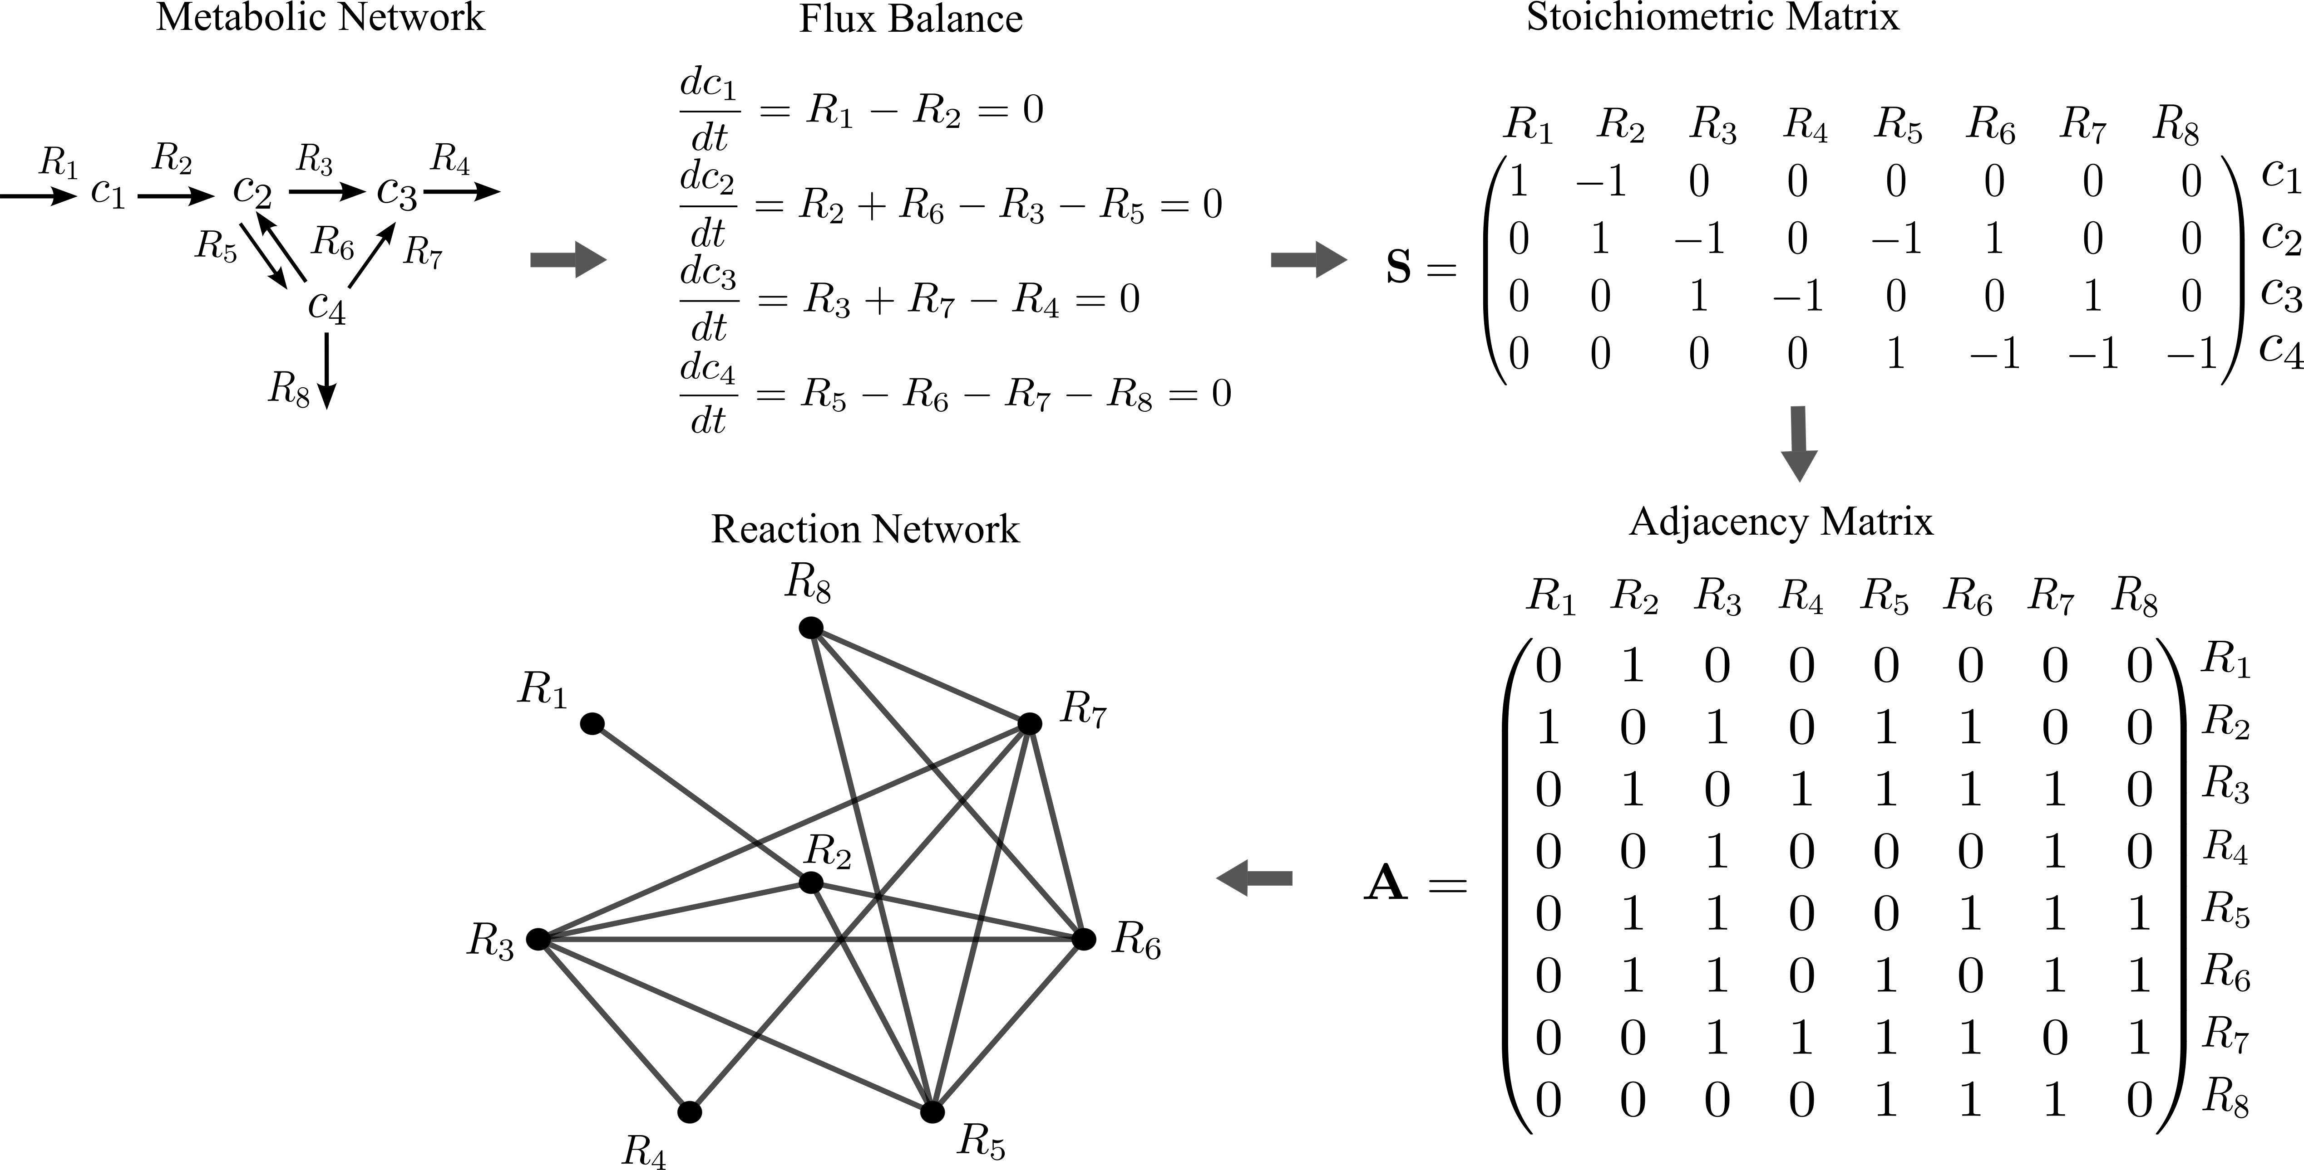
Fig. 1. Schematic diagram of the algorithm of the construction of the reaction network.

To develop the graph representation to build a metabolic network it is necessary to define an adjacency matrix, namely, a binary matrix associated with all possible connections between metabolites. For instance, when the i-th metabolite participates in a reaction with the j-th metabolite A_{ij} = 1, and A_{ij} = 0 otherwise (notice that an undirected graph is defined by a symmetric adjacency matrix A_{ij} = A_{ji}). The adjacency matrix is constructed in such a way as to be a undirected graph of reactions. Non-zero components of the j-th column of the stoichiometric matrix correspond to a connection between two reactions. This information allows to create all the tuples between two reactions; likewise, if the k-th reaction is connected to l-th one there is a non-zero entry [see Fig. (1)].
In order to characterize the neuron-astrocyte interaction through topological properties of the network we study the effect of blocking single reactions. We introduce two geometric descriptors: i) the degree of connectivity or the connection of the i-th site k_{j} = Σ_{j} A_{ij}, which specifies the number of connections of the i-th vertex of the graph; and ii) the betweenness centrality c_{i} = Σ_{j,k} c_{jk}(i)/c_{jk} , where c_{jk}(i) is the number of paths between the j-th and the k-th node that go through the i-th node, and c_{jk} is the total number of paths between nodes j and k. Fig. (2) shows the fully connected NA metabolic network. Highly connected sites are distributed at the ends of each cluster, while the sites with large betweenness centrality appear on the central path between the two clusters [see Fig. (2)]. This means there are two emergent topological structures with a hierarchical metabolic structure and a spatial correspondence for large values of the connectivity and betweenness centrality per node.

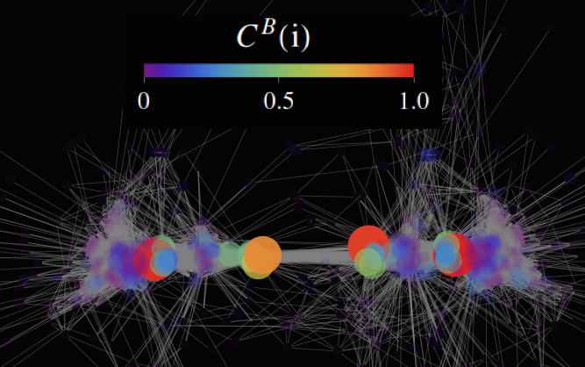
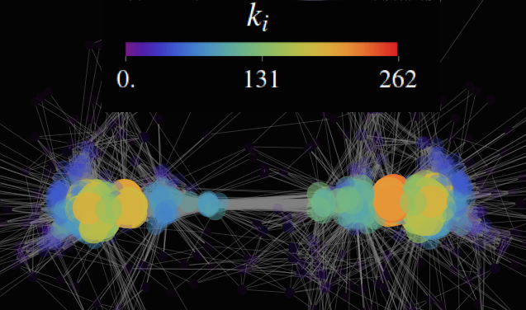

Fig. 2. Graph representation of the NA metabolic network. Connectivity (left-panel), and normalized betweenness centrality (right-panel) of each reaction. Two clusters can be identified directly by a spatial correspondence for large values of the connectivity and betweenness centrality per node. However, while highly connected sites are mainly distributed at the ends of each cluster, the sites with large betweenness centrality appear underneath the central path between the two clusters.

The effect of blocking a single metabolite is shown in Fig. (3). In this case the variations between the centroids of neuron δN and astrocyte δA exhibit a linear dependence, where a global optimization and compensation effect emerges, since reactions belonging to neurons and astrocytes appear on opposite extremes of the line plot, which means that the decreasing connectivity/centrality of one structure should be compensated for by the enhancement of the other. The bifurcated branch indicates a breakdown of the neuron-astrocyte symmetry, in this case the centrality of the astrocyte is increased keeping the connectivity centroid of the neuron. This result supports the strong neuron-astrocyte communication, which plays an important role in the synaptic transmission.
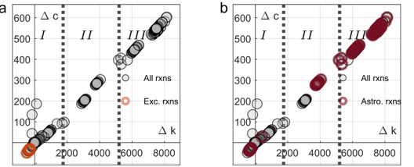

Fig. 3. Astrocyte-neuron topological characterization. a) Deviations generated by removing uptakes from the endothelium. b) Deviations obtained by eliminating internal astrocyte reactions. The neuron and astrocyte networks that are exhibited optimize the relation between connectivity and centrality simultaneously. For the fully activated state the centroids (star markers) are close to each other. Neurons and astrocytes present the same optimized relation between local (connectivity) and global (centrality) geometric properties.

Conclusions

We provide a method linking the geometric properties of a metabolic network and the balanced-flux steady states. Using a topological characterization, instead of a dynamical simulation which has a higher computational cost, we demonstrate that a neuron and astrocyte metabolic network individually optimize the relation between connectivity and centrality. This can be interpreted as a universal behavior of biological systems satisfying specific objective functions, such as homeostatic equilibrium or energy exchange. From a geometric point of view the inhibition of a specific reaction allows to classify them into two categories: i) the ones that produce an asymmetry between the NA centroids; and ii) the ones that keep the NA symmetry. In the first class there are inhibited reactions whose functions is to increase the connectivity and centrality of a single element of the NA unit, as for instance the neuron or the astrocyte. But also there are several reactions that raise the centrality maintaining the connectivity of the neuron. The applications of our findings span the link between structural and functional properties of the metabolic reactions, qualitative insights into NA interactions, and the improvement of the current flux balanced methods

Acknowledgment

F. Torres, and M. Kiwi acknowledges financial support from grants AFORS FA9550-16-1-0122, FA9550-18-1-0438, Fondecyt 1160639, and CEDENNA through the Financiamiento Basal para Centros Científicos y Tecnológicos de Excelencia-FB0807.

Bibliography

- Hille, B. Ionic Channels of Excitable Membranes. (2nd edn.), Sinauer Associates Inc. (1992).

- Aguado, F. et al. Neuronal activity regulates correlated network properties of spontaneous calcium transients in astrocytes in situ. J. Neurosci. 22, 9430–9444, (2002).

- Nett, W.J. et al. Hippocampal astrocytes in situ exhibit calcium oscillations that occur independent of neuronal activity. J. Neurophysiol. 87, 528–537, (2002) .

- 4 Parri, H.R. et al. Spontaneous astrocytic Ca 2+ oscillations in situ drive NMDAR-mediated neuronal excitation. Nat. Neurosci. 4, 803–812, (2001) .

- Peters, O. et al. Different mechanisms promote astrocyte Ca 2+ waves and spreading depression in the mouse neocortex. J. Neurosci. 23, 9888–9896, (2003).

- Orkand, R.K. et al. Effect of nerve impulses on the membrane potential of glial cells in the central nervous system of amphibian. J. Neurophysiol. 29, 788–806, (1966).

- Seifert, G. and Steinhauser, C. Ionotropic glutamate receptors in astrocytes. Prog. Brain Res. 132, 287–299, (2001) .

- Sontheimer, H. Voltage-dependent ion channels in glial cells. Glia 11, 156–172, (1994) .

- Verkhratsky, A. and Steinhauser, C. Ion channels in glial cells. Brain Res. Brain Res. Rev. 32, 380–412, (2000).

- Aguado, F. et al. Neuronal activity regulates correlated network properties of spontaneous calcium transients in astrocytes in situ. J. Neurosci. 22, 9430–9444, (2002).

- Nett, W.J. et al. Hippocampal astrocytes in situ exhibit calcium oscillations that occur independent of neuronal activity. J. Neurophysiol. 87, 528–537, (2002).

- Parri, H.R. et al. Spontaneous astrocytic Ca 2+ oscillations in situ drive NMDAR-mediated neuronal excitation. Nat. Neurosci. 4, 803–812, (2001).

- Peters, O. et al. Different mechanisms promote astrocyte Ca 2+ waves and spreading depression in the mouse neocortex. J. Neurosci. 23, 9888–9896, (2003).

- G. Perea, and A. Araque, Glial calcium signalling and neuron- glia communication. Cell Calcium 38, 375–382, (2005).

- A. Varma, and B. O. Palsson, Bio/Technology 12, 994-998 (1994).

- M. Beguerisse-Díaz, G. Bosque, D. Oyarzún, J. Picó, and M. Barahona, Mauricio, npj Systems Biology and Applications 4, 32 (2018).

- G. Ricci, L. Volpi, L. Pasquali, L. Petrozzi, and G. Siciliano, J. Bio. Phys. 35, 317-336 (2009).

- B. Niebel, S. Leupold, and M. Heinemann, Nature Metabolism 1, 125.132 (2019).

- D. De Martino, A. Mc Anderson, T. Bergmiller, C. C. Guet, and G. Tkacik, Nature Communications 9, 2988 (2018).

- D. Simão, A. P. Terrasso, A. P. Teixeira, C. Brito, U. Sonnewald, and P. M. Alves, Sci. Rep. 6, 33285 (2016).

- P. Hasel, O. Dando, Z. Jiwaji, P. Baxter, A. C. Todd, S. Heron, N. M. Márkus, J. McQueen, D. W. Hampto, M. Torvell, S. S. Tiwari, S. Mckay, A. Eraso-Pichot, A. Zorzano, R. Masgrau, E. Galea, S. Chandran, D. J. A. Wyllie, T. I. Simpson, and G. Hardingham, Nature Communications 8, 15132 (2017).

- Z. Xu, J. Sun, Q. Wu, and D. Zhu, Sci. Rep. 7, 17334 (2017).

- A. Bordbar, J. T. Yurkovich, G. Paglia, O. Rolfsson, O. E. Sigurjónsson, and B. O. Palsson, Sci. Rep.7, 46249 (2017).

- T. Shen, Z. Zhang, Z. Chen, D. Gu, S. Liang, Y. Xu, R. Li, Y. Wei,Z. Liu, Y. Yi, and X. Xie, Sci. Rep. 8, 16376 (2018).

- Sharan, R. et al. Conserved patterns of protein interaction in multiple species. Proc. Natl. Acad. Sci. USA 102, 1974–1979 (2005).

- Flannick, J., Novak, A., Do, C. B., Srinivasan, B. S. & Batzoglou, S. Automatic parameter learning for multiple network alignment in Research in Computational Molecular Biology, 214–231 (2008).

- Pržulj, N. Biological network comparison using graphlet degree distribution. Bioinformatics 23, 853–854 (2007).

- Kuchaiev, O. & Pržulj, N. Integrative network alignment reveals large regions of global network similarity in yeast and human. Bioinformatics 27, 1390–1396 (2011).

- Pache, R. A. & Aloy, P. A Novel Framework for the Comparative Analysis of Biological Networks. PLoS One 7, e31220 (2012).

- Neyshabur, B., Khadem, A., Hashemifar, S. & Arab, S. S. NETAL: a new graph-based method for global alignment of protein-protein interaction networks. Bioinformatics 29, 1654–1662 (2013).

- Saraph, V. & Milenkovic, T. MAGNA: Maximizing Accuracy in Global Network Alignment. Bioinformatics 30, 2931–2940 (2014).

