**Kathmandu University**

**Department of Computer Science and Engineering**

**Dhulikhel, Kavre**



**COMP 202**

**Mini Project**

**Submitted by**

Deependra Kumar Gupta(18)

Shreyam Pokharel(40)

CE 2nd Year/1st Sem

**Submitted To**

Dr. Rajani Chulyadyo

Department of Computer Science and Engineering

**Introduction**

We all the student of computer engineering studying in 3rd semester were assigned to do a mini project of the subject “Data Structures And Algorithms”.Our respected teacher Dr. Rajani Chulyadyo told us to make a group consisting maximum of three students and send me your prefences .Our group was assigned to do first number which is entitled as “Convert the given prefix expression to post and find its time complexity”.

Prefix:An expression is called the prefix expression if the operator appears in the expression before the operands e.g.*+ab-cd

Postfix:An expression is called the postfix expression if the operator appears in the expression after the operands eg.ab+cd-*

**Objectives**

The objective of this mini project is to convert the given valid prefix expression into postfix expression.

**Procedure**

First of all we made a stack of character. Under stack we defined function pop,push,top and also we check whether the stack is full or empty. After that we read the prefix expression from the user in reverse order(from right to left).Then we check each character of the expression, if the character is operand we push it into stack otherwise if the symbol is operator then we pop two character from the stack and create a string by concatenating the two operands and the operator after them and push the resultant string into the stack. We repeat the process until the end of prefix operation.

**Outcome**

For a valid prefix expression:

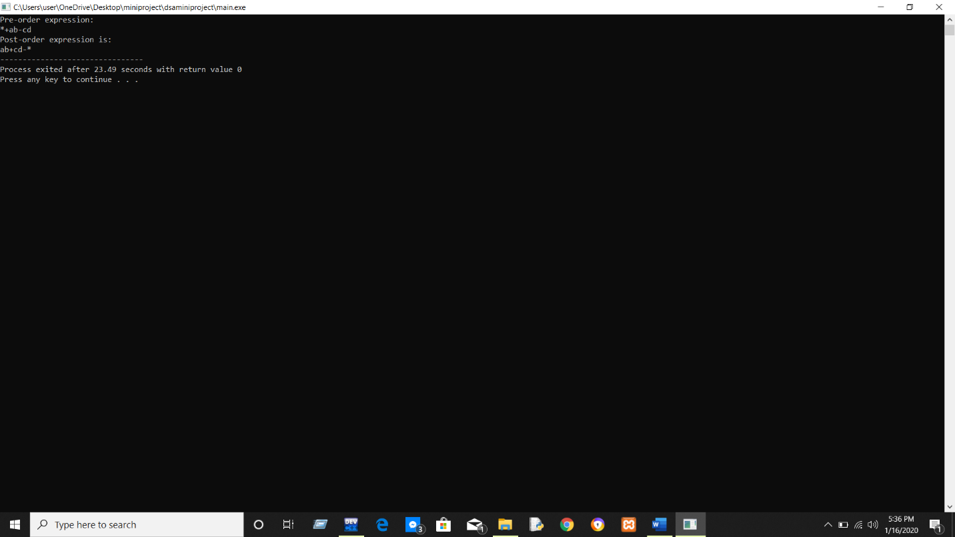

For a invalid prefix expression:

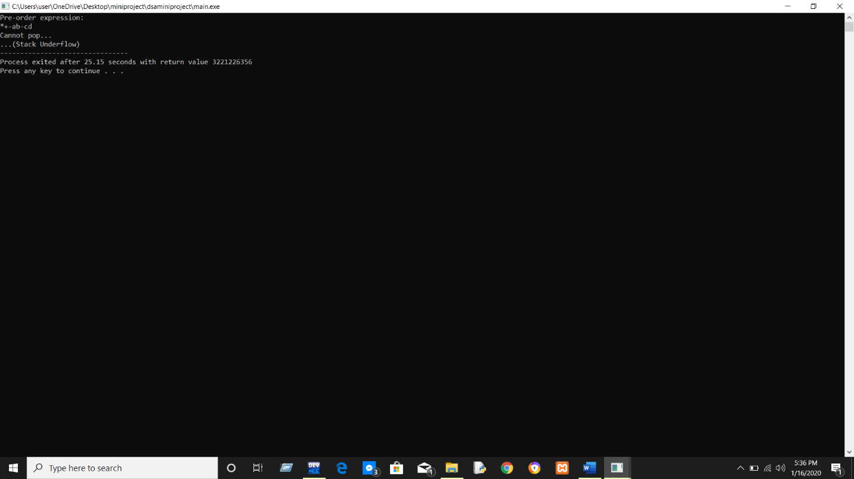

**Time Complexity**