**Study of features of mitosis**

1. Introduction

2. Procedure

3. Diagram of mitosis events

4. Key learnings

**Study of features of meiosis**

1. Introduction

2. Procedure

3. Diagram of meiosis events

4. Key learnings

**Numerical problems on Law of Segregation**

1. While performing a large scale grow out experiment of pea germplasm, a plant with three cotyledons was discovered (normally, there are 2 cotyledons). This plant was crossed with a normal pure-breeding wild-type plant, and 600 seeds from this cross were planted. There were 298 plants with two cotyledons and 302 with three cotyledons. What can be said about the inheritance of three cotyledons ?

2. PKU is caused by a recessive allele with simple Mendelian inheritance.

A couple intends to have children but consult a genetic counselor because the man has a sister with PKU and the woman has a brother with PKU. There are no other known cases in their families. They ask the genetic ian to determine the probability that their first child will have PKU. What is this probability? (Ans: 1/9)

**Numerical problems on Law of Independent Assortment**

1. In tomatoes, one gene determines whether the plant has purple (P) or green (G) stems, and a separate, independent gene determines whether the leaves are “cut” (C) or “potato” (Po). Five matings of tomato-plant phenotypes give the following results.

a. Which alleles are dominant ?

b. What are the most probable genotypes for the parents in each cross ?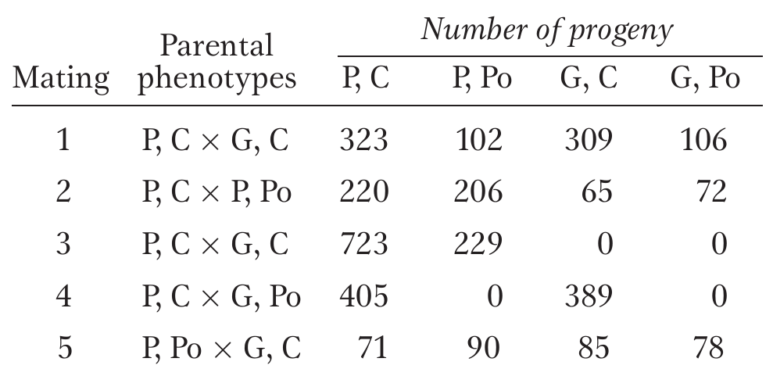

2. A presumed dihybrid in Drosophila, B/b ; F/f is test- crossed with b/b ; f/f. (B = black body ; b = brown body; F = forked bristles; f = unforked bristles.) The results are

Black, forked : 230

Black, unforked : 210

Brown, forked : 240

Brown, unforked : 250

Use the Chi-square test to determine if these results fit the results expected from testcrossing the hypothesized dihybrid.

**Numerical problems on cytoplasmic inheritance and sex linked inheritance and sex determination**

1. A sex-linked recessive allele c produces a red-green color blindness in humans. A normal woman whose father was color blind marries a color-blind man.

a. What genotypes are possible for the mother of the color blind man ?

b. What are the chances that the first child from this marriage will be a color-blind boy ?

c. Of the girls produced by these parents, what proportion can be expected to be color blind ?

d. Of all the children (sex unspecified) of these parents, what proportion can be expected to have normal color vision ?

2. The recessive gene e, produces color blind in human, which is sex linked gene. A carrier woman of this gene married a color blind man and produced first child, a normal vision klinefelter but in the second time this couple gave birth a color blind daughter. How such klinefelter and daughter may be produced? Show with the help of clean diagram.

3. In maize, recessive gene ba produces barren cob and ts gene converts male flower into female flower. Ba and Ts are the dominant genes give the normal cob and male flowers, respectively. A genetician working at IAAS crossed a plant having genotype Baba Tsts with other plant having genotype BaBa Tsts. Show this cross and determine the sex expression in the progeny.

**Numerical problems on linkage analysis**

1. In maize, F1 heterozygous plants were test crossed with colourless, shrunken, waxy plants and the following types of progeny were obtained.

CfS 50, cFs 46, CFs 383, cfS 380 , Dfs 72, cFS 68, CFS 6, cfs 5

Symbols: coloured= C, colourless= c, full= F, shrunken= f, starchy= S, and waxy= s

i) Are these genes linked? Give reason.

ii) Write the genes in correct order on the chromosome.

iii) What are double crossover, non- crossover and single crossover types?

iv) Write the genotypes involved in the parental and test crosses.

v) Draw a linkage map showing map distances.

vi) Calculate Coefficient of coincidence (CC) and interfer ence (I). Interpret the value.

2. Female F1 maize heterozygous for tall producing round and starchy seed was test- crossed and the following progenies were obtained.

Tall round starchy :10 , Dwarf shrunken waxy : 05 , Tall shrunken waxy : 300, Dwarf round starchy : 350 , Tall round waxy :70 , Tall shrunken starchy : 135 , Dwarf round waxy : 70 , Dwarf shrunken starchy : 60

i. Is there linkage between genes?

ii. Draw a linkage map of the linked genes showing the correct genes order and their map distances.

iii. What are double crossover, non crossover and single crossover types?

iv. Write the genotypes of flies involved in the parental and test crosses.

v. Diagram the cross showing the arrangement of the genetic markers on the chromosomes.

vi. Calculate I and CC and interpret the results.

3. An individual heterozygous for four genes; Aa.Bb.Cc.Dd is test crossed to aabbccdd and 1000 progeny were classified by the gametic contribution of the heterozygous parent as follows:

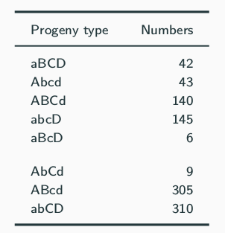

1. Which genes are linked ?

2. If two pure breeding lines had been crossed to produce the heterozygous individual, what would their genotypes have been ?

3. Draw a linkage map of the linked genes showing the correct genes order and their map distances.

4. Calculate CC and I.

**Examples of gene action and interaction**

1. What are the different types of gene action and interactions ? Give examples of each.

**Study of structure of DNA**

1. DNA and its forms

2. Structure of DNA double helix

3. Deoxyribonucleotide bases

4. Sugar phosphate bond

5. Nature of DNA helix

**Study of structure of RNA**

1. RNA and its forms

2. Structure of RNA (mRNA, tRNA, rRNA)

3. Ribonucleotide bases

5. Nature of different RNA molecules