**Objective:**

**Hypothesis:**

**Null Hypothesis:**

* There is no significant difference among various Mize genotypes. (H0: μ1 = μ2).

**Alternative Hypothesis:**

* There is significant difference among various Mize Genotypes. (H0: μ1 ≠ μ2).

**Methodology:**

**Site selection:**

**Climate and Soil:** Maize does well on a wide range of climatic conditions, and it is grown in the tropical as well as temperate regions. It is however susceptible to frost at all stages of its growth.

Maize can be grown successfully in variety of soils ranging from loamy sand to clay loam. However, soils with good organic matter content having high water holding capacity with neutral pH (5-7) are considered good for higher productivity

**Site selection:** Land should be free from volunteer plant. Selected land should be followed by 2 deep ploughing followed by harrowing. Fine tilth was suitable for seed sowing.

**Layout and design**: All trials were set on alpha lattice design with two to three replicates. Plot size was one or two rows of 4 m per entry.

**Spacing:** Row to row 60 cm and plant to plant was 20 and 25 cm

**Fertilizer**: Maize hybrids are responsive to nutrients applied either through organic or inorganic sources. The rate of nutrient application depends mainly on soil nutrient status/balance and cropping system. For obtaining desirable yield 180:60:40 kg NPK/ha with minimum 2 split dose of nitrogen should be followed. As the number of split of N increase the crop yield will increase accordingly.

**Weeding**: two hand weeding at 20 to 25 days after sowing and 40 to 45 days of sowing is necessary to control weed. Atrazine 1 to 2 manual weeding was followed as according to field condition. Pre-emergence application of Atrazine @ of 1.0-1.5 kg a.i ha-1 in 600 litre water will be very effective in control of wide range of annual and broad leaf weeds.

**Irrigation:** Sufficient moisture should be available in soil during seed sowing, if not immediate irrigation should be given. Irrigation should be followed as according to the soil and climatic condition.

**Data collection and detail of trait recorded**

Data collection was followed as according to CIMMYT field book, Days to flower (male and female), plant height, ear height, field weight, Moisture cob Aspect and plant aspect were mainly considered.

1. **Days to Male Flowering**: Record number of days from seed sowing to date of flowering of tassel (pollen shedding) in 50% of plants in plot.
2. **Days to Female Flowering:** Record number of days from seed sowing to date of appearance of silk in 50% of plants in plot.
3. **Anthesis Silking interval (ASI):** It is the difference of days from female flowering to the male flowering.
4. **Plant height:** It is the height of plant from base of the plant to the base of lower tassel branch. It should be collected form minimum 5 representative plants from plot.
5. 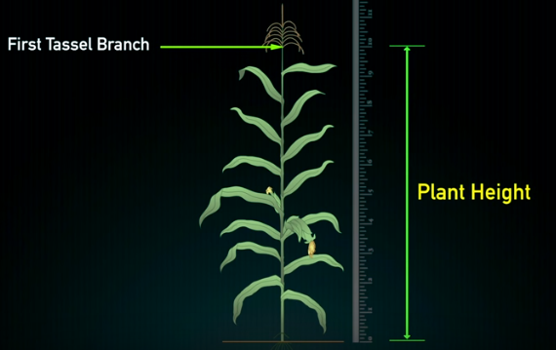**Ear height:** Height from base of the plant to the base of top most cob.

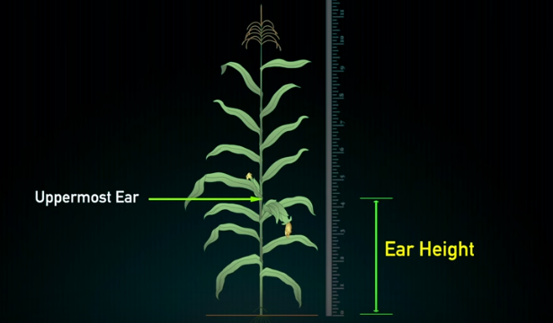*Figure: measurement of plant height and ear height in maize*

1. **Field weight:** Total weight of the dehusked cob during harvesting at field.
2. **Number of plant and cob:** Count the number of plants in whole plot during harvesting and total number of cobs from whole plot. It will help to find the prolificacy and barren plants in plot.
3. 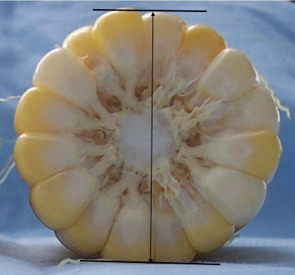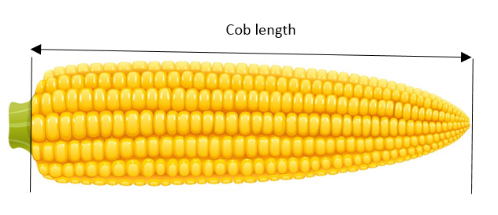**Cob length:** It is the length of cob from base to the tip of cob.

*Figure: Measurement of cob length and cob Diameter*

1. **Cob circumferance:** it is the girth of the average sampled 5 cobs from middle part of cob. Cob diameter can also be measured by using vernier caliper from middle portion of cob.
2. **Number of rows per cob:** It is the number of rows presented in average sampled cob.
3. **Number of grain per row:** It is average number of grains presented in rows from sampled cobs.
4. **Lodging:** Number of plants fallen in ground should be counted. Plants fall from stem below cob are considered as **stem lodging** and if plants fall from ground (root) are counted as **rood lodging**.
5. **Moisture:** Several sampled cobs were selected and grain from middle portion of cob was taken at the time of harvesting when field weight is taken. Moisture was converted into 12.5% for final data analysis.
6. **Plant aspect:** Complete visual score given by breeder to the overall plant performance of a variety. It incorporate major traits such as:
   * 1. Ear position
     2. Plant architecture
     3. Tassel characteristics
     4. Disease prevalence

It is recorded prior to the onset of crop senescence. It is scored from 1 to 5 scale;

1 represent excellent plant type, good yield potential, crop uniformity, lower ear position, vigorous, good stalk strength.

5 represent poor plant type, low yield, lodging, diseased, discoloured leaves and poor tassel exertion.

1. **Ear aspect:** Ear aspect id the composite visual score given by breeders to the overall yield performance of the variety. It include key traits such as:
   * 1. Yield
     2. Ear rot
     3. Texture
     4. Ear uniformity
     5. Grain filling
     6. Cob covering
     7. Ear symmetry

It is recorded just after cob harvesting and scored as 1 to 5:

1 represent excellent ear type, flint texture, disease free, large straight uniform rows.

5 represent poor ear type, small, rotten, non-uniform rows.

1. 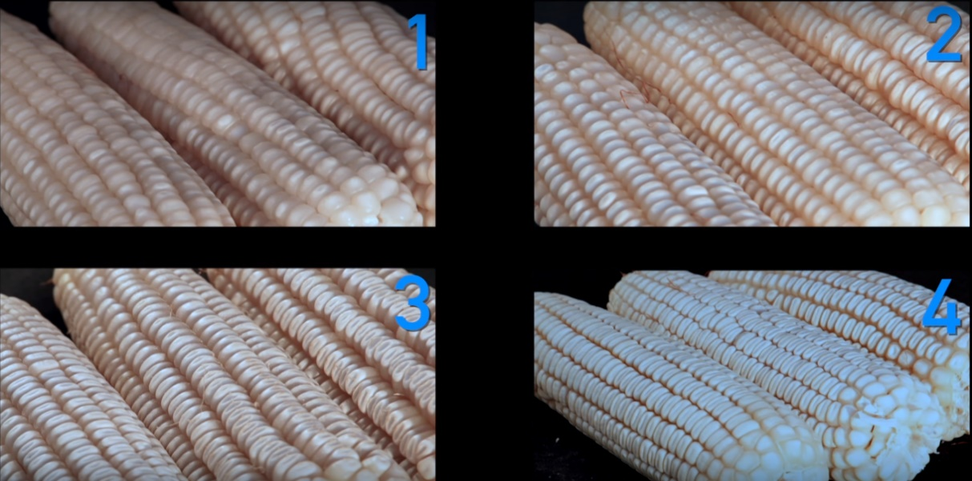**Texture:** maize grains can be differentiated into 4 texture group on the basis of their grain appearance: 1: flint, 2: semi flint, 3 semi dent and 4 dent. Grain texture is recorded at harvest from all entry of trials.

*Figure: scoring of grain texture in maize*

**Data analysis**

First field data was recorded in field book hard copy, later it was translated in Field book Excel sheet. Data compiled in MS-EXCEL was analysed by using META-R.

**Trial Location:**

|  |  |  |  |  |
| --- | --- | --- | --- | --- |
| **Collaborator** | **Location** | **GPS** | **Elevation** | **climate** |
| Unique Seed Company Pvt. Ltd | Dhangadhi-6, Kailali, Matayari | 28° 43' 48'' N 80° 35' 57'' E | 188 m | Tropical |