|  |  |
| --- | --- |
| TITLE OF THE EXPERIMENT | **EVALUATION OF HEAT STRESS TOLERENCE IN EXOTIC MAIZE GENOTYPE AT KAILALI CONDITION** |
| LOCATION OF RESEARCH | **Dhangadhi, Kailai** |
| DURATION OF RESEARCH | **…………….. months** |
| RESEARCHER | **Prachi Bista**  **Roll no…30………………….**  **……………Baitadi……………..Gokule** |
| Total budget | **Rs 40000** |
| E-Mail | **agriculturistprachi30@gmail.com** |
| ADDRESS | **GOKULESHWOR, TU** |
| MAJOR ADVISOR | **Dipendra Dhakal** |

INTRODUCTION

Zea is a genus of the family Graminae (Poaceae), commonly known as the grass family. Maize (Z. mays L.) is a tall, monecious annual grass with overlapping sheaths and broad conspicuously distichous blades. Plants have staminate spikelets in long spike-like racemes that form large spreading terminal panicles (tassels) and pistillate inflorescences in the leaf axils, in which the spikelets occur in 8 to 16 rows, approximately 30 long, on a thickened, almost woody axis (cob). The whole structure (ear) is enclosed in numerous large foliaceous bracts and a mass of long styles (silks) protrude from the tip as a mass of silky threads (Hitchcock & Chase, 1971).

It is an important cereal crop after rice and wheat in worldwide and second most staple crop in term of area and production after rice in Nepal. It is grown in 956447 ha producing 2713635 mt. tons, with productivity of 2.83 kg/ha (MoAD, 2077).

Climate change effects such as global warming is major challenge on crop production and identify possible ways that would allow yield ceilings to shift by developing improved thermos tolerant cultivars. Therefore these efforts are particularly important in south Asia, where current production systems are not sustainable and could be adversely impacted by climate change in the near future (Niyogi et al., 2010).

Maize is planted when soil temperatures are warm (greater than or equal to 10˚C) usually early to mid-May in southern Ontario (OMAF, 1994) and Quebec (MAPAQ, 1984).

Optimum yields occur when the appropriate hybrid maturity and population density are chosen. In addition, exogenous sources of nitrogen fertilizer are generally applied and weed and insect control measures are generally recommended. Choice of the appropriate hybrid for the intended growing area helps to ensure that the crop will mature before frost halts the growth of the plant at the end of the season; hybrids are categorized according to the amount of "heat units" that will be required for maturity. The maize-growing areas of Canada are illustrated on maps that indicate the number of heat units that they receive (e.g., OMAF, 1994; MAPAQ, 1984).

Heat and drought stress have emerged as a common problem worldwide which can reduce maize crop productivity (Ali et al., 2015 ). The effects of heat stress on plants are yield losses, growth inhi- bition and leaf scorching (Wahid et al. 2007), which was also reported for maize in temperate regions (Giaveno and Ferrero 2003). Especially during flowering and grain fill- ing, heat stress has severe impacts on maize plants (Barn- abás et al. 2008). Thus, breeding heat-tolerant cultivars is crucial to sustain crop production in the future (Chen et al. 2012).

Genetic diversity analysis is imperative in crop improvement and can be studied through morphological, biochemical and molecular markers. Morphological characterization for genetic divergence among genotypes is considered an initial step (Khan et al., 2014).

Therefore morphological data has play key role in management of genetic resources. To management of genetic resource study relationships and description and classification of germplasm the morphological characterization is the first step (Smith & Smith, 1989).

The production of hybrid seed requires the development and maintenance of inbred lines and subsequent controlled crosses to produce commercial seed. Self pollination is essential for inbred development while controlled cross pollination is mandatory for hybrid seed production. Mechanisms have been developed to ensure the correct form of pollination for each process and to prevent genetic contamination of seed stocks (Wych, 1988).

Rationale of study

Heat stress greatly limits the productivity of maize in many regions. Knowledge on the degree of genetic diversity of maize varieties along with their selective traits will facilitate the development of high yielding, stress-tolerant maize cultivar.

High temperatures have the potential to cause severe damages to maize production. This study aims to elucidate the genetic mechanisms of heat tolerance under field conditions in maize and the genome regions contributing to natural variation.

To investigate their contribution to the response to heat stress and heat tolerance, differential expression and sequence variation of the identified candidate genes should be subjected to further research.

Objective

The objective of the research is to identify superior heat stress tolerant inbred lines after clustering them based on their response to heat stress condition.

Specific objectives :

**6. Literature review**

**6.1 Maize and stress**

Maize is an important food crop cultivated worldwide (Majid et. al., 2017; El Sabagh et. al., 2018) as it is used as human food, animal feed and in different energy industries like biofuel (Shiferaw, 2011). Several abiotic stresses such as drought stress, heat stress hinder the maize quality and productivity, among them heat stress is major limiting factor which effects both nutrient composition and growth (Carnis et. al., 2012).

High temperature periods for extended length can causes irreversible damage in the plant growth and effect on economic yield is heat stress (Wahid et al. 2007; Fahad et al. 2017). These stress conditions change the metabolic activity of cells, effects on pollen fertility and dehiscence, silk emergence and stigma receptivity, seed setting and grain filling (Xiao et al. 2011).

**6.2 Genetics of heat stress and tolerance**

To understand the role of heat responsive genes experiments of transcriptomic and proteomic profiles of maize at different growth stages under heat stress can be observed. After these experiments, the genotypes expressing the gene that confers tolerance to heat stress can be selected for breeding or gene cloning purpose (Jagadish et al. 2010; Mangrauthia et al. 2016). In particular case, pk1 gene, bacterial RNA chaperones and ZmVPP1 gene expression in maize is related to stress tolerance (moisture). Similarly, in transgenic maize expression of OsMYB55 leads to active response against high temperature. Several transgenic heat-tolerant maize plant is being developed by manipulating genes that is over and under expression of genes from different crop species (Casaretto et al. 2016).

In addition to genes, heat shock transcriptional factors play vital role in controlling expression of HSP genes (Chen et al. 2006; Zafar et al. 2016). This identification of heat shock transcriptional factors and genome wide association studies helps in getting new QTLs to control heat tolerance through improved accuracy in breeding (Ma et al. 2016; Lafarge et al. 2017)..

**6.3 Effect of heat stress**

It affects plant growth and development by changing array of process in biochemical, morpho-anatomical and physiological system which ultimately cause a reduction in the economic yield of maize (Kandel et. al., 2018).

**6.3.1 Morpho-anatomical effect**

For avoidance of stress plant is able to change certain plant architecture such as high leaf wax, lower leaf angle, compact tassel and lower cob angle is seen in maize. These change is morphology and anatomy of plants helps to lower the direct exposure of sunlight and lower evaporation rate which helps plant to sustain in high temperature (Shah et. al., 2011). Furthermore, when there is sudden temperature rise it alters leaf angle and cooling by transpiration, also, there is adjustments in the composition and distribution of membrane lipid which enhances plant survival (Rodriguez et al. 2005).

**6.3.2 Physiological effect**

The heat stress in plant lowers the rate of photosynthesis due to lower stomatal conductance, which again acts to reduce the leaf area as well as overall plant biomass accumulation (Meena et. al., 2016). The low photosynthetic rate is due to conversion of chlrophyll-a into chlorophyll-b because of exposure to high temperature and this is added-on by leaf senescence (Yildiz and Terizi, 2007).

The high light intensity causes permanent damage in membrane structures (Meena et. al., 2016) which becomes functionally inactive at higher temperature (Blum, 1996). This damage in the membrane structure bring about changes in mobility of water, ions, soluble organic solid molecule within the membrane which leads to drastic loss in carbon production, transportation and in its accumulation (kumar et. al., 2018).

The physiological activities such as flower initiation, translocation, pod formation and pod falling are negatively impacted by heat stress (Duthin and Pigersire, 1991). In addition, reduction in the number of ears, number of kernels, chlorophyll efficiency, firing of leaf, and blasting of the tassel occurs due to heat stress (Noor et. al., 2019).

**6.3.3 Biochemical and molecular effect**

Generally, plant response to heat stress through production of Reactive Oxygen Species (ROS) in the sub-cellular structures. There is production of highly reactive oxygen species in chloroplasts, mitochondria, peroxisomes, cellular and sub-cellular membranes which damages the membrane, protein, nucleic acid in the cell. Among these damages, membrane lipid peroxidation has most destructive effect as it increases membrane fluidity and cause leakage of cellular fluid. This results in disequilibrium in ion balance of cell leading to cell death. In response to this, plant has developed antioxidant response system including enzymatic and non-enzymatic antioxidants (Rehman et al., 2015)

**6.3. 4 Effect on production and productivity**

Growth and development is negatively affected by prolonged temperature above 35 $℃$ which severely impacts the grain yield when temperature reaches 40 $℃$ (Shiferaw et. al., 2011). Simply, when leaf temperature in maize is above 38 $℃$ there is inhibition of photosynthesis (CraftsBrandner and Salvussi, 2002).

High temperature above 40 $℃$ is responsible for changes in the enzyme present in leaf and seed (Sehgal et. al., 2018). Along with this, there is instability in thylakoid membrane, chlorophyll degradation resulting in decreased photosynthesis which leads to less translocation of assimilate to grain that reduces the kernel weight and grain yield (Tao and Zhao, 2010; Muchow, 1990; Singletary et. al., 1999). Flowering and Grain filling period is negatively impacted which decreases the maize productivity during high temperature stress (Shiferaw et. al., 2011).

The large difference in grain yield of high temperature stress is due to a chain effect: oxidative damage, reduced chlorophyll content (Shiferaw et. al., 2011), tissue injury, leaf damage and increased leaf senescence rate causing a decrease in photosynthetic efficiency. All these results in reduced cob growth rate and change in biomass portioning (Edreira et. al., 2014).

Heat stress also effects the flour quality of maize as it changes the protein composition during the grain filling stage (Gooding et. al., 2003). This change starts from stress in the flowering stage which gradually lowers the starch content of grain which continues with reduced photosynthesis resulting in increased grain protein. In this way, heat stress reduces grain weight as well as influences the quality parameters such as starch, crude oil and protein contents (Barutcular et. al., 2017). Also, protein content is negatively related to the grain yield (El Sabagh, 2017; Barutcular, 2016) and there is association of cob length, thousand-grain weight, protein content in the yield under heat stress condition (Yousaf et. al., 2018).

**6.4 Heat resistance**

**6.4.1 Heat tolerance**

Heat stress triggers genes which are increases the synthesis and accumulation of metabolites that enhances the heat enduring capacity of the plant. With this, the heat tolerant plant decreases the plant height, leaf area index and number of leaves (Hasanuzzaman et. al., 2013). It is a very complex process which involves many separate process and sometimes, several process in combination but maintenance of high rate of photosynthesis under high temperature is a key tolerance process (Rehman et al., 2015).

**6.4.2 Heat avoidance**

Heat avoidance at cellular level is shown by change in several processes including ion transporters, LEA protein and other factor that are involved in signaling, osmolytes, antioxidant defense and transcriptional control (Rodríguez et al. 2005).

**6.4.3 Physiological and molecular approaches**

Physiologically maize plant response to heat stress by producing enzymatic and non-enzymatic antioxidants to reduce oxidative stress. A marked reduction of cellular metabolism is seen at temperature around 45 $℃$. There is increase expression of a new set of protein molecules such as heat-shock protein this causes a reduction in production of natural proteins (Perras and Sarhan, 1989). Also, change in chemical structure of these proteins (Monjardino et. al., 2005). In addition to this, plant shows adaptive mechanism to accumulate the osmolytes such as proline, glycine betaine and trehalose (Hasanuzzaman et. al., 2013).

These adaptive mechanism includes biosynthesis of enzymatic and non-enzymatic antioxidants which scavenge the reactive oxygen species (ROS) by antioxidant enzymes such as ascorbate peroxidase (APX), ascorbate reductase (AR), catalase (CAT), glutathione reductase (GR), glutathione peroxidase (GPX), and superoxide dismutase (SOD) and with non-enzymatic antioxidants such as ascorbate (AsA), glutathione (GSH), carotenoids, flavanones, and anthocyanins (Hasanuzzaman et. al., 2013).

**6.4.4 Avoidance and tolerance approaches**

**Delay Sowing**

A biological and farmer-friendly approach to avoid high temperature stress is to delay the sowing date or advancing the sowing date. These strategy of early sowing and long season varieties had been fruitful to overcome the negative effect of rising temperature (Liu et. al. 2013).

**Optimum irrigation**

Another strategy to avoid heat stress is optimizing irrigation preferably subsurface drip irrigation during night time reduces the root-zone soil temperature which improves both plant growth and yield. Also, the optimizing irrigation helps improve water use efficiency that enhances heat tolerance (Tao and Zhao, 2010).

**Hormones**

Both endogenous accumulation and exogenous application of different phyto-hormones in the plant tissue helps in strengthening heat tolerance in maize (Tao and Zhao, 2010). Exogenous application of ABA produces Heat Stress Proteins (HSP) that enhances photosystem II for tolerance (Maestri et. al., 2002). Similarly, exogenous application of CaCl2 increases the membrane antioxidant capacity to tolerate the effect of heat stress (Gong et. al., 1997). Along with these, phyto-hormones such as auxin (IAA), cytokinins (CKs), abscisic acid (ABA), ethylene (ET), gibberellins (GAs), salicylic acid (SA), brassinosteroids (BRs), and jasmonates (JAs) play key role in stress response of plant(Wani et. al., 2016).

**Nutrient management**

Nutrient management is important in stress tolerance, since, nutrition play essential role for integrity of plant structure and carryout key physiological processes (Cakmak, 2002; Waraich et. al., 2011). Nitrogen is needed for chlorophyll structure and photosynthesis which plays crucial role in high temperature stress tolerance. Also, it plays role in utilization of absorbed light energy and photosynthetic carbon metabolism. Similarly, magnesium and potassium are important in stress tolerance (Meena et. al., 2019; Meena et. al., 2020).

Another effective method to heat tolerance is breeding for improved heat tolerance at grain-filling stage of maize (Tao and Zhao, 2010). For this screening of various cultivar can be performed to observe the warmness of the plant canopy, stomata behavior of upper most leaf (flag leaf), and photosynthesizing efficiency that are closely related to each other for the production maximum grain production under high-temperature stress conditions (Reynolds et. al., 1998; Reynolds et. al., 2006; Amani et. al., 1996).

**6.5 Heat stress evaluating indices**

**6.5.1 Morphological indices**

Pollen fertility, silk receptivity, compact tassel, lesser gap between anthesis and silking (ASI) are the morphological markers for high temperature stress tolerance (Yadav et al. 2012).

Similarly, leaf number per plant, number of cobs per plant, number of rows of seeds per cob, number of seeds per cob, percent kernel abortion, grain yield and 1000-seed weight can be studied to screen the maize genotypes under high temperature stress (Cairns et al. 2013).

**6.5.2 Physiological indices**

Net photosynthetic rate, transpiration, stomatal conductivity, leaf surface temperature, canopy temperature depression, maximum quantum yield PSII photochemistry (Fv/Fm) and SPAD are physiological marker studied to screen the maize genotypes under high temperature stress. Those genotype which exhibit high photosynthetic rate, transpiration rate, stomatal conductance and SPAD value along with low leaf temertaure and membrance injury is considered heat tolerant (Lipiec et al. 2013; Yadav et al. 2016).

Moreover, electrolyte leakage, leakiness of thylakoid membrane (Schrader et al. 2004; Sharkey 2005) along with accumulation of osmolytes like, proline, soluble sugars, phenols, glycine betaine, level of various hormones and water relations are key physiological parameters to screen against heat tolerance (Wahid et al. 2007).

.

**Methodology**

**Experimental Site and layout**

**Field Experimentation**

The field experiment was conducted in the research field of Matayari, Dhangadi- 6, Kailali. The field is located at 28° 43' 48'' N latitude and 80° 35' 57'' E longitude at the altitude of 188 masl. It has tropical climate with hot summer with maximum temperature range of …… $℃$ to ……. $℃$ and cold winter with minimum temperature range of .. $℃$ to … $℃$ with total annual rainfall about …. mm.

**Treatment (Plant material)**

The research is conducted with …. maize genotypes collected from …………with ……….. as check varieties. The complete set of genotypes with their entry name is given in table no. 2 below:

|  |  |  |  |
| --- | --- | --- | --- |
| S.N. | Name of elite lines | Origin | Treatment |
| 1. |  |  |  |
| 2. |  |  |  |
| 3. |  |  |  |
| 4. |  |  |  |
| 5. |  |  |  |
| 6. |  |  |  |
| 7. |  |  |  |
| 8. |  |  |  |
| 9. |  |  |  |
| 1O. |  |  |  |
| 11. |  |  |  |
| 12. |  |  |  |
| 13. |  |  |  |
| 14. |  |  |  |
| 15. |  |  |  |
| 16. |  |  |  |
| 17. |  |  |  |
| 18. |  |  |  |
| 19. |  |  |  |
| 20. |  |  |  |

**Design of experiment**

The experiment was conducted in Alpha Lattice Design with ….. genotypes in …. blocks each consisting of …….. genotypes with two replication

**Layout of experiment field**

The experiment was performed in three replication, each with …. genotypes in ….. blocks and …… individual plots.

The each plots were separated by 1m distance.

The individual plots has

Dimension: … m $×$… m

Area: … m2

**Spacing:** Row to row 60 cm and plant to plant was 20 and 25 cm

The layout is given below 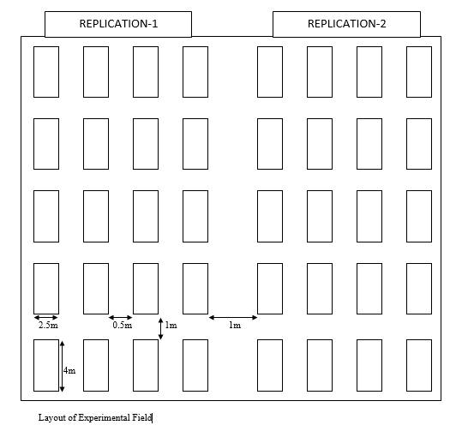

**Figure no. 1** Layout of experiment showing 20 plots in each of two replication with 10 blocks in total.

9/05 (2020)

Performance and stability of elite wheat lines under terminal heat stress and irrigated environment

13

**EXPERIMENTAL DESIGN**

* The experiment is conducted in
  + Alpha Lattice Design
  + 20 treatments in 5 blocks each consisting of 4 treatments
    - 1 m distance between blocks

0.5 m distance within blocks

* Plot Area: 10 m2,Dimension: 2.5 m × 4 m,
* Continuous line sowing
* 10 rows, Row – row distance: 25 cm

Number of Replication (r) = 2

Number of Blocks (b) = 10

Number of blocks per replication (s) = 5

Number of treatments per block (k) = 4

Lattice design: Alpha-lattice:

r $×s=b$ t = s $×k$

The experiment includes

Number of Replication (r) =

Number of Blocks (b) =

Number of blocks per replication (s) =

Number of treatments per block (k) =

Lattice design: Alpha-lattice:

r ×𝑠=𝑏 t = s ×𝑘

**Field preparation**

**Agrometeorological data**

The information of maximum and minimum temperatures, monthly rainfall and humidity was obtained from …………………. and is presented in the figure no. 2 below:

Source:

**Tillage**

The first ploughing was done 1 week prior sowing date followed by harrowing. At the date of sowing again harrowing was done followed by leveling of each plots. Then, rows for planting were ploughed manually.

**Date of sowing**

**………………**

**Fertilizers**

Maize hybrids are responsive to nutrients applied either through organic or inorganic sources. The rate of nutrient application depends mainly on soil nutrient status/balance and cropping system. For obtaining desirable yield 180:60:40 kg NPK/ha with minimum 2 split dose of nitrogen should be followed. As the number of split of N increase the crop yield will increase accordingly **Irrigation and crop management**

**Irrigation:** Sufficient moisture should be available in soil during seed sowing, if not immediate irrigation should be given. Irrigation should be followed as according to the soil and climatic condition.

**Weeding**: two hand weeding at 20 to 25 days after sowing and 40 to 45 days of sowing is necessary to control weed. Atrazine 1 to 2 manual weeding was followed as according to field condition. Pre-emergence application of Atrazine @ of 1.0-1.5 kg a.i ha-1 in 600 litre water will be very effective in control of wide range of annual and broad leaf weeds.

**Data collection**

Data collection was followed as according to CIMMYT field book, Days to flower (male and female), plant height, ear height, field weight, Moisture cob Aspect and plant aspect were mainly considered.

1. **Days to Male Flowering**: Record number of days from seed sowing to date of flowering of tassel (pollen shedding) in 50% of plants in plot.
2. **Days to Female Flowering:** Record number of days from seed sowing to date of appearance of silk in 50% of plants in plot.
3. **Anthesis Silking interval (ASI):** It is the difference of days from female flowering to the male flowering.
4. **Plant height:** It is the height of plant from base of the plant to the base of lower tassel branch. It should be collected form minimum 5 representative plants from plot.
5. 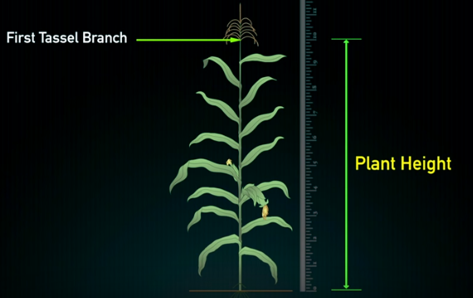**Ear height:** Height from base of the plant to the base of top most cob.

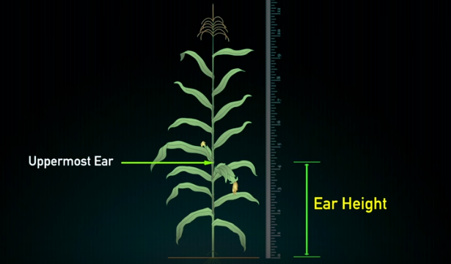*Figure: measurement of plant height and ear height in maize*

1. **Field weight:** Total weight of the dehusked cob during harvesting at field.
2. **Number of plant and cob:** Count the number of plants in whole plot during harvesting and total number of cobs from whole plot. It will help to find the prolificacy and barren plants in plot.
3. 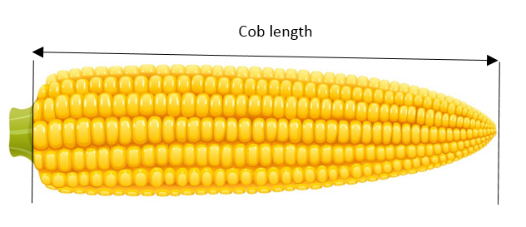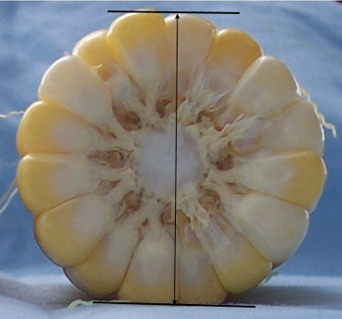**Cob length:** It is the length of cob from base to the tip of cob.

*Figure: Measurement of cob length and cob Diameter*

1. **Cob circumferance:** it is the girth of the average sampled 5 cobs from middle part of cob. Cob diameter can also be measured by using vernier caliper from middle portion of cob.
2. **Number of rows per cob:** It is the number of rows presented in average sampled cob.
3. **Number of grain per row:** It is average number of grains presented in rows from sampled cobs.
4. **Lodging:** Number of plants fallen in ground should be counted. Plants fall from stem below cob are considered as **stem lodging** and if plants fall from ground (root) are counted as **rood lodging**.
5. **Moisture:** Several sampled cobs were selected and grain from middle portion of cob was taken at the time of harvesting when field weight is taken. Moisture was converted into 12.5% for final data analysis.
6. **Plant aspect:** Complete visual score given by breeder to the overall plant performance of a variety. It incorporate major traits such as:
   * 1. Ear position
     2. Plant architecture
     3. Tassel characteristics
     4. Disease prevalence

It is recorded prior to the onset of crop senescence. It is scored from 1 to 5 scale;

1 represent excellent plant type, good yield potential, crop uniformity, lower ear position, vigorous, good stalk strength.

5 represent poor plant type, low yield, lodging, diseased, discoloured leaves and poor tassel exertion.

1. **Ear aspect:** Ear aspect id the composite visual score given by breeders to the overall yield performance of the variety. It include key traits such as:
   * 1. Yield
     2. Ear rot
     3. Texture
     4. Ear uniformity
     5. Grain filling
     6. Cob covering
     7. Ear symmetry

It is recorded just after cob harvesting and scored as 1 to 5:

1 represent excellent ear type, flint texture, disease free, large straight uniform rows.

5 represent poor ear type, small, rotten, non-uniform rows.

1. 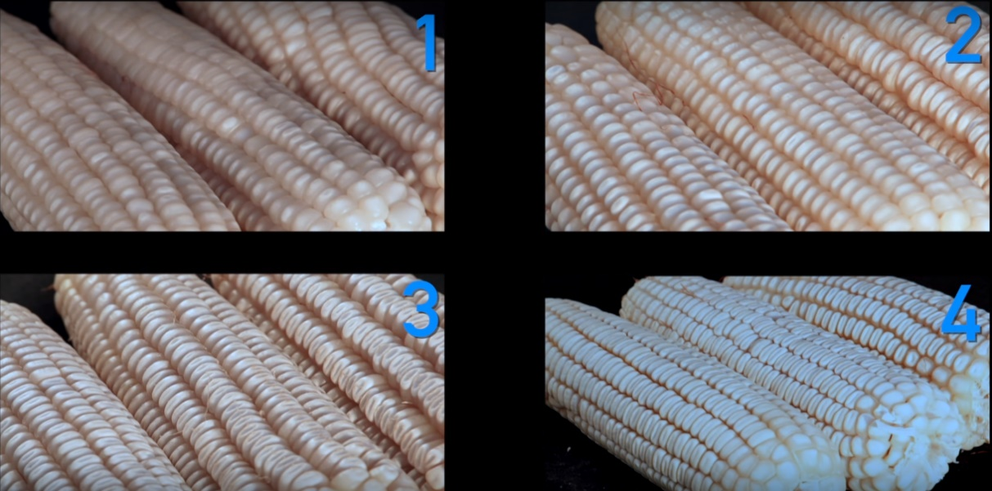**Texture:** maize grains can be differentiated into 4 texture group on the basis of their grain appearance: 1: flint, 2: semi flint, 3 semi dent and 4 dent. Grain texture is recorded at harvest from all entry of trials.

*Figure: scoring of grain texture in maize*

**Statistical analysis**

MS Office 2013 was used data entry and processing. The parameters taken were statistically analyzed by Fischer test in alpha-lattice design in R 3.5.0 software package by ADEL- R (CIMMYT Mexico). Further analysis was done using META-R.

Expected Outcomes :

Assumptions :

Gantt chart / time frame :

Budgeting :

**References**

Ali, F., Kanwal, N., Ahsan, M., Ali, Q., & Niazi, N. K. (2015). Crop improvement through

conventional and non-conventional breeding approaches for grain yield and quality traits in Zea mays. Life Science Journal, 12(4s).

Amani I, Fischer RA, Reynolds MP. Canopy temperature depression associated with yield of

irrigated spring wheat cultivars in a hot climate. Journal of Agronomy and Crop Science. 1996;176:119-129

Barnabás B, Jäger K, Fehér A (2008) The effect of drought and heat stress on reproductive

processes in cereals. Plant Cell Environ 31(1):11–38

Barutcular C, El Sabagh A, Koc M, Ratnasekera D. Relationships between grain yield and

physiological traits of durum wheat varieties under drought and high temperature stress in Mediterranean environments. Fresenius Environmental Bulletin. 2017;26:4282-4291

Barutçular C, Yıldırım M, Koç M, Akıncı C, Toptaş I, Albayrak O, et al. Evaluation of SPAD

chlorophyll in spring wheat genotypes under different environments. Fresenius Environmental Bulletin. 2016;25(4):1258-1266

Blum A. Crop responses to drought and the interpretation to adaptation. Plant Growth

Regulation. 1996;20:135-148

Cairns JE, Crossa J, Zaidi PH, Grudloyma P, Sanchez C, Araus JL, Thaitad S, Makumbi D,

Magorokosho C, Bänziger M, Menkir A, Hearne S, Atlin GN (2013) Identification of drought, heat, and combined drought and heat tolerant donors in maize. Crop Sci 53:1335−1346

Cairns JE, Sonder K, Zaidi PH, Verhulst N, Mahuku G, Babu R. Maize production in a changing

climate. Advances in Agronomy. 2012;144:1-58

Cakmak I. Plant nutrition research: Priorities to meet human needs for food in sustainable ways.

Plant and Soil. 2002;247:3-24

Casaretto JA, El-kereamy A, Zeng B, Stiegelmeyer SM, Chen X, Bi Y-M, Rothstein SJ (2016)

Expression of OsMYB55 in maize activates stress-responsive genes and enhances heat and drought tolerance. BMC Genom 17:312

Chen J, Xu W, Velten J, Xin Z, Stout J (2012) Characterization of maize inbred lines for drought

and heat tolerance. J Soil Water Conserv 67(5):354–364

Chen XJ, Ye CJ, Lu HY (2006) Cloning of GmHSFA1 gene and its over-expression leading to

enhancement of heat tolerance in transgenic soybean. Hereditas 28:1411−1420

Crafts-Brandner SJ, ME Salvussi (2002) Sensitivity of photosynthesis in C4 plant, maize, to heat

stress. Plant Physiology, 129: 1773-1780.

Duthion C, Pigesire A. Seed length corresponding to the final stage seed abortion of three grain

legumes. Crop Science. 1991;31:1579-1583

Edreira JI, Mayer LI, Otegui ME. Heat stress in temperate and tropical maize hybrids: Kernel

growth, water relations and assimilate availability for grain filling. Field Crops Research. 2014;166:162-172

El Sabagh A, Barutcular C, Islam MS. Relationships between stomatal conductance and yield

under deficit irrigation in maize (Zea mays L.). Journal of Experimental Biology and Agricultural Sciences. 2017;5:15-21. DOI: 10.18006/2017.5 (1).014.021

El Sabagh A, Hossain A, Barutçular C, Abdelaal K, Fahad S, Anjorin F, et al. Sustainable maize

(Zea mays L.) production under drought stress by understanding its adverse effect, survival mechanism and drought tolerance indices. Journal of Experimental Biology and Agricultural Sciences. 2018;6(2):282-295

Fahad S, Bajwa AA, Nazir U, Anjum SA, Farooq A, Zohaib A, Sadia S, Nasim W, Adkins S,

Saud S, Ihsan MZ, Alharby H, Wu C, Wang D, Huang J (2017) Crop Production under Drought and Heat Stress: Plant Responses and Management Options. Front Plant Sci 8:1147

Giaveno C, Ferrero J (2003) Introduction of tropical maize genotypes to increase silage

production in the central area of Santa Fe, Argentina. Crop Breed Appl Biotechnol 3(2):89–94

Gooding MJ, Ellis RH, Shewry PR. Effects of restricted water availability and increased

temperature on the grain filling, drying and quality of winter wheat. Journal of Cereal Science. 2003;37:295-309. DOI: 10.1006/ jcrs.2002.0501

Hasanuzzaman M, Gill SS, Fujita M. Physiological role of nitric oxide in plants grown under

adverse environmental conditions. In: Gill SS, Tuteja N, editors. Plant Acclimation to Environmental Stress. New York: Springer; 2013. pp. 269-322

Hasanuzzaman M, Gill SS, Fujita M. Physiological role of nitric oxide in plants grown under

adverse environmental conditions. In: Gill SS, Tuteja N, editors. Plant Acclimation to Environmental Stress. New York: Springer; 2013. pp. 269-322

Hitchcock, A.S., & A. Chase. 1971. Manual of the grasses of the United States Volume 2. p.

790-796. Dover Publications: N.Y.

Jagadish S, Muthurajan R, Oane R, Wheeler T R, Heuer S, Bennett J, Craufurd PQ (2010)

Physiological and proteomic approaches to address heat tolerance during anthesis in rice (Oryza sativa L.). J Exp Bot 61:143−156

Khan, H., Marwat, K. B., Khan, M. A., & Hashim, S. (2014). Herbicidal control of parthenium

weed in maize. Pak. J. Bot, 46(2), 497-504

Kumar S, Meena RS, Bohra JS. Interactive effect of sowing dates and nutrient sources on dry

matter accumulation of Indian mustard (Brassica juncea L.). Journal of Oilseed Brassica. 2018;9(1):72-76

Lipiec J, Doussan C, Nosalewicz A, Kondracka K (2013) Effect of drought and heat stresses on

plant growth and yield:a review. Int Agrophysic 27:463−477

Liu Z, Hubbard KG, Lin X, Yang X. Negative effects of climate warming on maize yield are

reversed by the changing of sowing date and cultivar selection in Northeast China. Global Change Biology. 2013;19(11):3481-3492

Ma X, Feng F, Wei H, Mei H, Xu K, Chen S, Li T, Liang X, Liu H, Luo L (2016) Genome-wide

association study for plant height and grain yield in rice under contrasting moisture regimes. Front Plant Sci 7:1801

Maestri E, Klueva N, Perrotta C. Molecular genetics of heat tolerance and heat shock proteins in

cereals. Plant Molecular Biology. 2002;48:667-681. DOI: 10.1023/A:1014826730024

Mangrauthia SK, Agarwal S, Sailaja B, Sarla N, Voleti S (2016) Transcriptome analysis of

Oryza sativa (Rice) seed germination at high temperature shows dynamics of genome expression associated with hormones signaling and abiotic stress pathways. Tropic Plant Biol 9:215−228

Manoj Kandel1, Surya Kant Ghimire and Jiban Shrestha. 2018. Mechanisms of heat stress

tolerance in maize, Azarian J. Agric. VOL 5(1). Azarian Journals Review paper. ISSN:2383-4420.

MAPAQ (Ministère de l'Agriculture, des Pécheries et de l'Alimentation du Quebec). 1984.

Agdex 111/20, 200-A Chemin Sainte-Foy, Quebec G1R 4X6 Biology Document BIO1994-11 11 OMAF (Ontario Ministry of Agriculture and Food). 1994. Field Crop Recommendations. Publication 296. Queen's Printer for Ontario, Toronto, Ontario.

Meena H, Meena RS, Rajput BS, Kumar S. Response of bio-regulators to morphology and yield

of clusterbean [Cyamopsis tetragonoloba (L.) Taub.] under different sowing environments. Journal of Applied and Natural Science. 2016;8:715-718

Meena RS, Kumar S, Datta R, Lal R, Vijayakumar V, Britnicky M, et al. Impact of

agrochemicals on soil microbiota and management: A review. Land. 2020;9:34. DOI: 10.1016/j. geoderma.2019.114164

Meena RS, Lal R, Yadav GS. Long term impacts of topsoil depth and amendments on soil

physical and hydrological properties of an Alfisol in central Ohio, USA. Geoderma. 2020;363:1141164

MoAD (2077) Statistical Information on Nepalese Agriculture.Agri business promotion and

statistical division, Agristatistic section, Singhdurbar, Kathmandu

Monjardino P, Smith AG, Jones RJ. Heat stress effects on protein accumulation of maize

endosperm. Crop Science. 2005;45:1203-1210

Niyogi, D., Kishtawal, C., Tripathi, S., & Govindaraju, R. S. (2010). Observational evidence that

agricultural intensification and land use change may be reducing the Indian summer monsoon rainfall. Water Resources Research, 46(3)

OMAF (Ontario Ministry of Agriculture and Food). 1994. Field Crop Recommendations.

Publication 296. Queen's Printer for Ontario, Toronto, Ontario.

Perras M, Sarhan F. Synthesis of freezing tolerance proteins in leaves, crown and roots during

cold acclimation of wheat. Plant Physiology. 1989;89:577-585

Rodríguez M, Canales E, Borrás-Hidalgo O (2005) Molecular aspects of abiotic stress in plants.

Biotecnol Aplic 22:1−10

Rodríguez VM, Butrón A, Rady MOA, Soengas P, Revilla P (2013) Identification of quantitative

trait loci involved in the response to cold stress in maize (Zea mays L.) Mol Breed 33:363−371

Saleem Ur Rehman, Muhammad Arif, Khadim Hussain, Muhammad Arshad, Shahid Hussain,

Tanweer Mukhtar and Abdul Razaq. 2015. Breeding for Heat Stress Tolerance of Maize in Pakistan . Journal of Environmental and Agricultural Sciences5:27-33.

Sehgal A, Sita K, Siddique KHM, Kumar R, Bhogireddy S, Varshney RK, et al. Drought or/and

heat-stress effects on seed filling in food crops: Impacts on functional biochemistry, seed yields, and nutritional quality. Frontiers in Plant Science. 2018;9:1705. DOI: 10.3389/fpls.2018.01705

Shah F, Huang J, Cui K, Nie L, Shah T, Chen C, Wang K (2011) Impact of high-temperature

stress on rice plant and its traits related to tolerance. J Agri Sci 149:545−556

Shiferaw B, Prasanna BM, Hellin J, Bänziger M. Crops that feed the world: Past successes and

future challenges to the role played by maize in global food security. Food Security. 2011;3s:307-311

Singletary GW, Banisadr R, Keeling PL. Heat stress during grain filling in maize, effects on

carbohydrate storage and metabolism. Australian Journal of Plant Ph

Smith, J. S. C., & Smith, O. S. (1989).The description and assessment of distance between inbred

lines of maize. 2: The utility of morphological-biochemical-and genetic descriptors and a scheme for the testing of distinctiveness between inbred lines [in USA]. Maydica (Italy).

Tao F, Zhao Z. Adaptation of maize production to climate change in North China Plain: Quantify

the relative contributions of adaptation options. European Journal of Agronomy. 2010;33:103-116

Wahid A, Gelani S, Ashraf M, Foolad M (2007) Heat tolerance in plants: an overview. Environ

Exp Bot 61(3):199–223

Wahid A, Gelani S, Ashraf M, Foolad MR (2007) Heat tolerance in plants: An overview.

Environ Exp Bot 61:199−223

Wani SH, Kumar V, Shriram V, Sah SK. Phytohormones and their metabolic engineering for

abiotic stress tolerance in crop plants. Crop Journal. 2016;4(3):162-176

Waraich EA, Ahmad R, Ashraf MY, Saifullah AM. Improving agricultural water use efficiency

by nutrient management in crop plants. Acta Agriculturae Scandinavica, Section B: Plant Soil Science. 2011;61(4):291-304

Wych, R.D. 1988. Production of hybrid seed corn. In G.F Sprague and J.W. Dudley, Eds. Maize

and Maize Improvement. Agronomy Monographs No.18; pp. 565-605. American Society of Agronomy: Madison, Wisconsin.

Xiao Y, Pan Y, Luo L, Deng H, Zhang G, Tang W, Chen L (2011) Quantitative Trait Loci

Associated with Pollen Fertility under High Temperature Stress at Flowering Stage in Rice (Oryza sativa). Rice Sci 18:204−209

Yadav SK, Singh Vikarm, Tiwari YK (2012) Physiological and Metabolic Indices for Heat

Tolerance in Maize. National Seminar of Plant Physiology on, ‘Physiological and Molecular Approaches for Development of Climate Resilient Crops’ at ANGRAU, Hyderabad, India

Yadav SK, Tiwari YK, Singh V, Patil AA, Shanker AK, Jyothi Lakshmi N, Vanaja M,

Maheswari M (2016) Physiological and biochemical basis of extended and sudden heat stress tolerance in maize. Proc Natl Acad Sci India Sect B Biol Sci 88:249−263

Yildiz M, Terzi H. Determination of plants’ tolerance to high temperature stress by cell viability

and photosynthetic pigmentation tests. Erciyes UFBE Der. 2007;23(1-2):47-60

Yousaf MI, Hussain K, Hussain S, Ghani A, Arshad M, Mumtaz A, et al. Characterization of

indigenous and exotic maize hybrids for grain yield and quality traits under heat stress. International Journal of Agriculture and Biology. 2018;20(2):333-337. DOI: 10.17957/IJAB/15.0493

Zafar SA, Hussain M, Raza M, Muhu-Din Ahmed HG, Rana IA, Sadia B, Atif RM (2016)

Genome wide analysis of heat shock transcription factor (HSF) family in chickpea and its comparison with Arabidopsis. Plant Omics 9:136