Price relations of food commodities in regional markets of Nepal

Samita Paudel

6/28/2019

# Administrative summary of Nepal

## Study districts and market centres

A map of study districts.

## Reading layer `NPL_districts_poly_sd_171123' from data source `/home/deependra/Desktop/economics/data/nepal_provincial/NPL_districts_poly_sd_171123.shp' using driver `ESRI Shapefile'  
## Simple feature collection with 75 features and 2 fields  
## geometry type: POLYGON  
## dimension: XY  
## bbox: xmin: 115727 ymin: 2919116 xmax: 916908 ymax: 3371480  
## epsg (SRID): NA  
## proj4string: +proj=tmerc +lat_0=0 +lon_0=84 +k=0.9999 +x_0=500000 +y_0=0 +a=6377276.345 +b=6356075.41314024 +units=m +no_defs

## Reading layer `Nepal_Province' from data source `/home/deependra/Desktop/economics/data/nepal_provincial/Nepal_Province.shp' using driver `ESRI Shapefile'  
## Simple feature collection with 7 features and 2 fields  
## geometry type: POLYGON  
## dimension: XY  
## bbox: xmin: 80.05845 ymin: 26.34798 xmax: 88.20152 ymax: 30.44738  
## epsg (SRID): 4326  
## proj4string: +proj=longlat +datum=WGS84 +no_defs

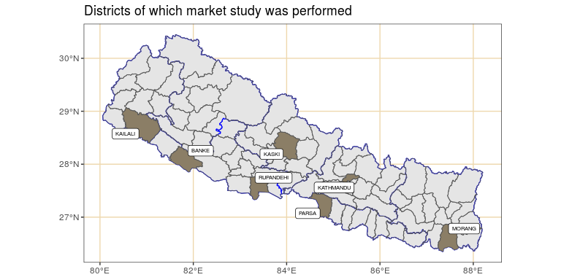

Geographical perspective on market selections for study

# Retail price of rice and wheat in major districtwise Nepalese market hubs

The price series of districtwise market hubs available for study is mostly imbalanced and irregular and contains data for following 21 districts.

Achham, Banke, Bhojpur, Chitwan, Dhankuta, Dhanusha, Doti, Illam, Jhapa, Jumla, Kailali, Kaski, Kathmandu, Morang, Nuwakot, Palpa, Parsa, Ramechap, Rolpa, Rupandehi, Surkhet.

## Aggregate series summary

Joint time series plot of rice and wheat retail prices aggregated over selected districtwise markets.

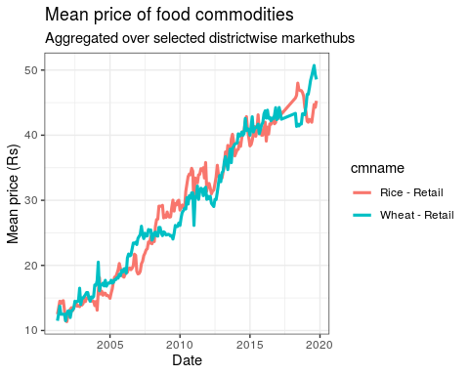

Time series plot of retail price of rice in Kathmandu market. Series has some time gaps at random periods (shown on line plot on the lower right). Similarly, autocorrelation of series for various lag, with first order difference, is presented in the lower left.

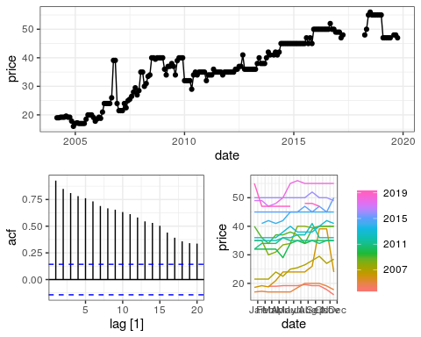

A possible measure to removing non-stationary trend in the series is by differencing (with diff) . However, before progressing we confirm that justifiable lag operations can infact render the series free of trends. For this at two fundamentally different unit tests are performed – Augmented Dickey-Fueller test and KPSS test.

While the series needs detrending in order to perform regression, we also have to consider the time gaps in the available dataset.

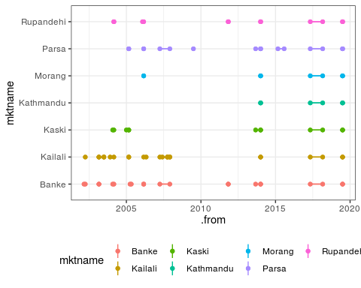

All district market series presented after time gap filling. First order lag is used to fill the missing entries in the series. Missing values for each series are imputed independent of other series.

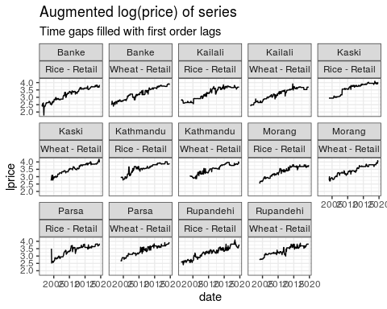

# Unit root testing

## Unit root (ADF and KPSS) test of retail price

The ADF, available in the function adf.test() (in the package tseries) implements the t-test of $H_{0}:γ=0$ in the regression, below.

$$ΔY_{t}=β_{1}+β_{2}t+γY_{t−1}+\sum_{i=1}^{m}{δ_{i}ΔY_{t−i}+ε_{t}}$$

The null is therefore that x has a unit root. If only x has a non-unit root, then the x is stationary (rejection of null hypothesis).

Table: Unit root test of district market retail log(price) data of Rice

mktname adf pvalue adf tstatistic adf stationary kpss pvalue kpss tstatistic kpss stationary ———- ———– ————— ————— ———— —————- —————- Banke 0.22 -2.86 FALSE 0.01 3.70 FALSE  
Kailali 0.52 -2.13 FALSE 0.01 3.72 FALSE  
Kaski 0.86 -1.33 FALSE 0.01 3.20 FALSE  
Kathmandu 0.45 -2.30 FALSE 0.01 3.00 FALSE  
Morang 0.44 -2.32 FALSE 0.01 3.42 FALSE  
Parsa 0.22 -2.86 FALSE 0.01 2.64 FALSE  
Rupandehi 0.01 -4.51 TRUE 0.01 3.91 FALSE

Unit root test of district market retail log(price) data of Wheat

mktname

adf pvalue

adf tstatistic

adf stationary

kpss pvalue

kpss tstatistic

kpss stationary

Banke

0.01

-4.09

TRUE

0.01

3.86

FALSE

Kailali

0.47

-2.26

FALSE

0.01

3.81

FALSE

Kaski

0.05

-3.41

FALSE

0.01

3.40

FALSE

Kathmandu

0.34

-2.56

FALSE

0.01

3.43

FALSE

Morang

0.03

-3.62

TRUE

0.01

3.40

FALSE

Parsa

0.04

-3.55

TRUE

0.01

3.05

FALSE

Rupandehi

0.02

-3.72

TRUE

0.01

3.16

FALSE

The ADF test was parametrized with the alternative hypothesis of stationarity. This extends to following assumption in the model parameters;

$$−2≤γ≤0 or (−1<1+ϕ<1)$$

k in the function refers to the number of $δ$ lags, i.e., $1,2,3,....,m$ in the model equation.

The number of lags k defaults to trunc((length(x)-1)^(1/3)), where x is the series being tested. The default value of k corresponds to the suggested upper bound on the rate at which the number of lags, k, should be made to grow with the sample size for the general ARMA(p,q) setup citation(package = "tseries").

For a Dickey-Fueller test, so only up to AR(1) time dependency in our stationary process, we set k = 0. Hence we have no $δ$ s (lags) in our test.

The DF model can be written as:

$$Y_{t}=β_{1}+β_{2}t+ϕY_{t−1}+ε_{t}$$

It can be re-written so we can do a linear regression of $ΔY_{t}$ against $t$ and $Y_{t−1}$ and test if $ϕ$ is different from 0. If only, $ϕ$ is not zero and assumption above ($−1<1+ϕ<1$) holds, the process is stationary. If $ϕ$ is straight up 0, then we have a random walk process – all white noise.

$$ΔY_{t}=β_{1}+β_{2}t+γY_{t−1}+ε_{t}$$

Alternative to above discussed tests, the Phillips-Perron test with its nonparametric correction for autocorrelation (essentially employing a HAC estimate of the long-run variance in a Dickey-Fuller-type test instead of parametric decorrelation) may be used. It is available in the function pp.test().

## Unit root test based lag order differencing determination

An alternative to decomposition for removing trends is differencing (Woodward, Gray, and Elliott 2017). We define the difference operator as,

and, more generally, for order $d$

Where $B$ is the backshift operator (i.e., $B^{k}x_{t}=x_{t−k}$ for $k≥1$).

Applying the difference to a random walk, the most simple and widely used time series model, will yield a time series of Gaussian white noise errors $\{w_{t}\}$:

Differencing is required for *all* series to make them stationary, as inferred by the ndiffs function which employed popular unit root tests. A detailed presentation of the test routines is given below. We describe in detail the ADF test, while only tabluation of summary statistics of kpss test is made herein.

## Unit root tests of first order differenced series

All major districtwise market series series are non-stationary, meaning that they have a trend associated with time.

We test the logged prices of the series after first order differencing. Here we perform a more conservative Dickey-Fueller, instead of Augmented DF, test.

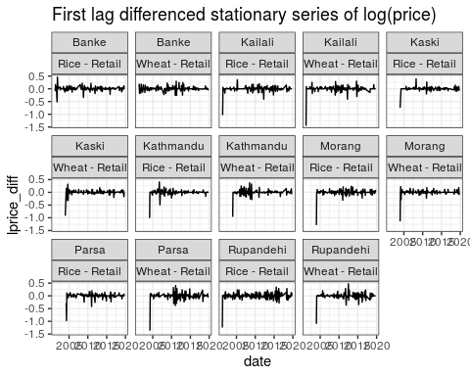

The first order differencing renders all series stationary.

## ARIMA modeling log(retail) price

### Model definition

A process $x_{t}$ is said to be ARIMA(p, d, q) if

$$\begin{matrix}∇^{d}x_{t}=(1−B)^{d}x_{t}\end{matrix}$$

if ARMA(p, q). In general, we write the total model as:

$$ϕ(B)(1−B)^{d}x_{t}=θ(B)w_{t}$$

If $E(∇^{d}x_{t})=μ$, we write the model as:

$$ϕ(B)(1−B)^{d}x_{t}=δ+θ(B)w_{t}$$

Where $δ=μ(1−ϕ_{1}−...−ϕ_{p})$.

Specification of an ARIMA model;

ARIMA model summary for multiple log(price) series of major districtwise market hubs of Rice - Retail

mktname

sigma2

log_lik

AIC

AICc

BIC

Kathmandu

0.004

243.522

-479.045

-478.825

-466.120

Parsa

0.010

167.945

-331.890

-331.824

-325.438

Morang

0.004

257.864

-509.728

-509.598

-500.003

Kailali

0.004

290.087

-568.173

-567.781

-547.784

Banke

0.005

265.152

-520.305

-520.027

-503.291

Kaski

0.002

304.876

-603.752

-603.622

-594.027

Rupandehi

0.007

234.554

-463.107

-462.997

-452.899

ARIMA model summary for multiple log(price) series of major districtwise market hubs of Wheat - Retail

mktname

sigma2

log_lik

AIC

AICc

BIC

Kathmandu

0.005

239.962

-473.923

-473.793

-464.198

Parsa

0.006

212.092

-418.184

-418.052

-408.507

Morang

0.003

282.470

-554.939

-554.611

-538.730

Kailali

0.004

293.371

-578.742

-578.558

-565.131

Banke

0.004

291.350

-568.700

-568.176

-544.881

Kaski

0.003

274.450

-540.900

-540.682

-527.933

Rupandehi

0.006

212.393

-414.786

-414.458

-398.578

Model coefficients of ARIMA model for multiple log(price) series of major districtwise market hubs of Rice - Retail

mktname

term

estimate

std.error

statistic

p.value

Kathmandu

ma1

0.025

0.072

0.350

0.727

Kathmandu

ma2

-0.353

0.074

-4.789

0.000

Kathmandu

constant

0.005

0.003

1.512

0.132

Parsa

ar1

-0.198

0.104

-1.912

0.057

Morang

ma1

-0.403

0.079

-5.096

0.000

Morang

constant

0.006

0.003

2.311

0.022

Kailali

ar1

1.387

NaN

NaN

NaN

Kailali

ar2

-0.485

NaN

NaN

NaN

Kailali

ma1

-1.579

NaN

NaN

NaN

Kailali

ma2

0.617

NaN

NaN

NaN

Kailali

constant

0.000

0.000

2.511

0.013

Banke

ar1

0.702

0.065

10.752

0.000

Banke

ma1

-0.947

0.030

-32.040

0.000

Banke

sar1

-0.013

0.093

-0.141

0.888

Banke

constant

0.002

0.000

6.728

0.000

Kaski

ma1

-0.316

0.070

-4.542

0.000

Kaski

constant

0.005

0.002

2.233

0.027

Rupandehi

ma1

-0.359

0.063

-5.701

0.000

Rupandehi

sma1

0.100

0.064

1.557

0.121

Model coefficients of ARIMA model for multiple log(price) series of major districtwise market hubs of Wheat - Retail

mktname

term

estimate

std.error

statistic

p.value

Kathmandu

ma1

-0.499

0.066

-7.600

0.000

Kathmandu

constant

0.005

0.002

1.901

0.059

Parsa

ma1

-0.618

0.061

-10.188

0.000

Parsa

constant

0.006

0.002

2.906

0.004

Morang

ma1

-0.235

0.072

-3.249

0.001

Morang

ma2

-0.107

0.077

-1.384

0.168

Morang

sar1

0.118

0.083

1.418

0.158

Morang

constant

0.006

0.003

2.249

0.026

Kailali

ar1

0.276

0.148

1.865

0.063

Kailali

ma1

-0.700

0.116

-6.017

0.000

Kailali

constant

0.004

0.001

3.111

0.002

Banke

ma1

-0.310

0.066

-4.678

0.000

Banke

ma2

-0.213

0.074

-2.872

0.004

Banke

sar1

-0.746

0.315

-2.366

0.019

Banke

sar2

-0.183

0.074

-2.481

0.014

Banke

sma1

0.647

0.323

2.002

0.047

Banke

constant

0.012

0.003

3.299

0.001

Kaski

ar1

-0.412

0.066

-6.196

0.000

Kaski

sar1

0.093

0.097

0.954

0.341

Kaski

constant

0.008

0.004

2.066

0.040

Rupandehi

ar1

-0.715

0.163

-4.393

0.000

Rupandehi

ma1

0.403

0.158

2.554

0.011

Rupandehi

ma2

-0.381

0.070

-5.480

0.000

Rupandehi

sma1

0.215

0.075

2.854

0.005

## Var modeling

Model performance indicators of VAR(AR(1)) model for selected districtwise market hub series in Rice and Wheat.

cmname-mktname

sigma2

log_lik

AIC

AICc

BIC

Rice - Retail / Banke

0.005987452

254.108

-502.216

-502.106

-492.008

Rice - Retail / Kailali

0.004562652

282.494

-560.989

-560.934

-554.192

Rice - Retail / Kaski

0.002558304

296.841

-587.682

-587.552

-577.956

Rice - Retail / Kathmandu

0.004799157

234.890

-463.780

-463.649

-454.086

Rice - Retail / Morang

0.004287195

248.052

-490.103

-489.973

-480.378

Rice - Retail / Parsa

0.009750488

167.714

-329.427

-329.295

-319.750

Rice - Retail / Rupandehi

0.007998555

221.963

-437.926

-437.816

-427.718

Wheat - Retail / Banke

0.004799646

278.653

-551.306

-551.196

-541.098

Wheat - Retail / Kailali

0.004939438

275.466

-544.932

-544.822

-534.724

Wheat - Retail / Kaski

0.003879621

257.492

-508.983

-508.854

-499.258

Wheat - Retail / Kathmandu

0.005504843

224.427

-442.854

-442.724

-433.129

Wheat - Retail / Morang

0.003155432

277.016

-548.033

-547.903

-538.308

Wheat - Retail / Parsa

0.007953767

186.655

-367.310

-367.178

-357.633

Wheat - Retail / Rupandehi

0.007253182

198.363

-390.725

-390.596

-381.000

Model coefficients of VAR model for multiple log(price) series of major districtwise market hubs of Rice - Retail

mktname

term

estimate

std.error

statistic

p.value

Banke

lag(lprice,1)

0.982

0.012

82.933

0.000

Banke

constant

0.062

0.038

1.626

0.105

Kailali

lag(lprice,1)

1.001

0.001

723.506

0.000

Kaski

lag(lprice,1)

0.985

0.010

99.189

0.000

Kaski

constant

0.059

0.036

1.654

0.100

Kathmandu

lag(lprice,1)

0.971

0.015

63.567

0.000

Kathmandu

constant

0.109

0.055

1.999

0.047

Morang

lag(lprice,1)

0.973

0.014

71.100

0.000

Morang

constant

0.098

0.046

2.121

0.035

Parsa

lag(lprice,1)

0.963

0.021

46.349

0.000

Parsa

constant

0.125

0.070

1.774

0.078

Rupandehi

lag(lprice,1)

0.972

0.016

62.573

0.000

Rupandehi

constant

0.097

0.050

1.927

0.055

Model coefficients of VAR model for multiple log(price) series of major districtwise market hubs of Wheat - Retail

mktname

term

estimate

std.error

statistic

p.value

Banke

lag(lprice,1)

0.982

0.011

86.538

0.000

Banke

constant

0.063

0.037

1.698

0.091

Kailali

lag(lprice,1)

0.977

0.012

80.478

0.000

Kailali

constant

0.080

0.039

2.033

0.043

Kaski

lag(lprice,1)

0.974

0.013

72.988

0.000

Kaski

constant

0.097

0.047

2.046

0.042

Kathmandu

lag(lprice,1)

0.972

0.017

57.967

0.000

Kathmandu

constant

0.103

0.059

1.741

0.083

Morang

lag(lprice,1)

0.983

0.012

79.565

0.000

Morang

constant

0.063

0.043

1.492

0.137

Parsa

lag(lprice,1)

0.949

0.021

45.575

0.000

Parsa

constant

0.178

0.071

2.514

0.013

Rupandehi

lag(lprice,1)

0.955

0.021

46.210

0.000

Rupandehi

constant

0.157

0.070

2.259

0.025

## Differenced series

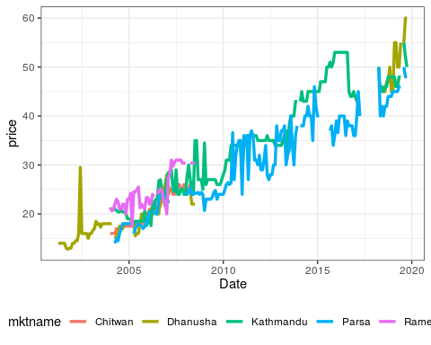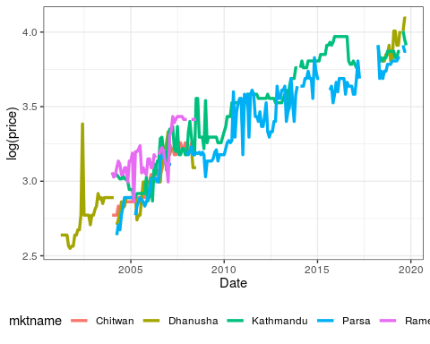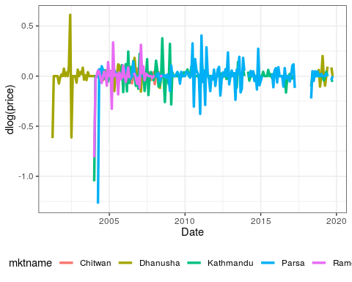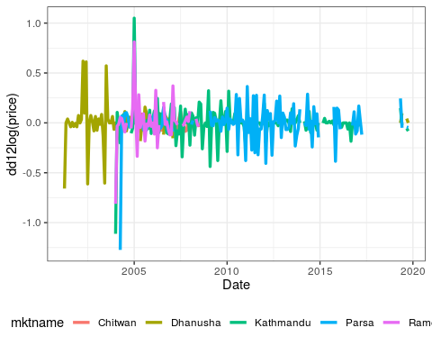

# Import historical rice and wheat data

Retail price of various rice commodities and wheat flour since 1976 AD.

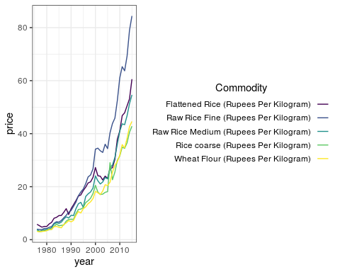

# Cointegration

## Residual based

Since the food commodities are spatially linked, more of so because they occupy the same domestic market, it is obvious that factor affecting price of one inevitably affects other, especially that of same crop in a nearby market. Having evidence for nonstationarity, it is of interest to test for a common nonstationary component by means of a cointegration test (Non-stationarity is more valid for development regionwise price series).

A two step method proposed by Hylleberg et al. (1990) can be used to test for cointegration.

The procedure simply regressess one series on the other and performs a unit root test on the residuals. This test is often named after Phillips, Ouliaris, and others (1990). Specifically, po.test() performs a Phillips-Perron test using an auxiliary regression without a constant and linear trend and the Newey-West estimator for the required long-run variance.

The test computes the Phillips-Ouliaris test for the null hypothesis that series is not cointegrated (Trapletti and Hornik 2019).

We check the rice retail price series for all combination major districtwise markets.

Phillips-Ouliaris cointegration test for Rice log(price) series of selected district markethubs

|  |  |  |
| --- | --- | --- |
| combination | p_value | statistic |
| Morang-Parsa | 0.010 | -96.515 |
| Morang-Kathmandu | 0.010 | -34.869 |
| Morang-Kaski | 0.010 | -37.126 |
| Morang-Rupandehi | 0.010 | -42.435 |
| Morang-Banke | 0.010 | -65.794 |
| Morang-Kailali | 0.010 | -66.540 |
| Parsa-Kathmandu | 0.010 | -59.925 |
| Parsa-Kaski | 0.010 | -94.521 |
| Parsa-Rupandehi | 0.010 | -63.256 |
| Parsa-Banke | 0.010 | -91.480 |
| Parsa-Kailali | 0.010 | -89.453 |
| Kathmandu-Kaski | 0.010 | -35.060 |
| Kathmandu-Rupandehi | 0.010 | -37.100 |
| Kathmandu-Banke | 0.010 | -34.602 |
| Kathmandu-Kailali | 0.010 | -34.579 |
| Kaski-Rupandehi | 0.013 | -27.453 |
| Kaski-Banke | 0.010 | -41.121 |
| Kaski-Kailali | 0.010 | -52.289 |
| Rupandehi-Banke | 0.010 | -89.619 |
| Rupandehi-Kailali | 0.010 | -41.667 |
| Banke-Kailali | 0.010 | -58.835 |

Phillips-Ouliaris cointegration test for Wheat log(price) series of selected district markethubs

|  |  |  |
| --- | --- | --- |
| combination | p_value | statistic |
| Morang-Parsa | 0.01 | -79.626 |
| Morang-Kathmandu | 0.01 | -53.276 |
| Morang-Kaski | 0.01 | -71.222 |
| Morang-Rupandehi | 0.01 | -79.788 |
| Morang-Banke | 0.01 | -56.448 |
| Morang-Kailali | 0.01 | -55.875 |
| Parsa-Kathmandu | 0.01 | -80.952 |
| Parsa-Kaski | 0.01 | -90.071 |
| Parsa-Rupandehi | 0.01 | -78.571 |
| Parsa-Banke | 0.01 | -57.703 |
| Parsa-Kailali | 0.01 | -92.198 |
| Kathmandu-Kaski | 0.01 | -82.232 |
| Kathmandu-Rupandehi | 0.01 | -48.619 |
| Kathmandu-Banke | 0.01 | -50.344 |
| Kathmandu-Kailali | 0.01 | -73.156 |
| Kaski-Rupandehi | 0.01 | -58.758 |
| Kaski-Banke | 0.01 | -49.955 |
| Kaski-Kailali | 0.01 | -87.482 |
| Rupandehi-Banke | 0.01 | -57.133 |
| Rupandehi-Kailali | 0.01 | -64.151 |
| Banke-Kailali | 0.01 | -53.604 |

Note po.test does not handle missing values, so we fix them through imputation. It is implemented through tidyr::fill(..., .direction = "down").

The test suggests that all series (Both that of wheat and rice) are cointegrated for selected pairwise combination of district markets.

The problem with this approach is that it treats both series in an asymmetric fashion, while the concept of cointegration demands that the treatment be symmetric.

The po.test() function is testing the cointegration with Phillip’s Z_alpha test, which is the second residual-based test described by Phillips, Ouliaris, and others (1990). Because the po.test() will use the series at the first position to derive the residual used in the test, results would be determined by the series on the most left-hand side[1].

The Phillips-Ouliaris test implemented in the ca.po() function from the urca package is different. In the ca.po() function, there are two cointegration tests implemented, namely “Pu” and “Pz” tests. Although both the ca.po() function and the po.test() function are supposed to do the Phillips-Ouliaris test，outcomes from both functions are completely different.

Similar to Phillip’s Z_alpha test, the Pu test also is not invariant to the position of each series and therefore would give different outcomes based upon the series on the most left-hand side. On the contrary, the multivariate trace statistic of Pz test has its appeal in that the outcome won’t change by the position of each series.

## VAR based

The standard tests proceeding in a symmetric manner stem from Johansen’s full-information maximum likelihood approach (Johansen 1991).

A general vector autoregressive model is similar to the AR(p) model except that each quantity is vector valued and matrices are used as the coefficients. The general form of the VAR(p) model, without drift, is given by:

$$
\label{eqn:var-general}
{\bf y_t} = {\bf \mu} + A_1 {\bf y_{t-1}} + \ldots + A_j {\bf y_{t-j}} + {\bf \varepsilon_t}
$$

Where ${\bf \mu}$ is the vector-valued mean of the series, $A_{i}$ are the coefficient matrices for each lag and ${\bf \varepsilon_t}$ is a multivariate Gaussian noise term with mean zero.

At this stage we can form a Vector Error Correction Model (VECM) by differencing the series (Equation @ref(eqn:vecm-differenced)).

$$
\label{eqn:vecm-differenced}
\Delta {\bf y_t} = {\bf \mu} + A {\bf y_{t-1}} + \Gamma_1 \Delta {\bf y_{t-1}} + \ldots + \Gamma_j \Delta {\bf y_{t-j}} + {\bf \varepsilon_t}
$$

Where $\Delta {\bf y_t} = {\bf y_t} - {\bf y_{t-1}}$ is the differencing operator, $A$ is the coefficient matrix for the first lag and $Γ_{i}$ are the matrices for each differenced lag.

For a $p^{th}$-order cointegrated vector autoregressive (VAR) model, the error correction form is (omitting deterministic components; both no intercept or trend in either cointegrating equation or test var), we may rewrite the VAR in the form of Equation @ref(eqn:johansens) (Johansen 1991).

$$Δy_{t}=Πy_{t−1}+\sum_{j=1}^{p−1}{Γ_{j}Δy_{t−j}}+ε_{t}$$

(Although, for simplicity sake, we assume absence of deterministic trends, there are five popular scenarios of including such trends in a cointegration test. All of these are described in (Johansen 1995).)

Where,

$$Π=\sum_{i=1}^{p}{A_{i}−I};Γ=−\sum_{j=i+1}^{p}{j}$$

Granger’s representation theorem asserts that if the coefficient matrix $Π$ has reduced rank $r<k$, then there exist $kxr$ matrices $α$ and $β$ each with rank $k$ such that $Π=αβ^{′}$ and $β^{′}y_{t}$ is $I(0)$.

To achieve this an eigenvalue decomposition of $A$ is carried out. The rank of the matrix $A$ is given by $r$ and the Johansen test sequentially tests whether this rank $r$ is equal to zero, equal to one, through to $r=n−1$, where $n$ is the number of time series under test.

The null hypothesis of $r=0$ means that there is no cointegration at all. A rank $r>0$ implies a cointegrating relationship between two or possibly more time series.

The eigenvalue decomposition results in a set of eigenvectors. The components of the largest eigenvector admits the important property of forming the coefficients of a linear combination of time series to produce a stationary portfolio. Notice how this differs from the CADF test (often known as the Engle-Granger procedure) where it is necessary to ascertain the linear combination a priori via linear regression and ordinary least squares (OLS).

In summary, the test checks for the situation of no cointegration, which occurs when the matrix $A=0$. So, starting with the base value of $r$ (i.e., $r=0$), if the test statistic is greater than critical values of at the 10%, 5% and 1% levels, this would imply that we are **able** to reject the null of no cointegration. For the case r<=1, we if the calculated test statistic is below the critical values of, we are **unable** to reject the null, and the number of cointegrating vectors is between 0 and 1. The relevant tests are available in the function urca::ca.jo(). The basic version considers the eigenvalues of the matrix $Π$ in the preceding equation.

Here, we employ the trace statistic – the maximum eigenvalue, or “lambdamax” test is available as well – in an equation amended by a constant term (specified by ecdet = “const”), yielding:

Johansen cointegration test summary and time series plots for rice (district marketwise)

Johansen cointegration test summary for Morang-Parsa

gamma

test_stat

10pct

5pct

1pct

r <= 1 |

8.047588

7.52

9.24

12.97

r = 0 |

29.352546

17.85

19.96

24.60

Johansen cointegration test summary for Morang-Kathmandu

gamma

test_stat

10pct

5pct

1pct

r <= 1 |

7.080797

7.52

9.24

12.97

r = 0 |

26.213687

17.85

19.96

24.60

Johansen cointegration test summary for Morang-Kaski

gamma

test_stat

10pct

5pct

1pct

r <= 1 |

10.47841

7.52

9.24

12.97

r = 0 |

26.58143

17.85

19.96

24.60

Johansen cointegration test summary for Morang-Rupandehi

gamma

test_stat

10pct

5pct

1pct

r <= 1 |

9.529231

7.52

9.24

12.97

r = 0 |

28.702528

17.85

19.96

24.60

Johansen cointegration test summary for Morang-Banke

gamma

test_stat

10pct

5pct

1pct

r <= 1 |

11.07168

7.52

9.24

12.97

r = 0 |

43.79799

17.85

19.96

24.60

Johansen cointegration test summary for Morang-Kailali

gamma

test_stat

10pct

5pct

1pct

r <= 1 |

8.627746

7.52

9.24

12.97

r = 0 |

37.159947

17.85

19.96

24.60

Johansen cointegration test summary for Parsa-Kathmandu

gamma

test_stat

10pct

5pct

1pct

r <= 1 |

7.117339

7.52

9.24

12.97

r = 0 |

28.121237

17.85

19.96

24.60

Johansen cointegration test summary for Parsa-Kaski

gamma

test_stat

10pct

5pct

1pct

r <= 1 |

8.739686

7.52

9.24

12.97

r = 0 |

33.345326

17.85

19.96

24.60

Johansen cointegration test summary for Parsa-Rupandehi

gamma

test_stat

10pct

5pct

1pct

r <= 1 |

5.241234

7.52

9.24

12.97

r = 0 |

21.237513

17.85

19.96

24.60

Johansen cointegration test summary for Parsa-Banke

gamma

test_stat

10pct

5pct

1pct

r <= 1 |

8.905272

7.52

9.24

12.97

r = 0 |

35.297439

17.85

19.96

24.60

Johansen cointegration test summary for Parsa-Kailali

gamma

test_stat

10pct

5pct

1pct

r <= 1 |

6.477453

7.52

9.24

12.97

r = 0 |

30.475019

17.85

19.96

24.60

Johansen cointegration test summary for Kathmandu-Kaski

gamma

test_stat

10pct

5pct

1pct

r <= 1 |

6.896813

7.52

9.24

12.97

r = 0 |

30.474234

17.85

19.96

24.60

Johansen cointegration test summary for Kathmandu-Rupandehi

gamma

test_stat

10pct

5pct

1pct

r <= 1 |

5.706426

7.52

9.24

12.97

r = 0 |

24.640127

17.85

19.96

24.60

Johansen cointegration test summary for Kathmandu-Banke

gamma

test_stat

10pct

5pct

1pct

r <= 1 |

9.024811

7.52

9.24

12.97

r = 0 |

30.343046

17.85

19.96

24.60

Johansen cointegration test summary for Kathmandu-Kailali

gamma

test_stat

10pct

5pct

1pct

r <= 1 |

6.166887

7.52

9.24

12.97

r = 0 |

27.654849

17.85

19.96

24.60

Johansen cointegration test summary for Kaski-Rupandehi

gamma

test_stat

10pct

5pct

1pct

r <= 1 |

7.905289

7.52

9.24

12.97

r = 0 |

22.551933

17.85

19.96

24.60

Johansen cointegration test summary for Kaski-Banke

gamma

test_stat

10pct

5pct

1pct

r <= 1 |

8.927975

7.52

9.24

12.97

r = 0 |

29.193633

17.85

19.96

24.60

Johansen cointegration test summary for Kaski-Kailali

gamma

test_stat

10pct

5pct

1pct

r <= 1 |

7.744047

7.52

9.24

12.97

r = 0 |

31.015706

17.85

19.96

24.60

Johansen cointegration test summary for Rupandehi-Banke

gamma

test_stat

10pct

5pct

1pct

r <= 1 |

4.441382

7.52

9.24

12.97

r = 0 |

46.391884

17.85

19.96

24.60

Johansen cointegration test summary for Rupandehi-Kailali

gamma

test_stat

10pct

5pct

1pct

r <= 1 |

2.995481

7.52

9.24

12.97

r = 0 |

20.488277

17.85

19.96

24.60

Johansen cointegration test summary for Banke-Kailali

gamma

test_stat

10pct

5pct

1pct

r <= 1 |

2.788889

7.52

9.24

12.97

r = 0 |

40.728755

17.85

19.96

24.60

Johansen cointegration test summary and time series plots for wheat (district marketwise)

Johansen cointegration test summary for Morang-Parsa

gamma

test_stat

10pct

5pct

1pct

r <= 1 |

8.67185

7.52

9.24

12.97

r = 0 |

38.90466

17.85

19.96

24.60

Johansen cointegration test summary for Morang-Kathmandu

gamma

test_stat

10pct

5pct

1pct

r <= 1 |

6.03380

7.52

9.24

12.97

r = 0 |

32.39395

17.85

19.96

24.60

Johansen cointegration test summary for Morang-Kaski

gamma

test_stat

10pct

5pct

1pct

r <= 1 |

14.80835

7.52

9.24

12.97

r = 0 |

47.39019

17.85

19.96

24.60

Johansen cointegration test summary for Morang-Rupandehi

gamma

test_stat

10pct

5pct

1pct

r <= 1 |

6.698168

7.52

9.24

12.97

r = 0 |

41.851350

17.85

19.96

24.60

Johansen cointegration test summary for Morang-Banke

gamma

test_stat

10pct

5pct

1pct

r <= 1 |

6.791701

7.52

9.24

12.97

r = 0 |

29.981567

17.85

19.96

24.60

Johansen cointegration test summary for Morang-Kailali

gamma

test_stat

10pct

5pct

1pct

r <= 1 |

10.09031

7.52

9.24

12.97

r = 0 |

34.84797

17.85

19.96

24.60

Johansen cointegration test summary for Parsa-Kathmandu

gamma

test_stat

10pct

5pct

1pct

r <= 1 |

5.572257

7.52

9.24

12.97

r = 0 |

39.875312

17.85

19.96

24.60

Johansen cointegration test summary for Parsa-Kaski

gamma

test_stat

10pct

5pct

1pct

r <= 1 |

9.047446

7.52

9.24

12.97

r = 0 |

43.549450

17.85

19.96

24.60

Johansen cointegration test summary for Parsa-Rupandehi

gamma

test_stat

10pct

5pct

1pct

r <= 1 |

7.098776

7.52

9.24

12.97

r = 0 |

35.167352

17.85

19.96

24.60

Johansen cointegration test summary for Parsa-Banke

gamma

test_stat

10pct

5pct

1pct

r <= 1 |

7.52789

7.52

9.24

12.97

r = 0 |

36.13913

17.85

19.96

24.60

Johansen cointegration test summary for Parsa-Kailali

gamma

test_stat

10pct

5pct

1pct

r <= 1 |

8.944134

7.52

9.24

12.97

r = 0 |

48.858929

17.85

19.96

24.60

Johansen cointegration test summary for Kathmandu-Kaski

gamma

test_stat

10pct

5pct

1pct

r <= 1 |

9.856107

7.52

9.24

12.97

r = 0 |

48.980703

17.85

19.96

24.60

Johansen cointegration test summary for Kathmandu-Rupandehi

gamma

test_stat

10pct

5pct

1pct

r <= 1 |

4.913668

7.52

9.24

12.97

r = 0 |

27.111863

17.85

19.96

24.60

Johansen cointegration test summary for Kathmandu-Banke

gamma

test_stat

10pct

5pct

1pct

r <= 1 |

5.079637

7.52

9.24

12.97

r = 0 |

27.171088

17.85

19.96

24.60

Johansen cointegration test summary for Kathmandu-Kailali

gamma

test_stat

10pct

5pct

1pct

r <= 1 |

6.417786

7.52

9.24

12.97

r = 0 |

35.001568

17.85

19.96

24.60

Johansen cointegration test summary for Kaski-Rupandehi

gamma

test_stat

10pct

5pct

1pct

r <= 1 |

10.27943

7.52

9.24

12.97

r = 0 |

33.21418

17.85

19.96

24.60

Johansen cointegration test summary for Kaski-Banke

gamma

test_stat

10pct

5pct

1pct

r <= 1 |

8.023414

7.52

9.24

12.97

r = 0 |

32.713727

17.85

19.96

24.60

Johansen cointegration test summary for Kaski-Kailali

gamma

test_stat

10pct

5pct

1pct

r <= 1 |

11.36236

7.52

9.24

12.97

r = 0 |

40.97431

17.85

19.96

24.60

Johansen cointegration test summary for Rupandehi-Banke

gamma

test_stat

10pct

5pct

1pct

r <= 1 |

6.253642

7.52

9.24

12.97

r = 0 |

34.339634

17.85

19.96

24.60

Johansen cointegration test summary for Rupandehi-Kailali

gamma

test_stat

10pct

5pct

1pct

r <= 1 |

7.004144

7.52

9.24

12.97

r = 0 |

31.782559

17.85

19.96

24.60

Johansen cointegration test summary for Banke-Kailali

gamma

test_stat

10pct

5pct

1pct

r <= 1 |

7.875127

7.52

9.24

12.97

r = 0 |

32.936232

17.85

19.96

24.60

Wheat series and cointegration plots

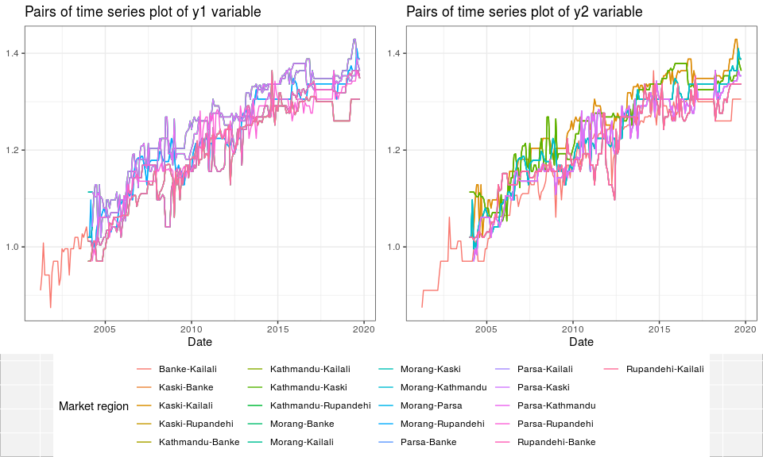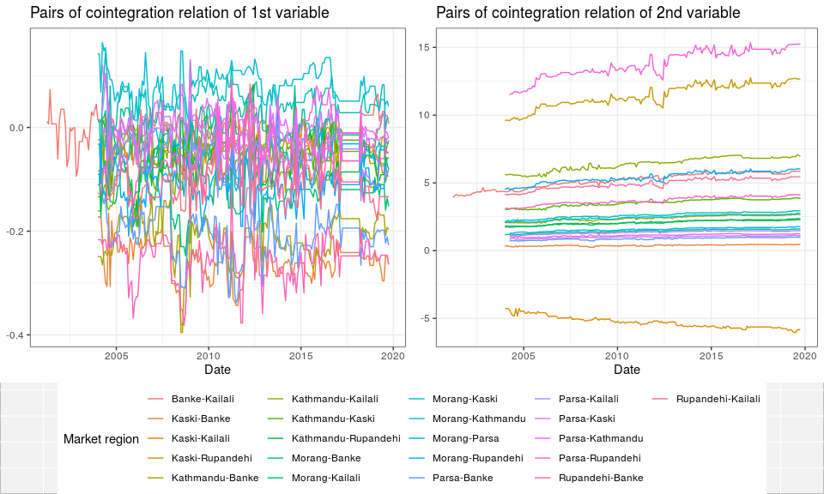

Rice series and cointegration plots

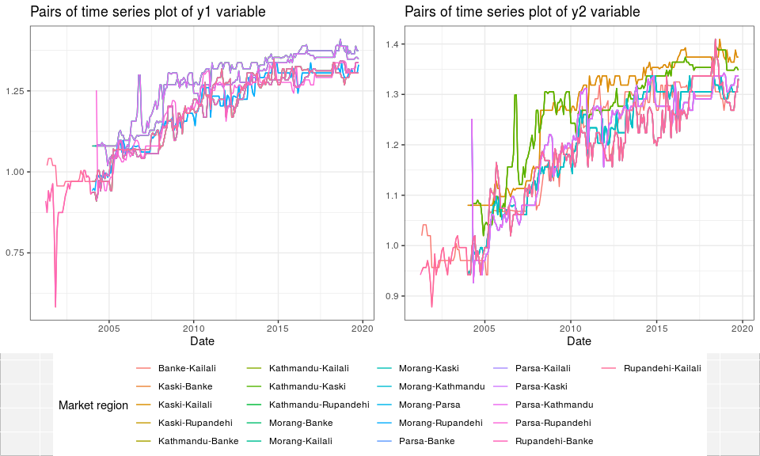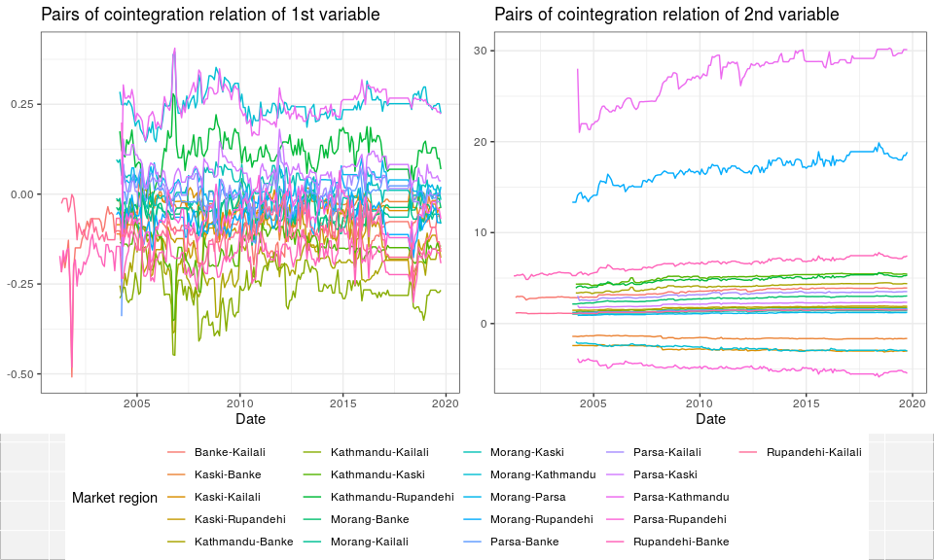

# Order of integration

In practice, “order of integration” provides you with the number of times you have to difference a series in order to obtain a covariance-stationary series.

The use of the term “integration” *does* have something to do with the usual meaning of the term, but in its discrete incarnation (i.e. with “summation”). It comes from the fact that, looking “upstream”, a series integrated of order $1$, $I(1)$, can be represented as the sum of the elements of a series integrated of order $0$:

Consider the stochastic process $\{X_{t}\}$, and assume that it is $I(0)$. Define the process;

$$Z_{t}=\sum_{i=1}^{t}{X_{i}}$$

Then

$$ΔZ_{t}=Z_{t}−Z_{t−1}=\sum_{i=1}^{t}{X_{i}}−\sum_{i=1}^{t−1}{X_{i}}=X_{t}$$

So the process $\{ΔZ_{t}\}$ is $I(0)$ and then the process $\{Z_{t}\}$ is $I(1)$, while also being the sum of the elements of $\{X_{t}\}$.

And this can continue for higher orders of integration, as you can easily check.

# Bibliography

Hylleberg, Svend, Robert F Engle, Clive WJ Granger, and Byung Sam Yoo. 1990. “Seasonal Integration and Cointegration.” *Journal of Econometrics* 44 (1-2). Elsevier: 215–38.

Johansen, Søren. 1991. “Estimation and Hypothesis Testing of Cointegration Vectors in Gaussian Vector Autoregressive Models.” *Econometrica: Journal of the Econometric Society*. JSTOR, 1551–80.

———. 1995. “Identifying Restrictions of Linear Equations with Applications to Simultaneous Equations and Cointegration.” *Journal of Econometrics* 69 (1). Elsevier: 111–32.

Phillips, Peter CB, Sam Ouliaris, and others. 1990. “Asymptotic Properties of Residual Based Tests for Cointegration.” *Econometrica* 58 (1): 165–93.

Trapletti, Adrian, and Kurt Hornik. 2019. *Tseries: Time Series Analysis and Computational Finance*. <https://CRAN.R-project.org/package=tseries>.

Woodward, Wayne A, Henry L Gray, and Alan C Elliott. 2017. *Applied Time Series Analysis with R*. CRC press.

1. <https://www.r-craft.org/r-news/phillips-ouliaris-test-for-cointegration/>