Heart Disease MLOps Pipeline
End-to-End ML Model Development, CI/CD, and Production Deployment

Course: MLOps (S2-25_AMLCSZG523)
Assignment - I
Total Marks: 50

Table of Contents
1. Introduction
2. Data Acquisition & Exploratory Data Analysis
3. Feature Engineering & Model Development
4. Experiment Tracking (MLflow)
5. Model Packaging & Reproducibility
6. CI/CD Pipeline & Automated Testing
7. Model Containerization (Docker)
8. Production Deployment (Kubernetes)
9. Monitoring & Logging
10. Architecture Overview & Conclusion

1. Introduction
This report documents the design, development, and deployment of an end-to-end MLOps pipeline for predicting heart disease risk using the UCI Heart Disease dataset (Cleveland subset). The pipeline implements modern MLOps best practices including automated data preprocessing, experiment tracking with MLflow, CI/CD pipelines with Jenkins and GitHub Actions, Docker containerization, Kubernetes deployment, and production monitoring with Prometheus and Grafana.

Problem Statement
Build a machine learning classifier to predict the risk of heart disease based on patient health data, and deploy the solution as a cloud-ready, monitored API.

Dataset
Heart Disease UCI Dataset (Cleveland subset) from the UCI Machine Learning Repository. 303 patients, 13 clinical features (age, sex, chest pain type, blood pressure, cholesterol, etc.), and a binary target (presence/absence of heart disease).

Tech Stack
Python 3.12, scikit-learn, MLflow, FastAPI, Docker, Kubernetes (Minikube), Jenkins, GitHub Actions, Prometheus, Grafana, pytest.

2. Data Acquisition & Exploratory Data Analysis

2.1 Data Acquisition
A download script (data/download_data.py) reads the raw processed Cleveland data from the UCI repository, adds proper column headers, converts the multi-class target (values 0-4) to binary classification (0 = no disease, 1 = disease present), and saves it as a clean CSV file.
Command to acquire data:
python data/download_data.py

2.2 Data Cleaning
- Missing values: 'ca' (4 missing) and 'thal' (2 missing) contained '?' markers, handled via median imputation.
- Target encoding: Values 1-4 mapped to 1 (disease present), value 0 kept as 0 (no disease).
- Final dataset: 303 rows, 14 columns (13 features + 1 target), zero missing values after cleaning.

2.3 EDA Highlights
The EDA notebook (notebooks/01_eda.ipynb) includes dataset statistics, feature distribution histograms, correlation heatmaps, class balance analysis, box plots of continuous features by target, and categorical feature cross-tabulations.
- Class distribution: ~54% no disease (164), ~46% disease (139) - reasonably balanced.
- Strong correlations with target: thal (0.52), ca (0.47), exang (0.44), cp (0.43), oldpeak (0.43).
- Disease patients show lower max heart rate and higher ST depression.
- Chest pain type 4 (asymptomatic) is strongly associated with heart disease.

2.4 Data Split
The cleaned dataset was split into training (242 samples, 80%) and test (61 samples, 20%) sets using stratified sampling to preserve target distribution.

3. Feature Engineering & Model Development

3.1 Preprocessing Pipeline
All 13 features are treated as numeric. The preprocessing pipeline is implemented as a scikit-learn Pipeline consisting of:
- SimpleImputer (median strategy) - handles any remaining missing values at inference time.
- StandardScaler - normalizes features to zero mean and unit variance.
- Classifier (Logistic Regression or Random Forest).

3.2 Models Trained
Two classification models were trained with hyperparameter tuning via GridSearchCV (5-fold CV):
- Logistic Regression: C = [0.01, 0.1, 1.0, 10.0]. Best: C=0.1, solver=lbfgs.
- Random Forest: n_estimators=[100,200], max_depth=[5,10,None], min_samples_split=[2,5], min_samples_leaf=[1,2]. Best: n_estimators=200, max_depth=5.

3.3 Test Set Evaluation
Metric | Logistic Regression | Random Forest
Accuracy | 0.8525 | 0.9016
Precision | 0.8065 | 0.8667
Recall | 0.8929 | 0.9286
F1 Score | 0.8475 | 0.8966
ROC-AUC | 0.9578 | 0.9567

3.4 Cross-Validation Results (5-Fold)
Metric | Logistic Regression | Random Forest
CV Accuracy | 0.8263 | 0.8221
CV Precision | 0.8392 | 0.8408
CV Recall | 0.7743 | 0.7557
CV F1 | 0.8034 | 0.7948
CV ROC-AUC | 0.8914 | 0.8940

3.5 ROC Curve Comparison
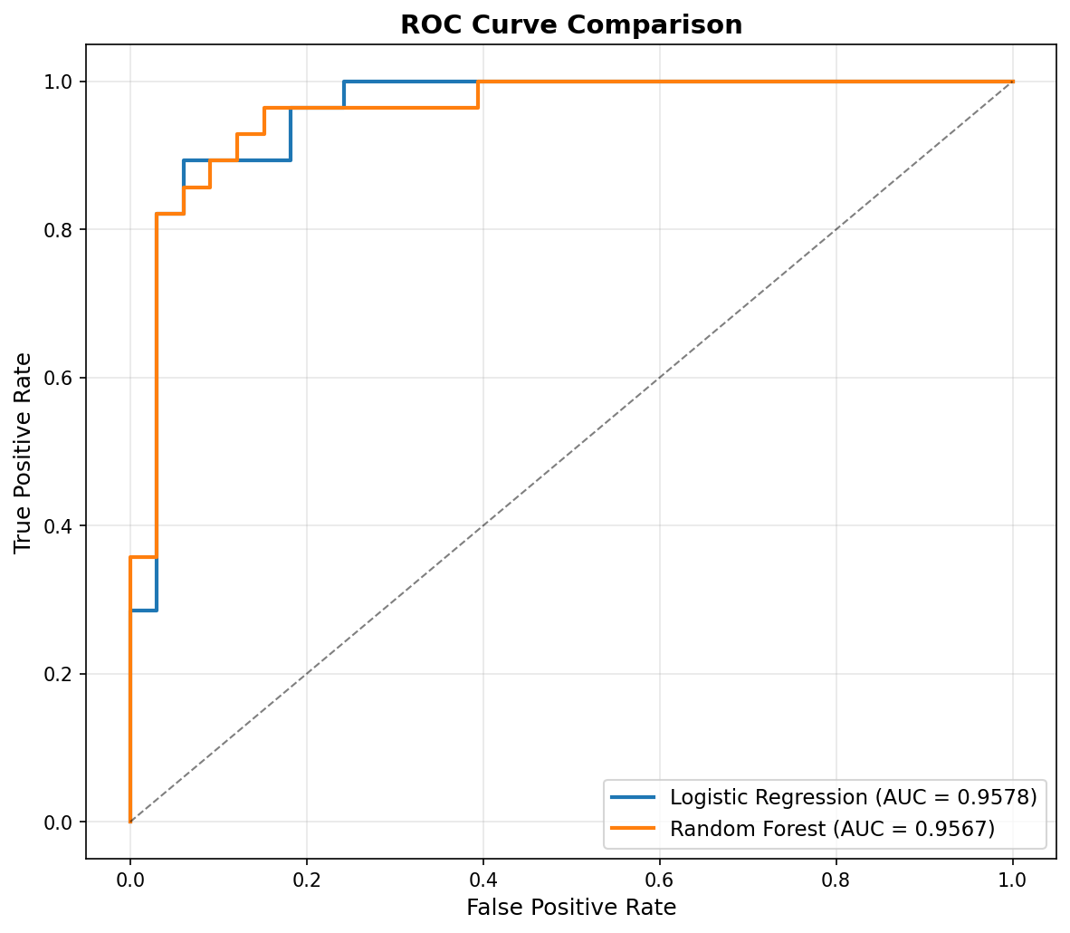
Figure 1: ROC Curve Comparison - Both models achieve AUC ~0.96

3.6 Confusion Matrix
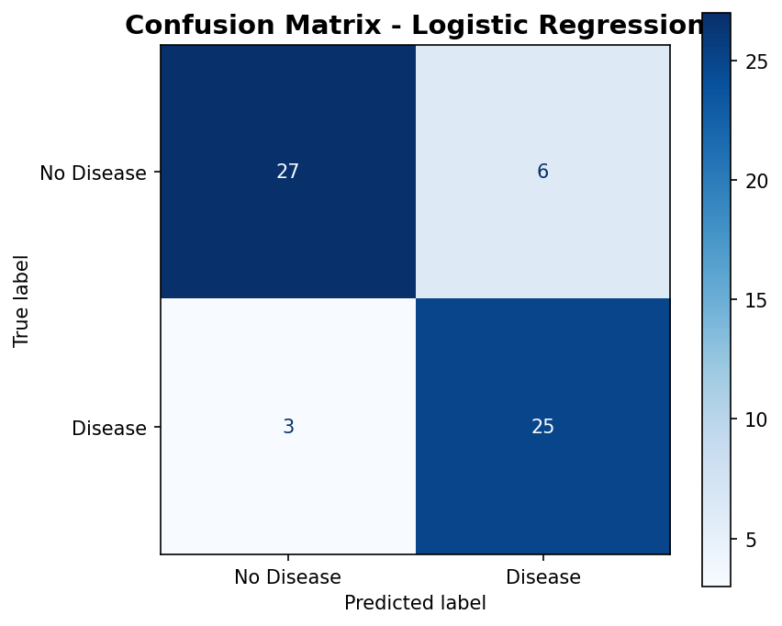
Figure 2: Confusion Matrix - Logistic Regression (selected model)

3.7 Model Selection
The best model was selected based on test ROC-AUC score. Logistic Regression (AUC=0.9578) was chosen as the production model due to its highest ROC-AUC, simpler architecture, faster inference time, and comparable performance to Random Forest (AUC=0.9567).

4. Experiment Tracking (MLflow)
MLflow is integrated into the training pipeline (src/training/train.py) with file-based tracking (./mlruns directory). The experiment name is 'heart-disease-classification'.

4.1 What Gets Logged
- Parameters: model_type, C, n_estimators, max_depth, min_samples_split, etc.
- Metrics: accuracy, precision, recall, F1, ROC-AUC (both test and 5-fold CV).
- Artifacts: confusion matrix plots, ROC curve plots, trained sklearn model.
- Tags: dataset=heart-disease-uci-cleveland, dataset_version=1.0, description.

4.2 Viewing Experiments
To view the MLflow experiment comparison UI:
mlflow ui --backend-store-uri ./mlruns
# Open http://localhost:5000
The MLflow UI provides side-by-side comparison of Logistic Regression vs Random Forest runs, metric charts showing performance, and an artifact browser for downloading models and plots.

5. Model Packaging & Reproducibility

5.1 Saved Formats
The final model is saved in two formats: (1) Joblib pickle at model/artifacts/heart_disease_model.pkl for direct loading in the serving API, and (2) MLflow model format in mlruns/ for the MLflow model registry.

5.2 Full Pipeline Bundling
The saved model is a complete scikit-learn Pipeline containing imputation, scaling, and classification steps. This guarantees that all preprocessing transformations are bundled with the model, ensuring identical behavior regardless of deployment environment.

5.3 Dependency Management
All dependencies are pinned with exact versions in requirements.txt. Key packages: scikit-learn==1.8.0, pandas==2.3.3, numpy==2.4.4, mlflow==3.11.1, fastapi==0.136.1, uvicorn==0.46.0, pytest==9.0.3.

5.4 Reproducibility Steps
python3 -m venv venv && source venv/bin/activate
pip install -r requirements.txt
python data/download_data.py
python -c "from src.data_prep.prepare import run; run()"
python -c "from src.training.train import run; run()"

6. CI/CD Pipeline & Automated Testing

6.1 Unit Tests
24 unit tests are organized across three test files, all passing successfully:
Test File | Count | Coverage
test_data_prep.py | 10 | Data loading, missing values, shape, target encoding, split, preprocessor
test_model.py | 8 | Training accuracy, prediction format, probabilities, saved model
test_api.py | 7 | Root endpoint, health check, prediction, validation, Swagger docs
python -m pytest tests/ -v
# 24 passed in 3.32s

6.2 Jenkins Pipeline (Jenkinsfile)
The Jenkinsfile defines a 7-stage pipeline:
- Checkout: Pull source code from repository.
- Setup Python Environment: Create virtual environment, install dependencies.
- Lint: Run flake8 for code quality (max-line-length=120).
- Prepare Data: Download dataset and run preprocessing.
- Unit Tests: Run pytest with JUnit XML reporting.
- Train Model: Execute the full training pipeline.
- Build Docker Image: Build container for model serving.

6.3 GitHub Actions (.github/workflows/ci.yml)
An equivalent GitHub Actions workflow is provided, triggered on push/PR to main. It includes all Jenkins stages plus Docker container testing with health check and prediction verification via curl. Model artifacts and test results are uploaded as workflow artifacts.

7. Model Containerization (Docker)

7.1 FastAPI Application
The serving API (src/serving/app.py) is built with FastAPI and exposes the following endpoints:
Method | Path | Description
GET | / | API information and available endpoints
GET | /health | Health check (model loaded status)
GET | /docs | Auto-generated Swagger UI documentation
POST | /predict | Accept 13 features, return prediction + confidence
GET | /metrics | Prometheus metrics endpoint

7.2 Dockerfile
Key security and production features:
- Base image: python:3.12-slim (minimal attack surface).
- Non-root user (appuser) for security.
- Requirements-first copy for Docker layer caching.
- Built-in HEALTHCHECK directive.
- Runs uvicorn ASGI server on port 8080.

7.3 Build and Test
docker build -t heart-disease-api .
docker run -p 8080:8080 heart-disease-api
# Test health
curl http://localhost:8080/health
# Test prediction
curl -X POST http://localhost:8080/predict \
-H "Content-Type: application/json" \
-d '{"age":63,"sex":1,"cp":1,"trestbps":145,"chol":233,...}'

8. Production Deployment (Kubernetes)

8.1 Kubernetes Manifests
Three Kubernetes manifests are provided in the k8s/ directory:
- deployment.yaml: 2 replicas, resource limits (256Mi-512Mi memory, 250m-500m CPU), liveness and readiness probes on /health, rolling update strategy.
- service.yaml: LoadBalancer type service, port 80 mapped to container port 8080.
- ingress.yaml: Nginx ingress controller with path-based routing.

8.2 Minikube Deployment Steps
minikube start
eval $(minikube docker-env)
docker build -t heart-disease-api:latest .
kubectl apply -f k8s/
minikube service heart-disease-api --url

8.3 Verification
After deployment, verify with: kubectl get pods (shows 2 running replicas), kubectl get svc (shows external URL), curl <URL>/health (healthy response), and curl -X POST <URL>/predict (prediction response).

9. Monitoring & Logging

9.1 Structured JSON Logging
All API requests are logged in JSON format with HTTP method, path, status code, response latency (ms), and UTC timestamp.

9.2 Prometheus Metrics
The API exposes a /metrics endpoint with the following metrics:
Metric | Type | Description
http_requests_total | Counter | Total requests by method/handler/status
http_request_duration_seconds | Histogram | Request latency distribution
http_requests_inprogress | Gauge | Currently processing requests
heart_disease_predictions_total | Counter | Predictions by class (Disease/No Disease)

9.3 Grafana Dashboard
A pre-configured Grafana dashboard provides: request rate time series, p95 latency time series, prediction distribution pie chart, error rate stat panel, and requests in-progress gauge.

9.4 Docker Compose Monitoring Stack
docker compose up --build
# App: http://localhost:8080
# Prometheus: http://localhost:9090
# Grafana: http://localhost:3000 (admin/admin)

10. Architecture Overview & Conclusion

10.1 Architecture Diagram
The complete pipeline flows through five major stages:
- Data Pipeline: UCI Dataset -> download_data.py -> prepare.py -> Train/Test CSVs
- Training Pipeline: train.py -> GridSearchCV (LR + RF) -> MLflow Tracking -> Model Artifact
- CI/CD Pipeline: Git Push -> Jenkins/GitHub Actions -> Lint -> Test -> Train -> Docker Build
- Deployment: Docker Image -> Kubernetes (Minikube) -> FastAPI Service (2 replicas) -> LoadBalancer
- Monitoring: API -> Prometheus (metrics scraping) -> Grafana (dashboards) -> JSON Logging

10.2 Project Structure
heart-disease-mlops/
data/ - download script, raw & processed CSVs
notebooks/ - 01_eda.ipynb, 02_training.ipynb
src/data_prep/ - prepare.py (preprocessing pipeline)
src/training/ - train.py (training + MLflow)
src/evaluation/ - evaluate.py (metrics)
src/serving/ - app.py (FastAPI /predict endpoint)
src/monitoring/ - middleware.py (Prometheus metrics)
tests/ - 24 pytest unit tests
model/artifacts/ - saved model + metrics
k8s/ - deployment, service, ingress YAML
monitoring/ - prometheus.yml, Grafana configs
Dockerfile, docker-compose.yml, Jenkinsfile
.github/workflows/ci.yml, requirements.txt

10.3 Conclusion
This project demonstrates a complete MLOps lifecycle from data acquisition through production deployment and monitoring. The pipeline achieves a ROC-AUC of 0.958 for heart disease prediction, with full automation via CI/CD pipelines, containerized deployment on Kubernetes, and real-time monitoring through Prometheus and Grafana. All 24 unit tests pass with zero lint errors, and the entire pipeline is reproducible from a clean setup using the provided requirements file.

