The Third Space
Progress Report for the Founder
Last updated: 28 June 2026 | Branch: feature/role-dashboards
This report is written in plain language. No engineering background needed. It explains what the app is, what works today, and what is left before launch. Diagrams are included wherever a picture makes things clearer.

1. The one-minute summary
The Third Space is a mobile app that helps people discover real-life community events near them, show up, and connect with the people they meet there.
We built the app in two stages:
- Stage 1 - the look and feel. Every screen was designed and built so the app looks finished. At this stage the screens showed example (fake) content so we could perfect the experience.
- Stage 2 - making it real. We are now replacing the fake content, one area at a time, with live data that flows to and from the cloud. So far three of six areas are fully live.
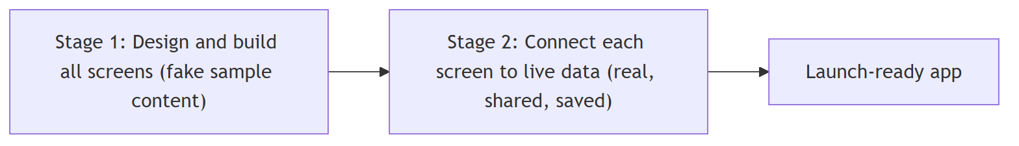
Where we are right now: Stage 2 is 50% complete (3 of 6 areas live). The three that are live are the core of the everyday experience: your profile, finding events, and chatting.

2. What the app actually is
Think of The Third Space as having two kinds of people:
- Attenders - people who want to find and join events and meet others.
- Hosters - venues or organisers who create and run events.
The app shows each person a different home screen based on who they are.
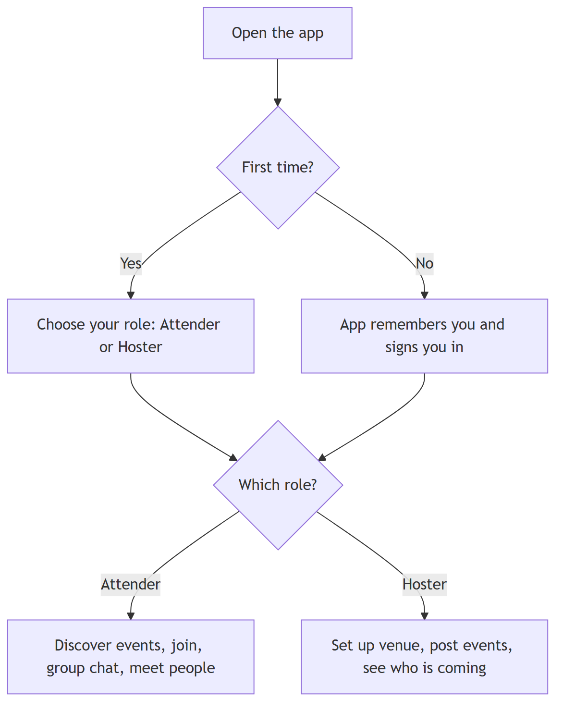

3. How the app works, at a glance
The app on the phone is the part people see and touch. Everything that needs to be saved, shared, or kept in sync between people lives in the cloud (we use Google's Firebase, a trusted, industry-standard service). When one person sends a message or joins an event, the cloud instantly updates what everyone else sees.
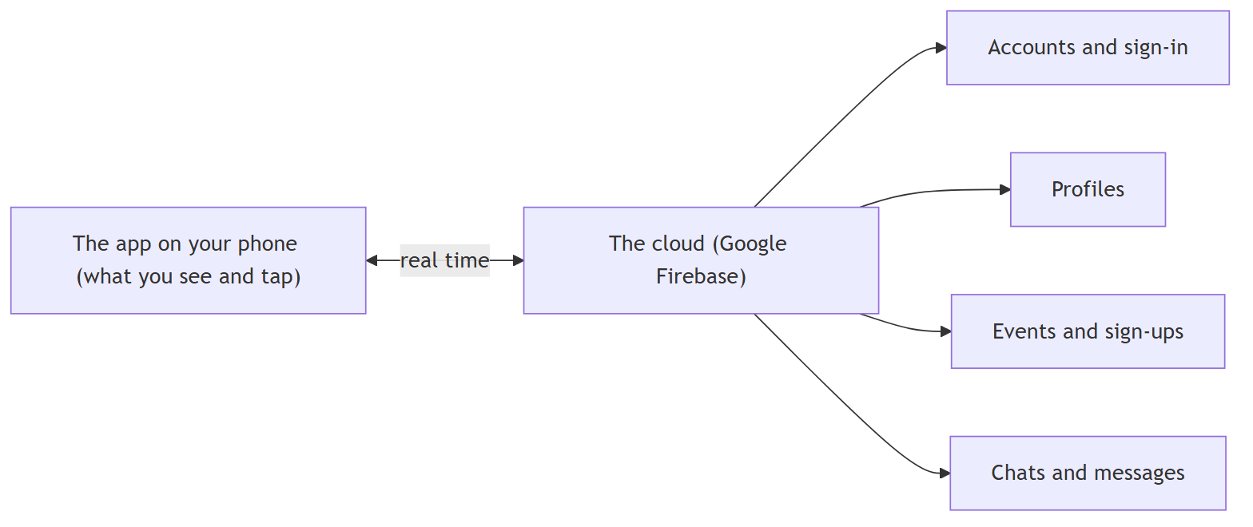
Why real time matters: when a venue posts a new event, or someone replies in a group chat, it shows up for everyone immediately - no refreshing, no waiting.

4. Progress: the six areas of Stage 2
The everyday experience is made of six areas. We are building them one at a time so each is solid before moving on.
# | Area | What it does | Status
A | Profiles & Identity | Who you are: photo, bio, interests, neighbourhood | LIVE
B | Discover & Filters | Finding events: search, categories, filters | LIVE
C | Chat & Messaging | Group chats for events + private messages | LIVE
D | Points & Badges | Rewards for showing up and taking part | Planned
E | Connections | Following and connecting with people you meet | Planned
F | Venue Announcements | Hosters broadcasting updates to attendees | Planned
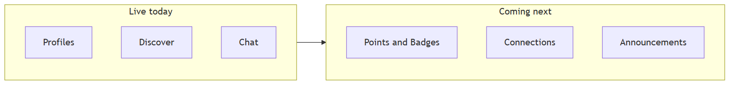
The three live areas are the heart of the app - a person can sign up, build a profile, find an event, join it, and start chatting with the group. That full loop works today.

5. The three areas that are now live

A. Profiles & Identity (Live)
Every member has a real profile: a photo, a short bio, their interests, their neighbourhood, and their age. When you look at someone in an event's guest list or in a chat, you see their real profile, not a placeholder. Profiles update instantly - edit yours and it is reflected everywhere it appears.

B. Discover & Filters (Live)
The Discover screen now shows real, upcoming events as venues post them. People can:
- Search by event name, venue, or neighbourhood.
- Filter by category (Music, Wellness, Food & Drink, etc.), by date (today, this weekend, this week), by neighbourhood, and hide 21+ events.
- See a live count (Show 12 events) that updates as they adjust filters.
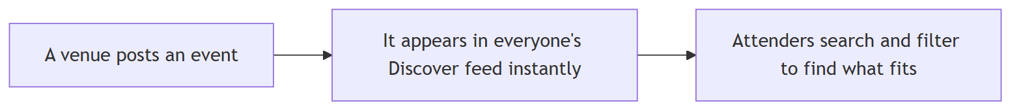

C. Chat & Messaging (just completed)
This area has three parts:
1. Event group chats.
When you register for an event, you are automatically placed in that event's group chat with everyone else who is going (and the host). Cancel your spot and you leave the chat. This is where attendees coordinate before and after.
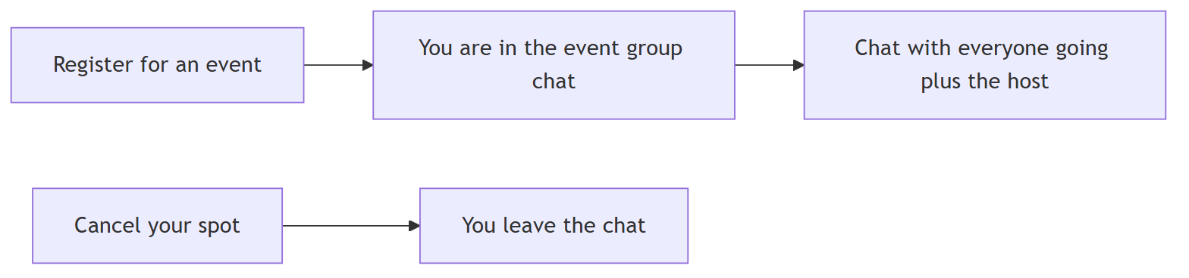
2. Private messages with a polite gate.
You can message another member directly. To protect people from unwanted messages, the first message to someone new lands in their Requests folder rather than their main inbox. They choose what happens next:
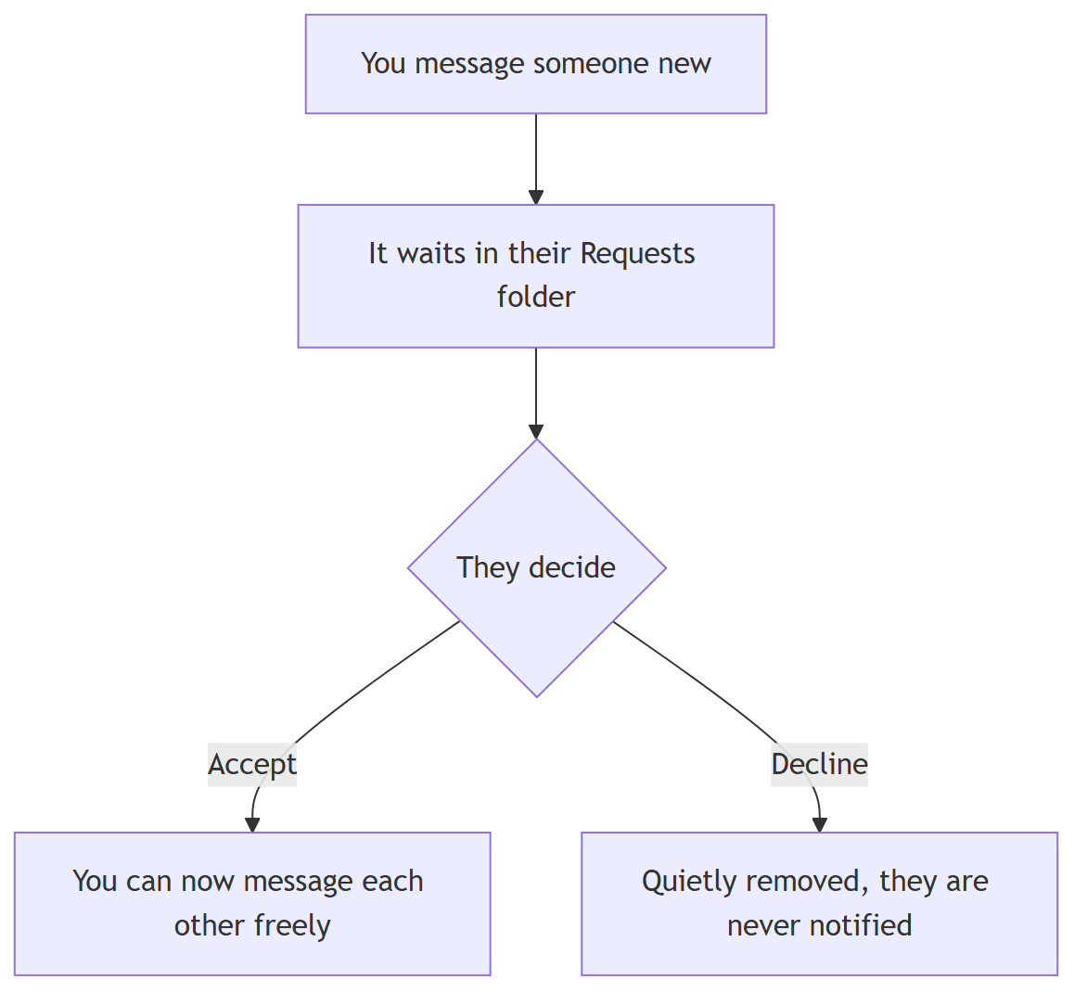
This ask once, then it is open approach keeps the app friendly and safe without being annoying.
3. Unread counts and mute.
Every chat shows an accurate unread badge, and any chat can be muted - exactly what people expect from a messaging experience.

6. A note on safety and privacy
Because chats and profiles involve people's personal interactions, we put rules in the cloud that enforce who can see and do what. In plain terms:
- You can only read an event's group chat if you have actually registered for that event (or you are the host).
- You can only read a private conversation you are part of.
- Only you can edit your own profile and your own read/notification settings.
- A declined message request is silently removed - the sender is never told, which protects the receiver.
These protections are written and in place. They switch on the moment we publish them to the live service (a quick, routine step - see the next section).

7. What is left before this can go live to real users
The code for the three live areas is complete and tested. Two practical, non-coding steps remain before real users can use the chat features on their phones:
1. Publish the cloud safety rules. A routine one-step action that turns on the permissions described in Section 6.
2. Real-device test with two accounts. Confirm two real phones can message each other, join an event group, and that requests, unread badges, and mute all behave correctly. (Automated tests already pass; this is the final human check.)
Neither is a development task - they are standard release steps.

8. What is coming next
The remaining three areas build on the foundation that is now in place:
- Points & Badges (D) - reward members for showing up and participating, to drive repeat engagement.
- Connections (E) - let people follow and stay connected with those they meet, turning one-off meetups into a real network.
- Venue Announcements (F) - let hosts broadcast updates to everyone attending their events.
Each will be designed, built, and connected to live data the same careful way - one solid area at a time.

9. Plain-language glossary
Term | What it means
Live data | Real information that is saved and shared between people, instead of fake sample content.
The cloud / Firebase | Google's trusted online service where accounts, profiles, events, and messages are stored and kept in sync.
Real time | Updates appear for everyone instantly, with no refreshing.
Attender / Hoster | The two roles: people who join events vs. venues that run them.
Request gate | The first-message-waits-in-Requests-until-accepted safety feature for private messages.
Cloud safety rules | The cloud-side guardrails that enforce who can read and write what.

This report reflects the state of the feature/role-dashboards branch as of 28 June 2026: Stage 2 areas A, B, and C complete; areas D, E, and F planned.

