**1. db.Products.find()**

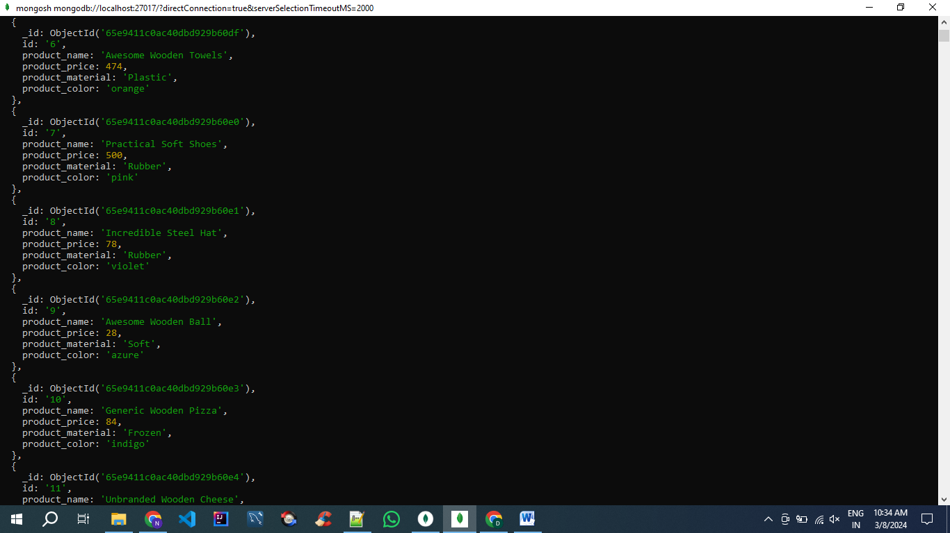

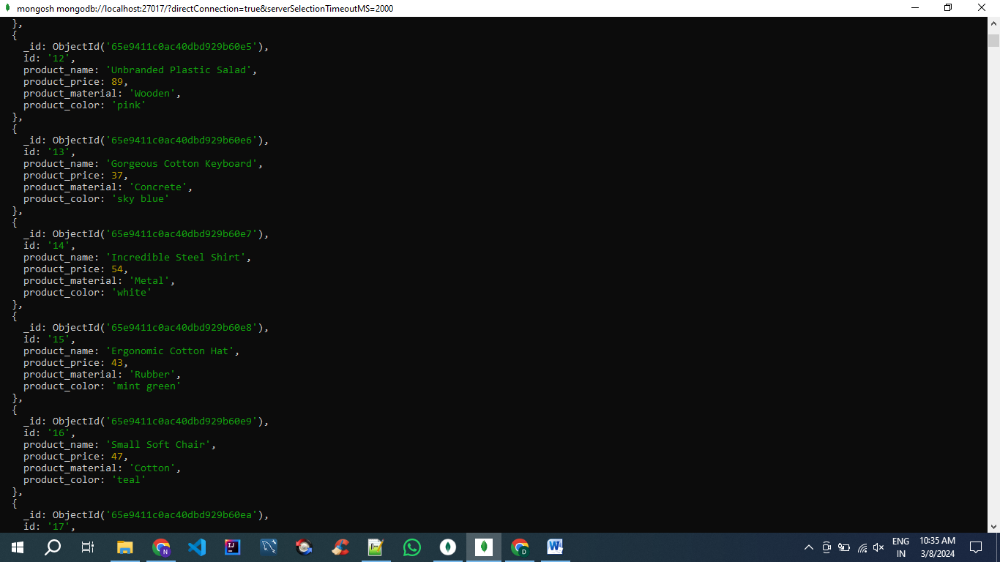

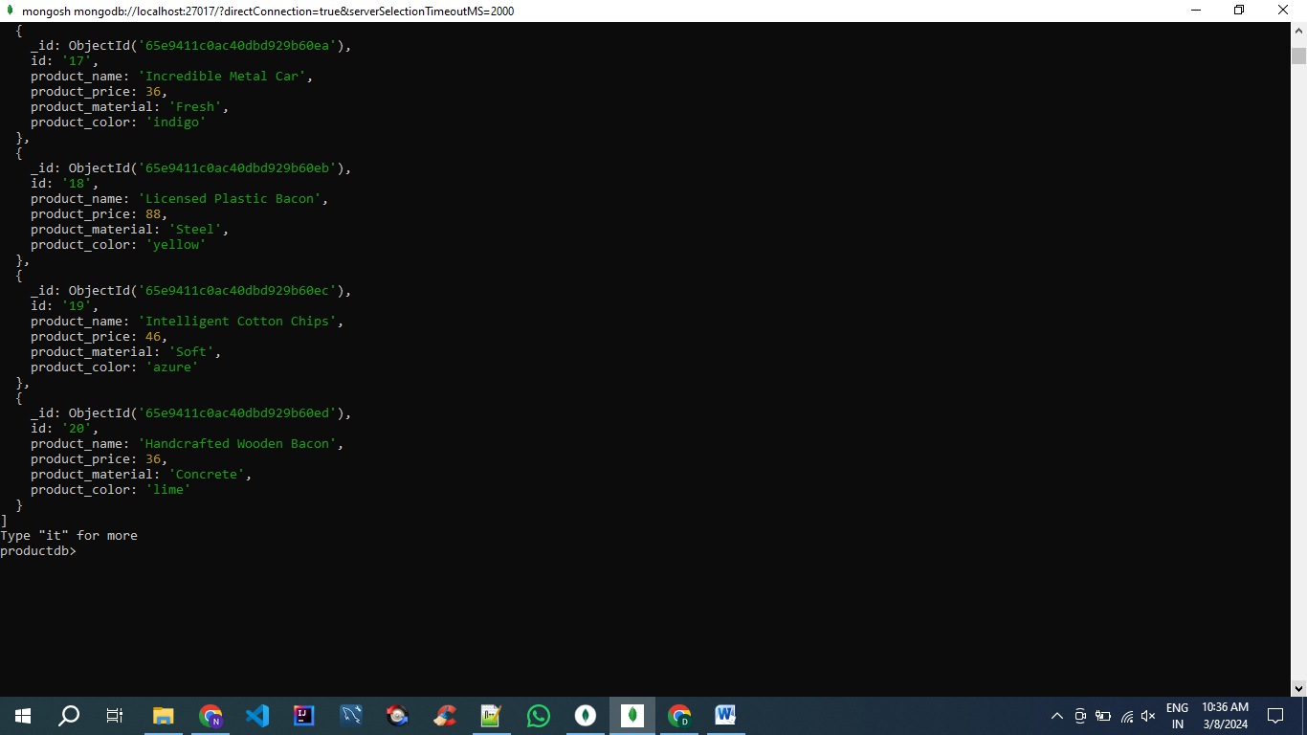

**2. db.Products.find({product_price :{$gte:400, $lte:800}})**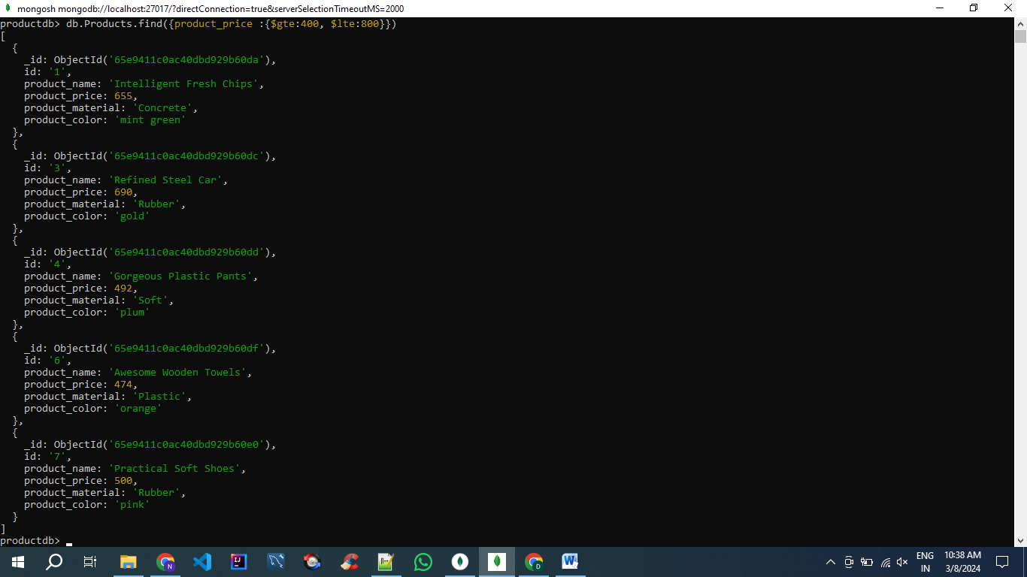

**3. db.Products.find({$or: [{product_price: {$lte:400}}, {product_price:{$gte:600}}]})**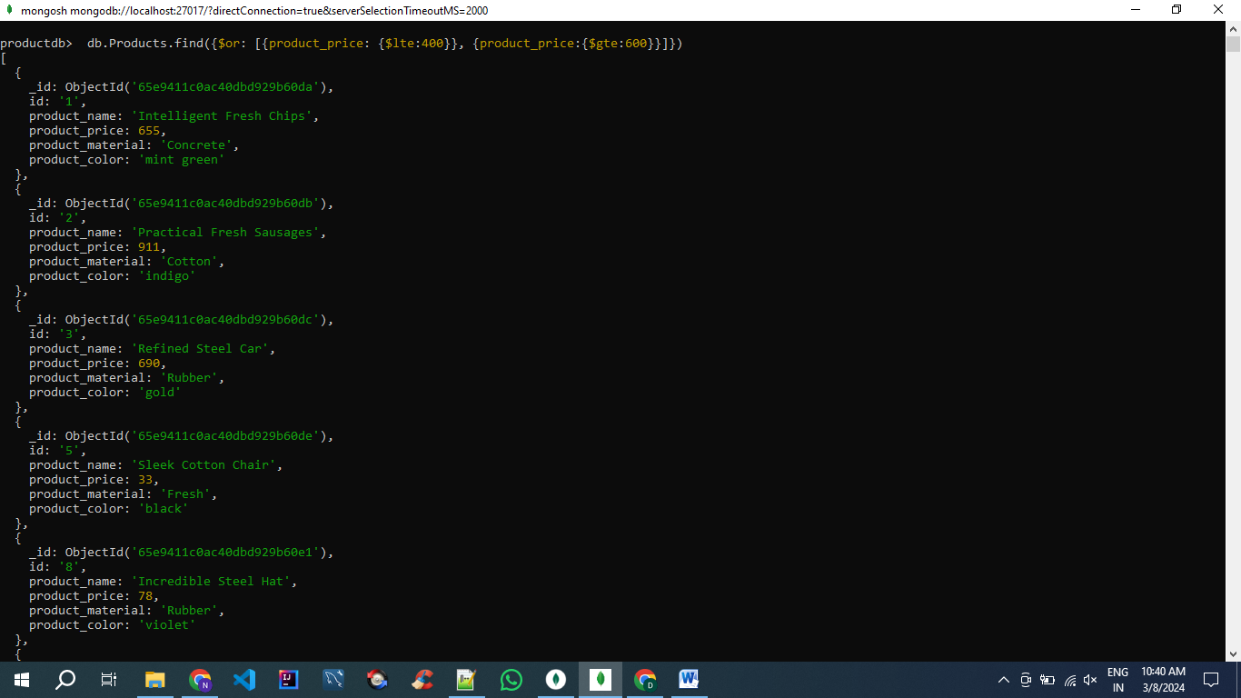

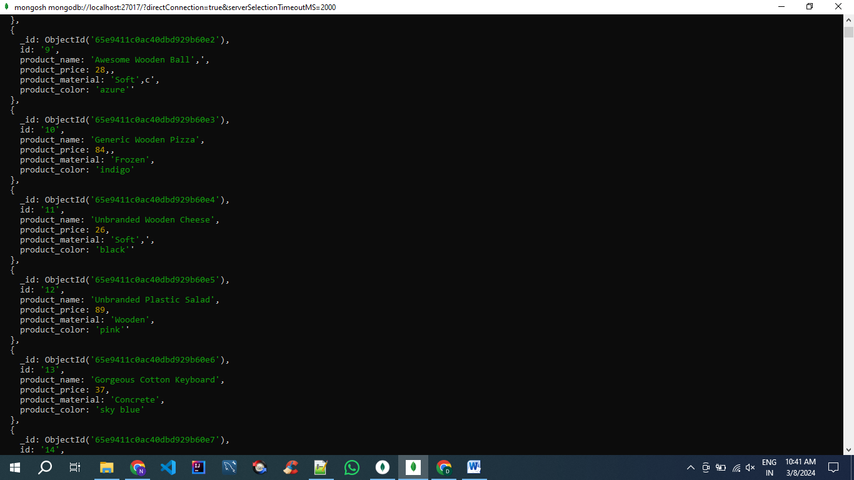

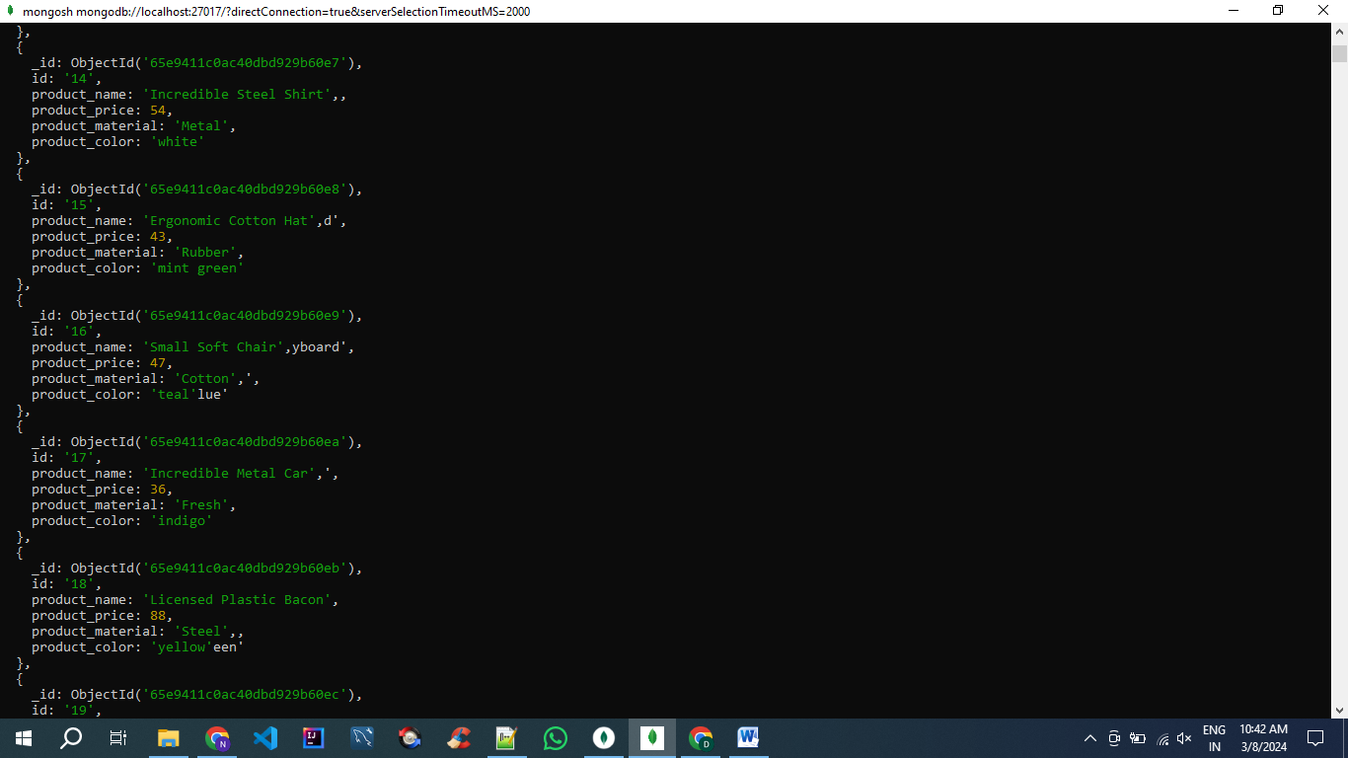

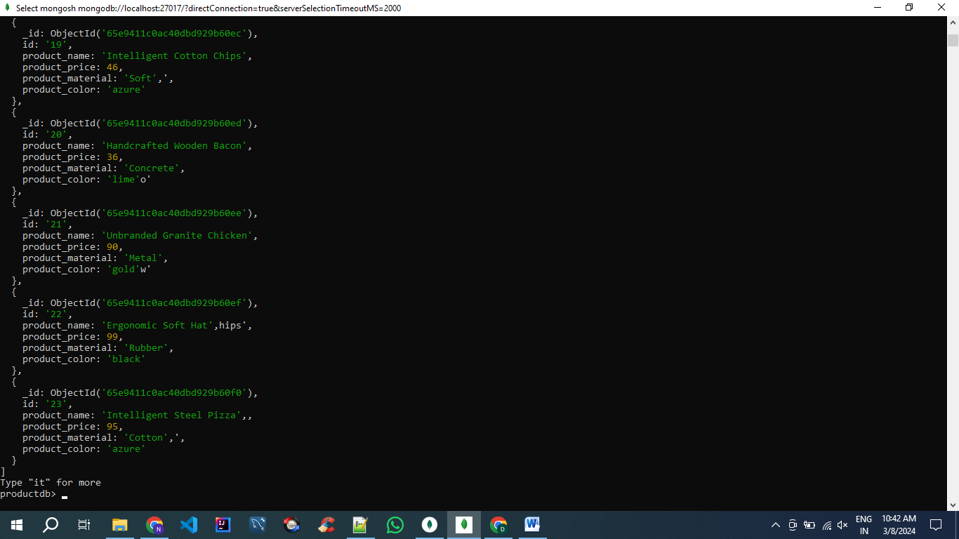

**4. db.Products.find({product_price:{$gt:500}})**

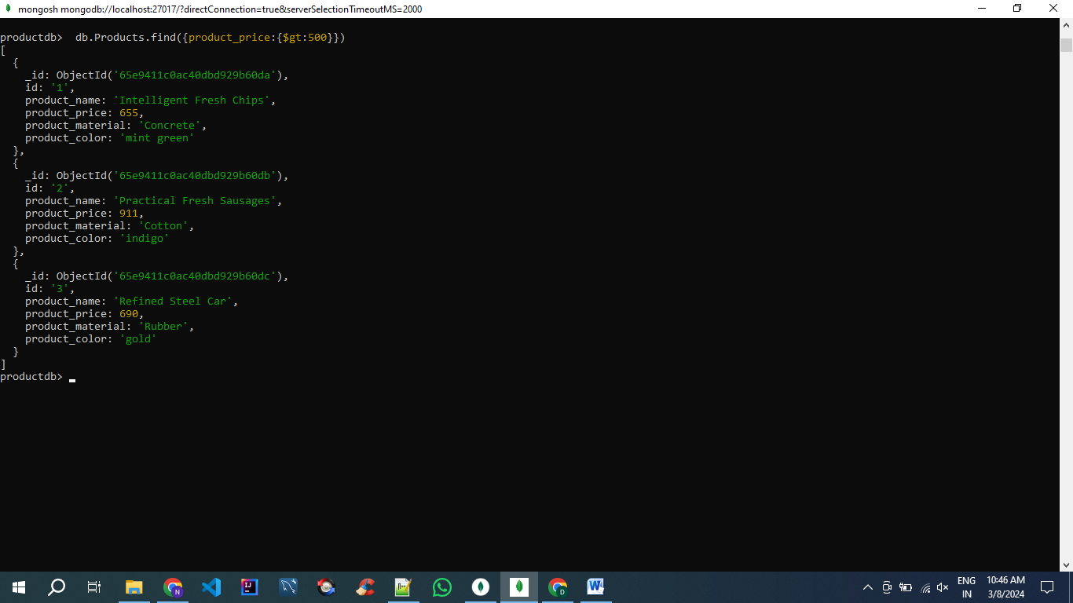

**5. db.Products.find({}, { product_name: 1, product_material: 1})**

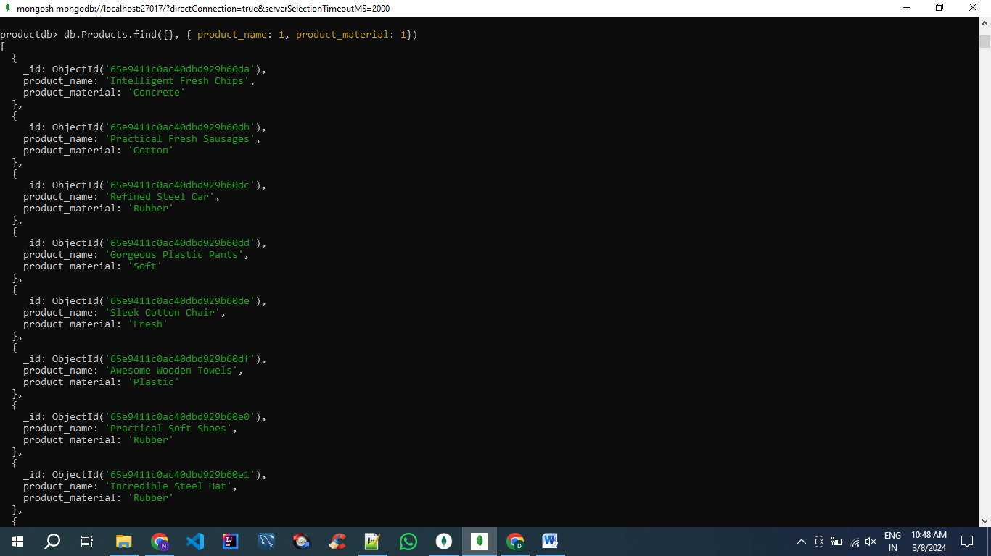

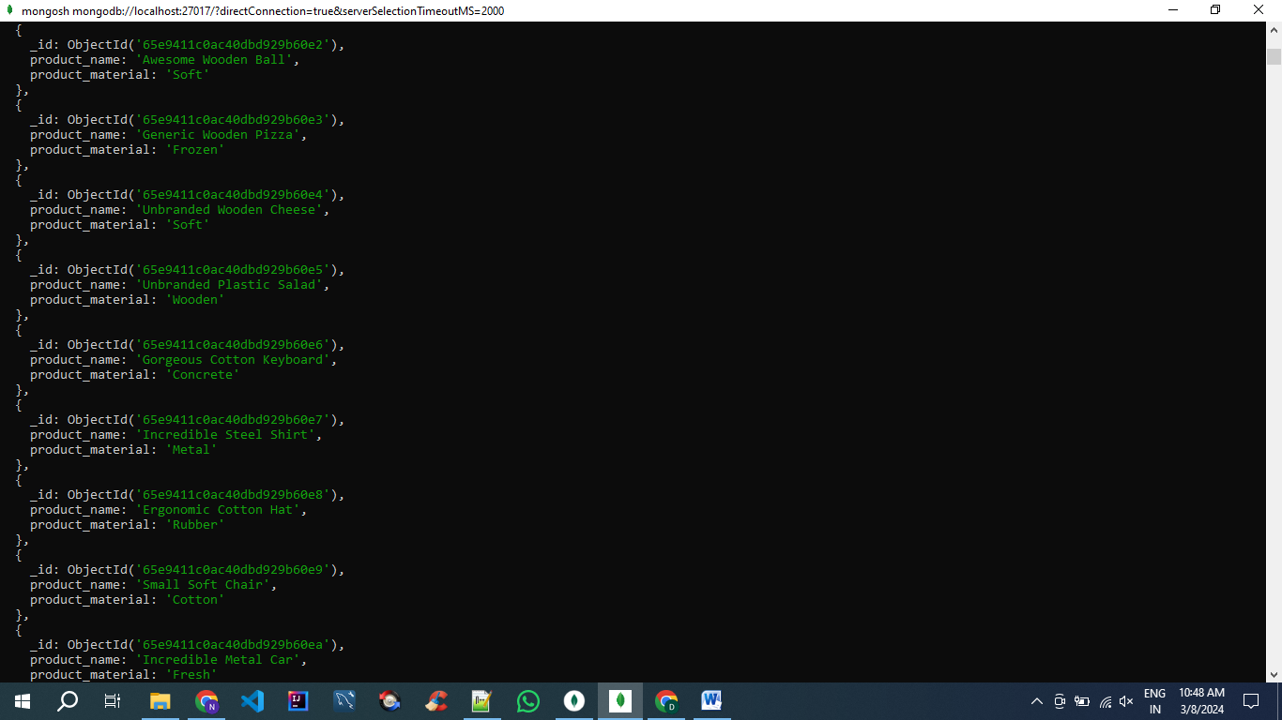



**6. db.Products.find({id: {$eq:"10"}})**

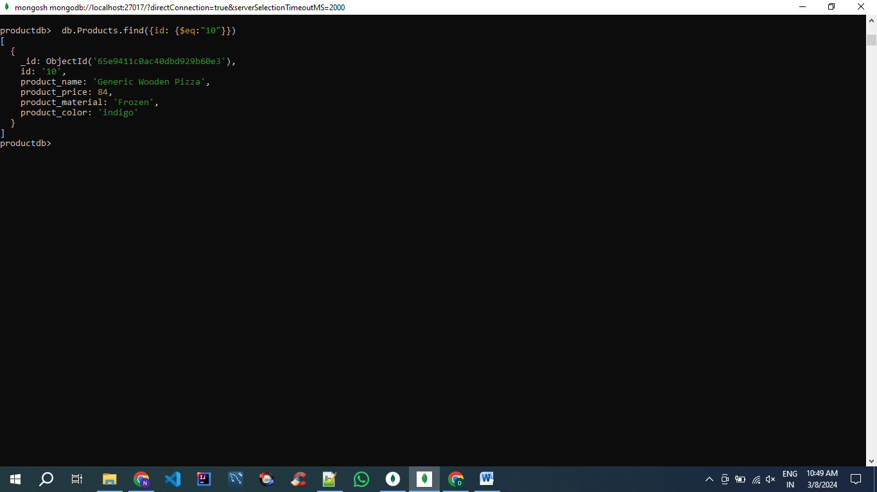

**7. db.Products.find({}, { product_name: 1, product_material: 1})**







**8.** **db.Products.find({product_material:{$eq:"Soft"}})**

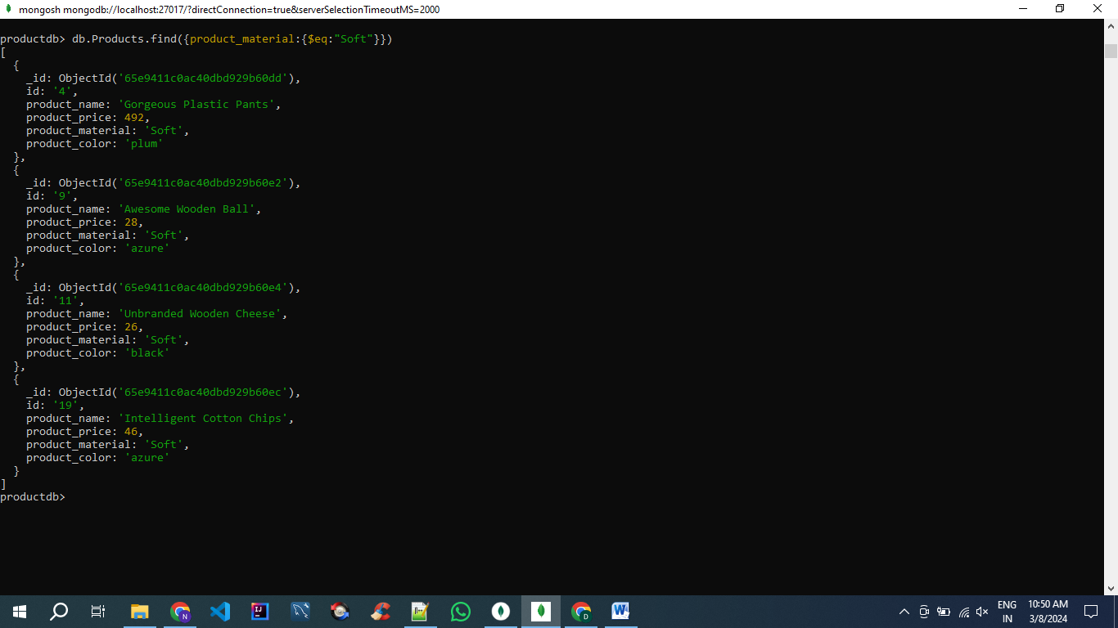

**9.** **db.Products.find({$or:[{product_color:{$eq:"indigo"}},{product_price: {$eq:492}}]})**

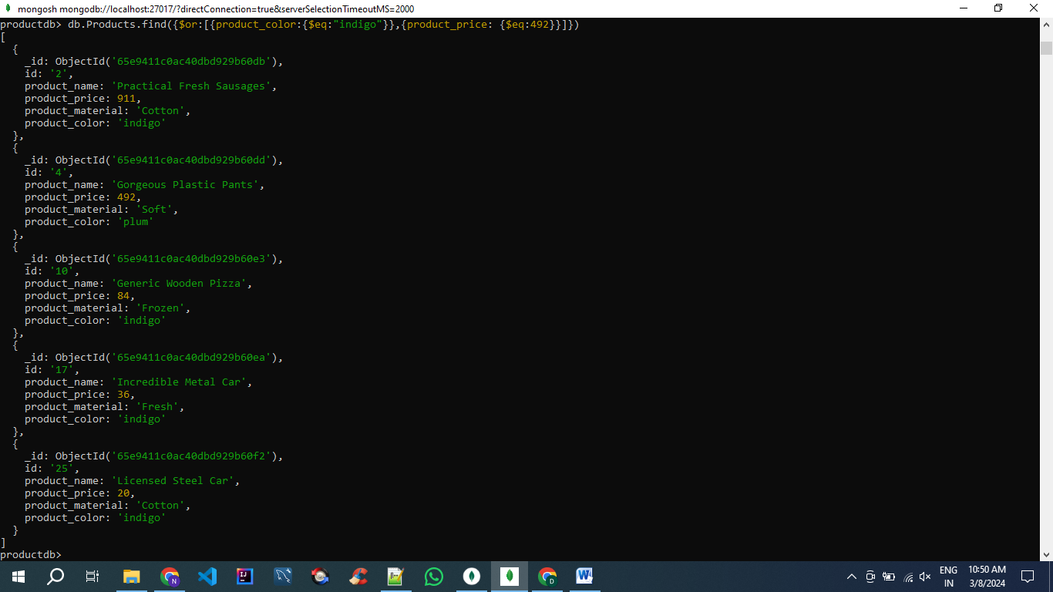

**10.** **db.Products.aggregate([{$group: {_id: "$product_price",count: { $sum: 1 },ids: { $push: "$_id" }}},{$match: {count: { $gt: 1 }}}]).forEach(function(duplicate) {var duplicateIds = duplicate.ids.slice(1);db.Products.deleteMany({ _id: { $in: duplicateIds } });});**

