| Name: | Deepika Trivedi |
| --- | --- |
| UID: | 2021700069 |
| Experiment: | 2 |

Dataset used: Argentina.csv

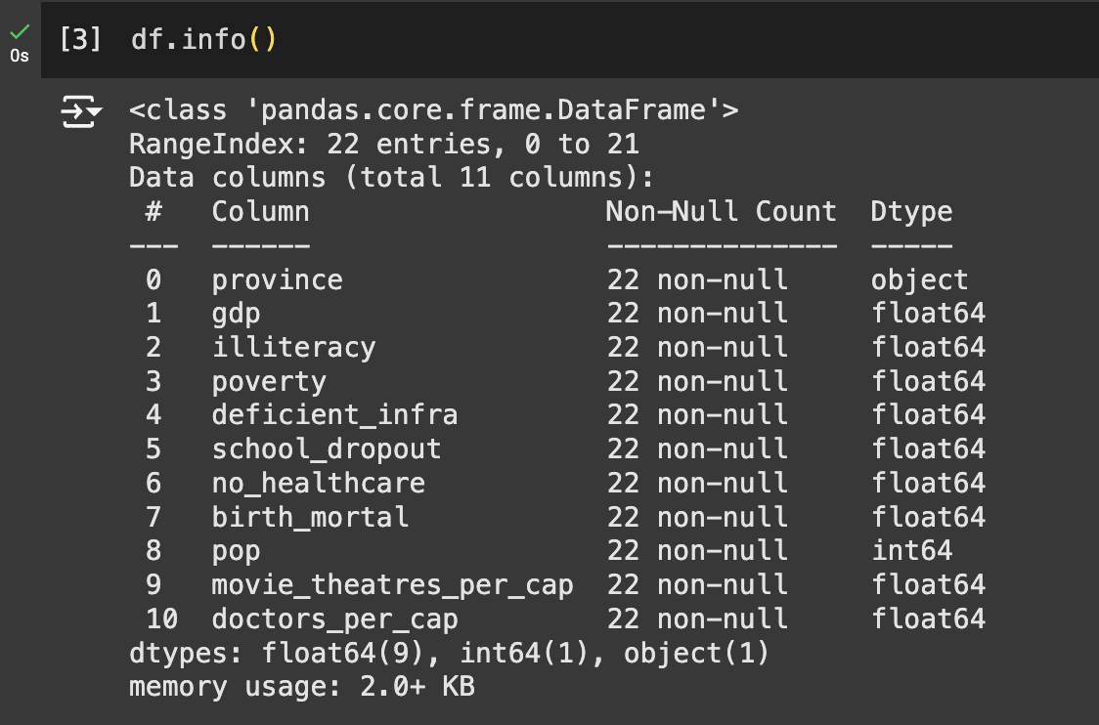

**Graphs made:**

1. **Word Cloud:** A word cloud can be used on the province column to show the distribution of provinces.

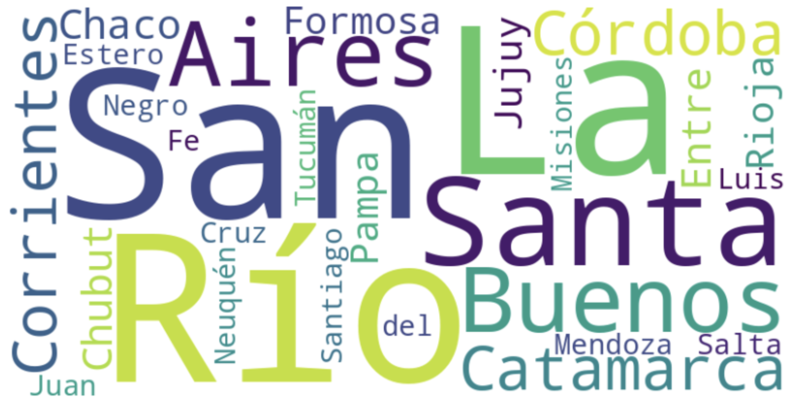

**Observation**: The most frequently occurring province names appear larger in the word cloud. This indicates the presence of a higher number of data points or records associated with these provinces. Provinces that are mentioned less frequently appear smaller.

1. **Box and Whisker Plot:** We'll visualize the distribution of gdp for different provinces.(GDP Distribution by Province).

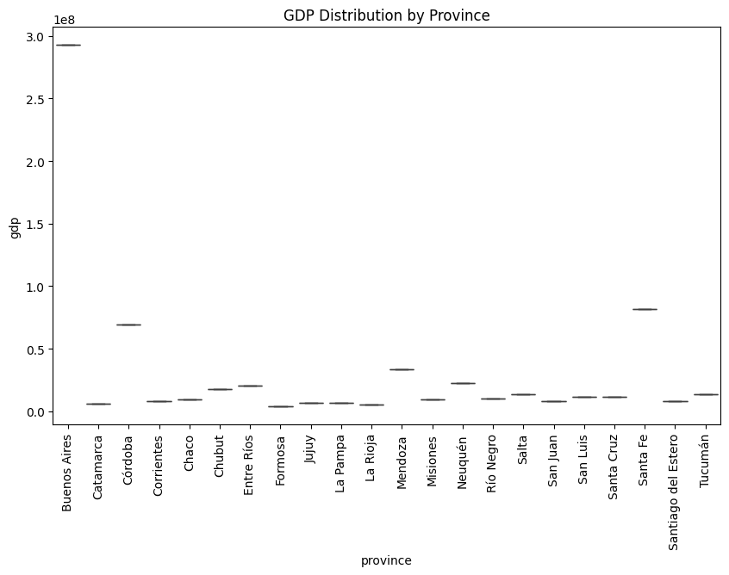

**Observation**: The GDP distribution varies significantly across provinces, with some regions showing much higher GDP values (outliers) compared to others. Provinces with a wider interquartile range have more variation in their GDP values, while others are more consistent. This suggests disparities in economic conditions across regions.

1. **Violin Plot:** We'll plot the distribution of school_dropout rates across provinces.(School Dropout Rate Distribution by Province).

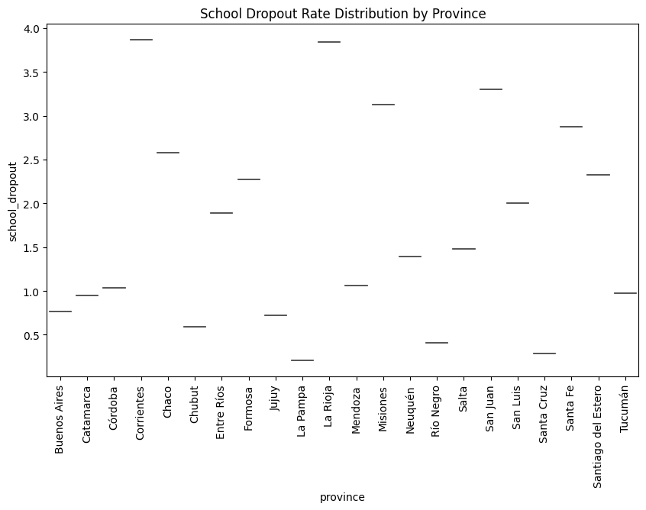

**Observation**: The school dropout rates show a skewed distribution in certain provinces, with some regions having higher dropout rates concentrated towards one end. The wider sections of the violin plot indicate where dropout rates are most prevalent, suggesting some provinces have a more severe issue with education retention.

1. **Regression Plot (Linear and NonLinear):** We'll create a linear regression plot and a polynomial (non-linear) regression plot between gdp and poverty.(GDP vs Poverty).

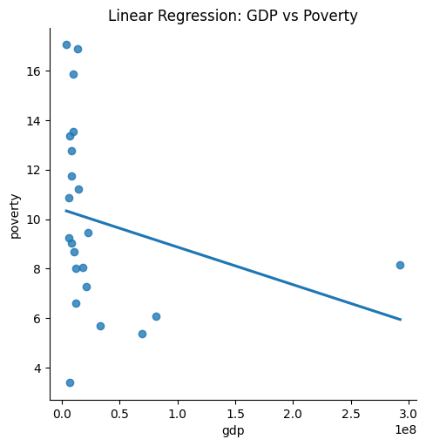

**Linear Regression**: **Observation**: There is a negative correlation between GDP and poverty rates, indicating that as GDP increases, poverty levels tend to decrease. However, there are a few outliers where provinces with higher GDP still have relatively high poverty rates.

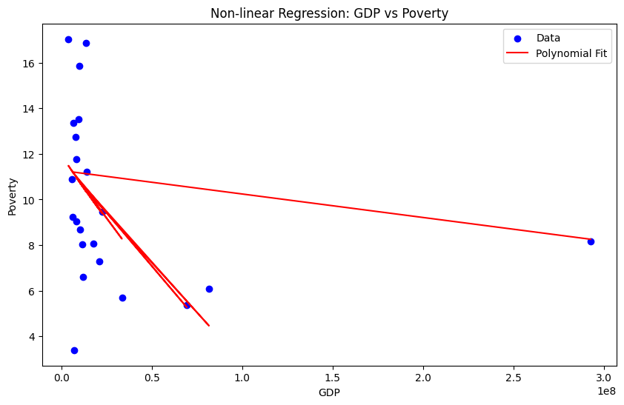

**Non-linear (Polynomial) Regression**: **Observation**: The non-linear regression line better fits the data, showing that the relationship between GDP and poverty is not strictly linear. In some provinces, poverty rates decline sharply with a modest increase in GDP, while in others, the reduction is more gradual.

1. **3D Scatterplot (GDP, Poverty, Doctors per Capita):**A 3D scatter plot to visualize gdp, poverty, and doctors_per_cap.

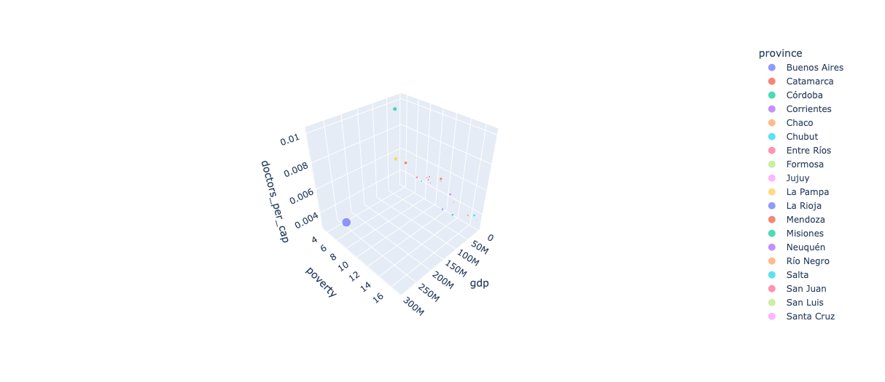

**Observation**: There is a noticeable clustering pattern where provinces with higher GDP also tend to have more doctors per capita and lower poverty rates. However, some provinces with moderate GDP levels have varying levels of healthcare access and poverty rates, indicating other influencing factors.

1. **Jitter Plot (Birth Mortality by Province):**We'll use a jitter plot to show the distribution of birth_mortal.

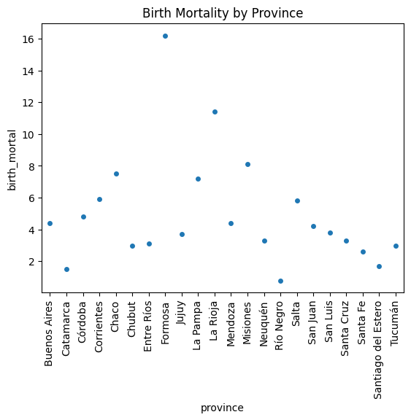

**Observation**: The distribution of birth mortality rates shows considerable variation across provinces. Some regions have consistently high or low mortality rates, while others show a wider spread, indicating inconsistencies in healthcare quality and access.

1. **Line Plot(Illiteracy rate by Province):** We can visualize the trend of illiteracy over provinces.

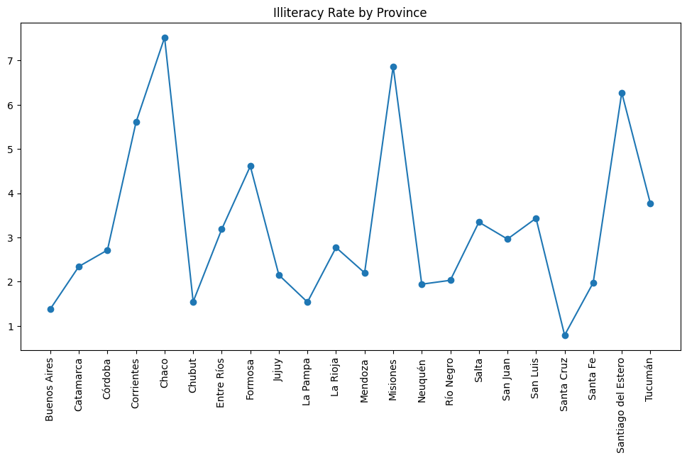

**Observation**: The illiteracy rate fluctuates significantly between provinces. Some regions show spikes, indicating higher levels of illiteracy, which might correlate with factors such as lack of educational facilities or socio-economic barriers. Other provinces maintain a relatively low and stable illiteracy rate.

1. **Area Plot(No healthcare rate by Province):** An area plot for the no_healthcare rate across provinces.

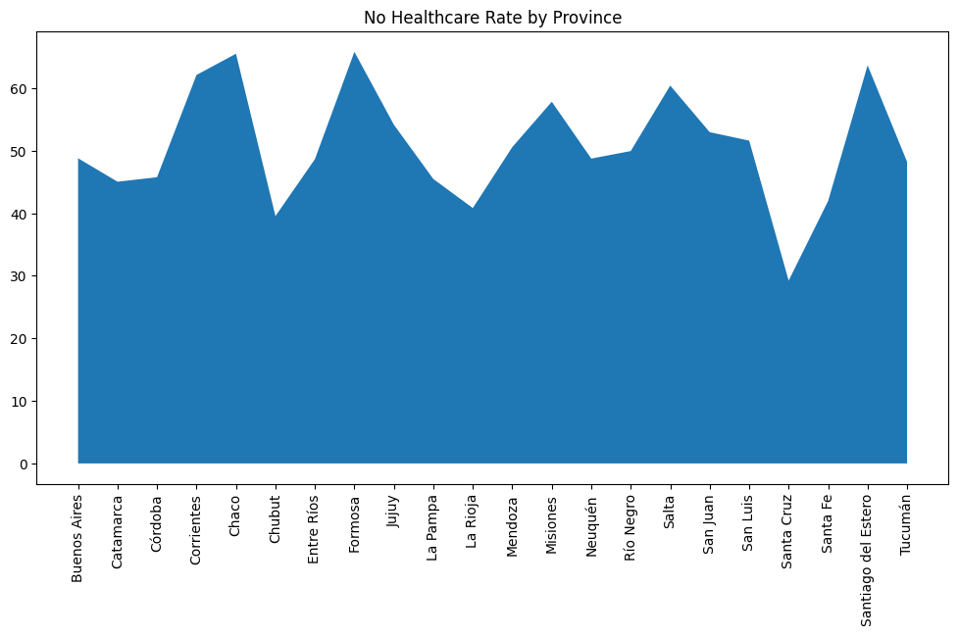

**Observation**: The area plot highlights provinces with high rates of lack of healthcare access. Provinces with larger areas under the curve indicate higher proportions of the population without healthcare services. This could point to disparities in healthcare infrastructure and accessibility.

1. **Donut Chart(Population Distribution by Province):**We'll visualize the distribution of population by province.

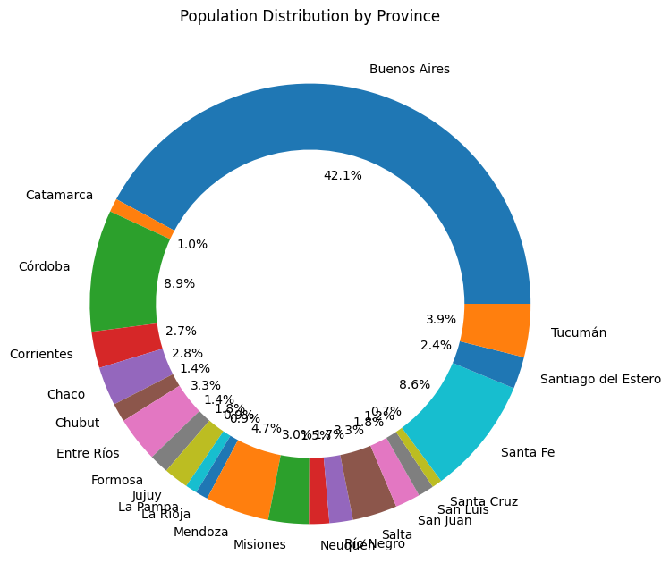

**Observation**: The population distribution is not uniform across provinces. A few provinces have a significantly larger population share, dominating the chart. This suggests that resources and policies targeted at densely populated provinces could have a greater impact on overall socio-economic outcomes.

1. **Treemap(GDP by Province):**We'll use a treemap to visualize the distribution of gdp by province.

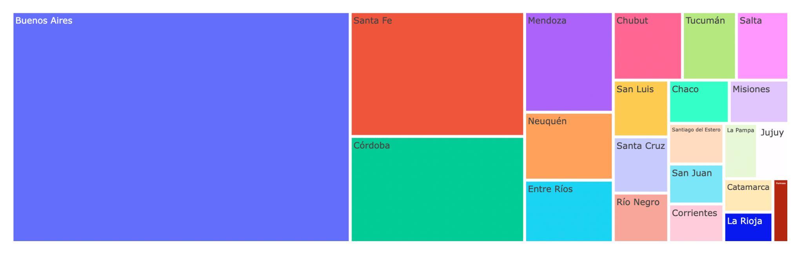

**Observation**: The treemap shows a few provinces contributing significantly to the overall GDP, with the rest having comparatively smaller contributions. The size of each section indicates that economic activity is concentrated in a few key regions, which could imply the need for policies to promote economic growth in underperforming areas.

1. Funnel Plot (School Dropout Rate by Province): We'll visualize the school_dropout rates as a funnel.

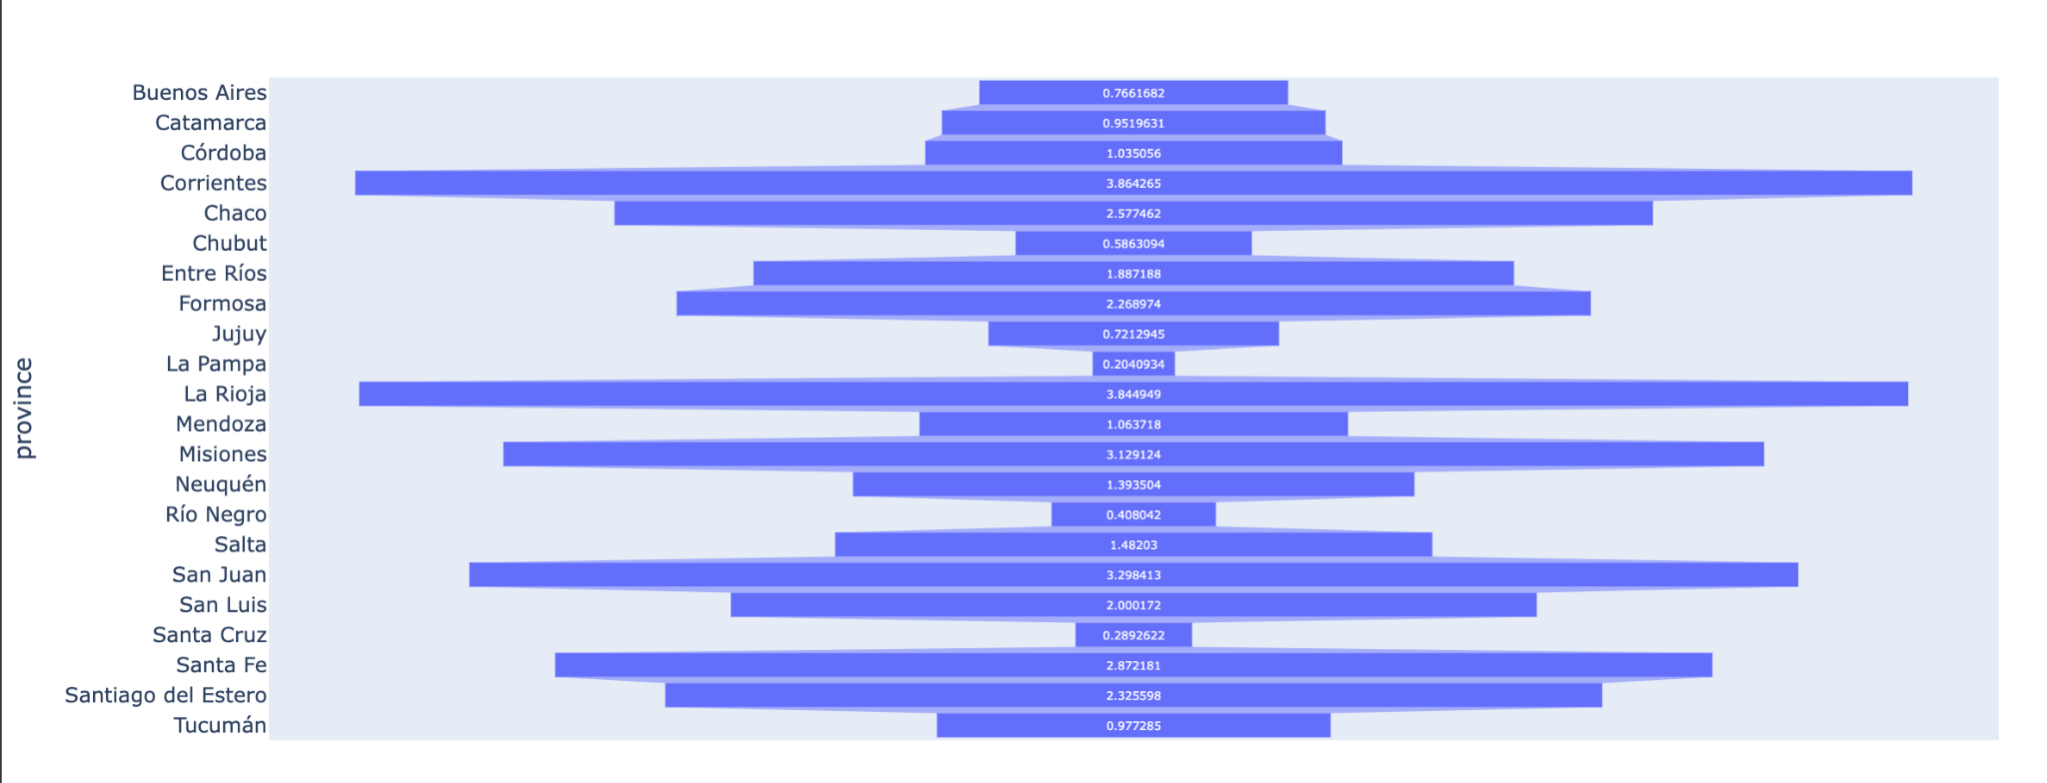

**Observation**: The funnel chart shows that a few provinces have significantly higher school dropout rates, with a gradual decrease as we move to provinces with lower dropout rates. This suggests that targeted interventions may be needed in regions with the highest dropout rates to improve educational outcomes.