| Name: | Deepika Trivedi |
| --- | --- |
| UID: | 2021700069 |
| Experiment No: | 4 |

1. **Bar Chart (Top 10 States by Stolen Property Cases)**:

* Shows which states have the highest number of property crime cases
* Helps identify crime hotspots in the country
* Useful for resource allocation and policy planning

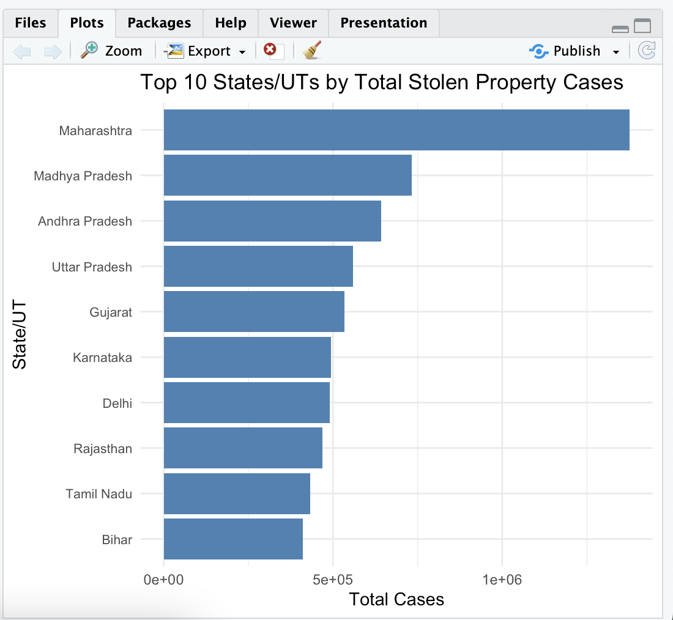

1. **Pie Chart (Distribution by Crime Type)**:

* Visualizes the proportion of different types of property crimes
* Helps understand which types of property crimes are most common
* Useful for law enforcement strategy development

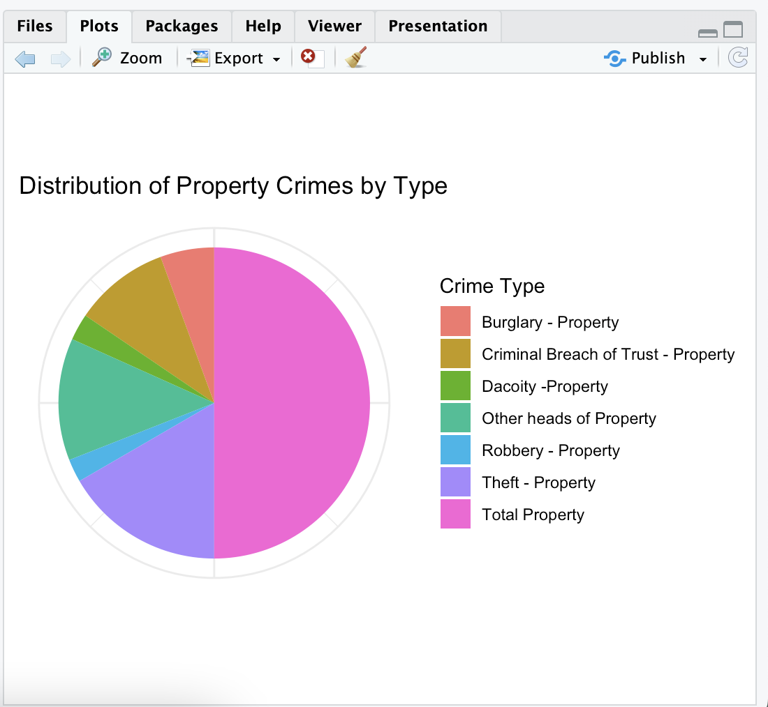

1. **Histogram (Distribution of Property Value Stolen)**:

* Shows the distribution pattern of stolen property values
* Reveals whether most crimes involve small or large property values
* Uses log scale due to wide range of values

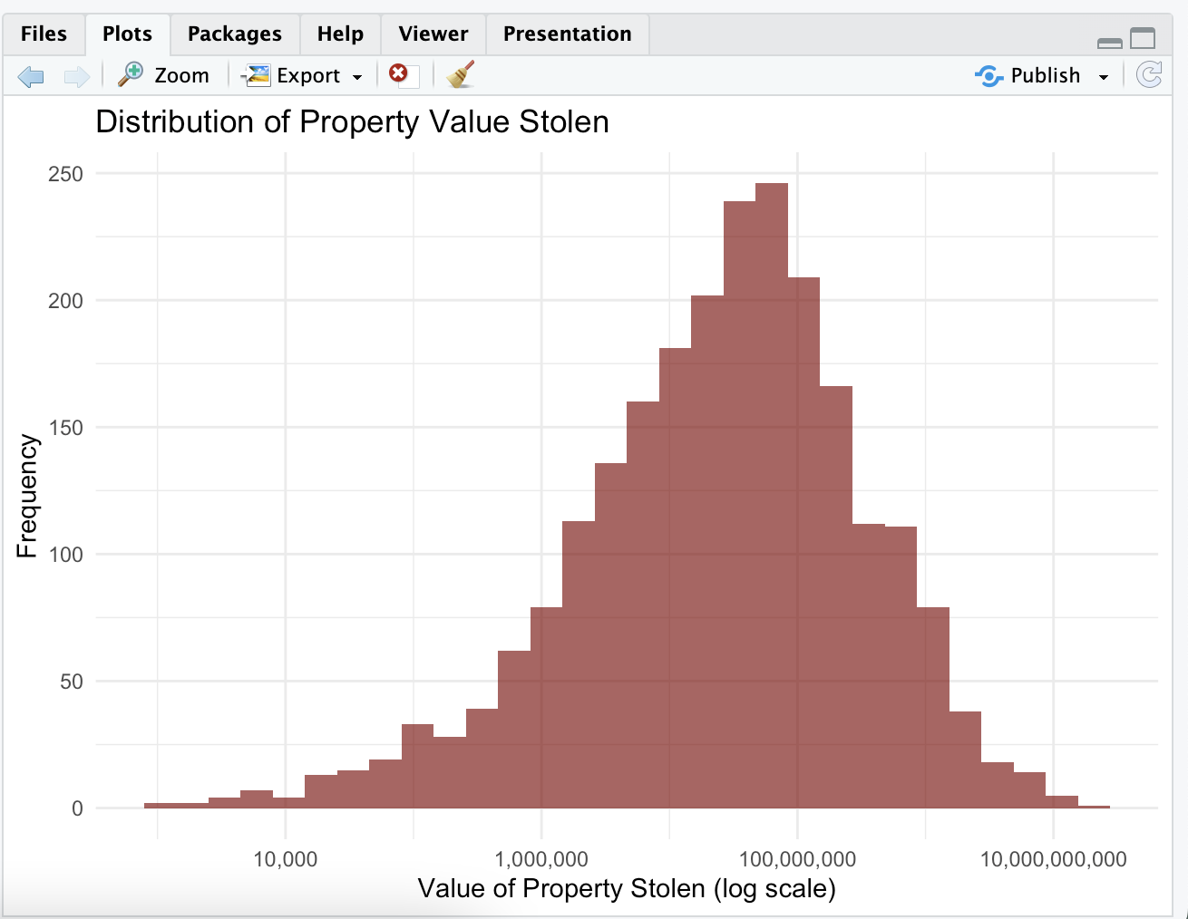

1. **Timeline Chart (Trend Over Years)**:

* Displays temporal trends in property crime cases
* Helps identify seasonal patterns or long-term trends
* Useful for predicting future crime rates

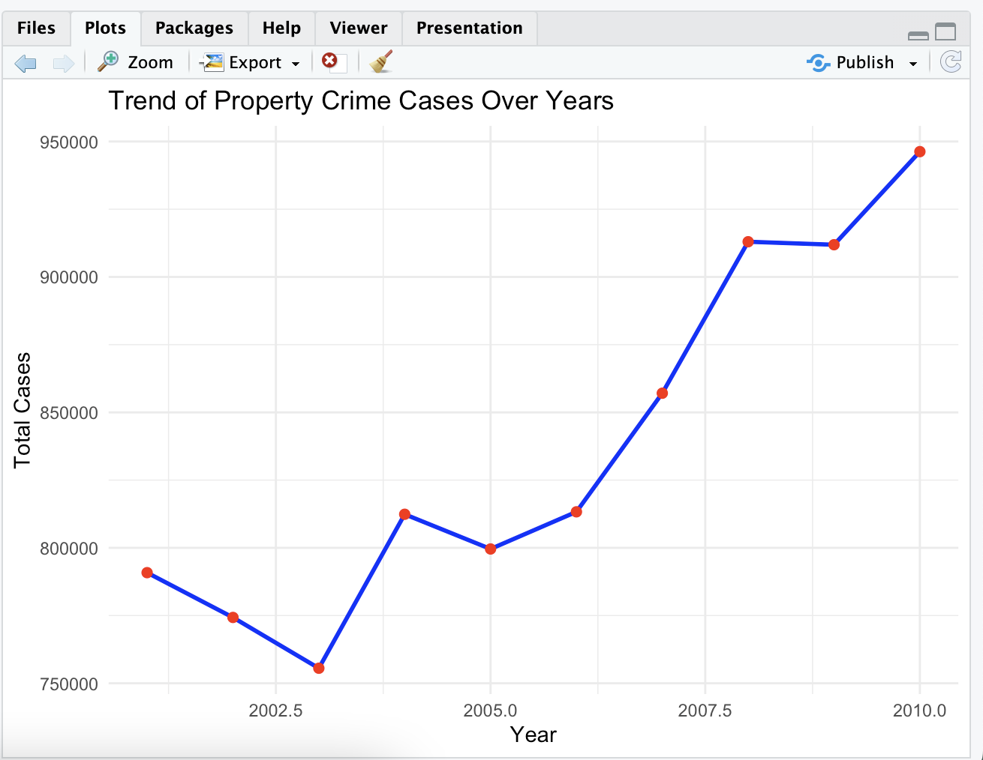

1. **Scatter Plot (Stolen vs Recovered Cases)**:

* Shows the relationship between stolen and recovered cases
* Includes a trend line to show correlation
* Helps evaluate law enforcement effectiveness

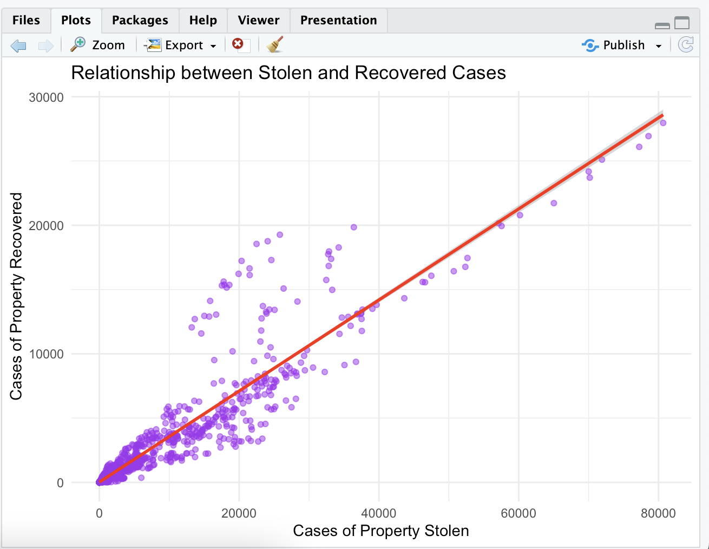

1. **Bubble Plot (Cases, Value, Recovery Rate)**:

* Three-dimensional view combining multiple metrics
* Size of bubbles represents recovery rate
* Helps identify states with both high crime rates and poor recovery rates

