| Name: | Deepika Trivedi |
| --- | --- |
| UID: | 2021700069 |
| Experiment Number: | 6 |

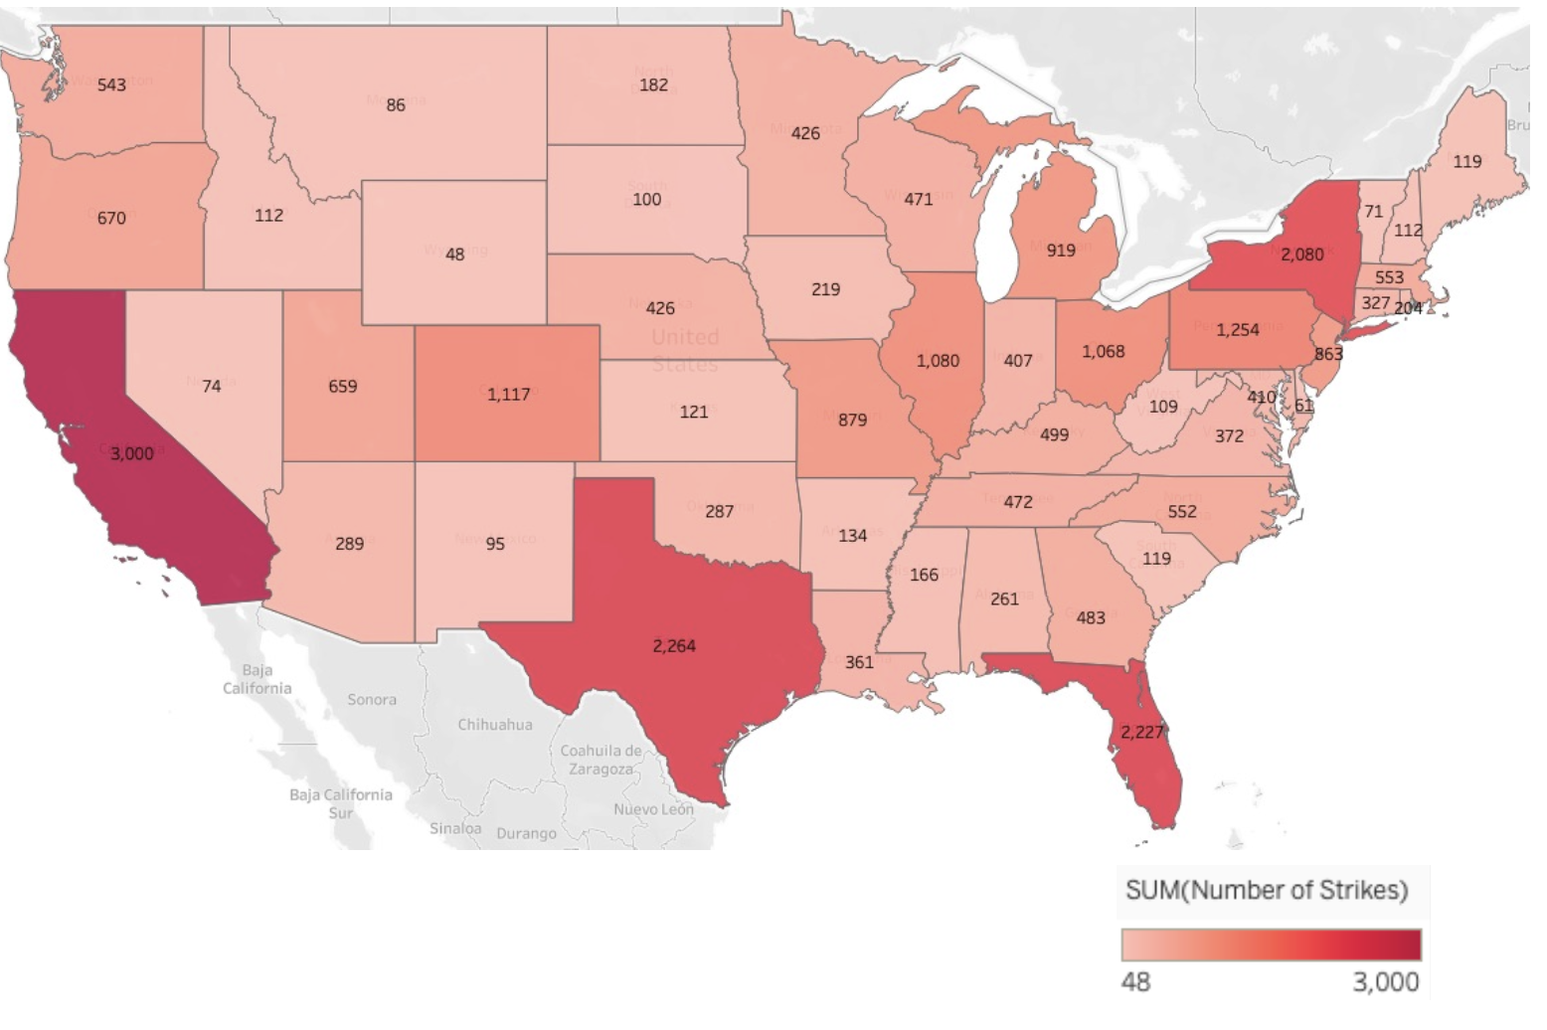

The states with higher wildlife strikes are:

1. California
2. Texas
3. Florida
4. New York

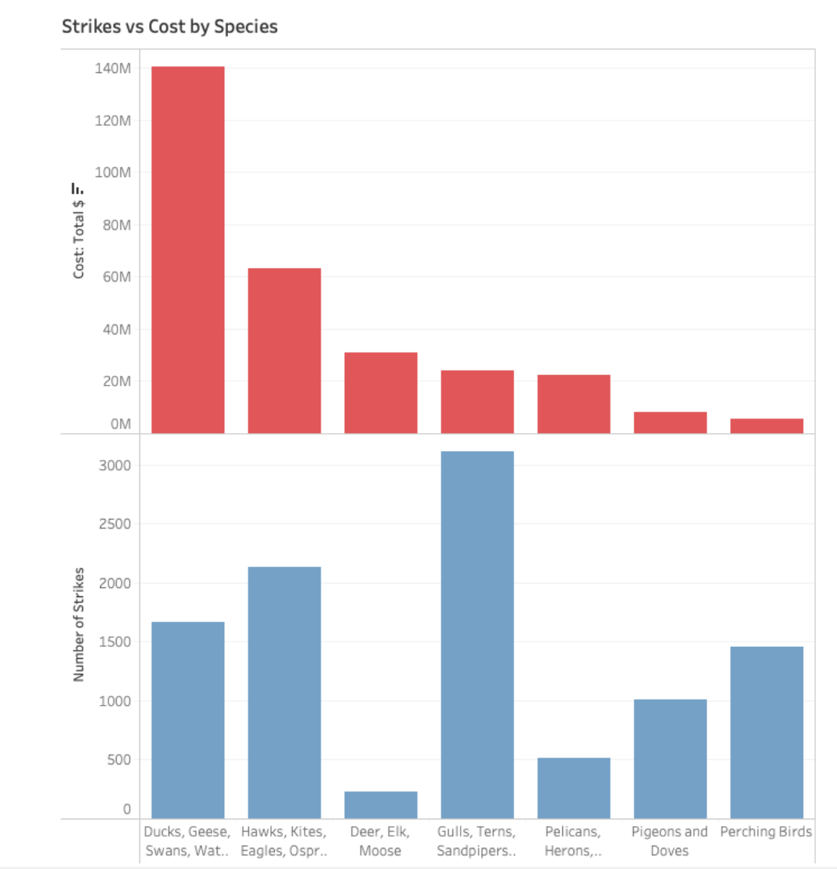

Most affected animal species and cost:

Interestingly, most strikes occur with the Gulls, Terns and Sandpipers species family, but they are the fourth in cost.

The most expensive incidents occur with the Geese, Ducks and Swans species family.

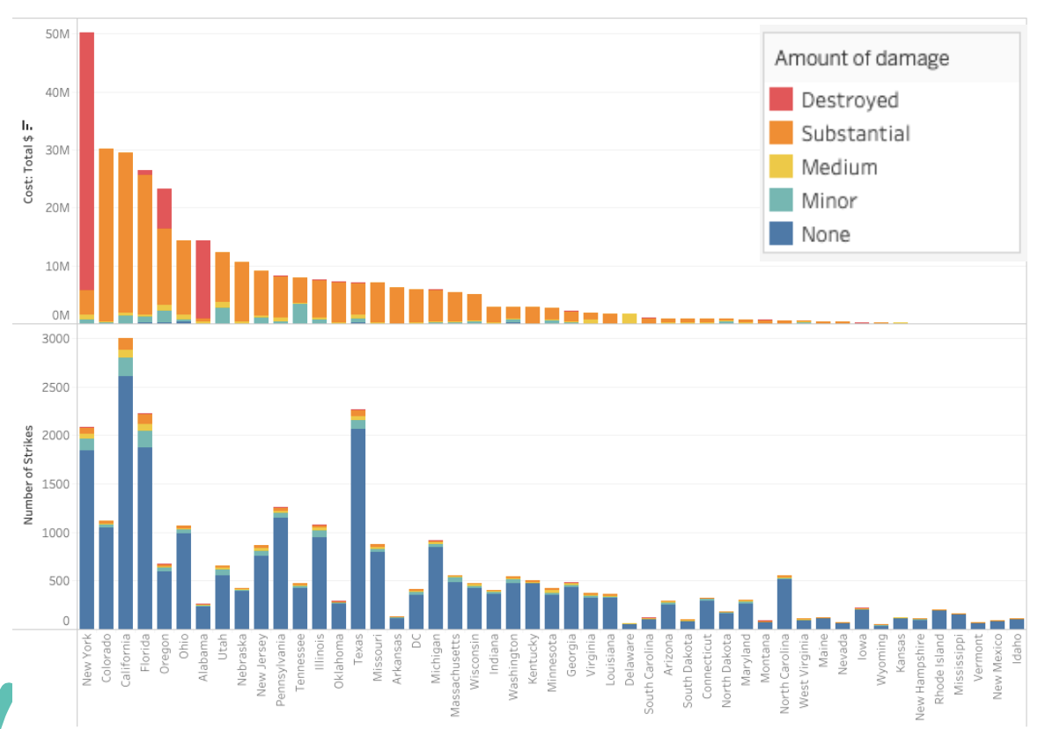

**What is the cost of these strikes by each state?**

The state with the highest number of incidents is California, but it is the third state by cost. This is because the type of damage in most cases with the cost is only substantial.

On the other hand, New York has the most expensive damage due to some incidents that destroyed the aircraft.

Coral Reef Dataset and Visualization:

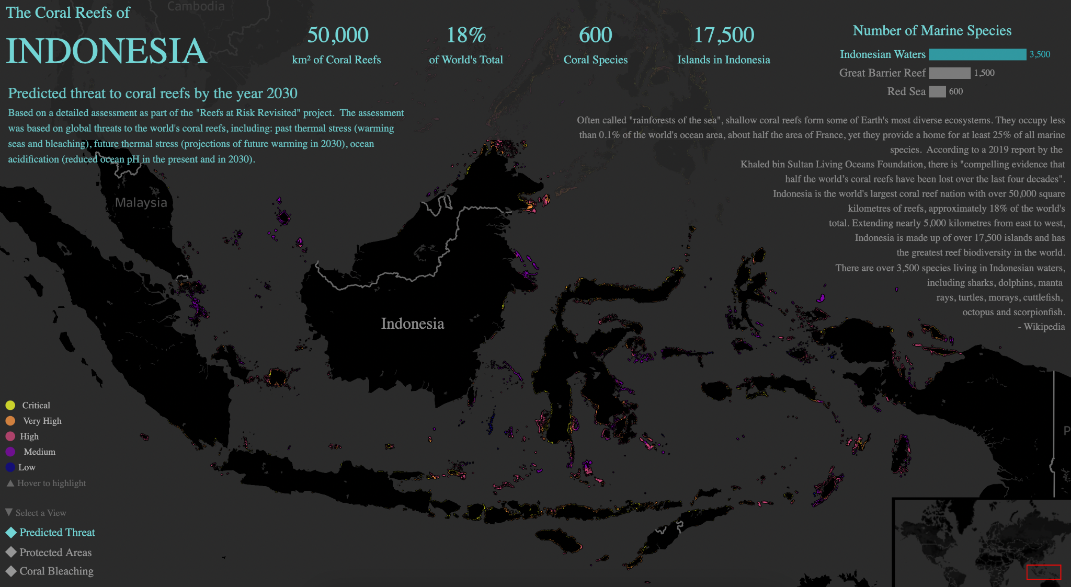

This is a geospatial visualization showing the predicted threat to coral reefs in Indonesia by the year 2030.

The map uses color-coding to indicate the different levels of threat (critical, very high, high, medium, low).

This map likely considers factors like past thermal stress (warming), future thermal stress (projections of future warming), and ocean acidification to assess the predicted threat.

These are numerical statistics presented in a clear, infographic-like manner, providing key facts about Indonesia's coral reefs.

The statistics cover the total area of coral reefs, the percentage of the world's total coral reefs, the number of coral species, and the number of islands in Indonesia.

This information likely comes from various scientific assessments and reports on the state of Indonesia's coral reef ecosystems.

This numerical statistic provides the total number of marine species found in Indonesian waters, the Great Barrier Reef, and the Red Sea.

This information helps put the biodiversity of Indonesia's coral reef ecosystems into a broader global context.