| Name: | Deepika Trivedi |
| --- | --- |
| UID: | 2021700069 |
| Experiment Number: | 7 |

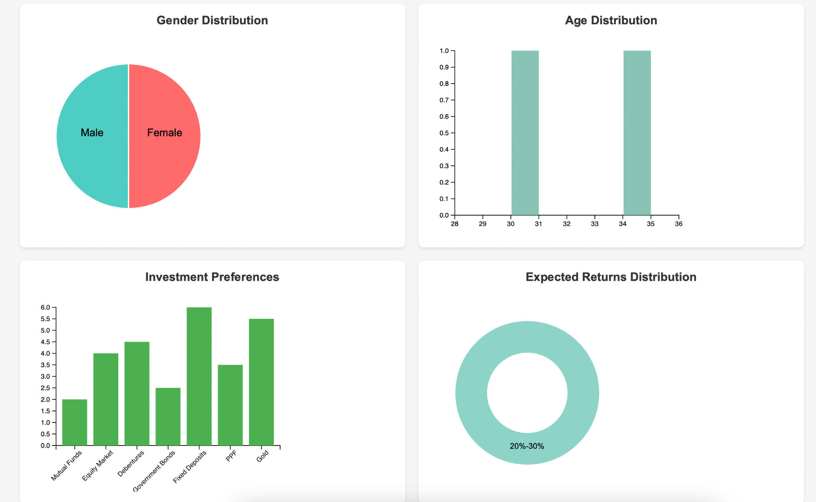

Gender Distribution:

* The gender distribution is approximately 50% male and 50% female.

Age Distribution:

* The age distribution is skewed towards the younger age groups, with the majority of individuals being between 29-34 years old.

Investment Preferences:

* Individuals tend to prefer Mutual Funds and Equity Markets over other investment options like Fixed Deposits, Government Bonds, and PPF.
* The investment preference for Mutual Funds and Equity Markets increases with age, as shown in the "Age vs Investment Preference (Violin Plot)".

Investment Distribution (Box Plot):

* There is a wider distribution of investment amounts in Mutual Funds and Equity Markets compared to other investment options.
* Government Bonds and Fixed Deposits have a relatively lower and more concentrated investment distribution.

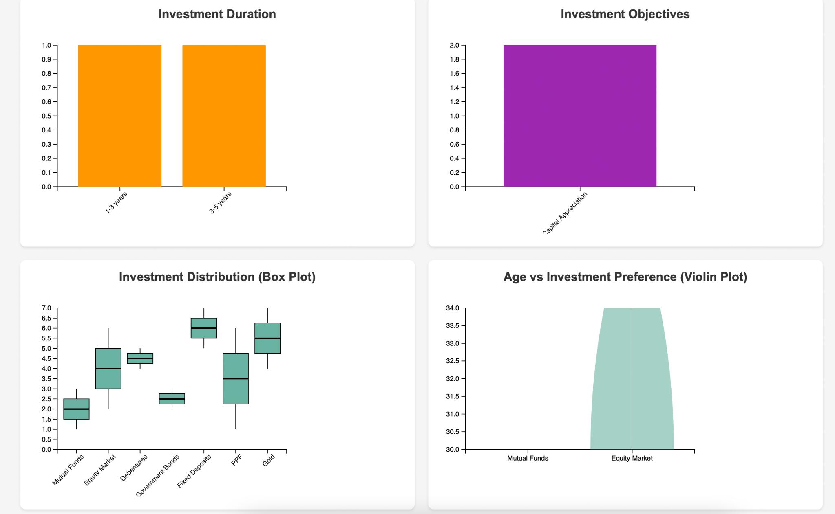

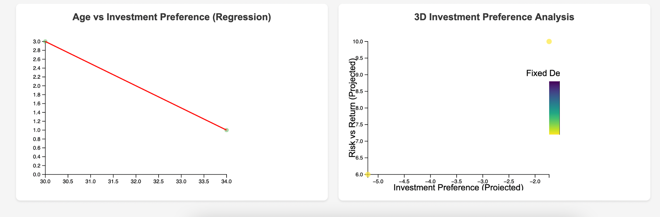

Investment Duration:

* Investments tend to have a shorter duration, with most investments being 1-3 years in duration.

Investment Objectives:

* The primary investment objective is "Capital Appreciation", indicating a focus on growth and returns.

Age vs Investment Preference (Regression):

* As age increases, the preference for investment options like Mutual Funds and Equity Markets increases, while the preference for Fixed Deposits decreases.

3D Investment Preference Analysis:

* The 3D visualization shows that Fixed Deposits have the highest projected risk-return ratio, while Equity Markets have the lowest projected risk-return ratio.