| Name: | Deepika Trivedi |
| --- | --- |
| UID: | 2021700069 |
| Experiment Number: | 8 |

#### **Aim:**

To design interactive dashboards and create visual storytelling using D3.js on a dataset related to Environment/Forest cover, covering basic and advanced charts.

#### **Objectives:**

1. To understand how to use D3.js for data visualization.
2. To implement basic charts like Bar chart, Pie chart, Histogram, Timeline chart, Scatter plot, and Bubble plot.
3. To implement advanced charts like Word chart, Box and whisker plot, Violin plot, Regression plot (linear and nonlinear), 3D chart, and Jitter.
4. To draw observations and insights from each chart.
5. To create an interactive storytelling dashboard using the above visualizations.

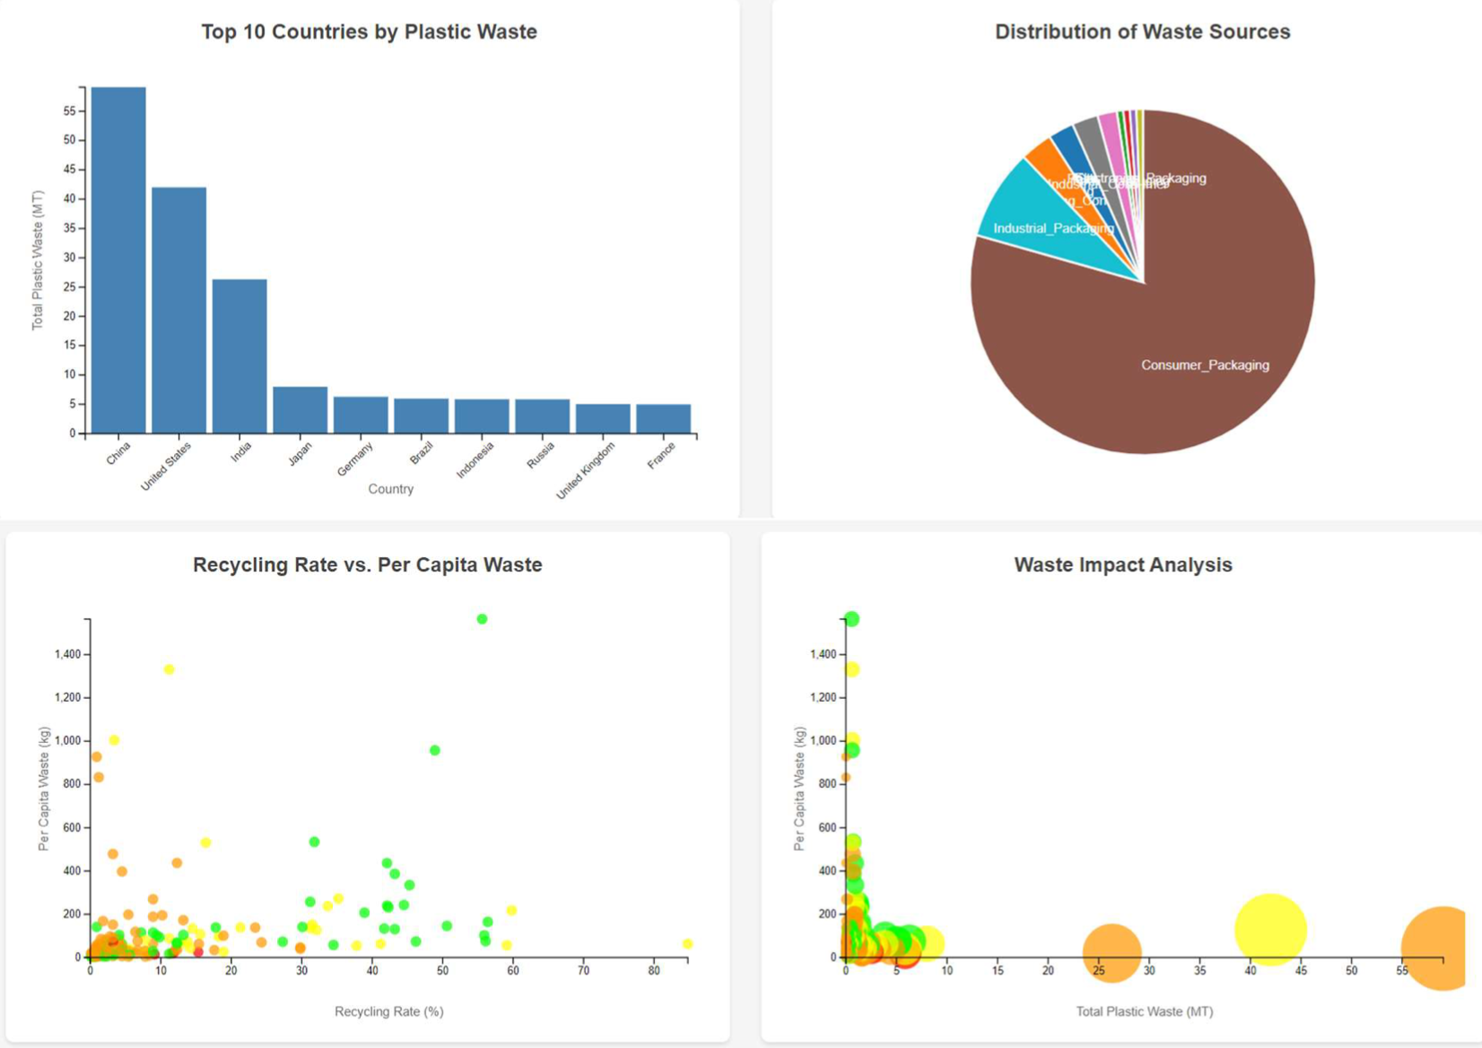

I had taken “Plastic Wastes around the world” as a dataset.

I'll help you analyze each of the four visualizations and draw key conclusions from them:

1. Top 10 Countries by Plastic Waste (Bar Chart):

- China is the largest producer of plastic waste, generating around 55 MT (Million Tonnes)

- The United States is second, producing approximately 40 MT

- India is third with about 25 MT

- There's a significant drop between the top 3 countries and the rest

- The remaining countries (Japan, Germany, Brazil, Indonesia, Russia, UK, France) all produce less than 10 MT each

- The gap between #1 (China) and #10 (France) is roughly 50 MT

2. Distribution of Waste Sources (Pie Chart):

- Consumer packaging dominates the plastic waste sources, representing the majority of the chart

- Industrial packaging is the second largest source

- Other categories appear to make up relatively small portions of the total

- This suggests that targeting consumer packaging habits could have the biggest impact on reducing plastic waste

3. Recycling Rate vs. Per Capita Waste (Scatter Plot):

- Shows a complex relationship between recycling rates and per capita waste

- Some data points show very high per capita waste (>1000 kg) despite varying recycling rates

- Most countries cluster in the lower portion of the graph (below 400 kg per capita)

- Recycling rates vary widely from 0% to about 80%

- There doesn't appear to be a strong correlation between recycling rates and per capita waste

4. Waste Impact Analysis (Bubble Chart):

- Shows the relationship between total plastic waste (x-axis) and per capita waste (y-axis)

- Bubble sizes likely represent another metric (possibly population or economic impact)

- There are some outliers with very high per capita waste

- Most countries cluster on the left side of the chart, indicating that few countries produce extremely large amounts of total waste

- The larger bubbles on the right side likely represent countries with both high total waste and significant economic/population factors

Overall insights:

- There's a significant disparity between the top plastic waste producers and the rest of the world

- Consumer packaging is the primary source of plastic waste

- Higher recycling rates don't necessarily correlate with lower per capita waste

- A few countries dominate global plastic waste production while most countries produce relatively modest amounts