| Name: | Deepika Trivedi |
| --- | --- |
| UID: | 2021700069 |
| Experiment Number: | 9 and 10 |

**Women’s economic empowerment is central to realizing women’s rights and gender equality.** Women’s economic empowerment includes women’s ability to participate equally in existing markets; their access to and control over productive resources, access to decent work, control over their own time, lives and bodies; and increased voice, agency and meaningful participation in economic decision-making at all levels from the household to international institutions.

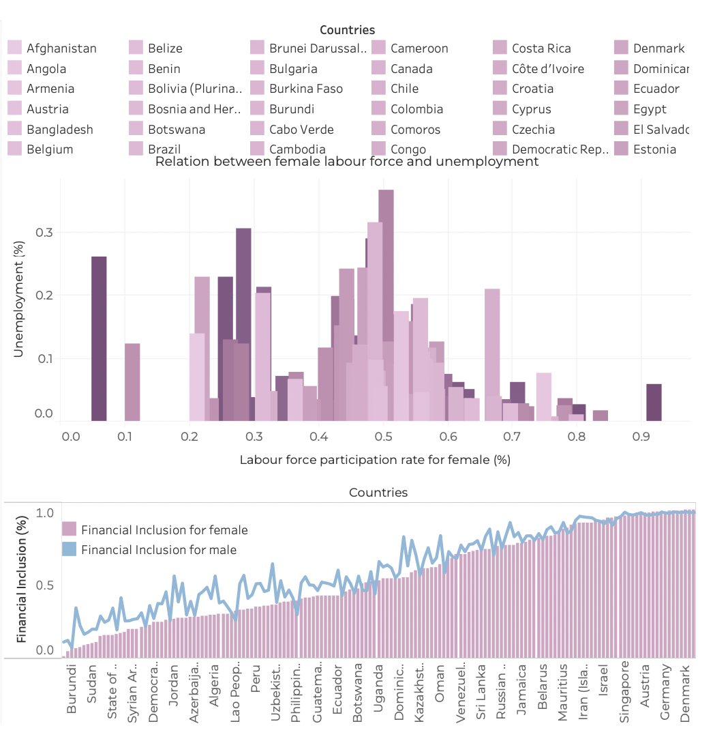

1. Bar Chart:
   * This is a horizontal bar chart showing the "Relation between female labour force and unemployment" for various countries.
   * The y-axis represents the countries, and the x-axis shows the "Labour force participation rate for female (%)" value for each country.
   * The data used to create this bar chart is likely sourced from a dataset containing the female labor force participation rates for these countries.
2. Line Chart:
   * The second part of the visualization is a line chart showing the "Financial Inclusion for female" and "Financial Inclusion for male" over time.
   * The x-axis represents the countries, and the y-axis shows the "Financial Inclusion" values, which range from 0 to 1.
   * This line chart is likely using a dataset that contains financial inclusion data for both males and females across these countries.

The combination of the bar chart and the line chart provides a comprehensive view of the relationship between female labor force participation and financial inclusion for both genders across the countries included in the dataset.

Link: <https://public.tableau.com/authoring/WomenEmpowermentEconomic/Dashboard1#1>  
  
Link: <https://public.tableau.com/authoring/Sportsparticipationwithstateandgender/Dashboard1#1>

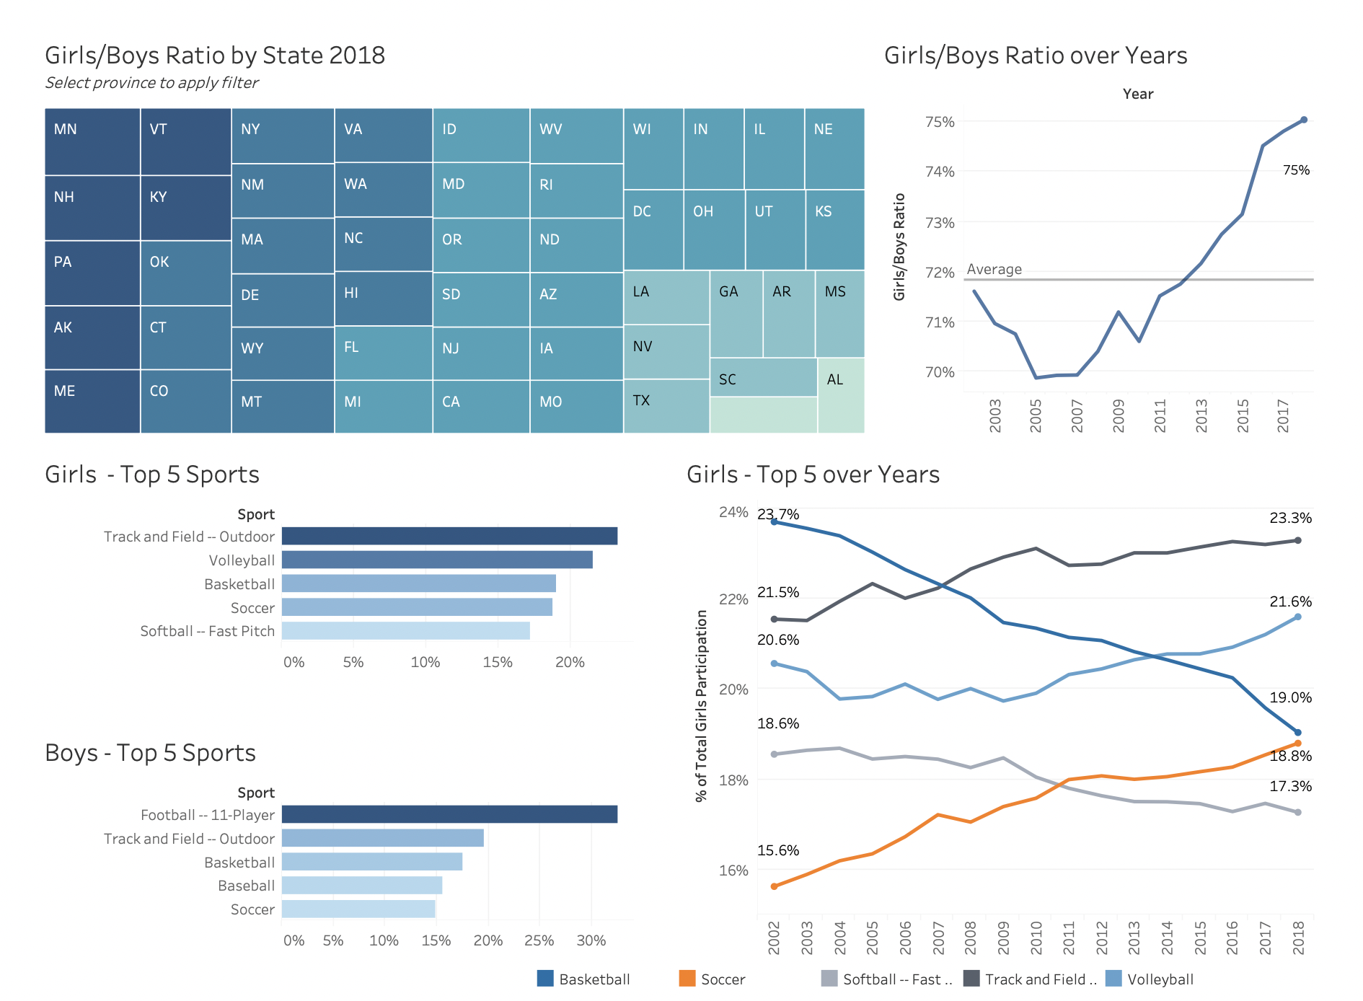

### **1. Girls/Boys Ratio by State 2018 (Treemap)**

* **Description**: The treemap shows the ratio of girls to boys participating in sports across different states in the year 2018. Each state is represented as a block, with the color intensity indicating the ratio (darker shades represent higher ratios).
* **Purpose**: This visualization helps identify states with higher or lower female participation relative to males.
* **Conclusion**: From the color gradient, it appears that states like Minnesota (MN) and New York (NY) have a higher girls-to-boys ratio, while states like Alabama (AL) and South Carolina (SC) have lower ratios. This could indicate differences in gender equality in sports participation across states.

### **2. Girls/Boys Ratio Over Years (Line Graph)**

* **Description**: This line graph tracks the girls-to-boys ratio over several years, from 2003 to 2017.
* **Purpose**: The trend over time shows whether gender parity in sports participation has improved or worsened.
* **Conclusion**: The line graph indicates a general upward trend, reaching a peak of 75% in 2017. This suggests that female participation in sports relative to male participation has increased steadily over the years.

### **3. Girls - Top 5 Sports (Horizontal Bar Chart)**

* **Description**: This bar chart illustrates the most popular sports among girls, based on participation percentages.
* **Data**:
  + Track and Field (Outdoor) has the highest participation rate, followed by Volleyball, Basketball, Soccer, and Softball (Fast Pitch).
* **Purpose**: To highlight which sports are more favored by girls.
* **Conclusion**: Outdoor track and field is the most popular sport among girls, capturing the interest of nearly 20% of female participants. Volleyball and Basketball also have strong participation rates.

### **4. Boys - Top 5 Sports (Horizontal Bar Chart)**

* **Description**: Similar to the previous chart, this one shows the top sports for boys.
* **Data**:
  + Football (11-Player) is the most popular, followed by Track and Field (Outdoor), Basketball, Baseball, and Soccer.
* **Purpose**: To identify the most popular sports for boys.
* **Conclusion**: Football is clearly the leading sport among boys, indicating a significant cultural preference. Other popular choices include basketball and track and field.

### **5. Girls - Top 5 Over Years (Line Graph)**

* **Description**: This line graph shows the trend of participation percentages for the top 5 sports among girls over time (2002-2018).
* **Data**: The graph tracks:
  + Track and Field (Outdoor)
  + Volleyball
  + Basketball
  + Soccer
  + Softball (Fast Pitch)
* **Purpose**: To show how preferences for certain sports have evolved among girls over the years.
* **Conclusion**:
  + Track and Field participation has grown consistently, peaking at 23.3% in recent years.
  + Volleyball has also shown a steady increase.
  + Meanwhile, sports like Softball and Basketball have seen fluctuations or slight declines in participation rates.
  + Soccer, while not the top sport, has shown gradual growth, indicating a rising interest.

### **Overall Insights:**

* There has been a positive trend in increasing the girls-to-boys ratio in sports over the years, suggesting better inclusion efforts.
* Track and Field stands out as a popular choice for both boys and girls, although the specific preferences for sports vary by gender.
* State-specific differences highlight areas where more work might be needed to encourage female sports participation.

—-----------------------------------------------------------------------------------------

<https://public.tableau.com/authoring/UdemyCourseAnalysis_17315090966940/Dashboard#1>

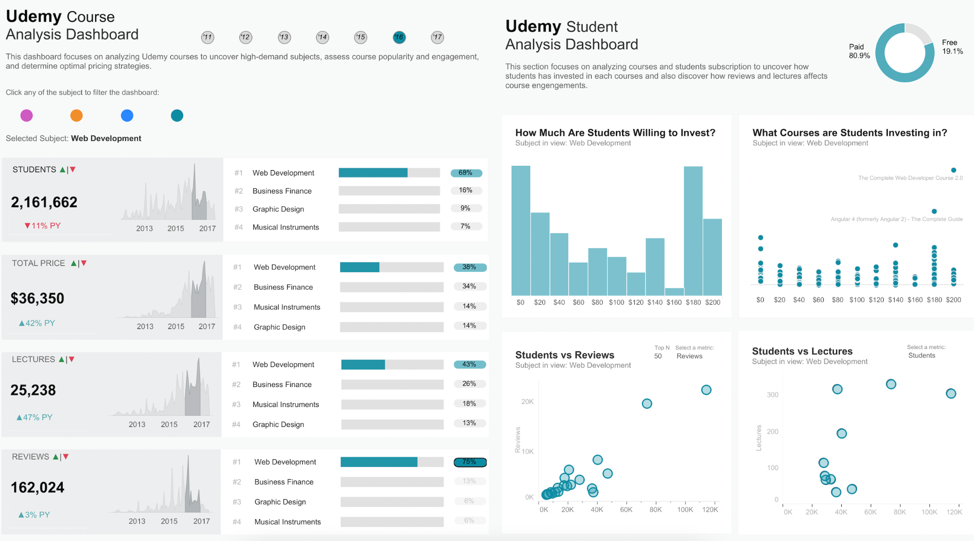

### **1. Students Over Time (Area Chart)**

* **Description**: The area chart on the left shows the trend in the number of students enrolling in Udemy courses from 2013 to 2017.
* **Data**:
  + **Total Students**: 2,161,662 with a decrease of 11% compared to the previous year.
* **Insights**:
  + The graph indicates an overall increase in student enrollments until 2017, despite the recent decline.
  + The decreasing trend might suggest market saturation or changes in course popularity.

### **2. Total Revenue Over Time (Area Chart)**

* **Description**: This chart tracks total revenue generated by Udemy courses over the years.
* **Data**:
  + **Total Price**: $36,350 with a significant increase of 42% from the previous year.
* **Insights**:
  + Despite a decline in student numbers, the revenue has increased, suggesting that students may be investing in higher-priced courses.
  + A higher revenue might indicate successful premium pricing strategies or the introduction of higher-value courses.

### **3. Lectures Over Time (Area Chart)**

* **Description**: Shows the total number of lectures uploaded to the Udemy platform.
* **Data**:
  + **Lectures**: 25,238, with a 47% increase from the previous year.
* **Insights**:
  + The significant growth in lecture content suggests an expansion in course offerings.
  + Increased content could attract more students, especially if aligned with high-demand topics.

### **4. Reviews Over Time (Area Chart)**

* **Description**: Displays the trend in the number of reviews submitted by students.
* **Data**:
  + **Reviews**: 162,024 with a slight increase of 3%.
* **Insights**:
  + A smaller increase in reviews compared to the number of lectures might indicate that students are not as engaged in leaving feedback.
  + Courses may need to encourage reviews to enhance credibility and attract new students.

### **5. Subject Popularity (Bar Chart)**

* **Description**: This horizontal bar chart ranks subjects based on their student enrollment, revenue, lectures, and reviews.
* **Data**:
  + **Top Subjects**:
    1. Web Development
    2. Business Finance
    3. Graphic Design
    4. Musical Instruments
* **Insights**:
  + **Web Development** has the highest engagement across all metrics, with 68% of total students enrolled in courses related to this subject.
  + Business Finance and Graphic Design are also popular, indicating a strong demand for skills in these areas.

### **6. How Much Are Students Willing to Invest? (Histogram)**

* **Description**: This bar graph shows the distribution of the amount students are willing to invest in courses.
* **Insights**:
  + The majority of students are willing to pay between **$120 and $180** for courses, indicating a sweet spot for pricing.
  + Lower price points have fewer enrollments, suggesting that students perceive higher-priced courses as more valuable.

### **7. What Courses Are Students Investing In? (Bubble Chart)**

* **Description**: A scatter plot shows various courses, with bubbles sized based on enrollment and positioned based on price.
* **Insights**:
  + Courses like **"The Complete Web Developer Course 2.0"** and **"Angular 4"** attract students even at higher price points.
  + Investing in comprehensive and specialized courses can be a successful strategy for attracting students willing to pay more.

### **8. Students vs. Reviews (Scatter Plot)**

* **Description**: This scatter plot shows the relationship between the number of students enrolled and the number of reviews.
* **Insights**:
  + Courses with higher enrollments generally have more reviews, but there's a point of diminishing returns where adding more students does not significantly increase reviews.
  + Encouraging feedback might help leverage positive reviews for popular courses.

### **9. Students vs. Lectures (Scatter Plot)**

* **Description**: This scatter plot highlights the relationship between the number of lectures in a course and student enrollment.
* **Insights**:
  + Courses with a moderate number of lectures (around 100-200) seem to attract more students, suggesting that students prefer concise yet comprehensive content.
  + Courses with too few or too many lectures might not be as appealing, indicating the need for balance in content length.

### **10. Paid vs. Free Courses (Pie Chart)**

* **Description**: The pie chart shows the proportion of paid versus free courses.
* **Data**:
  + **Paid Courses**: 80.9%
  + **Free Courses**: 19.1%
* **Insights**:
  + The vast majority of popular courses are paid, which aligns with the revenue growth observed.
  + Offering free courses might serve as a gateway to attract users who later invest in paid content.

### **Overall Conclusions:**

* **Web Development** remains the most sought-after subject on Udemy, followed by Business Finance and Graphic Design.
* Students are willing to invest significantly in courses that are perceived to offer substantial value, particularly in skill-driven fields.
* Reviews and lecture quantity play an essential role in student engagement, but there is an optimal range for content length that maximizes student enrollment.
* The focus on paid courses indicates a strong revenue model, but maintaining a balance with free offerings could attract a broader audience.