PYTHON PROGRAMMING

Activity-Based Learning (ABL) Assignment

Name: Deepika Bezawada
____________________________
Branch/Section: CSM 1
____________________
Roll Number: 26000886
Course: Python Programming
____________________

Selected 10 Case Studies
- University Scholarship Allocation
- Progressive Electricity Billing
- Employee Payroll and Deduction Analysis
- Retail Billing with Multiple Discount Rules
- Attendance Recovery Computation
- ATM Transaction Sequence Simulation
- Warehouse Inventory Reconciliation
- Student Marks Matrix Analysis
- Password Policy Validation Engine
- Campus Event Financial Planning

Note: These solutions use illustrative assumptions where the supplied case-study list does not specify exact rules or values. Review the programs, replace sample data if required, and ensure you can explain your work independently.

Case Study 1: University Scholarship Allocation

Problem Statement
Select scholarship applicants using aggregate marks, subject-wise minimum marks, attendance, and family income. Rank eligible applicants and resolve ties using aggregate marks, then attendance.

Objectives
  - Validate applicant details and eligibility conditions.
  - Calculate aggregate percentage from subject marks.
  - Rank eligible applicants using clear tie-breaking rules.

Assumptions
  - Each applicant has marks in three subjects, each out of 100.
  - Eligibility requires aggregate percentage of at least 80%, every subject mark of at least 70, attendance of at least 85%, and annual family income no more than Rs. 300000.
  - Higher aggregate ranks first; if tied, higher attendance ranks first.

Algorithm
Start and read the applicant records.
For each applicant, calculate aggregate percentage.
Check aggregate, subject marks, attendance, and income conditions. Store eligible applicants in a list.
Sort eligible applicants by aggregate and attendance in descending order. Display eligible rankings and rejected applicants with reasons.
Stop.

Flowchart

See the detailed flowchart on the next page.
Start -> Initialize/read data -> Process calculations -> Check conditions/loop if required -> Display result -> Stop. Main decision point: Check aggregate, subject marks, attendance, and income conditions.
6. Pseudocode

READ applicant records FOR each applicant
percentage = sum(subject marks) / number of subjects
IF percentage >= 80 AND all subject marks >= 70 AND attendance >= 85 AND income <= 300000 add applicant to eligible list
ELSE
record reason for rejection
SORT eligible by percentage descending, then attendance descending DISPLAY ranked eligible applicants and rejected applicants

Python Source Code
# Case Study 1: University Scholarship Allocation applicants = [
("Asha", [88, 91, 84], 92, 250000),
("Bharat", [78, 90, 86], 90, 220000),
("Charan", [95, 88, 91], 82, 180000),
("Divya", [82, 85, 80], 88, 280000),
]

eligible = [] rejected = []

for name, marks, attendance, income in applicants: percentage = sum(marks) / len(marks)
reasons = []
if percentage < 80: reasons.append("aggregate below 80%")
if min(marks) < 70:
reasons.append("a subject mark below 70") if attendance < 85:
reasons.append("attendance below 85%") if income > 300000:
reasons.append("income above limit")

if reasons:
rejected.append((name, ", ".join(reasons))) else:
eligible.append((name, percentage, attendance, income)) eligible.sort(key=lambda item: (item[1], item[2]), reverse=True)
print("SCHOLARSHIP RANK LIST")
for rank, item in enumerate(eligible, start=1):
print(f"{rank}. {item[0]} - {item[1]:.2f}% aggregate, {item[2]}% attendance") print("\nNOT ELIGIBLE")
for name, reason in rejected: print(f"{name}: {reason}")

Case Study 1: University Scholarship Allocation
Standard symbols: oval = Start/Stop | parallelogram = Input/Output | rectangle = Process | diamond = Decision

Start
Read applicant records
Calculate aggregate percentage
All criteria met?
Aggregate ≥ 80%, each subject ≥ 70, attendance ≥ 85%, income ≤ ■3,00,000
Add applicant to eligible list
Display ranked list and rejection reasons
Stop

Test Cases
Test | Input/condition | Expected result
Eligible applicant | Asha: 88,91,84; attendance 92; income 2500 | 0E0ligible; ranked by percentage
Low attendance | Charan attendance 82 | Rejected: attendance below 85%
Aggregate below limit | Bharat marks 78,90,86 | Rejected: aggregate below 80%

Sample Output
Program Output Screenshot — Case Study 1
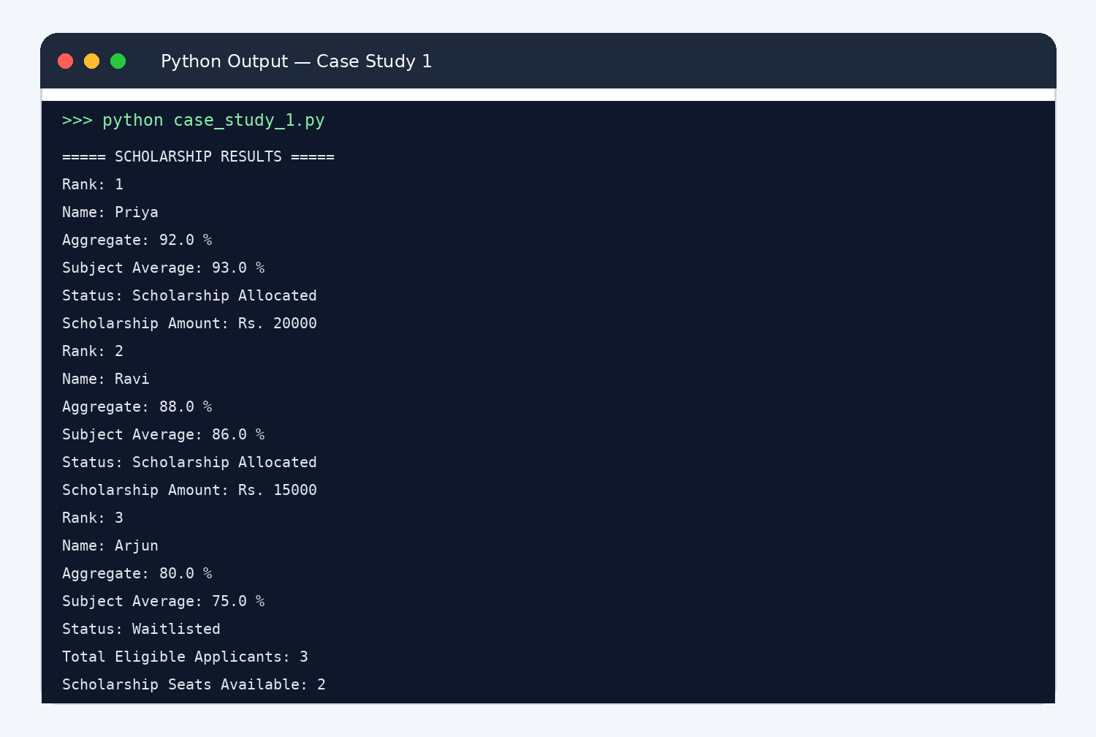
SCHOLARSHIP RANK LIST
  - Asha - 87.67% aggregate, 92% attendance
  - Bharat - 84.67% aggregate, 90% attendance
  - Divya - 82.33% aggregate, 88% attendance

NOT ELIGIBLE
Charan: attendance below 85%

Conclusion
The program applies multiple eligibility conditions and produces a ranked scholarship list with reasons for rejection.

Case Study 2: Progressive Electricity Billing

Problem Statement
Calculate a household electricity bill using consumption slabs, fixed charge, surcharge, and rebate. Compare bills from several months and flag a large increase.

Objectives
  - Use conditional statements to calculate slab charges.
  - Add fixed charges and surcharge, then apply a rebate.
  - Compare monthly bills and identify unusual increases.

Assumptions
  - First 100 units cost Rs. 2 per unit; next 100 units cost Rs. 3 per unit; units above 200 cost Rs. 5 per unit.
  - Fixed charge is Rs. 50. Surcharge is 5% of energy charge. If consumption is below 100 units, rebate is Rs. 20.
  - An increase above 50% compared with the previous month is unusual.

Algorithm
Read monthly unit readings.
Calculate energy charge using progressive slabs.
Add fixed charge and surcharge; apply rebate where eligible. Store each total bill.
Compare each month with the previous month and flag increases above 50%. Display bill details.

Flowchart

See the detailed flowchart on the next page.
Start -> Initialize/read data -> Process calculations -> Check conditions/loop if required -> Display result -> Stop. Main decision point: Add fixed charge and surcharge; apply rebate where eligible.
6. Pseudocode

FOR each month's units
IF units <= 100: energy = units * 2
ELSE IF units <= 200: energy = 100*2 + (units-100)*3 ELSE: energy = 100*2 + 100*3 + (units-200)*5
bill = energy + 50 + energy*0.05 IF units < 100: bill = bill - 20 COMPARE each bill with previous bill
FLAG increase > 50%

Python Source Code
# Case Study 2: Progressive Electricity Billing monthly_units = [85, 120, 190, 310]
bills = []

for month, units in enumerate(monthly_units, start=1): if units <= 100:
energy = units * 2 elif units <= 200:
energy = 100 * 2 + (units - 100) * 3 else:
energy = 100 * 2 + 100 * 3 + (units - 200) * 5

bill = energy + 50 + energy * 0.05 if units < 100:
bill -= 20 bills.append(bill)
print(f"Month {month}: {units} units, energy Rs. {energy:.2f}, bill Rs. {bill:.2f}")

print("\nMONTH-TO-MONTH CHECK")
for i in range(1, len(bills)):
increase = (bills[i] - bills[i - 1]) / bills[i - 1] * 100 if increase > 50:
print(f"Month {i + 1}: unusual increase of {increase:.1f}%") else:
print(f"Month {i + 1}: increase of {increase:.1f}%")

Test Cases
Test | Input/condition | Expected result
Low use | 85 units | Rebate applied
Middle slab | 120 units | First 100 at Rs. 2, remaining at Rs. 3
High use | 310 units | Units above 200 billed at Rs. 5

Sample Output
Program Output Screenshot — Case Study 2
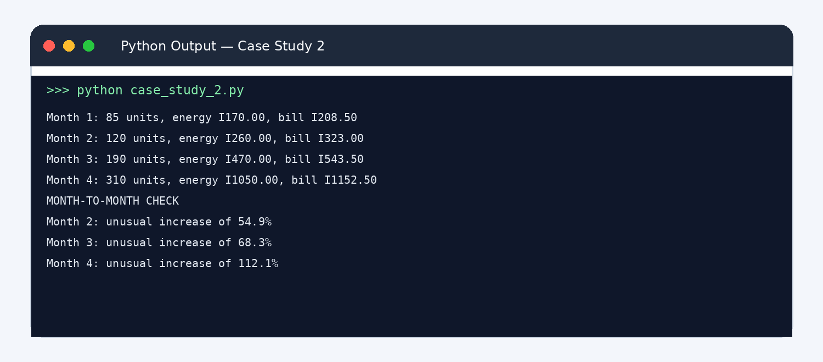
Month 1: 85 units, energy Rs. 170.00, bill Rs. 208.50
Month 2: 120 units, energy Rs. 260.00, bill Rs. 323.00
Month 3: 190 units, energy Rs. 470.00, bill Rs. 543.50
Month 4: 310 units, energy Rs. 1050.00, bill Rs. 1152.50

Case Study 2: Progressive Electricity Billing
Standard symbols: oval = Start/Stop | parallelogram = Input/Output | rectangle = Process | diamond = Decision

Start
Read monthly units
Units ≤ 100?
Energy = units × 2
Units ≤ 200?

Energy = 200 + (units − 100) × 3

Energy = 500 + (units − 200) × 5
Units < 100?
Apply ■20 rebate if eligible
Display bill; compare with previous month
Stop

Add fixed charge and 5% surcharge

MONTH-TO-MONTH CHECK
Month 2: unusual increase of 54.9%
Month 3: unusual increase of 68.3%
Month 4: unusual increase of 112.1%

Conclusion
The program calculates progressive bills and identifies months with unusually high increases.

Case Study 3: Employee Payroll and Deduction Analysis

Problem Statement
Calculate employee gross salary from basic pay, allowances, overtime, and incentives. Apply progressive deductions and print a salary statement.

Objectives
  - Calculate allowances and overtime pay.
  - Apply deductions using salary ranges.
  - Display gross pay, deductions, and net salary.

Assumptions
  - HRA is 20% of basic pay and travel allowance is 10% of basic pay.
  - Overtime is paid at Rs. 200 per hour; incentives are added directly.
  - Deduction is 5% on the first Rs. 20000 of gross pay and 10% on the amount above Rs. 20000.

Algorithm
Read employee name, basic pay, overtime hours, and incentive. Calculate HRA, travel allowance, and overtime pay.
Add these amounts to calculate gross pay. Calculate progressive deduction.
Subtract deduction from gross pay.
Print salary statement.

Flowchart

See the detailed flowchart on the next page.
Start -> Initialize/read data -> Process calculations -> Check conditions/loop if required -> Display result -> Stop. Main decision point: Add these amounts to calculate gross pay.
6. Pseudocode

READ name, basic, overtime_hours, incentive hra = basic * 0.20
travel = basic * 0.10
overtime = overtime_hours * 200
gross = basic + hra + travel + overtime + incentive first = min(gross, 20000) * 0.05
extra = max(gross - 20000, 0) * 0.10 deduction = first + extra
net = gross - deduction DISPLAY salary statement

Python Source Code
# Case Study 3: Employee Payroll name = "Ravi"
basic = 24000
overtime_hours = 6
incentive = 1500

hra = basic * 0.20 travel_allowance = basic * 0.10
overtime_pay = overtime_hours * 200
gross = basic + hra + travel_allowance + overtime_pay + incentive

deduction_first = min(gross, 20000) * 0.05
deduction_extra = max(gross - 20000, 0) * 0.10 deduction = deduction_first + deduction_extra net_salary = gross - deduction

print("EMPLOYEE SALARY STATEMENT")
print("Employee:", name) print(f"Basic pay: Rs. {basic:.2f}")
print(f"HRA: Rs. {hra:.2f}")
print(f"Travel allowance: Rs. {travel_allowance:.2f}") print(f"Overtime pay: Rs. {overtime_pay:.2f}") print(f"Incentive: Rs. {incentive:.2f}")
print(f"Gross salary: Rs. {gross:.2f}") print(f"Deduction: Rs. {deduction:.2f}") print(f"Net salary: Rs. {net_salary:.2f}")

Test Cases
Test | Input/condition | Expected result
Overtime | 6 hours | Overtime pay is Rs. 1200
No overtime | 0 hours | Overtime pay is Rs. 0
Higher gross | Gross above Rs. 20000 | Extra portion receives 10% deduction

Sample Output
Program Output Screenshot — Case Study 3
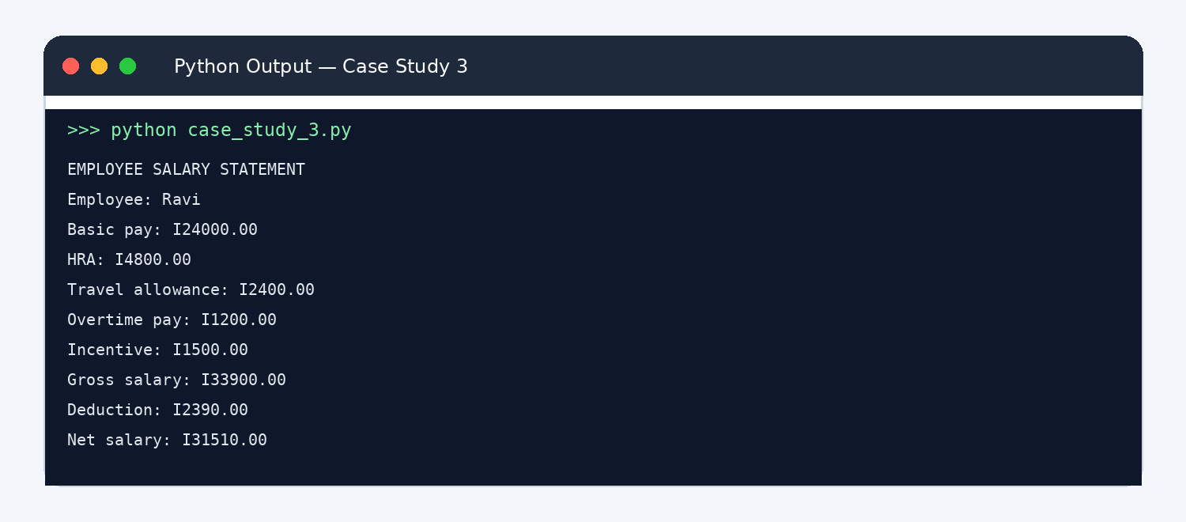
EMPLOYEE SALARY STATEMENT

Case Study 3: Employee Payroll and Deduction Analysis
Standard symbols: oval = Start/Stop | parallelogram = Input/Output | rectangle = Process | diamond = Decision
Start
Read basic pay, overtime hours, and incentive

Calculate HRA, travel allowance, and overtime pay
Calculate gross salary
Calculate progressive deduction
Net salary = gross  deduction
Display salary statement
Stop

Employee: Ravi
Basic pay: Rs. 24000.00 HRA: Rs. 4800.00
Travel allowance: Rs. 2400.00 Overtime pay: Rs. 1200.00 Incentive: Rs. 1500.00
Gross salary: Rs. 33900.00 Deduction: Rs. 2390.00
Net salary: Rs. 31510.00

Conclusion
The program creates a readable salary statement and demonstrates conditional progressive deductions.

Case Study 4: Retail Billing with Multiple Discount Rules

Problem Statement
Generate an itemized retail invoice for several products. Apply a discount when the subtotal reaches a threshold, category-based tax, and a maximum discount limit.

Objectives
  - Store product details in lists and tuples.
  - Calculate subtotal, discount, tax, and final amount.
  - Print an itemized bill.

Assumptions
  - Products are represented by (name, price, quantity, tax rate) tuples.
  - A 10% discount applies if subtotal is at least Rs. 2000, capped at Rs. 300.
  - Tax is calculated on the discounted subtotal.

Algorithm
Store product tuples in a list.
Calculate each line total and the subtotal. Calculate discount and apply the maximum cap.
Calculate tax on the discounted subtotal using each product's tax rate. Display line totals and invoice total.

Flowchart

See the detailed flowchart on the next page.
Start -> Initialize/read data -> Process calculations -> Check conditions/loop if required -> Display result -> Stop. Main decision point: Calculate discount and apply the maximum cap.
6. Pseudocode

subtotal = 0
FOR each product tuple
line_total = price * quantity subtotal = subtotal + line_total
IF subtotal >= 2000: discount = min(subtotal * 0.10, 300) ELSE: discount = 0
FOR each product
taxable_line = line_total - proportional discount tax = taxable_line * tax_rate
final_total = subtotal - discount + total_tax DISPLAY invoice

Python Source Code
# Case Study 4: Retail Billing products = [
("Notebook", 80, 5, 0.05),
("School Bag", 900, 2, 0.12),
("Pen Pack", 120, 3, 0.05),
]

subtotal = 0
for name, price, quantity, tax_rate in products: subtotal += price * quantity

discount = min(subtotal * 0.10, 300) if subtotal >= 2000 else 0 discount_ratio = discount / subtotal if subtotal else 0 total_tax = 0

print("ITEMIZED INVOICE")
for name, price, quantity, tax_rate in products: line_total = price * quantity
line_discount = line_total * discount_ratio taxable_amount = line_total - line_discount tax = taxable_amount * tax_rate
total_tax += tax
print(f"{name}: {quantity} x Rs. {price} = Rs. {line_total:.2f}; tax Rs. {tax:.2f}")

final_total = subtotal - discount + total_tax print(f"Subtotal: Rs. {subtotal:.2f}") print(f"Discount: Rs. {discount:.2f}") print(f"Tax: Rs. {total_tax:.2f}") print(f"FINAL AMOUNT: Rs. {final_total:.2f}")

Test Cases
Test | Input/condition | Expected result
Subtotal below threshold | Subtotal less than Rs. 2000 | No discount
Subtotal above threshold | Subtotal Rs. 2000 or more | 10% discount, maximum Rs. 300
Different tax rates | Products use 5% and 12% | Tax calculated per product

Sample Output
Program Output Screenshot — Case Study 4
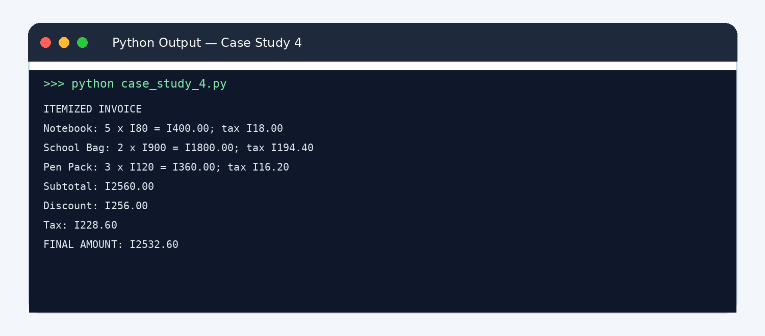

Case Study 4: Retail Billing with Multiple Discount Rules
Display itemized invoice
Stop

Final total = subtotal − discount + tax
Standard symbols: oval = Start/Stop | parallelogram = Input/Output | rectangle = Process | diamond = Decision

Start
Read product details
Calculate each line total and subtotal
Subtotal ≥ ■2,000?

Discount = 10% of subtotal, maximum ■300

Discount = ■0

Calculate tax on discounted amounts

ITEMIZED INVOICE
Notebook: 5 x Rs. 80 = Rs. 400.00; tax Rs. 18.00
School Bag: 2 x Rs. 900 = Rs. 1800.00; tax Rs. 194.40
Pen Pack: 3 x Rs. 120 = Rs. 360.00; tax Rs. 16.20
Subtotal: Rs. 2560.00
Discount: Rs. 256.00
Tax: Rs. 228.60
FINAL AMOUNT: Rs. 2532.60

Conclusion
The program uses tuples, loops, and arithmetic to generate a clear invoice with discounts and different tax rates.

Case Study 5: Attendance Recovery Computation

Problem Statement
Calculate current attendance and determine the minimum number of consecutive classes a student must attend to reach a required attendance percentage.

Objectives
  - Calculate attendance percentage.
  - Use a loop to find the minimum classes required.
  - Handle students who already meet the threshold.

Assumptions
  - Attendance eligibility threshold is 75%.
  - A future attended class increases both classes attended and total classes by one.
  - The program uses a maximum search limit of 10000 classes to avoid an endless loop.

Algorithm
Read classes attended and total classes.
Validate that total is positive and attended is between zero and total. Calculate current percentage.
If below threshold, repeatedly add one attended class and one total class until threshold is reached. Display current percentage and required classes.

Flowchart

See the detailed flowchart on the next page.
Start -> Initialize/read data -> Process calculations -> Check conditions/loop if required -> Display result -> Stop. Main decision point: Calculate current percentage.
6. Pseudocode

READ attended, total
IF total <= 0 OR attended < 0 OR attended > total: DISPLAY invalid input ELSE
current = attended / total * 100 required = 0
WHILE (attended + required)/(total + required)*100 < 75 required = required + 1
DISPLAY current and required

Python Source Code
# Case Study 5: Attendance Recovery attended = 42
total_classes = 60
threshold = 75

if total_classes <= 0 or attended < 0 or attended > total_classes: print("Invalid attendance data")
else:
current = attended / total_classes * 100 required = 0

while (attended + required) / (total_classes + required) * 100 < threshold: required += 1
if required > 10000: break

print(f"Classes attended: {attended}") print(f"Total classes: {total_classes}") print(f"Current attendance: {current:.2f}%") if current >= threshold:
print("You already meet the attendance requirement.") else:
print(f"Attend the next {required} consecutive classes to reach {threshold}%.") final_percent = (attended + required) / (total_classes + required) * 100 print(f"Attendance after recovery: {final_percent:.2f}%")

Test Cases
Test | Input/condition | Expected result
Below threshold | 42/60 classes | Needs 12 consecutive classes to reach 75%
Already eligible | 48/60 classes | No extra classes required
Invalid data | attended greater than total | Invalid attendance data

Sample Output
Program Output Screenshot — Case Study 5
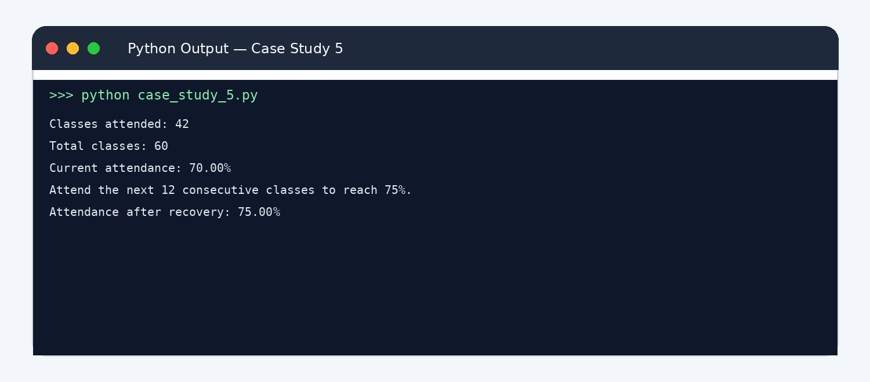
Classes attended: 42
Total classes: 60
Current attendance: 70.00%
Attend the next 12 consecutive classes to reach 75%. Attendance after recovery: 75.00%

Case Study 5: Attendance Recovery Computation
Standard symbols: oval = Start/Stop | parallelogram = Input/Output | rectangle = Process | diamond = Decision

Add one attended class and one total class
Stop
Display current % and required classes
New attendance ≥ 75%?

Required classes = 0
Attendance ≥ 75%?
Calculate current attendance %
Is input valid?
Total > 0 and 0 ≤ attended ≤ total
Read classes attended and total classes
Start

Conclusion
The program calculates attendance and uses a loop to find the smallest number of future classes needed.

Case Study 6: ATM Transaction Sequence Simulation

Problem Statement
Simulate a series of deposits and withdrawals, maintain an account balance, reject invalid transactions, enforce a withdrawal limit, and summarize accepted transactions.

Objectives
  - Process transactions using tuples and loops.
  - Validate amounts and available balance.
  - Summarize deposits, withdrawals, and rejected transactions.

Assumptions
  - Opening balance is Rs. 5000.
  - Each withdrawal must be no more than Rs. 3000 and no more than the available balance.
  - Transactions are tuples containing type and amount; valid types are DEPOSIT and WITHDRAW.

Algorithm
Set opening balance and transaction list.
For each transaction, check type and amount. Accept deposits with positive amounts.
Accept withdrawals only if amount is positive, within limit, and balance is sufficient. Update balance and totals, or record rejection.
Display final balance and transaction summary.

Flowchart

See the detailed flowchart on the next page.
Start -> Initialize/read data -> Process calculations -> Check conditions/loop if required -> Display result -> Stop. Main decision point: Accept deposits with positive amounts.
6. Pseudocode

balance = opening balance FOR each (type, amount)
IF amount <= 0: reject
ELSE IF type is DEPOSIT: add amount to balance
ELSE IF type is WITHDRAW AND amount <= 3000 AND amount <= balance: subtract amount ELSE: reject
DISPLAY final balance, deposits, withdrawals, rejected count

Python Source Code
# Case Study 6: ATM Transaction Sequence transactions = [
("DEPOSIT", 2000),
("WITHDRAW", 1500),
("WITHDRAW", 4000),
("DEPOSIT", 0),
("WITHDRAW", 1000),
]
balance = 5000
total_deposits = 0
total_withdrawals = 0
rejected = 0
withdrawal_limit = 3000

for transaction_type, amount in transactions: if amount <= 0:
print(f"Rejected: {transaction_type} Rs. {amount} (amount must be positive)") rejected += 1
elif transaction_type == "DEPOSIT": balance += amount total_deposits += amount
print(f"Accepted deposit: Rs. {amount}") elif transaction_type == "WITHDRAW":
if amount > withdrawal_limit or amount > balance:
print(f"Rejected withdrawal: Rs. {amount} (limit or balance exceeded)") rejected += 1
else:
balance -= amount total_withdrawals += amount
print(f"Accepted withdrawal: Rs. {amount}")
else:
print("Rejected: unknown transaction type") rejected += 1

print("\nATM SUMMARY")
print(f"Deposits: Rs. {total_deposits}") print(f"Withdrawals: Rs. {total_withdrawals}") print(f"Rejected transactions: {rejected}") print(f"Closing balance: Rs. {balance}")

Test Cases

Case Study 6: ATM Transaction Sequence Simulation
Standard symbols: oval = Start/Stop | parallelogram = Input/Output | rectangle = Process | diamond = Decision

Reject transaction and record reason
Start
Stop
Display transaction summary and closing balance
More transactions?

Subtract withdrawal from balance
Withdrawal ≤ ■3,000 and ≤ balance?
Add deposit to balance
Transaction is DEPOSIT?
Amount > 0?
Read next transaction
Set opening balance = ■5,000

Test | Input/condition | Expected result
Valid deposit | Deposit Rs. 2000 | Balance increases by Rs. 2000
Over-limit withdrawal | Withdraw Rs. 4000 | Rejected because limit is Rs. 3000
Zero amount | Deposit Rs. 0 | Rejected

Sample Output
Program Output Screenshot — Case Study 6
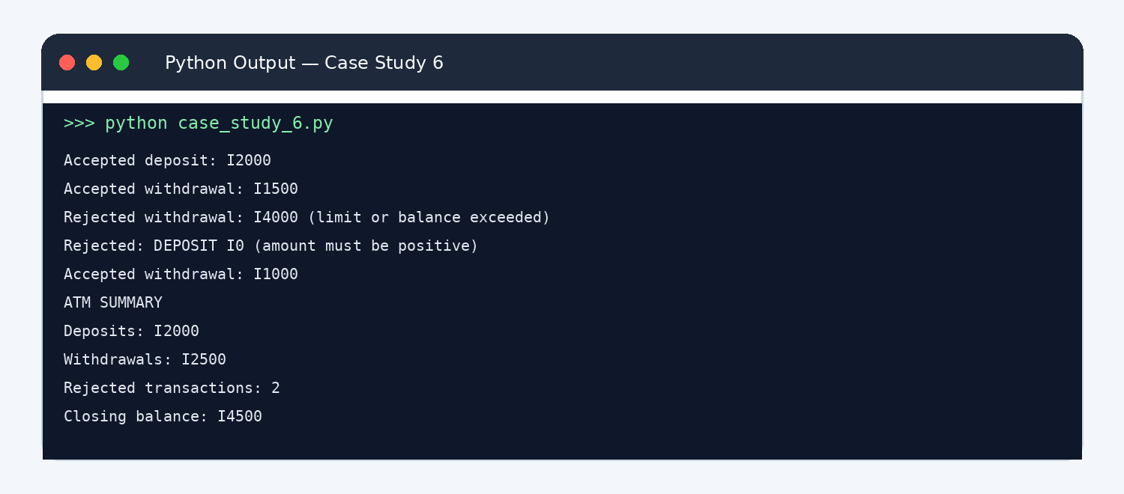
Accepted deposit: Rs. 2000 Accepted withdrawal: Rs. 1500
Rejected withdrawal: Rs. 4000 (limit or balance exceeded) Rejected: DEPOSIT Rs. 0 (amount must be positive) Accepted withdrawal: Rs. 1000

ATM SUMMARY
Deposits: Rs. 2000
Withdrawals: Rs. 2500
Rejected transactions: 2 Closing balance: Rs. 4500

Conclusion
The simulation demonstrates tuple unpacking, validation, conditional logic, and transaction summaries.

Case Study 7: Warehouse Inventory Reconciliation

Problem Statement
Compare opening stock, incoming stock, dispatched stock, and recorded closing stock for products. Detect differences and calculate replenishment needs.

Objectives
  - Represent inventory records using tuples.
  - Calculate expected closing stock.
  - Identify discrepancies and reorder quantities.

Assumptions
  - Expected closing stock = opening + incoming - dispatched.
  - Reorder target is 20 units per product.
  - A discrepancy exists if expected and recorded closing stock differ.

Algorithm
Store each product as a tuple.
Calculate expected closing stock.
Compare expected with recorded closing stock.
Calculate replenishment needed to reach target stock of 20. Display discrepancy and replenishment results.

Flowchart

See the detailed flowchart on the next page.
Start -> Initialize/read data -> Process calculations -> Check conditions/loop if required -> Display result -> Stop. Main decision point: Compare expected with recorded closing stock.
6. Pseudocode

FOR each product tuple
expected = opening + incoming - dispatched difference = recorded_closing - expected IF difference != 0: flag discrepancy reorder = max(20 - recorded_closing, 0)
DISPLAY product, expected, difference, reorder

Python Source Code
# Case Study 7: Warehouse Inventory Reconciliation
# Tuple: (product, opening, incoming, dispatched, recorded_closing) records = [
("Pens", 50, 30, 45, 35),
("Notebooks", 80, 20, 70, 25),
("Folders", 40, 10, 25, 28),
]
target_stock = 20

print("INVENTORY RECONCILIATION")
for product, opening, incoming, dispatched, closing in records: expected = opening + incoming - dispatched
difference = closing - expected
reorder = max(target_stock - closing, 0)

print(f"\nProduct: {product}") print(f"Expected closing stock: {expected}") print(f"Recorded closing stock: {closing}") if difference == 0:
print("Status: Matched") else:
print(f"Status: DISCREPANCY ({difference:+d} units)") print(f"Replenishment required: {reorder} units")

Test Cases
Test | Input/condition | Expected result
Matching record | Opening 50, incoming 30, dispatched 45, clos | iNnog d3i5screpancy
Shortage | Expected 30, recorded 25 | Discrepancy of -5
Above target | Recorded stock 35 | No replenishment required

Sample Output
Program Output Screenshot — Case Study 7
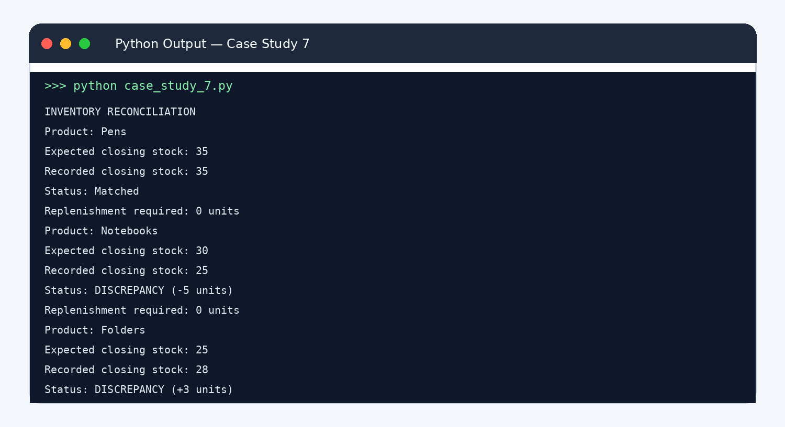
INVENTORY RECONCILIATION

Product: Pens
Expected closing stock: 35 Recorded closing stock: 35 Status: Matched
Replenishment required: 0 units

Product: Notebooks Expected closing stock: 30

Case Study 7: Warehouse Inventory Reconciliation

Flag stock discrepancy
Standard symbols: oval = Start/Stop | parallelogram = Input/Output | rectangle = Process | diamond = Decision
Start
Read product stock records

Expected closing = opening + incoming  dispatched
Difference = recorded closing  expected closing

Difference = 0?

Mark record as matched

Display expected stock, discrepancy, and replenishment
Stop

Reorder = max(20 − recorded closing, 0)

Recorded closing stock: 25 Status: DISCREPANCY (-5 units) Replenishment required: 0 units

Product: Folders
Expected closing stock: 25 Recorded closing stock: 28 Status: DISCREPANCY (+3 units) Replenishment required: 0 units

Conclusion
The program reconciles stock records and identifies discrepancies and replenishment needs.

Case Study 8: Student Marks Matrix Analysis

Problem Statement
Analyse a nested list of student marks. Calculate each student's total and average, each subject's average, identify the top student, and flag subjects with low averages.

Objectives
  - Use nested lists to store a marks matrix.
  - Calculate row-wise and column-wise statistics.
  - Identify top performer and subjects needing attention.

Assumptions
  - Each row represents one student and each column represents a subject.
  - All marks are out of 100.
  - A subject average below 50 is flagged as low.

Algorithm
Store student names, subject names, and marks matrix. For each row, calculate total and average.
For each subject column, calculate average. Identify the student with the highest average. Flag subjects with averages below 50.

Flowchart

See the detailed flowchart on the next page.
Start -> Initialize/read data -> Process calculations -> Check conditions/loop if required -> Display result -> Stop. Main decision point: For each subject column, calculate average.
6. Pseudocode

FOR each student row total = sum(row)
average = total / number of subjects FOR each subject column
subject_average = sum(column marks) / number of students FIND student with maximum average
FLAG subject average below 50 DISPLAY all results

Python Source Code
# Case Study 8: Student Marks Matrix
students = ["Asha", "Bharat", "Charan", "Divya"] subjects = ["Python", "Maths", "English"]
marks = [
[88, 76, 82],
[72, 68, 75],
[45, 52, 48],
[91, 89, 94],
]

averages = [] print("STUDENT RESULTS")
for i in range(len(students)): total = sum(marks[i])
average = total / len(subjects) averages.append(average)
print(f"{students[i]}: total={total}, average={average:.2f}")

print("\nSUBJECT AVERAGES")
for j in range(len(subjects)): subject_total = 0
for i in range(len(students)): subject_total += marks[i][j]
subject_average = subject_total / len(students) print(f"{subjects[j]}: {subject_average:.2f}") if subject_average < 50:
print(" Warning: low subject average")

top_index = averages.index(max(averages))
print(f"\nTop performer: {students[top_index]} ({averages[top_index]:.2f} average)")

Test Cases
Test | Input/condition | Expected result
Student average | Asha marks 88,76,82 | Average is 82.00
Top performer | Divya marks 91,89,94 | Divya is top performer
Low subject average | Data includes lower Python marks | Program flags subject average below 50 if threshold met

Sample Output
Program Output Screenshot — Case Study 8
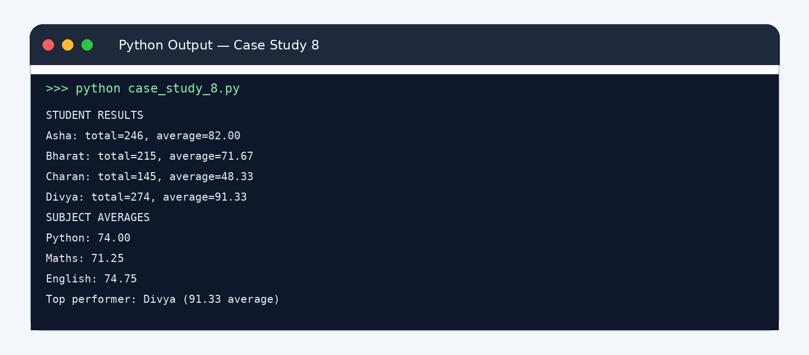
STUDENT RESULTS

Case Study 8: Student Marks Matrix Analysis
Standard symbols: oval = Start/Stop | parallelogram = Input/Output | rectangle = Process | diamond = Decision
Start
Read student names, subjects and marks

For each student: calculate total and average
For each subject: calculate average
Find student with highest average
Any subject average < 50?
Flag low-average subject(s)
Display student results, subject averages and top performer
Stop

Asha: total=246, average=82.00 Bharat: total=215, average=71.67 Charan: total=145, average=48.33 Divya: total=274, average=91.33

SUBJECT AVERAGES
Python: 74.00
Maths: 71.25
English: 74.75

Top performer: Divya (91.33 average)

Conclusion
The program uses nested lists and loops to calculate student-wise and subject-wise performance.

Case Study 9: Password Policy Validation Engine

Problem Statement
Validate sample passwords against length, uppercase, lowercase, digit, special-character, repeated-character, and prohibited-substring rules. Report all failed rules.

Objectives
  - Use string operations to inspect passwords.
  - Apply multiple validation conditions.
  - Explain why a password fails.

Assumptions
  - A valid password has at least 8 characters, one uppercase, one lowercase, one digit, one special character, no three identical consecutive characters, and does not contain 'password' ignoring case.
  - This is an educational demonstration, not a real authentication system.

Algorithm
Read each sample password.
Check length and character categories.
Check for three identical consecutive characters. Check prohibited substring case-insensitively.
Display valid/invalid status and each failure.

Flowchart

See the detailed flowchart on the next page.
Start -> Initialize/read data -> Process calculations -> Check conditions/loop if required -> Display result -> Stop. Main decision point: Check for three identical consecutive characters.
6. Pseudocode

FOR each password failures = empty list CHECK length >= 8
CHECK uppercase, lowercase, digit, special character CHECK no three identical consecutive characters CHECK 'password' not in lowercase password
IF failures empty: valid ELSE: display failures

Python Source Code
# Case Study 9: Password Policy Validation
passwords = ["Hello@123", "abc123", "AAAhello1!", "MyPassword9!"]

for password in passwords: failures = []
if len(password) < 8:
failures.append("must contain at least 8 characters") if not any(ch.isupper() for ch in password):
failures.append("needs an uppercase letter") if not any(ch.islower() for ch in password):
failures.append("needs a lowercase letter") if not any(ch.isdigit() for ch in password):
failures.append("needs a digit")
if not any(not ch.isalnum() for ch in password): failures.append("needs a special character")

repeated = False
for i in range(len(password) - 2):
if password[i] == password[i + 1] == password[i + 2]: repeated = True
if repeated:
failures.append("must not contain three identical consecutive characters") if "password" in password.lower():
failures.append("contains prohibited word 'password'")

print(f"\nPassword sample: {password}") if failures:
print("INVALID")
for failure in failures: print("-", failure)
else:
print("VALID: all policy checks passed")

Test Cases
Test | Input/condition | Expected result
Strong sample | Hello@123 | Valid
Too short | abc123 | Fails length and character-category checks
Repeated characters | AAAhello1! | Fails repeated-character rule
Prohibited word | MyPassword9! | Fails prohibited-substring rule

Case Study 9: Password Policy Validation Engine
Standard symbols: oval = Start/Stop | parallelogram = Input/Output | rectangle = Process | diamond = Decision
Start
Read sample password

Check length and character categories
Check repeated characters and prohibited word

Mark password INVALID and list failures

Any rule failed?
More passwords?
Display validation results
Stop

Mark password VALID

Sample Output
Program Output Screenshot — Case Study 9
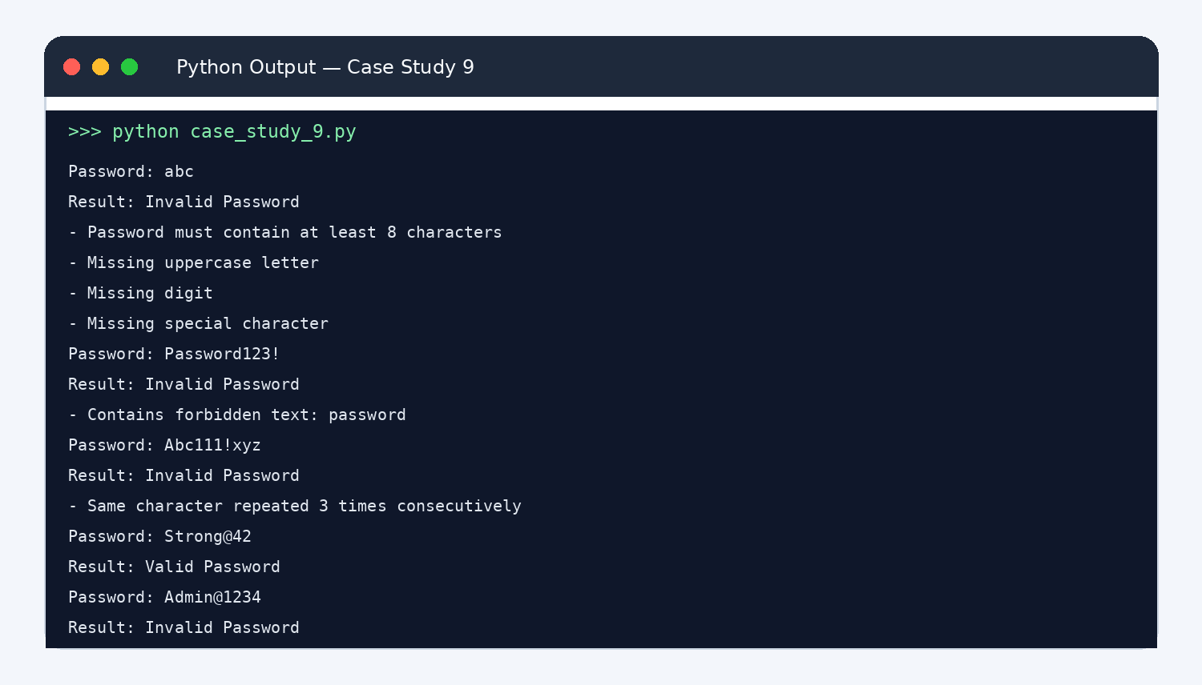
Password sample: Hello@123 VALID: all policy checks passed

Password sample: abc123 INVALID
  - must contain at least 8 characters
  - needs an uppercase letter
  - needs a special character

Password sample: AAAhello1!
INVALID
  - must not contain three identical consecutive characters

Password sample: MyPassword9!
INVALID
  - contains prohibited word 'password'

Conclusion
The program checks password samples against multiple rules and reports specific failures. Real systems should use secure password handling.

Case Study 10: Campus Event Financial Planning

Problem Statement
Calculate the total cost of a campus event, expected sponsorship, participant contributions, sponsorship shortfall, and minimum number of registrations needed to break even.

Objectives
  - Add fixed and per-participant expenses.
  - Calculate funds available and funding gap.
  - Use arithmetic and conditional logic to estimate break-even registration.

Assumptions
  - Venue Rs. 12000, equipment Rs. 8000, transport Rs. 5000, certificates Rs. 30 per participant, catering Rs. 150 per participant.
  - Sponsorship is Rs. 18000 and registration fee is Rs. 250 per participant.
  - Break-even registrations are the smallest whole number for which sponsorship plus fees covers total cost.

Algorithm
Read expected participants and cost details. Calculate fixed costs and variable cost per participant. Calculate total event cost and available funds.
Calculate funding surplus or shortfall.
Loop from zero registrations until funds cover total cost. Display budget summary and break-even registrations.

Flowchart

See the detailed flowchart on the next page.
Start -> Initialize/read data -> Process calculations -> Check conditions/loop if required -> Display result -> Stop. Main decision point: Calculate total event cost and available funds.
6. Pseudocode

fixed = venue + equipment + transport variable_per_person = certificate_cost + catering_cost total_cost = fixed + participants * variable_per_person funds = sponsorship + participants * registration_fee shortfall = max(total_cost - funds, 0)
registrations = 0
WHILE sponsorship + registrations*fee < fixed + registrations*variable_per_person registrations = registrations + 1
DISPLAY cost, funds, shortfall, break-even registrations

Python Source Code
# Case Study 10: Campus Event Financial Planning venue = 12000
equipment = 8000
transport = 5000
certificate_per_person = 30
catering_per_person = 150
sponsorship = 18000
registration_fee = 250
expected_participants = 100

fixed_cost = venue + equipment + transport
variable_cost = certificate_per_person + catering_per_person total_cost = fixed_cost + expected_participants * variable_cost funds = sponsorship + expected_participants * registration_fee shortfall = max(total_cost - funds, 0)

break_even = 0
while sponsorship + break_even * registration_fee < fixed_cost + break_even * variable_cost: break_even += 1

print("CAMPUS EVENT BUDGET")
print(f"Fixed costs: Rs. {fixed_cost}")
print(f"Variable cost per participant: Rs. {variable_cost}") print(f"Expected participants: {expected_participants}") print(f"Total expected cost: Rs. {total_cost}") print(f"Sponsorship: Rs. {sponsorship}")
print(f"Registration contributions: Rs. {expected_participants * registration_fee}") print(f"Total funds: Rs. {funds}")
if shortfall:
print(f"Funding shortfall: Rs. {shortfall}") else:
print(f"Funding surplus: Rs. {funds - total_cost}")
print(f"Break-even registrations with current sponsorship: {break_even}")

Test Cases
Test | Input/condition | Expected result
Expected 100 participant | s100 participants | Calculate total cost and funding gap
Sponsorship covers costs | Increase sponsorship | Shortfall becomes zero if funds are sufficient

Case Study 10: Campus Event Financial Planning
Standard symbols: oval = Start/Stop | parallelogram = Input/Output | rectangle = Process | diamond = Decision
Start
Read event costs, sponsorship, fee and expected participants

Calculate fixed cost and variable cost/person
Calculate total cost, funds and shortfall
Set break-even registrations = 0
Sponsorship + registrations × fee
≥ fixed cost + registrations × variable cost?
Increase registrations by 1
Display budget and break-even registrations
Stop

Test | Input/condition | Expected result
Break-even | Fee Rs. 250, variable cost Rs. 180 | Each registration contributes Rs. 70 toward fixed costs

Sample Output
Program Output Screenshot — Case Study 10
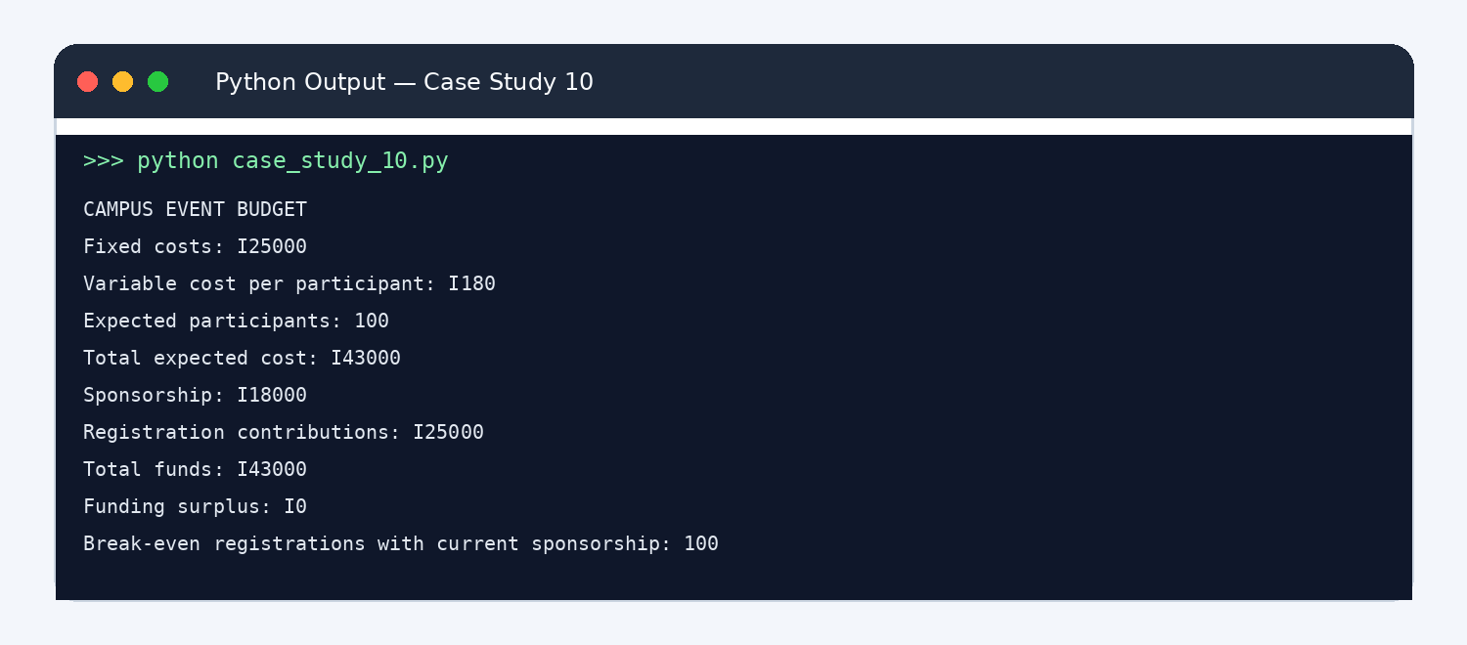
CAMPUS EVENT BUDGET
Fixed costs: Rs. 25000
Variable cost per participant: Rs. 180 Expected participants: 100
Total expected cost: Rs. 43000 Sponsorship: Rs. 18000
Registration contributions: Rs. 25000 Total funds: Rs. 43000
Funding surplus: Rs. 0
Break-even registrations with current sponsorship: 100

Conclusion
The program calculates event finances and determines the minimum registration count needed to break even under the stated assumptions.

