

DEPARTMENT OF COMPUTER SCIENCE AND ENGINEERING

CS23432 – Software Construction
(REGULATION 2023)
RAJALAKSHMI ENGINEERING COLLEGE
Thandalam, Chennai-602015

Name : Deepika.ss
Register No : 240701103
Year / Branch : II Year / B.E CSE
Semester : IV
Academic Year : 2024-2028

INDEX
S.No. | Date | Title
1. | 10/01/2026 | Azure Devops Environment Setup.
2. | 24/01/2026 | Azure Devops Project Setup and User Story Management.
3. | 31/01/2026 | Setting Up Epics, Features, And User Stories for Project Planning.
4. | 07/02/2026 | Sprint Planning.
5. | 21/02/2026 | Poker Estimation.
6. | 07/03/2026 | Designing Class and Sequence Diagrams for Project Architecture.
7. | 14/03/2026 | Designing Architectural and ER Diagrams for Project Structure.
8. | 11/04/2026 | Testing – Test Plans and Test Cases.
9. | 18/04/2026 | Load Testing and Pipelines.
10. | 25/04/2026 | GitHub: Project Structure & Naming Conventions.

EXP NO: 1
AZURE DEVOPS ENVIRONMENT SETUP

Create Epic, Features, User Stories, Task

Aim:
To set up and access the Azure DevOps environment by creating an organization through the Azure portal.

INSTALLATION
1.Open your web browser and go to the Azure website: https://azure.microsoft.com/en-us/get-started/azure-portal.
Sign in using your Microsoft account credentials.
If you don't have a Microsoft account, you can create one here: https://signup.live.com/?lic=1
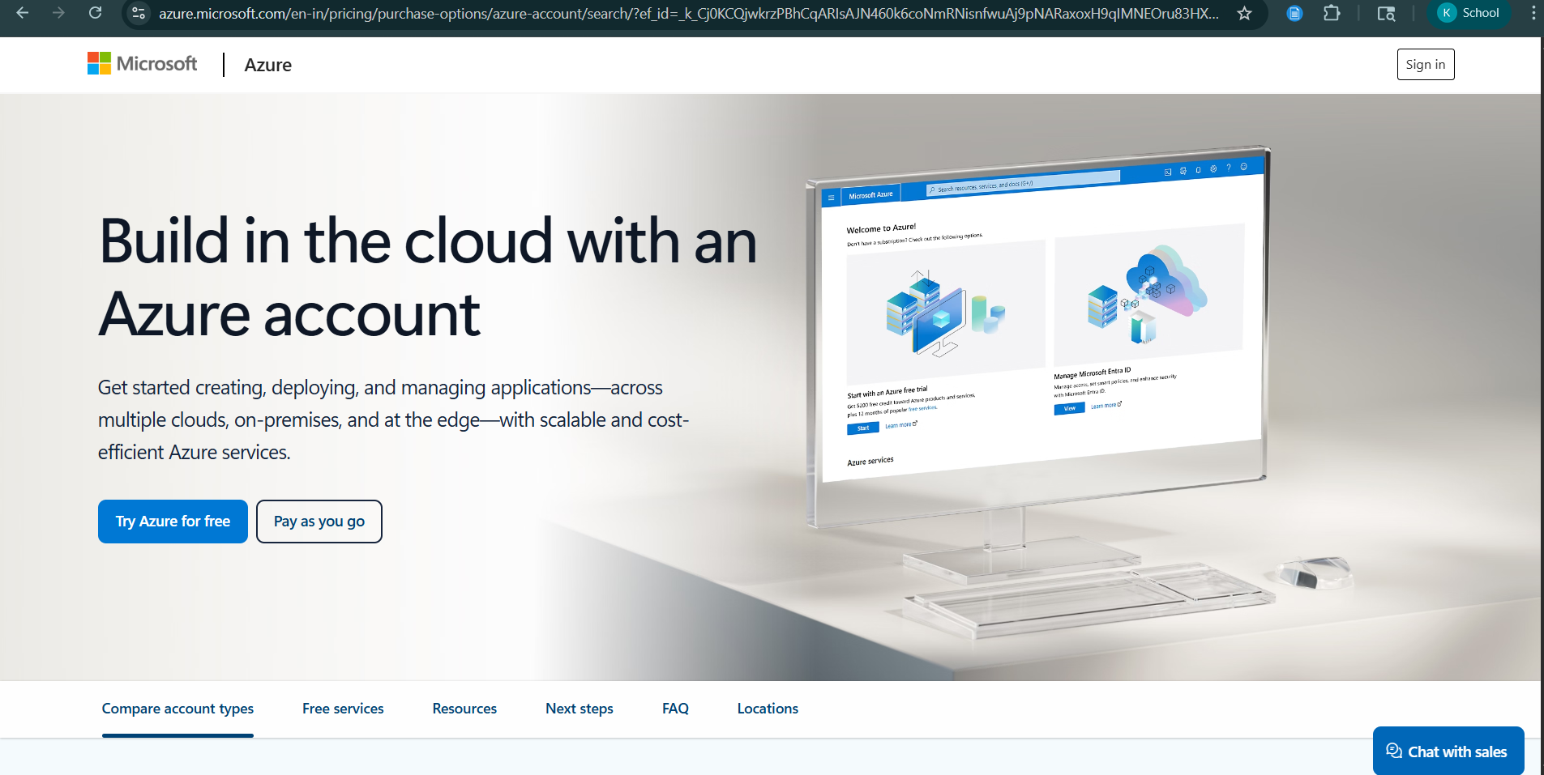

2.Azure home page
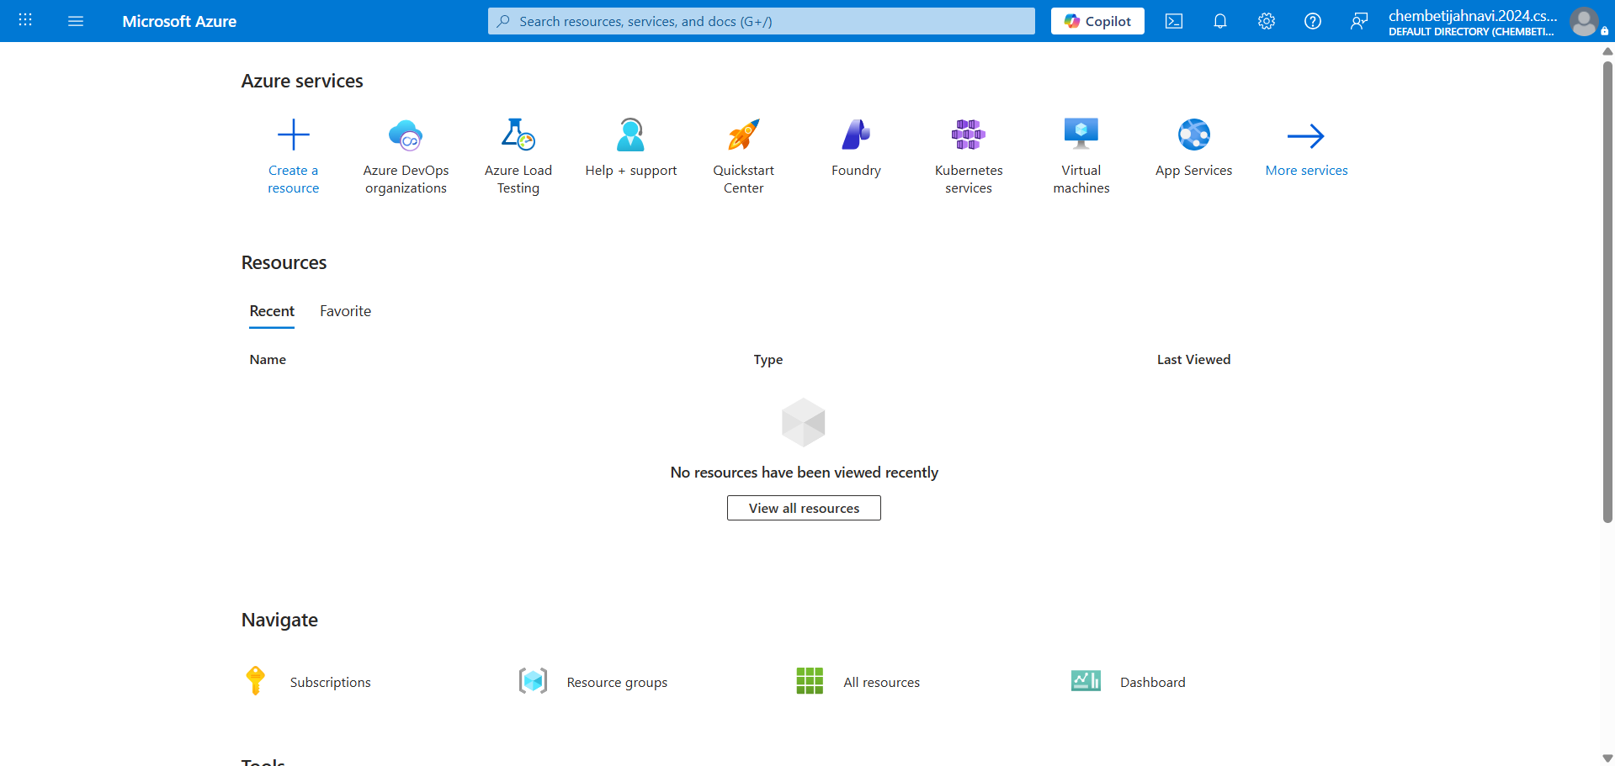
3.Open DevOps environment in the Azure platform by clicking 9 dots
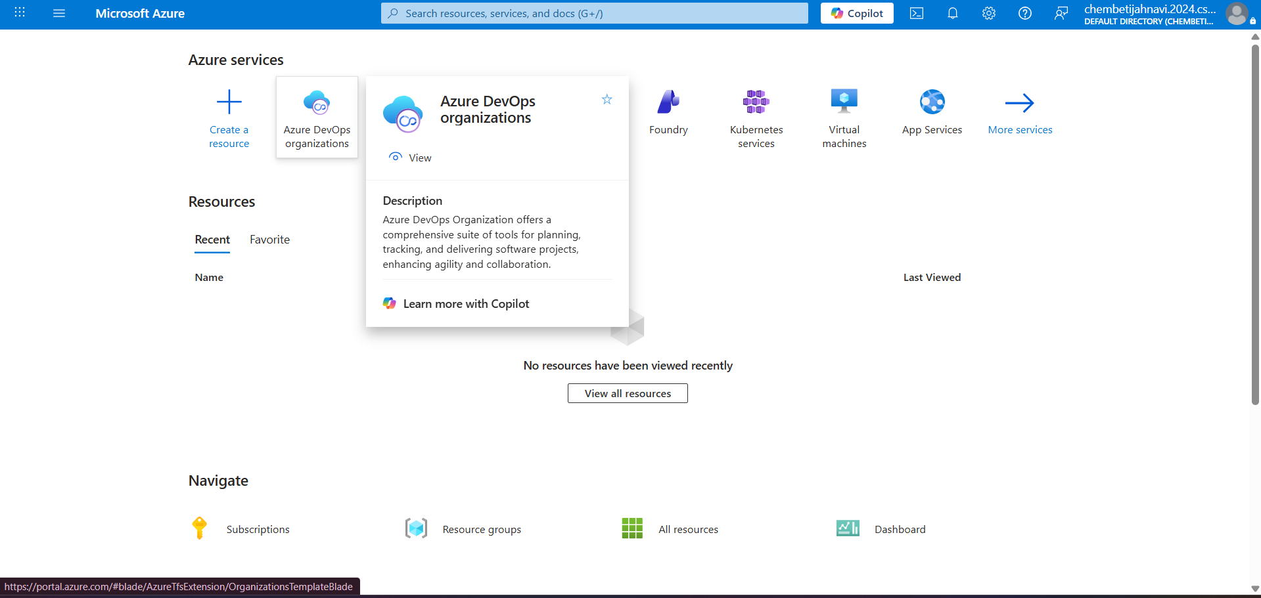

4.Click on the DevOps icon and create an organization and you should be taken to the Azure DevOps Organization Home page.
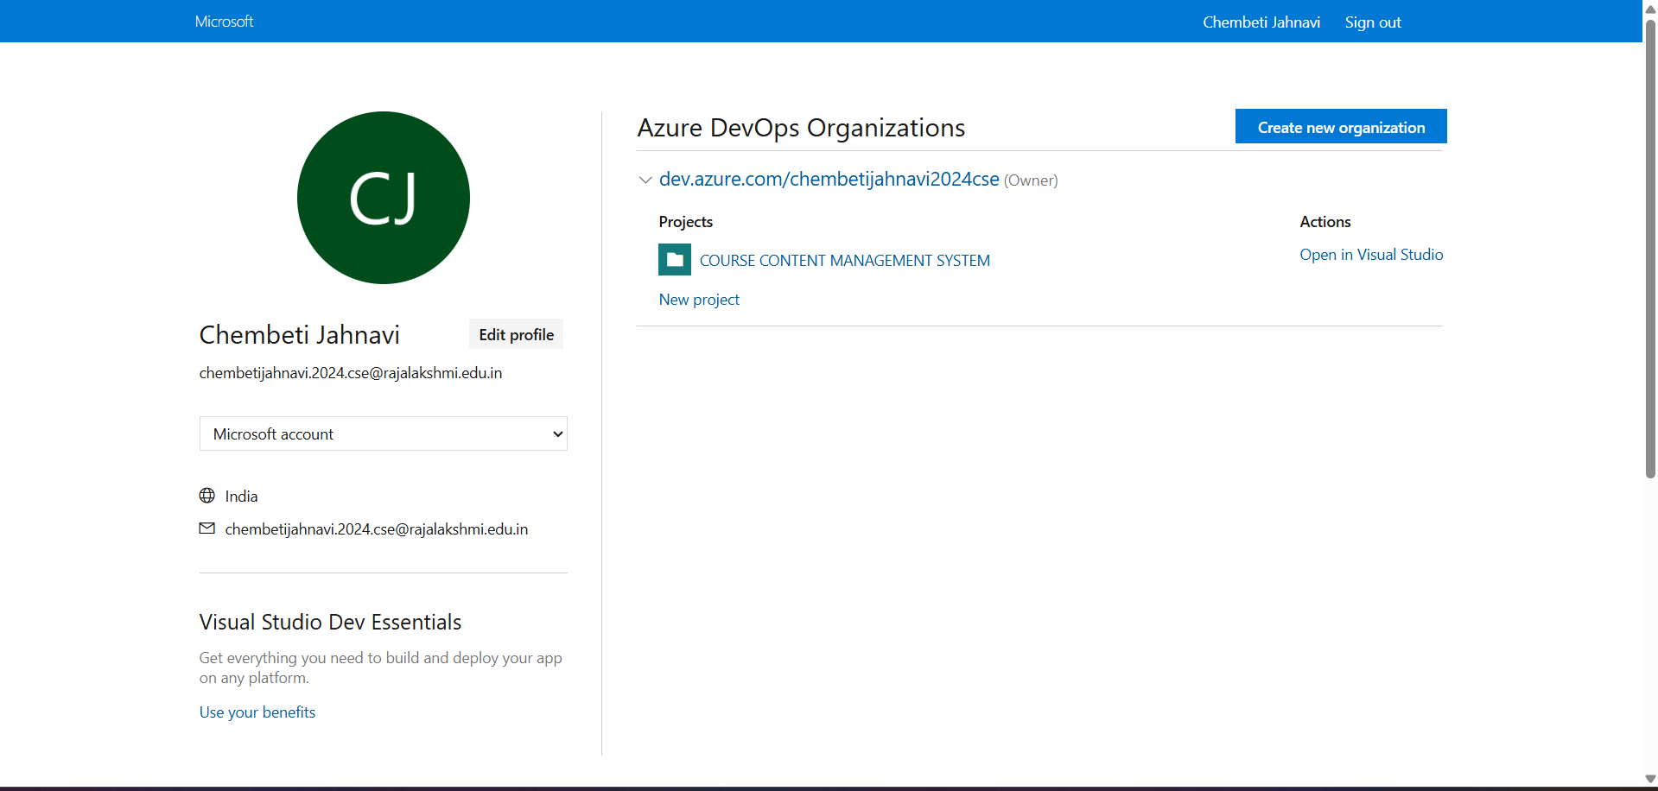

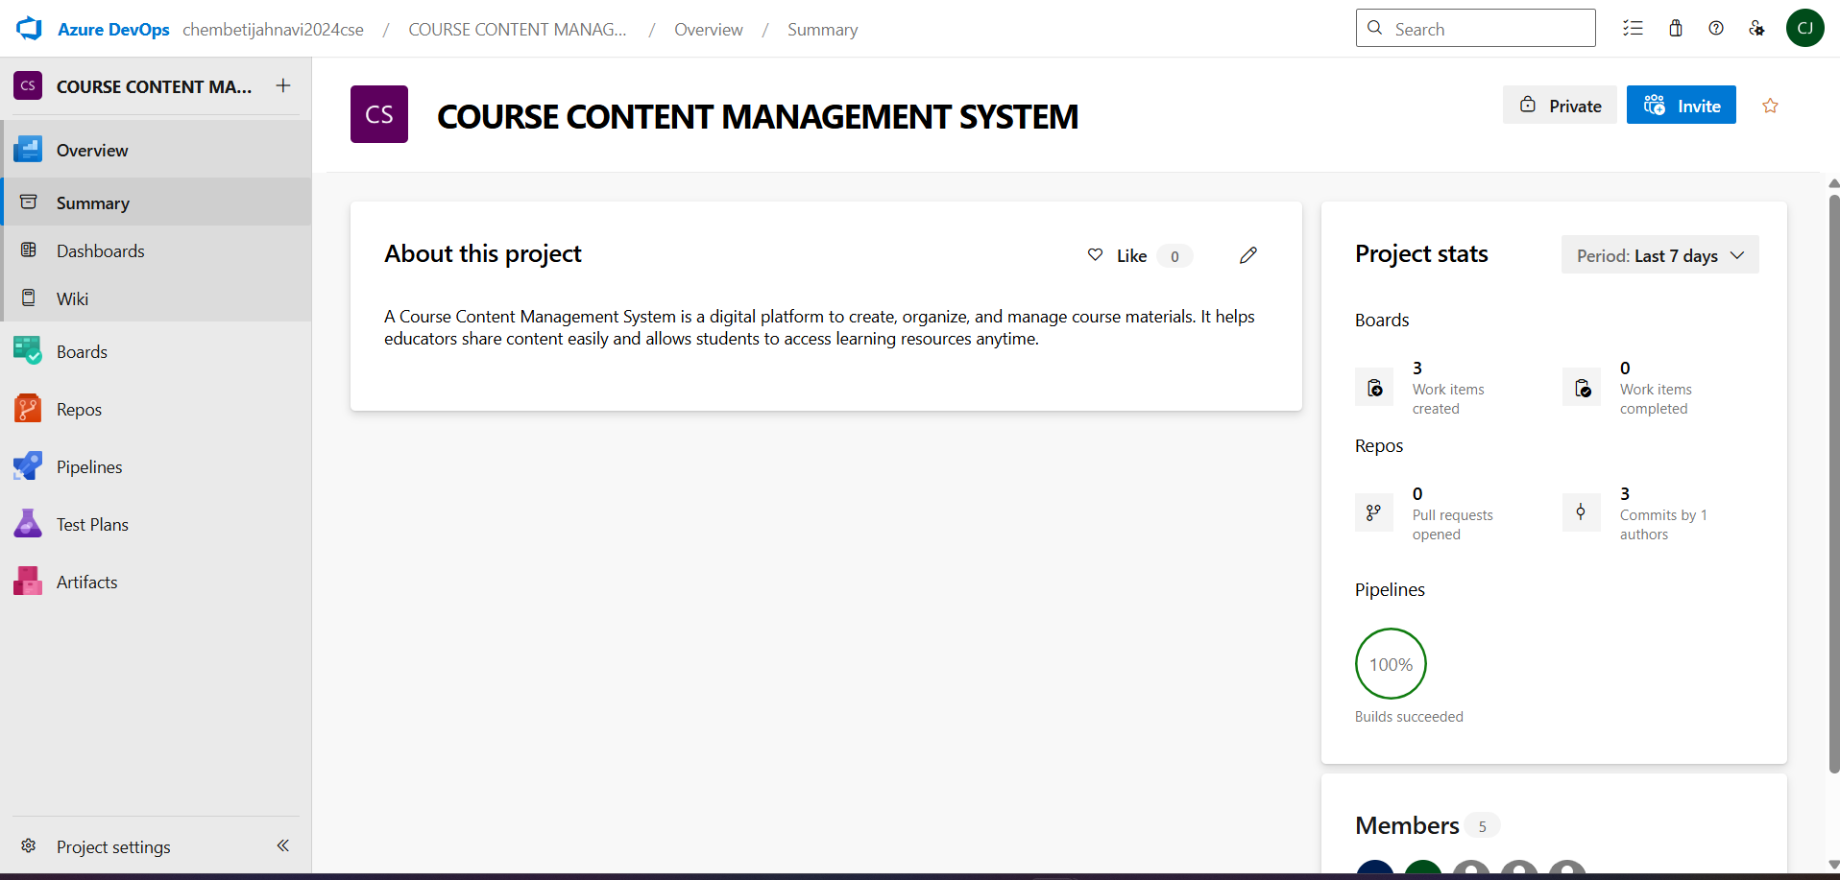

Result:
Successfully accessed the Azure DevOps environment and created a new organization through the Azure portal.

EXP NO: 2 AZURE DEVOPS PROJECT SETUP AND USER STORY MANAGEMENT
AZURE DEVOPS PROJECT SETUP AND USER STORY MANAGEMENT

Create Epic, Features, User Stories, Task

Aim:
To set up an Azure DevOps project for efficient collaboration and agile work management.

1.Create An Azure Account
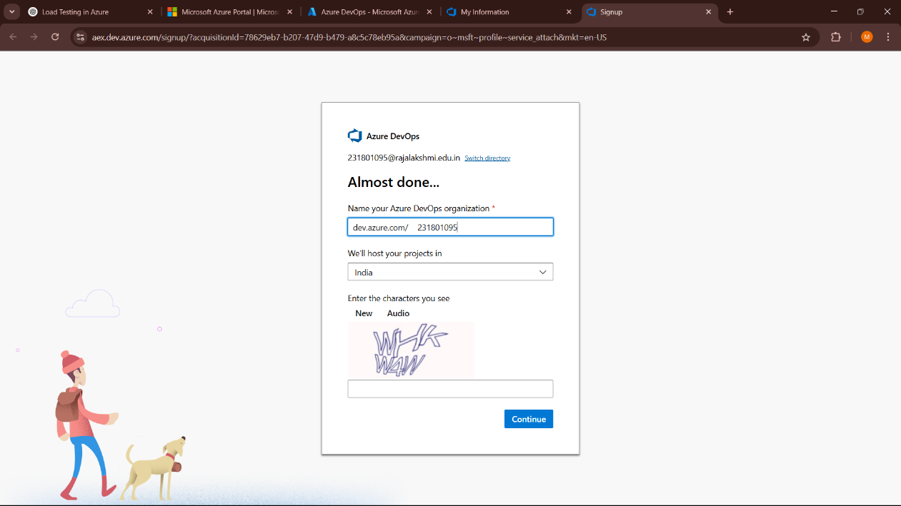
Vishnupriya DKiyak\\i

2.Create the First Project in Your Organization
a. After the organization is set up, you’ll need to create your first project. This is where you'll begin to manage code, pipelines, work items, and more.
b. On the organization’s Home page, click on the New Project button.
c. Enter the project name, description, and visibility options:
Name: Choose a name for the project (e.g., LMS).
Description: Optionally, add a description to provide more context about the project.
Visibility: Choose whether you want the project to be Private (accessible only to those invited) or Public (accessible to anyone).
d. Once you’ve filled out the details, click Create to set up your first project.

3.Once logged in, ensure you are in the correct organization. If you're part of multiple organizations, you can switch between them from the top left corner (next to your user profile). Click on the Organization name, and you should be taken to the Azure DevOps Organization Home page.

Product Price Comparison System

4.Project dashboard


5.To manage user stories:
a. From the left-hand navigation menu, click on Boards. This will take you to the main Boards page, where you can manage work items, backlogs, and sprints.
b. On the work items page, you'll see the option to Add a work item at the top. Alternatively, you can find a + button or Add New Work Item depending on the view you're in. From the Add a work item dropdown, select User Story. This will open a form to enter details for the new User Story.

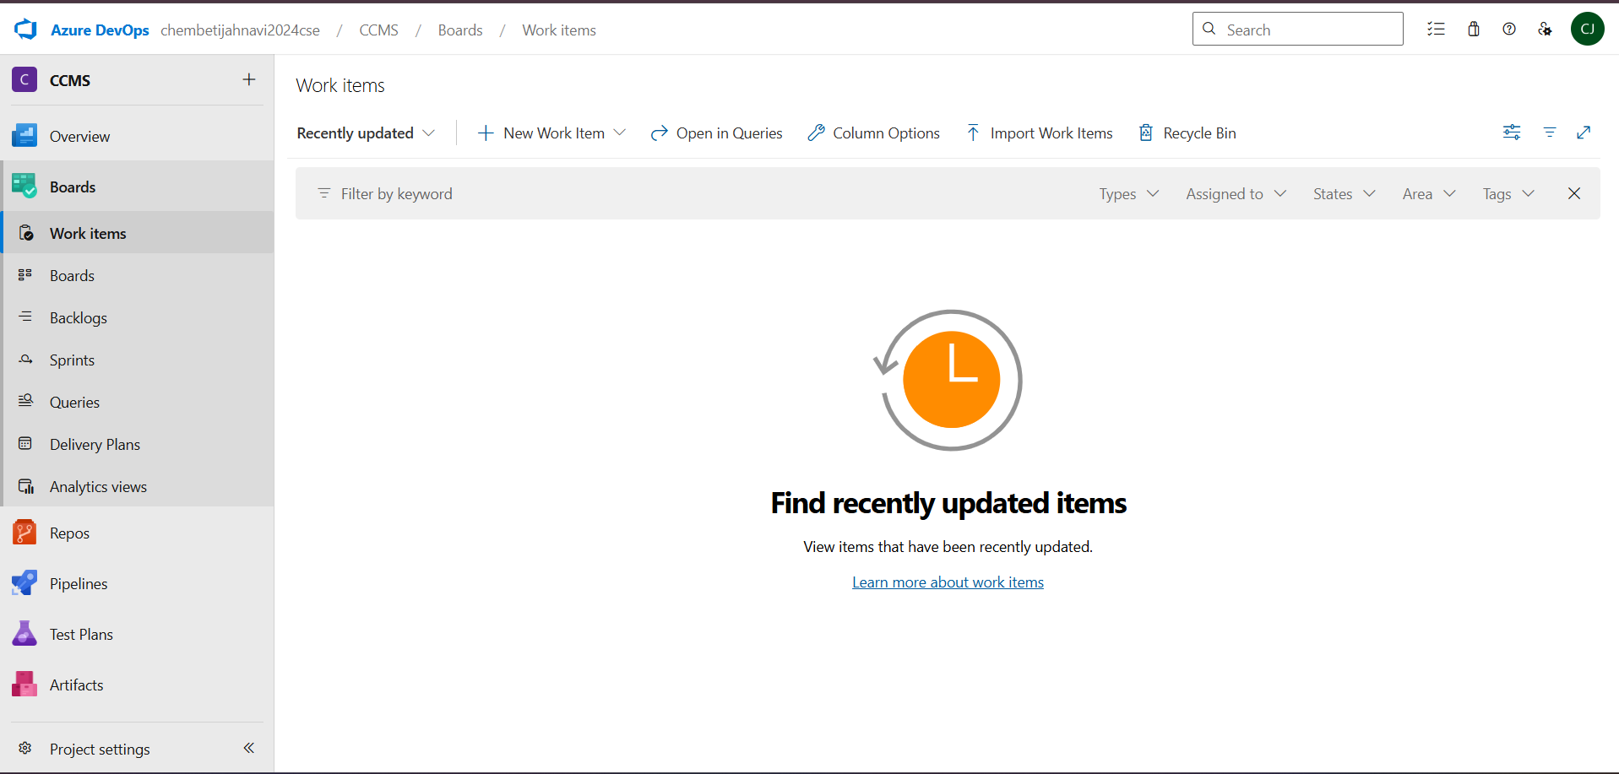

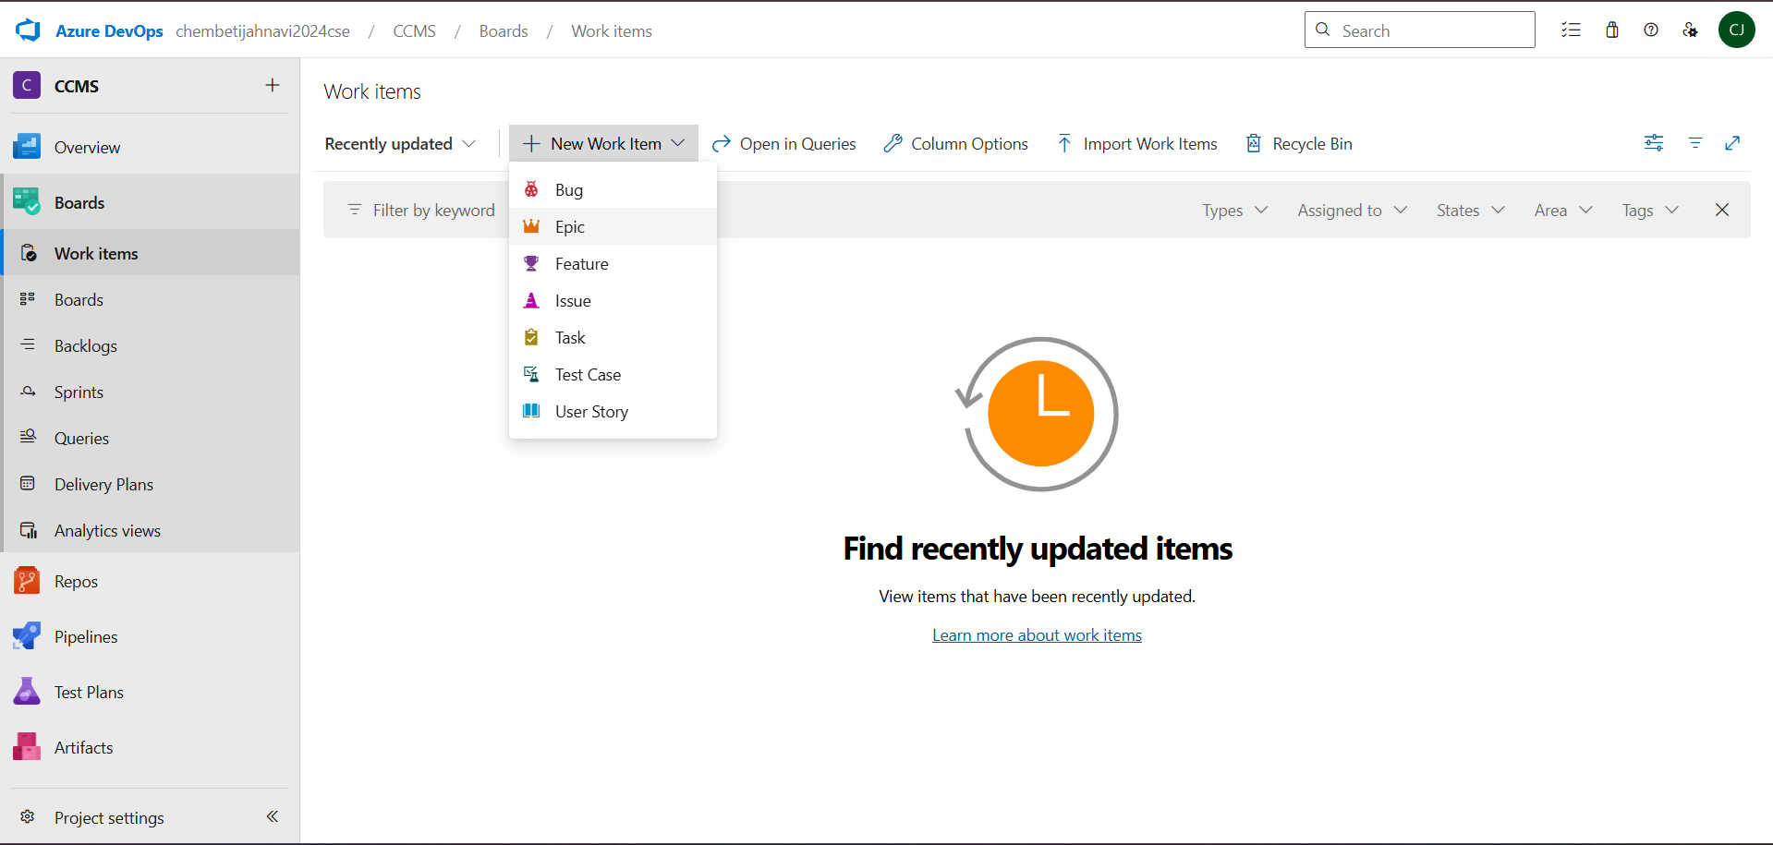

Result:
Successfully created an Azure DevOps project with user story management and agile workflow setup.

EXP NO: 3 SETTING UP EPICS,FEATURES, AND USER STORIES FOR PROJECT PLANNING

Create Epic, Features, User Stories, Task

Aim:
To learn about how to create epics, user story, features, backlogs for your assigned project.

Create Epic, Features, User Stories, Task
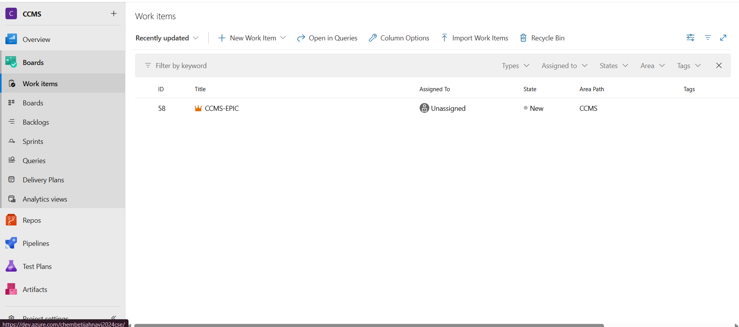
1.Fill in Epics
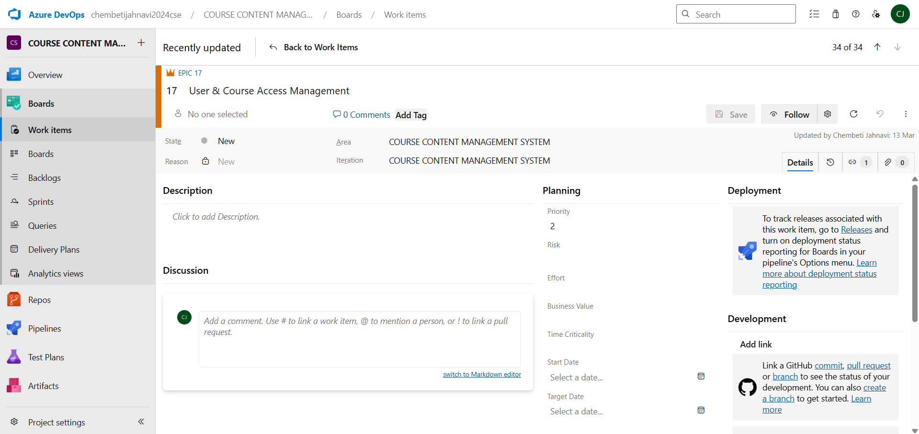

2.Fill in Features
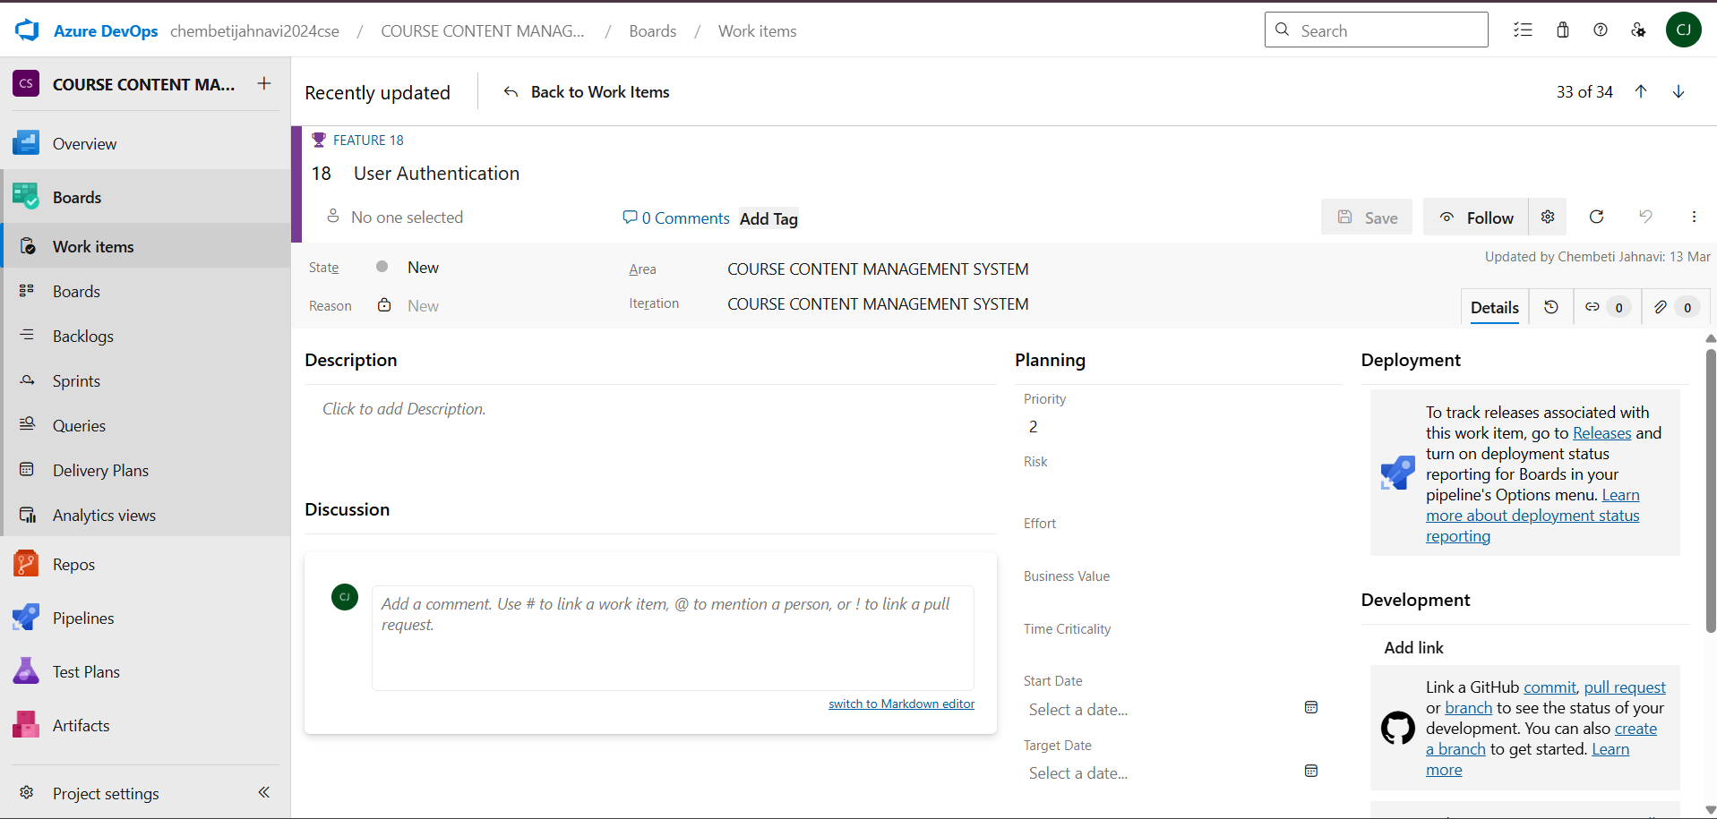

3.Fill in User Story Details
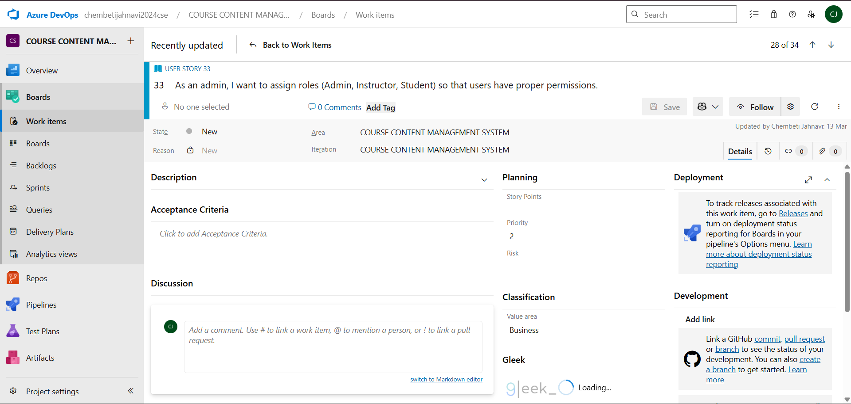

Result:
Thus, the creation of epics, features, user story and task has been created successfully.

EXP NO: 4 SPRINT PLANNING

Create Epic, Features, User Stories, Task

Aim:
To assign user story to specific sprint for “COURSE CONTENT MANAGEMENT SYSTEM” Project.

Sprint Planning
Sprint 1
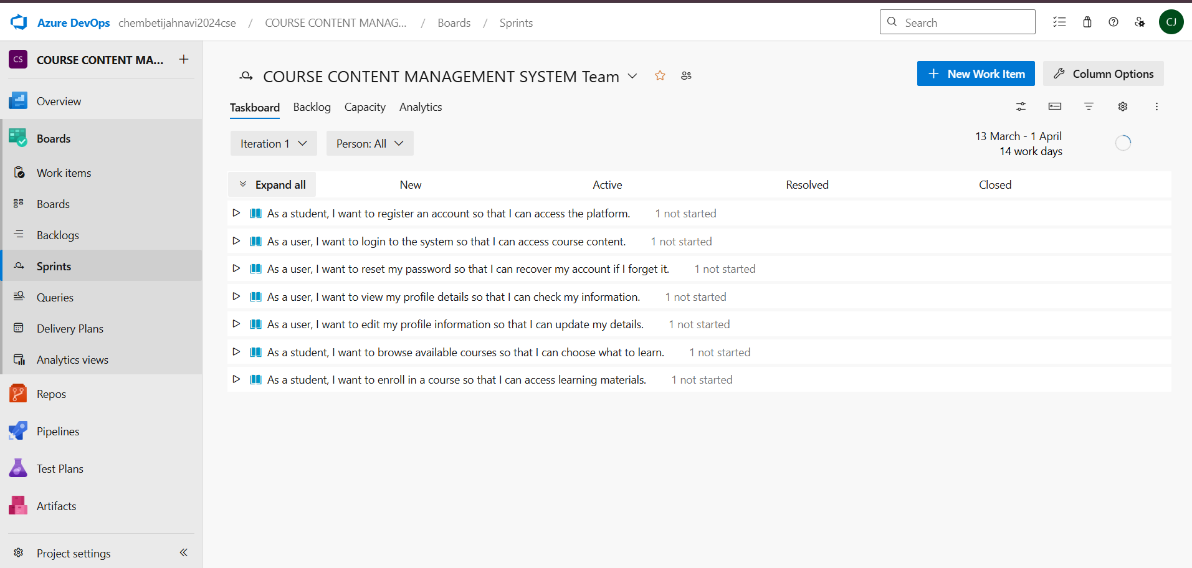

Sprint 2
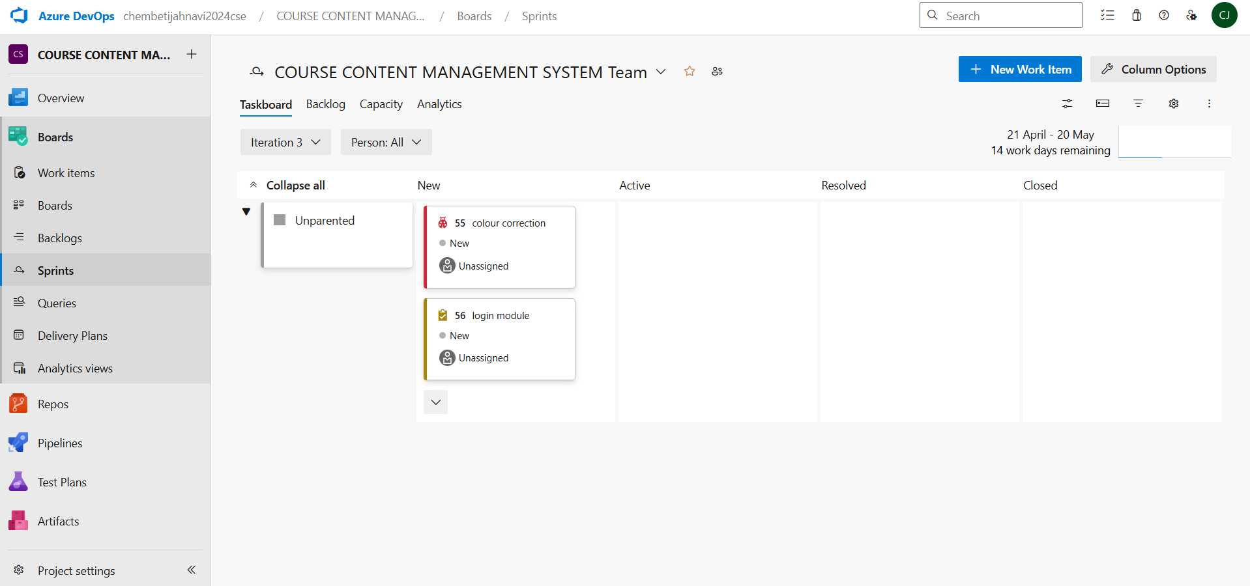

Result:
The Sprints are created for the “COURSE CONTENT MANAGEMENT SYSTEM” Project.

EXP NO: 5 POKER ESTIMATION

Create Epic, Features, User Stories, Task

Aim:
Create Poker Estimation for the user stories - “COURSE CONTENT MANAGEMENT SYSTEM” Project.
Poker Estimation

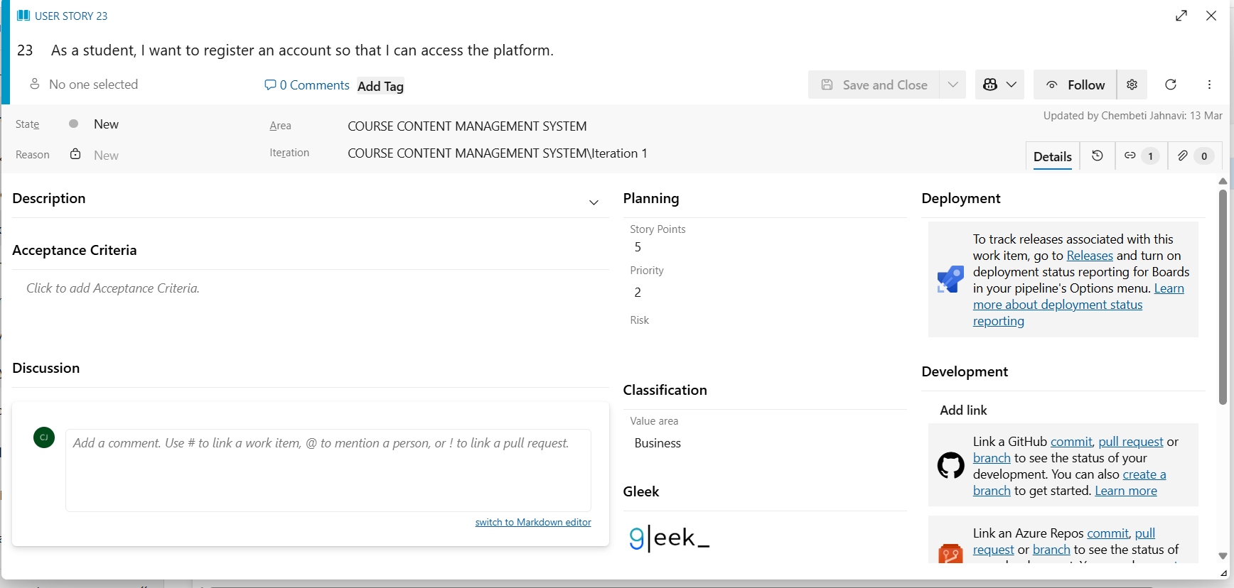

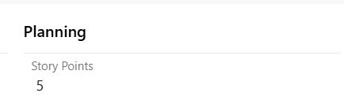
In our project “COURSE CONTENT MANAGEMENT SYSTEM” the total poker estimation we got is 24.

Result:
The Estimation/Story Points is created for the project using Poker Estimation.

EXP NO: 6 DESIGNIG CLASS AND SEQUENCE DIAGRAM FOR PROJECT ARCHITECTURE
DESIGNING CLASS AND SEQUENCE DIAGRAMS FOR PROJECT ARCHITECTURE

Create Epic, Features, User Stories, Task

Aim:
To Design a Class Diagram and Sequence Diagram for the “COURSE CONTENT MANAGEMENT SYSTEM” Project.

6A. Class Diagram
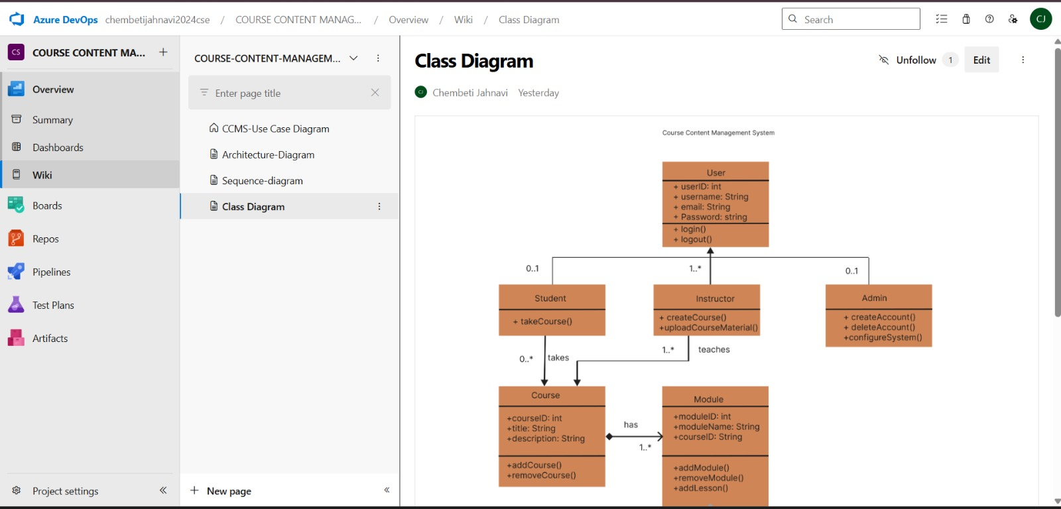
6B. Use case Diagram
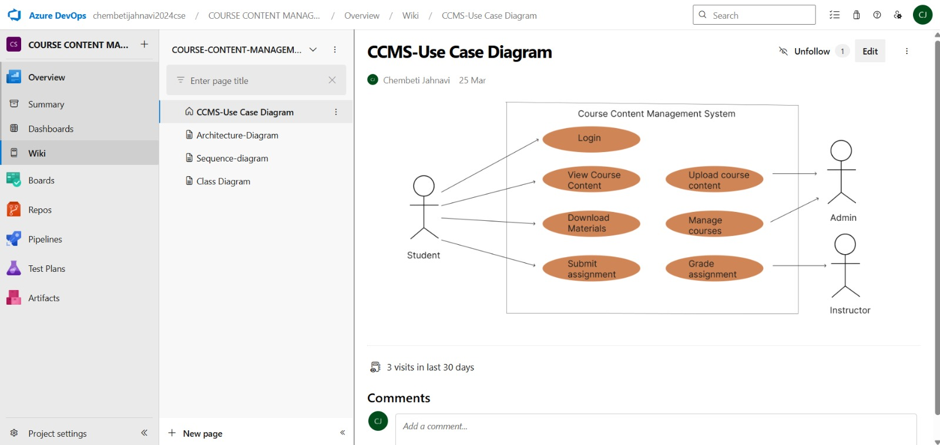
6C. Sequence Diagram
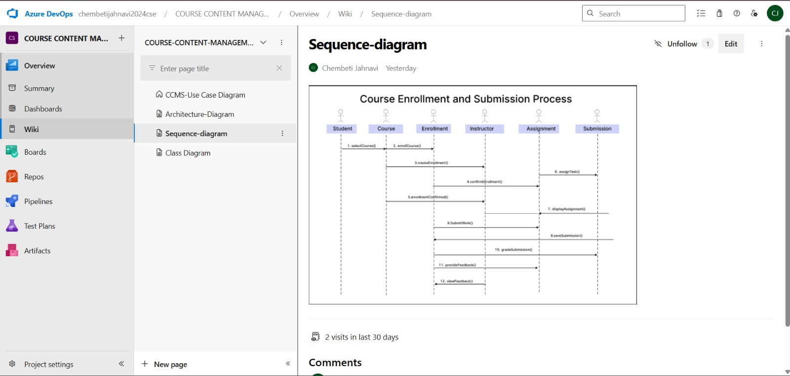

Result:
The Class Diagram and Sequence Diagram is designed Successfully for “COURSE CONTENT MANAGEMENT SYSTEM” Project.

EXP NO: 7 DESIGNING ARCHITECTURAL AND ER DIAGRAMS FOR PROJECT STRUCTURE

Create Epic, Features, User Stories, Task

Aim:
To Design an Architectural Diagram and ER Diagram for the given Project.
7A. Architectural Diagram
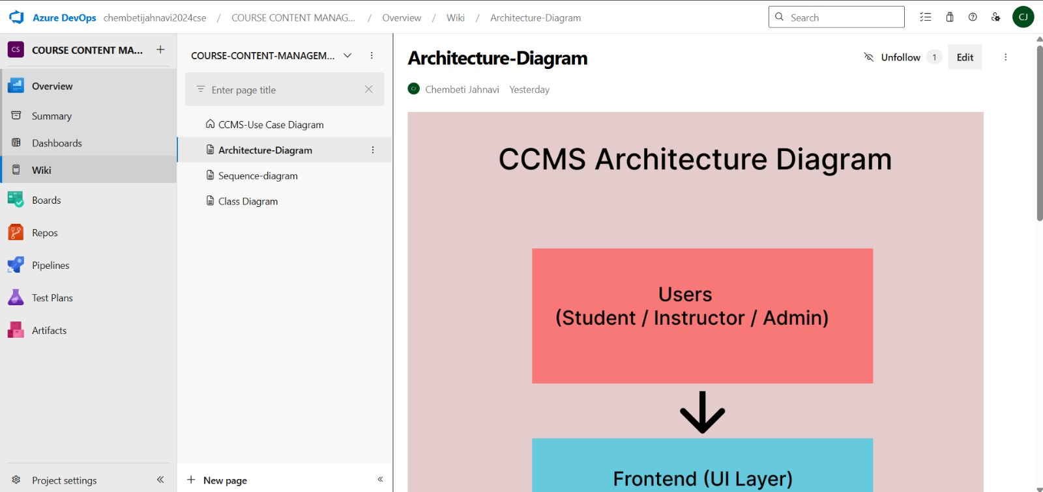

7B.ER Diagram
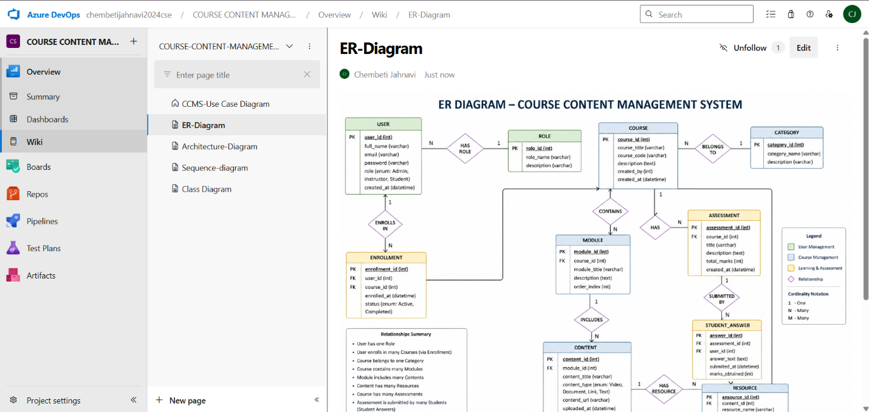

Result:
The Architecture Diagram and ER Diagram is designed Successfully for “COURSE CONTENT MANAGEMENT SYSTEM” project.

EXP NO: 8 TESTING- TEST PLANS AND TEST CASES
TESTING – TEST PLANS AND TEST CASES

Create Epic, Features, User Stories, Task

Aim:
To write two test cases for two user stories showcasing the happy path and error scenarios in azure DevOps platform.

Test Planning and Test Case
Test Case Design Procedure
- Understand Core Features of the Application
• User Account Management
- Student/Admin login and registration
• Course Management
- View available courses
- Access course materials and modules
• Quiz Management
- Attempt quizzes and submit answers
• Assignment Management
- View assignments and submission details
• Progress Tracking
- Monitor completed courses, quizzes, and assignments
• Content Access
- Access learning resources such as PDFs, videos, and notes
- Define User Interactions
Each test case simulates real user behaviour within the application.
Examples:
• User logs in successfully
• User opens a course
• User attempts a quiz
• User checks assignments
- Design Happy Path Test Cases
Focused on validating that all features function correctly under normal conditions.
Examples:
• User logs in with valid credentials
• User successfully views course content
• User completes quiz submission
• User accesses assignment page successfully
- Design Error Path Test Cases
Simulate invalid or unexpected scenarios to test robustness and error handling.
Examples:
• Login fails with invalid username or password
• Quiz submission fails without selecting answers
• Course page unavailable due to invalid access
• Assignment page shows error when content is missing
- Break Down Steps and Expected Results
Each test case contains step-by-step actions and corresponding expected outcomes.
Example:
Step: Enter valid login credentials
Expected Result: Redirects to home dashboard successfully
- Use Clear Naming and IDs
Test cases are named clearly for easy identification and traceability.
Examples:
TC01 – Successful Login
TC02 – Invalid Login
TC03 – View Course Content
TC04 – Attempt Quiz Successfully
TC05 – View Assignment Page
- Separate Test Suites
Group test cases based on functionality.
Examples:
• Login Module
• Course Module
• Quiz Module
• Assignment Module
• Dashboard Module
This improves organization and test execution flow in Azure DevOps.
- Prioritize and Review
Critical user actions are marked as high priority.
High Priority Features:
• Login
• Course Access
• Quiz Submission
• Assignment Access
Test cases are reviewed for completeness, accuracy, and traceability against project requirements.
1.New test plan
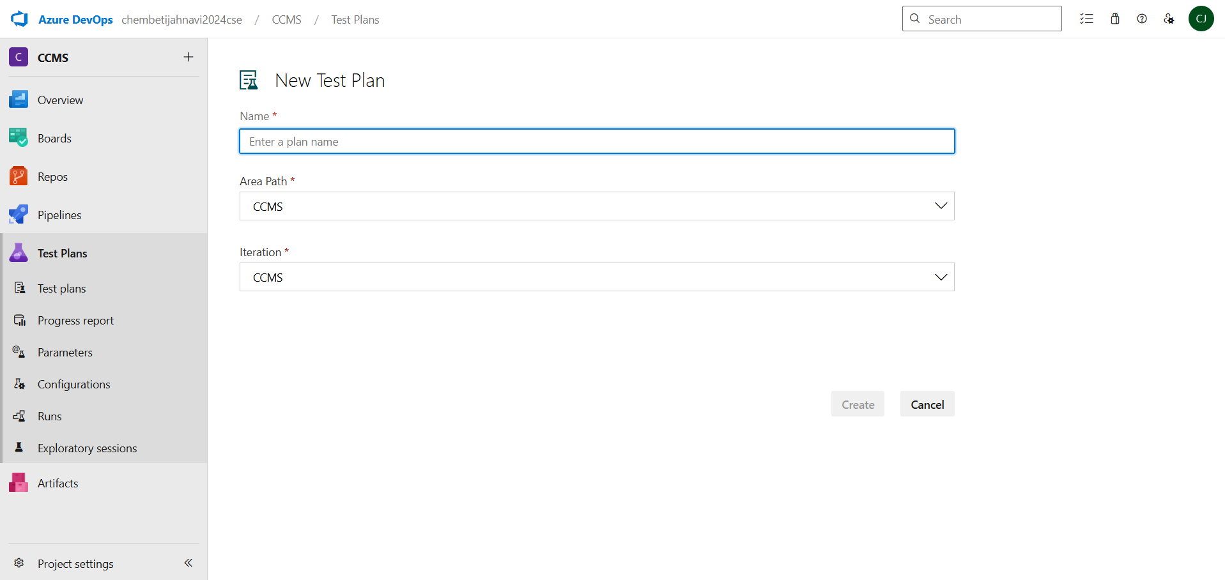
2.Test suite
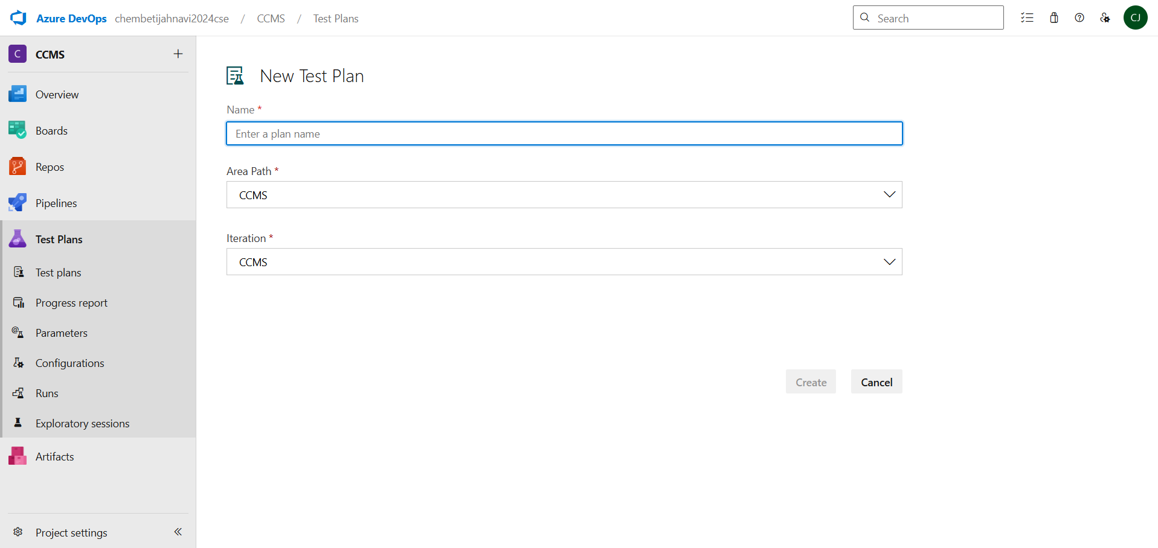

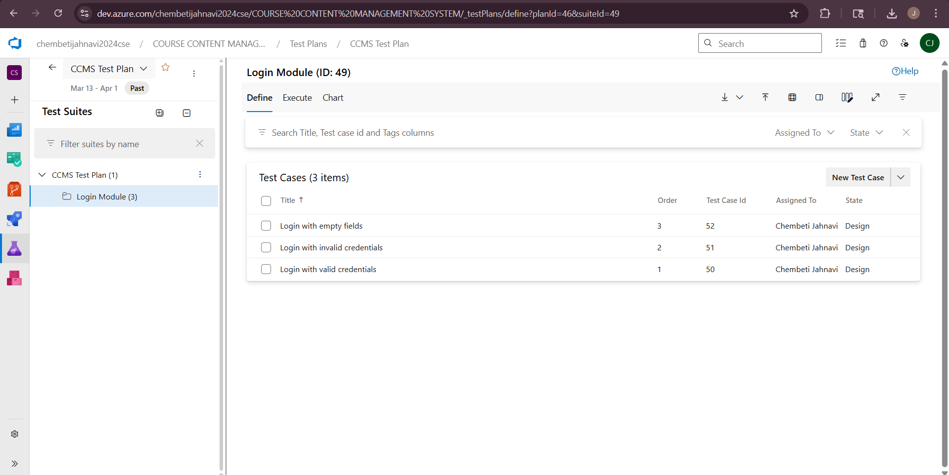
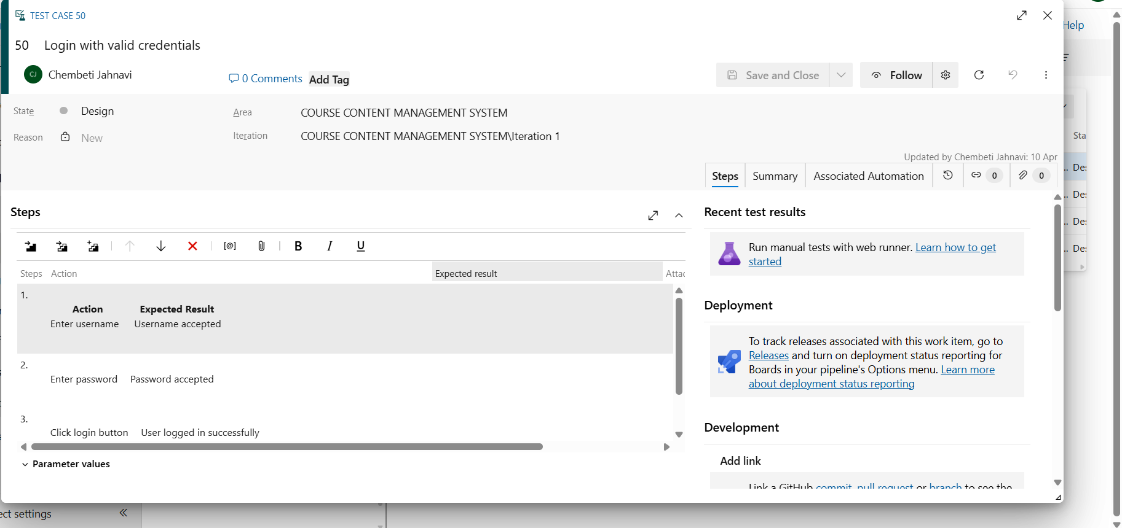

4.Installation of test
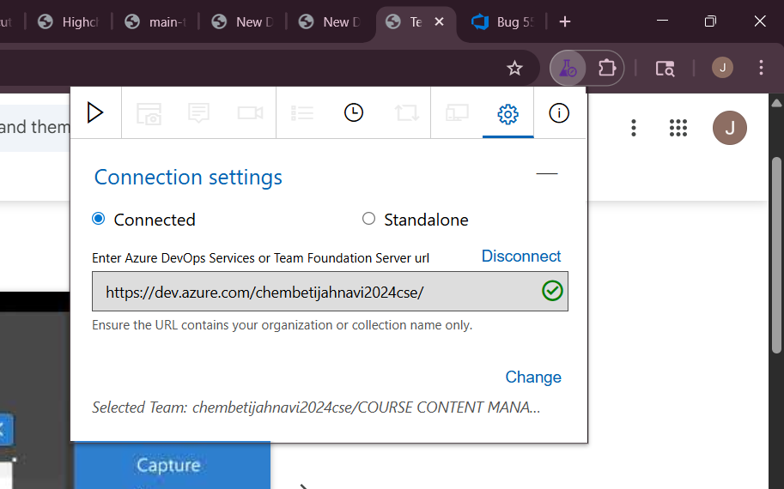
Test and feedback
Showing it as an extension

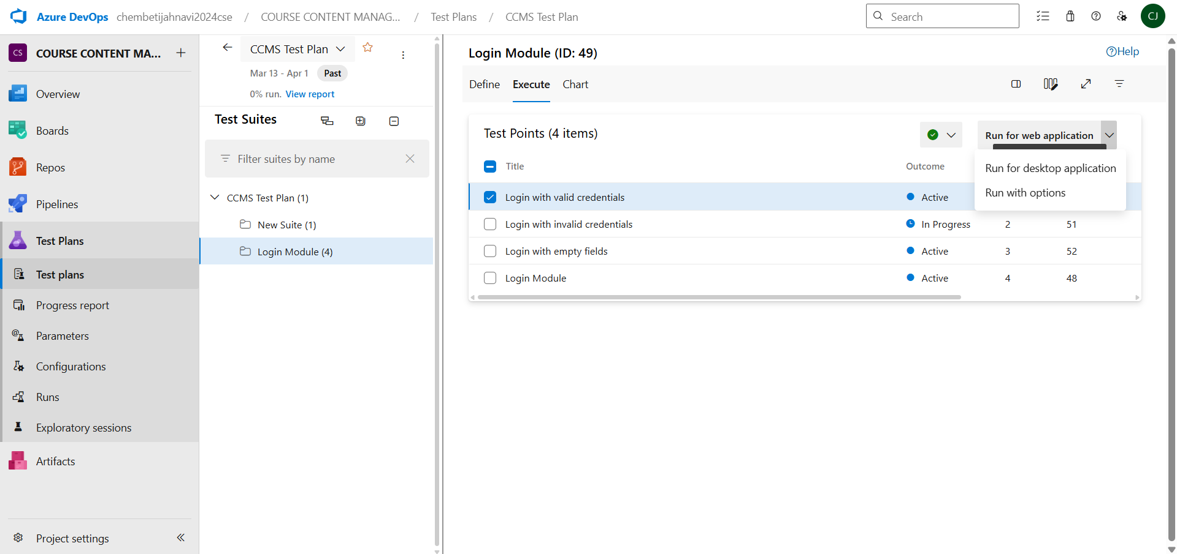

5.Running the test cases
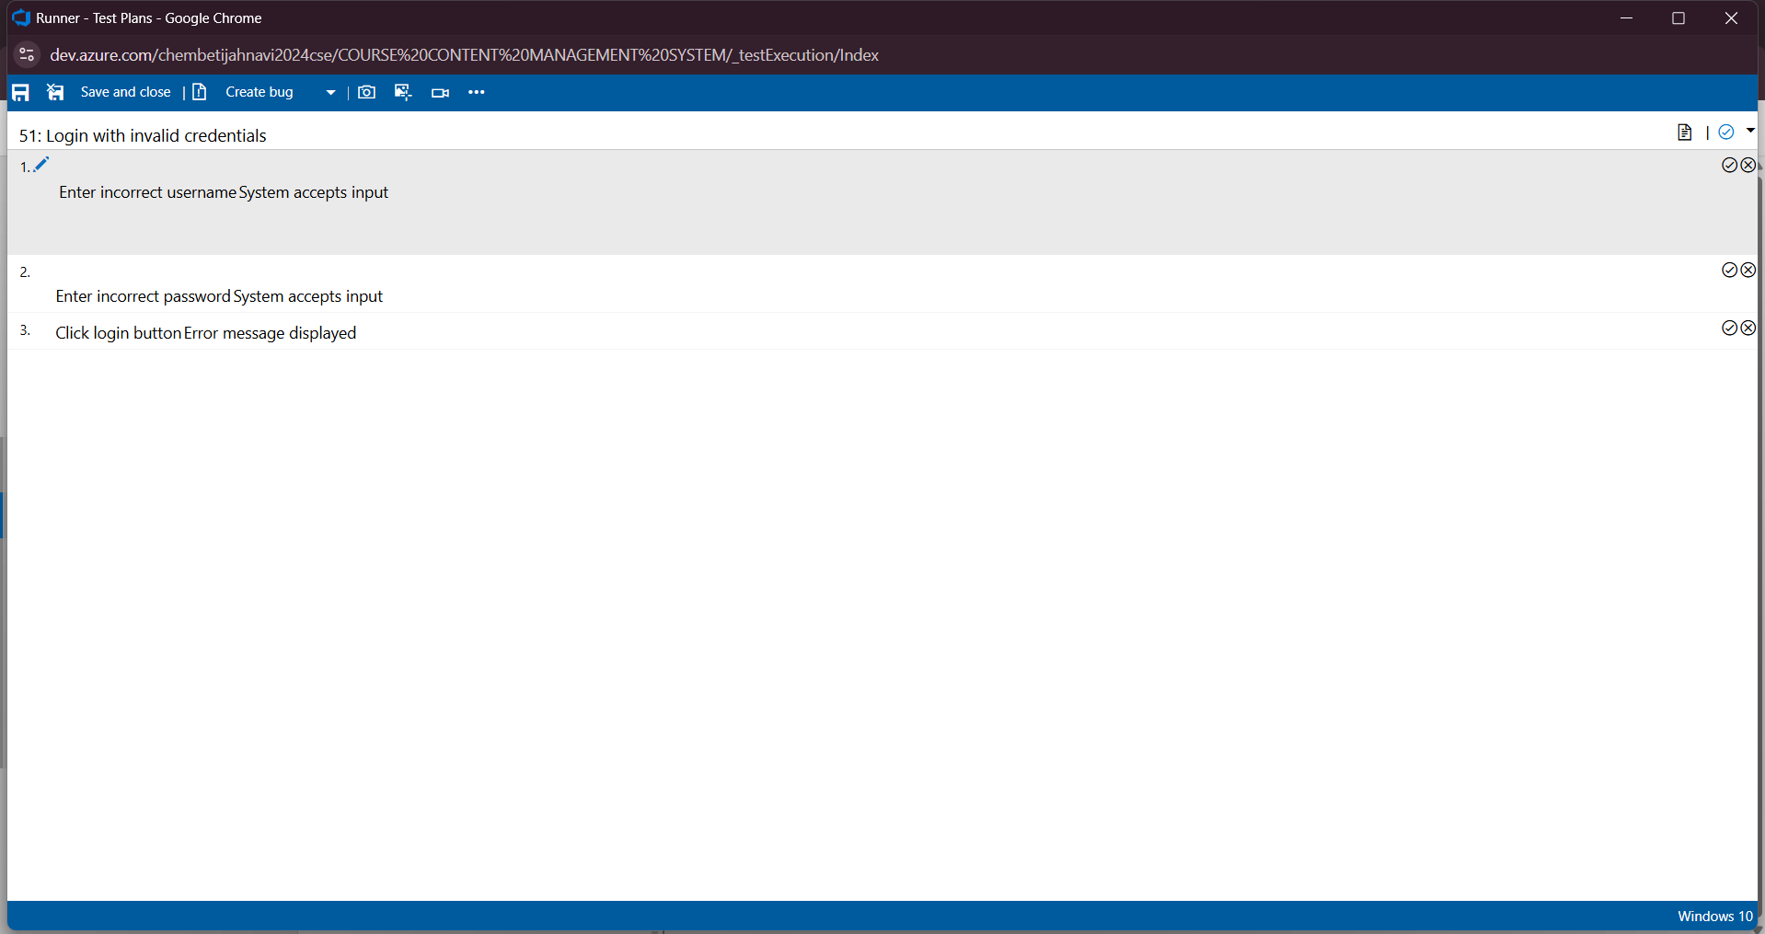

6.sample test chart
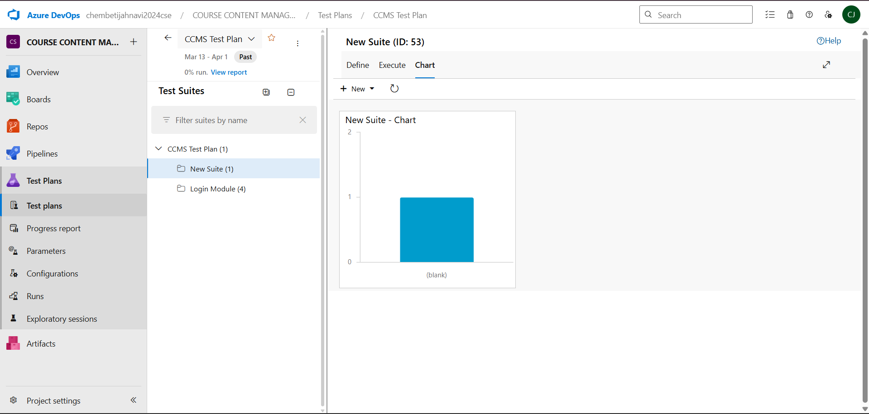

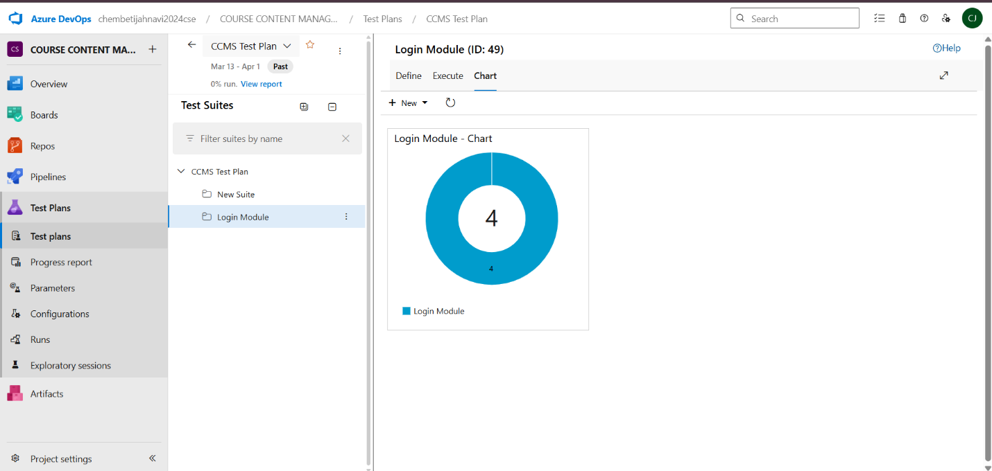

Result:
The test plans and test cases for the user stories is created in Azure DevOps with Happy Path and Error Path.

EXP NO: 9 LOAD TESTING AND PIPELINES
LOAD TESTING AND PIPELINES

Create Epic, Features, User Stories, Task

Aim:
To perform load testing on the Course Content Management System web application using BlazeMeter in order to evaluate application performance, response time, and system stability under multiple user requests.
BlazeMeter Load Testing:
BlazeMeter is a cloud-based performance testing tool used to simulate virtual users accessing a web application simultaneously. It helps identify performance bottlenecks, monitor response times, measure throughput, and evaluate application behavior under load conditions.
Steps to Perform Load Testing using BlazeMeter:
- Sign in to BlazeMeter
Go to https://www.blazemeter.com and log in using your registered account credentials.
- Create a New Test
After logging in, navigate to the dashboard and click on Create Test.
- Select Test Type
Choose the k6 load testing option for creating a web performance test.
- Create Load Testing Script
Create a JavaScript file named loadtest.js containing the load testing script for the target website.
Example script used:
import http from 'k6/http';
import { sleep } from 'k6';
export const options = {
vus: 10,
duration: '1m',
};
export default function () {
http.get('https://jahnavi-20070702.github.io/Course-Content-Management-System/');
sleep(1);
}
- Upload Test Script
Upload the loadtest.js file into BlazeMeter as the entry file for test execution.
- Configure Load Settings
Set the following test parameters:
• Virtual Users (VUs): 10
• Duration: 1 minute
• Ramp-up Time: 10 seconds
- Run the Test
Click Run Test to begin the load testing process.
- Analyze Results
After execution, observe and record the following performance metrics:
• Response Time
• Throughput
• Success Rate
• Error Percentage
• Requests per Second

Creating the test:
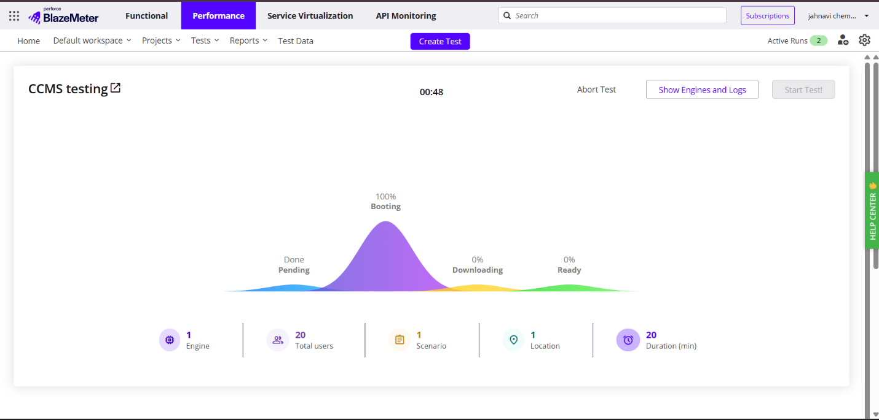

Load Testing
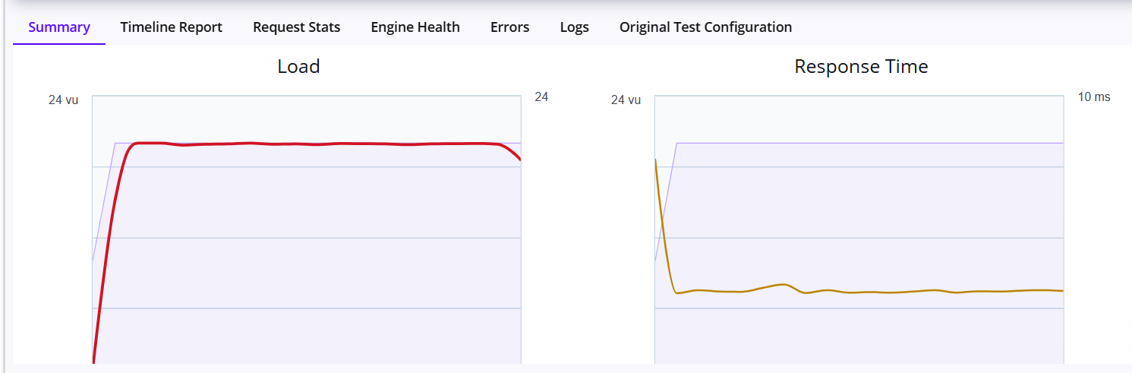

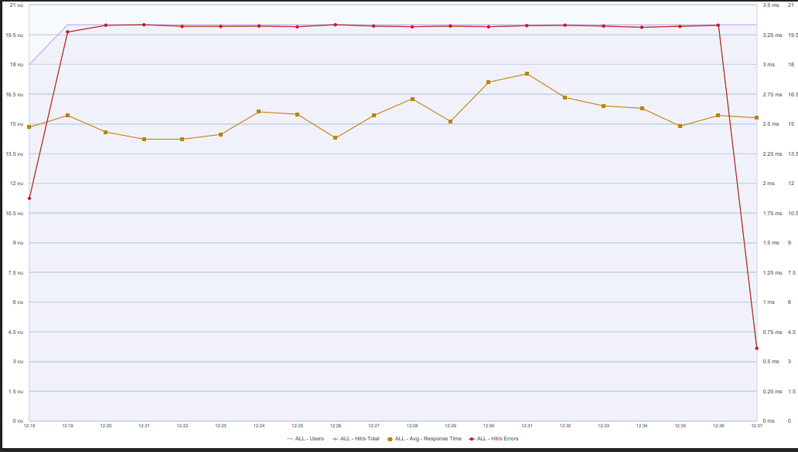
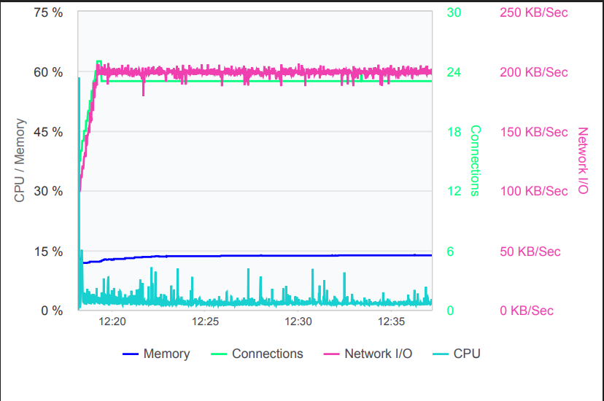

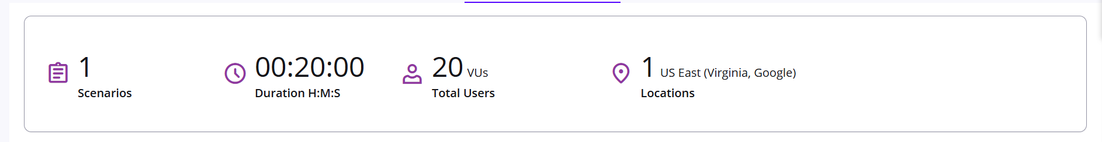

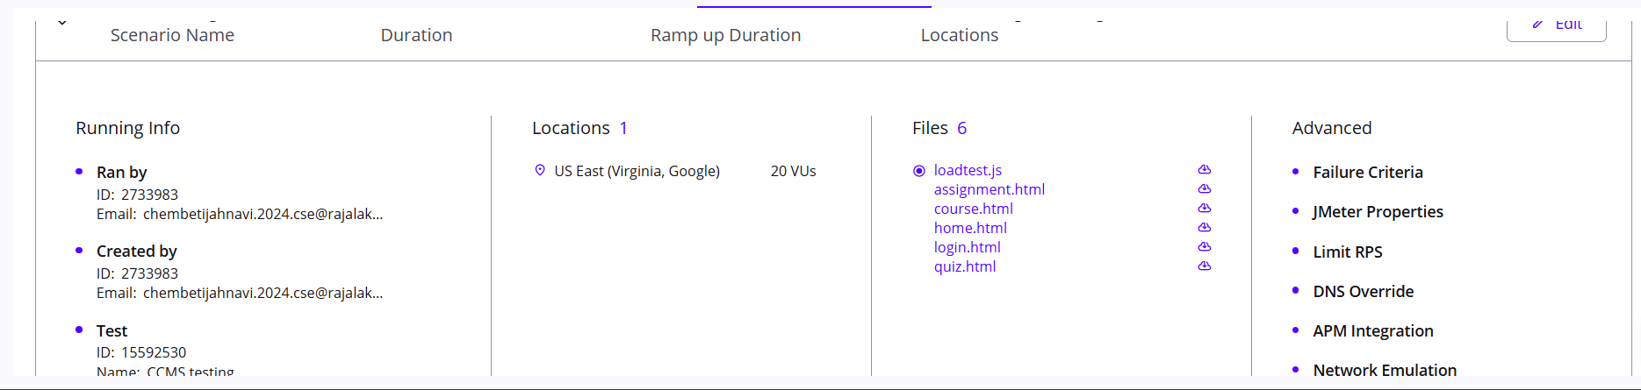

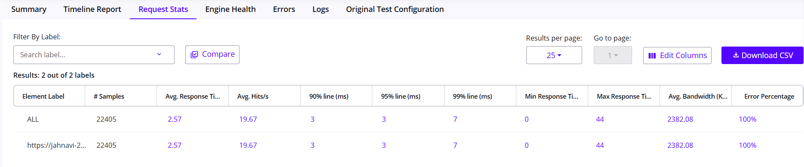

Project output(Webpage):
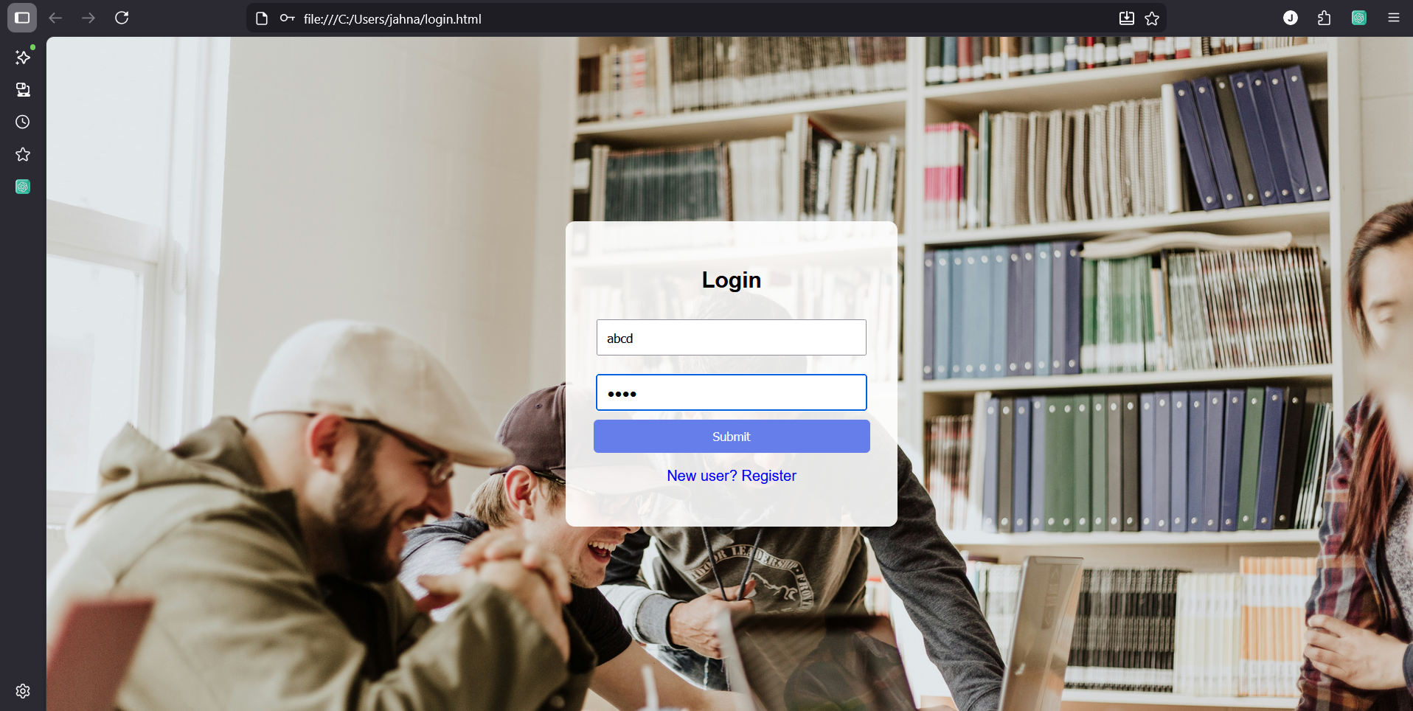

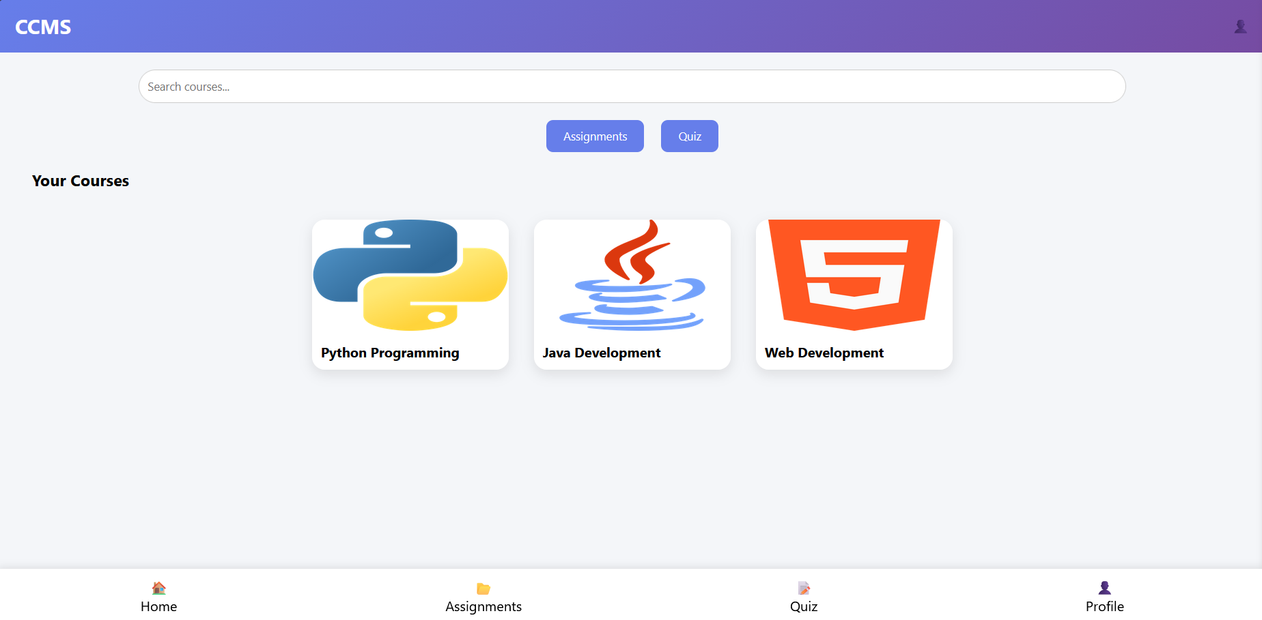

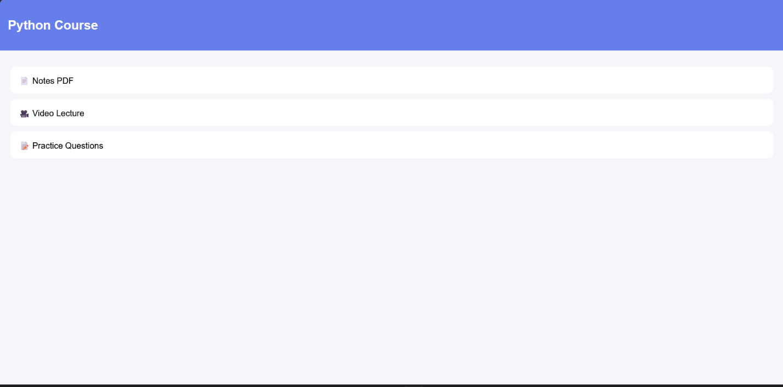

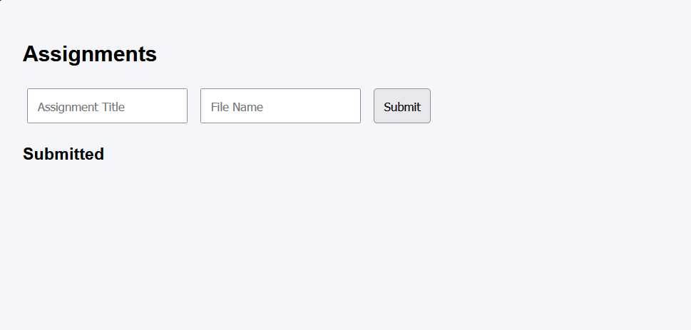

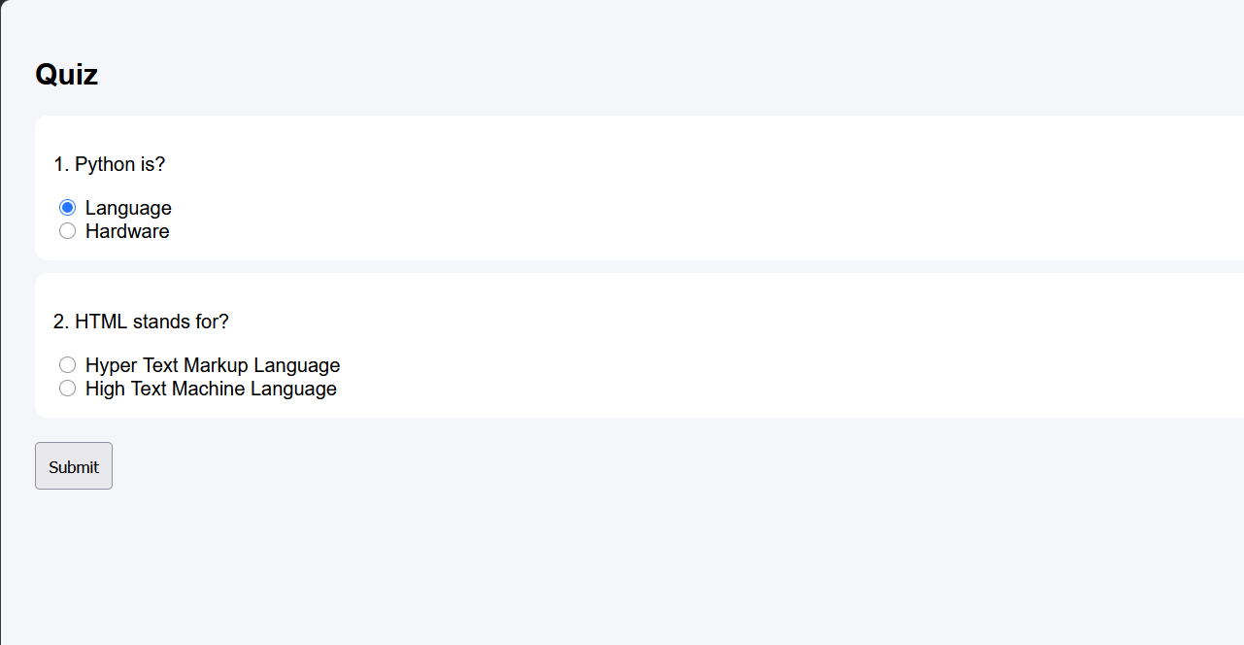

Pipelines

Steps:
Connect GitHub to Azure DevOps:
- Sign in to Azure DevOps using valid credentials.
- Create a new project named Course Content Management System.
- Navigate to the Pipelines section and click New Pipeline.
- Select GitHub as the source repository.
- Authorize Azure DevOps to access the GitHub repository.
- Select the repository containing the Course Content Management System project files.
Create azure-pipelines.yml in Repository Root:
- In the GitHub repository, create a new file named:
azure-pipelines.yml
- Add the pipeline configuration code inside the file.
- Save and commit the file to the main branch.

Pipeline

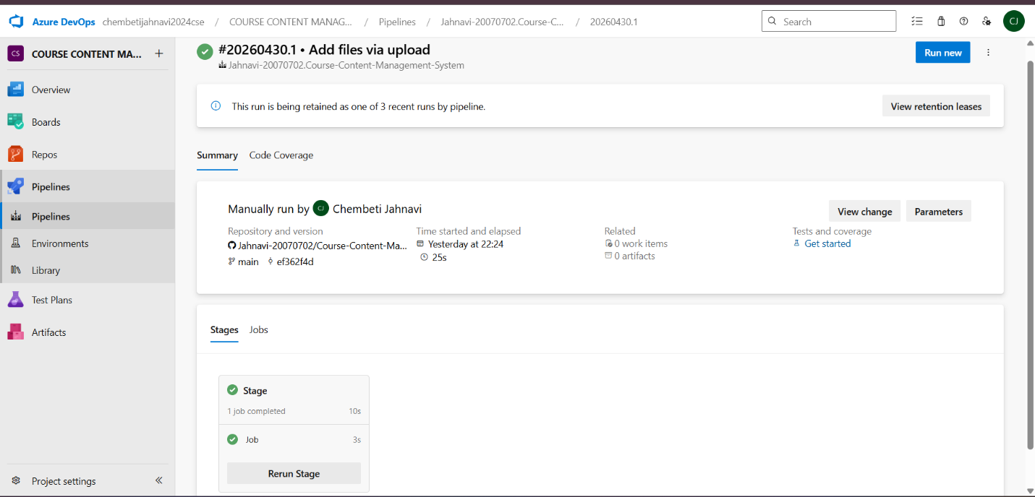
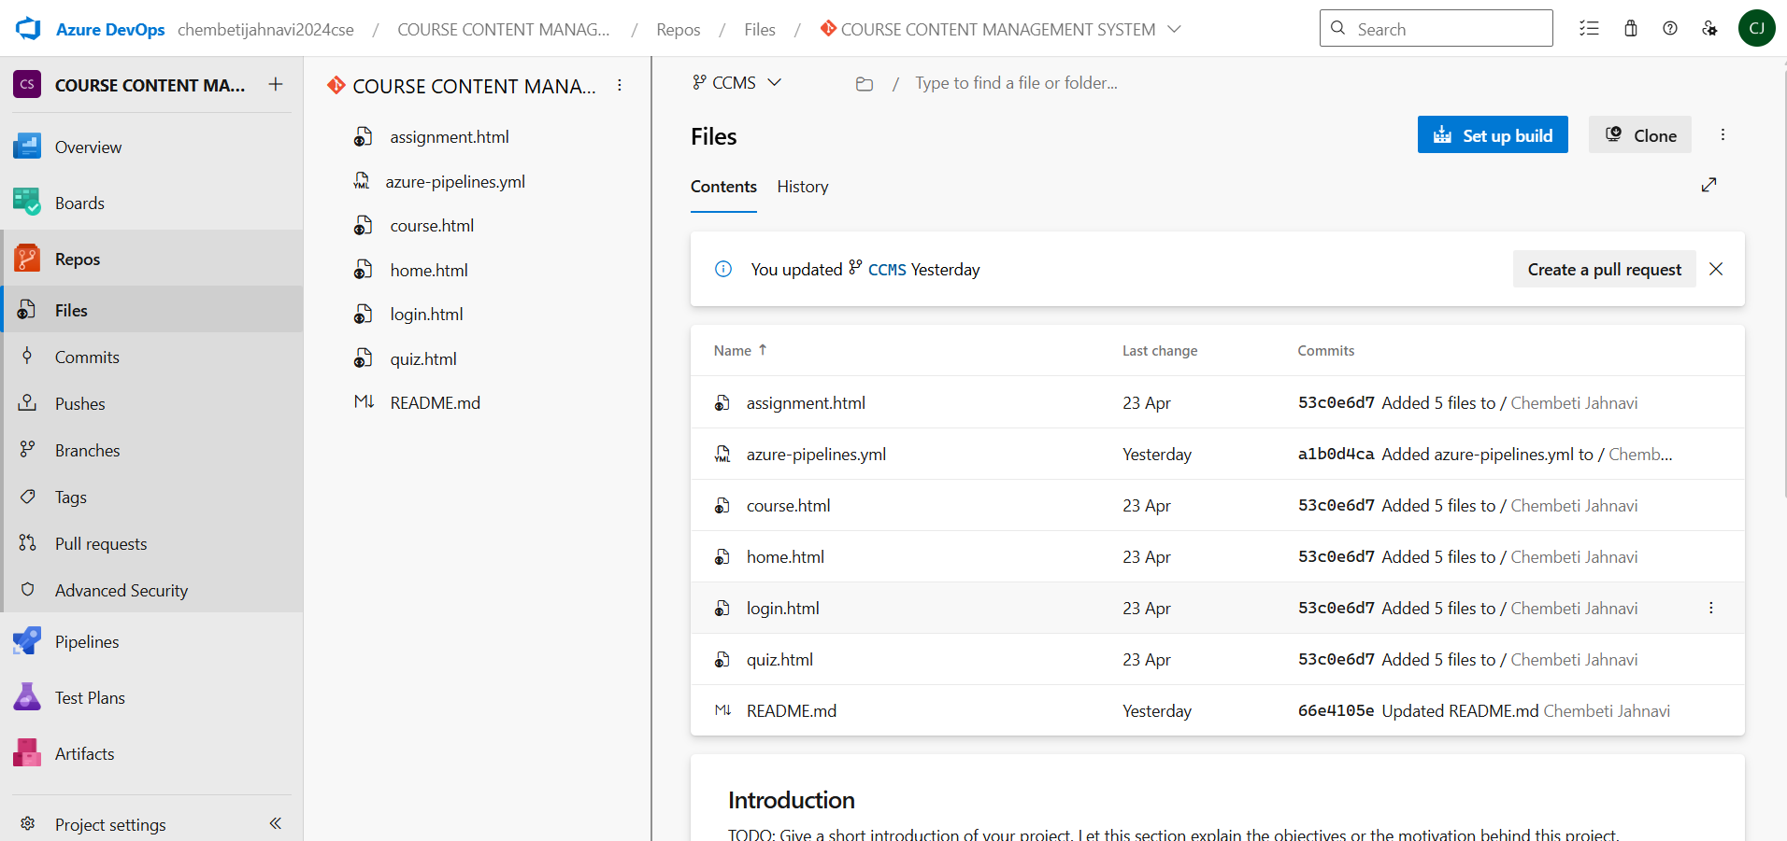
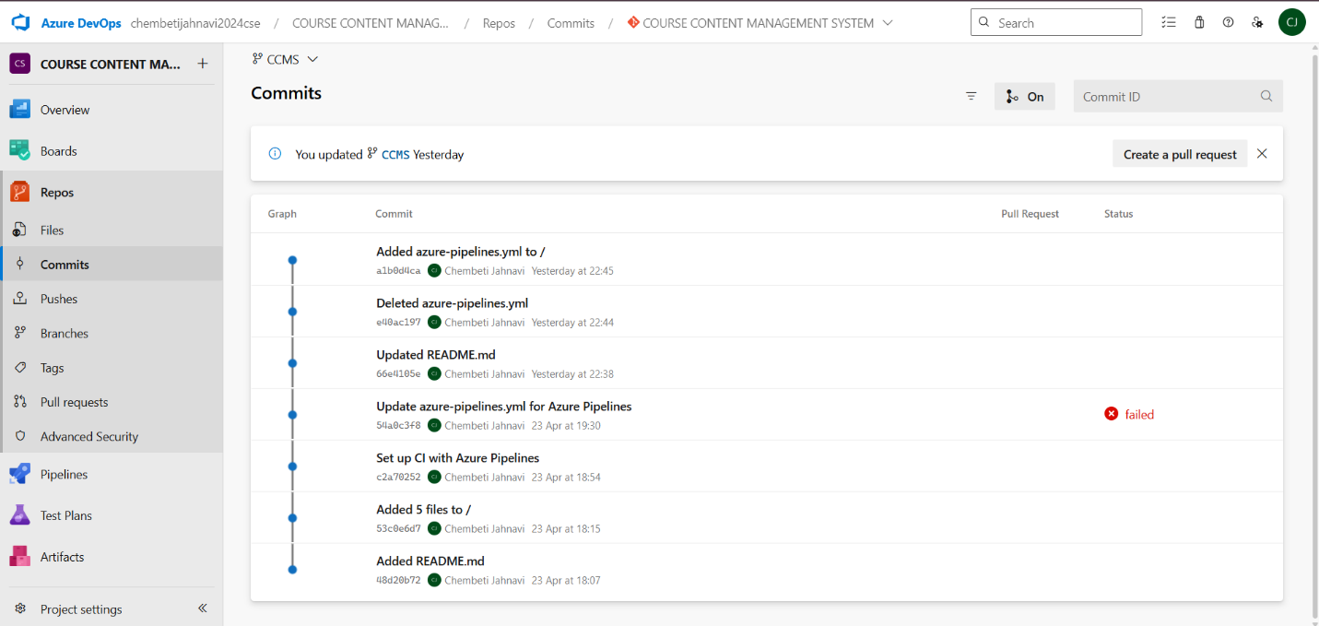

YML code:
trigger:
- main

pool:
vmImage: 'ubuntu-latest'

steps:
- script: echo "Building CCMS Project"
displayName: 'Build Step'

- task: CopyFiles@2
displayName: 'Copy Project Files'
inputs:
SourceFolder: '$(Build.SourcesDirectory)'
Contents: '**'
TargetFolder: '$(Build.ArtifactStagingDirectory)'

- task: PublishBuildArtifacts@1
displayName: 'Publish Artifact'
inputs:
PathtoPublish: '$(Build.ArtifactStagingDirectory)'
ArtifactName: 'ccms-site'

Result:
The load test was successfully executed on the Course Content Management System web application using BlazeMeter. The application handled multiple concurrent users successfully and performance metrics were generated for analysis.

EXP NO: 10 GITUB: PROJECT STRUCTURE & NAMING CONVENTIONS

Create Epic, Features, User Stories, Task

Aim:
To provide a clear and organized view of the project's folder structure and file naming conventions, helping contributors and users easily understand, navigate, and extend the “COURSE CONTENT MANAGEMENT SYSTEM” project.

GitHub Project Structure

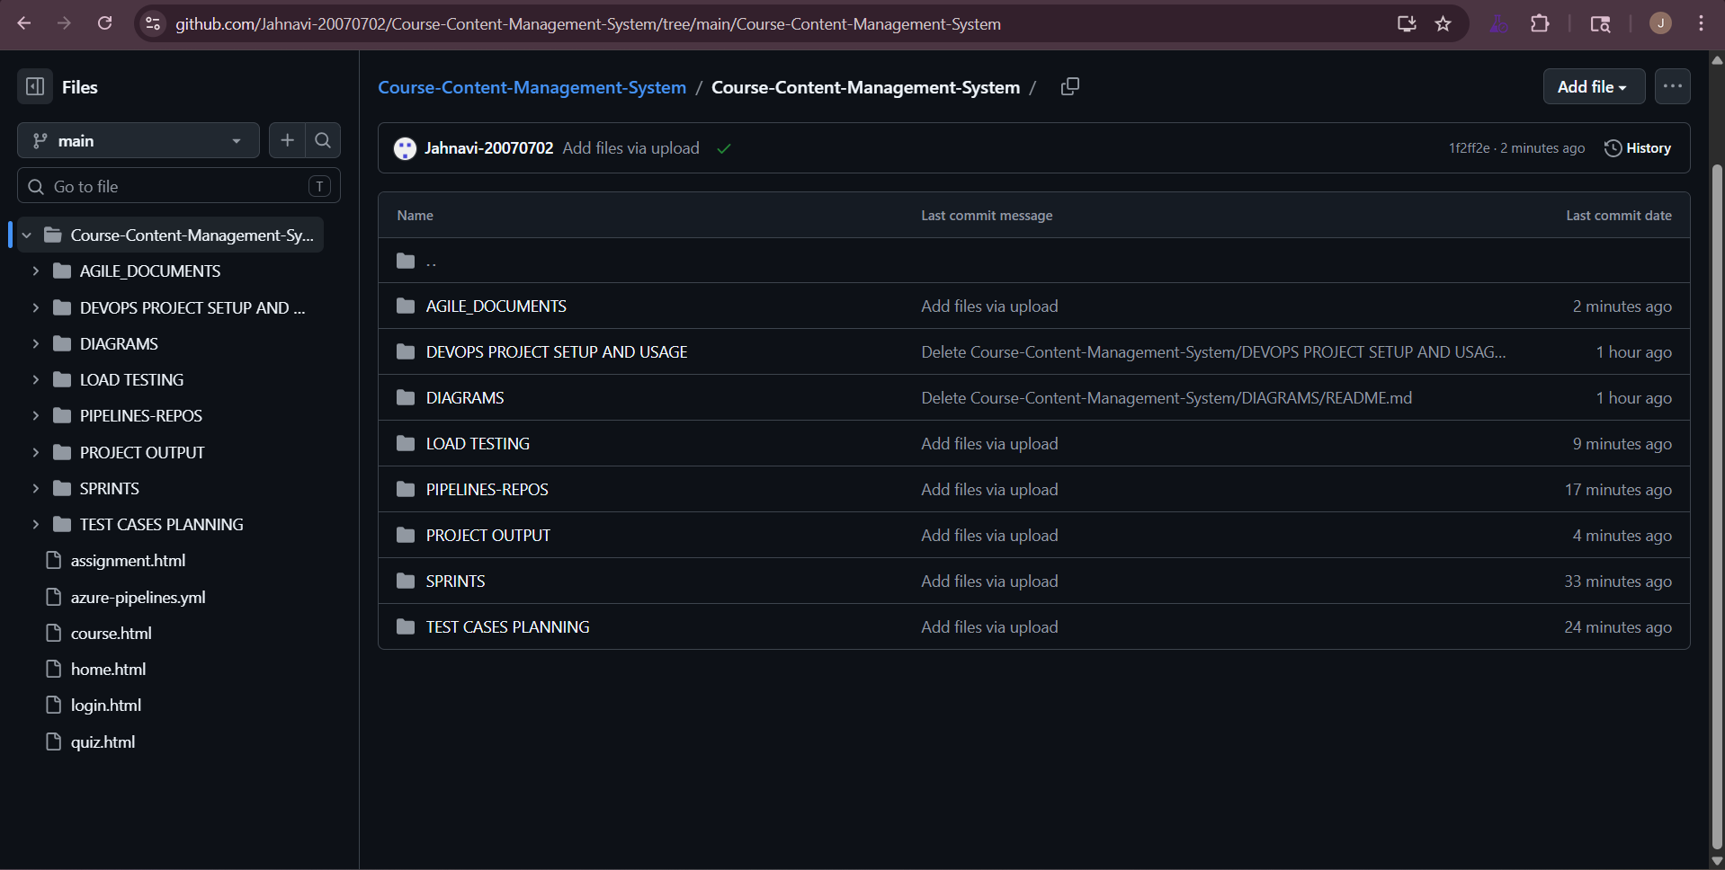

Result:
The GitHub repository clearly displays the organized project structure and consistent naming conventions, making it easy for users and contributors to understand and navigate the codebase.

