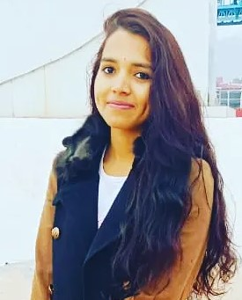**RESUME**

**DEEPIKA**

+91 75790 94590

Email Id: [deepika1252001@gmail.com](mailto:deepika1252001@gmail.com)

**OBJECTIVE**

To work with an organization where can learn new skill and increase my abilities for the organizational goals as well as myself.

**EDUCATIONAL QUALIFICATION**

* Pursuing BCA from SDIMT
* Passed out 12th from UK Board in 2019
* Passed out 10th from UK Board in 2017

**OTHER ACADAMIC DETAILS**

* Tally prime

**TECHNICAL SKILLS**

* Computer languages: C, C++ , HTML, CSS, Basic JAVA , DSA with JAVA.
* Basic knowledge of computer.

**WORK EXPERIENCE**

FRESHER

**STRENGTH & HOBBIES**

* Hard & smart working
* Honest & punctual
* Good communication skill
* Arts , Crafting, Reading books, learning new things.

**PERSONAL DETAILS**

Father’s name : Mr. Ripu Daman Singh

Date of birth : 12-05-2001

Address : R.K Mission road KANKHAL ,

HARIDWAR.

Merital status : single

DATE : …………………… DEEPIKA