“Comparative Study On Heamodynamic Stability
Between Butorphanol Vs Fentanyl In
Laproscopic Surgeries”

Submitted in partial fulfilment of the requirement for the award of a degree
B.Sc Anaesthesia and Operation Theater Technology



by
NUKULA HARISH
211904270003
2022-2026

CENTURION UNIVERSITY OF TECHNOLOGY & MANAGEMENT SCHOOL ALLIED AND HEALTHCARE SCIENCES
ANDHRAPRADESH 2026


DECLARATION

I hereby declare that the thesis entitled “Comparative Study On Heamodynamic Stability Between Butorphanol Vs Fentanyl In Laproscopic Surgeries” submitted by me, for the award of the degree of B.Sc. Anesthesia and operation theater technology to Centurion University of Technology and Management is a record of Bonafide work carried out by me at Q1 hospitals. The project work was carried out, under the supervision of Dr. S. Siddhardha, as the External Supervisor and, Mrs. Sireesha Gottapu as the Internal Supervisor, School of Paramedics and Allied Health Sciences (SoPAHS).
I further declare that the work reported in this thesis has not been submitted and will not be submitted either in part or in full, for the award of any other degree or diploma in this institute or any other Institute or University.

Place:
Date: Signature of the Candidate


CERTIFICATE

This is to certify that the thesis entitled “Hemodynamic alterations after administering bupivacaine heavy alone vs bupivacaine + fentanyl for tkr surgeries” submitted by P. BHAVANA SARANYA, for the award of the degree of B. Sc. Anesthesia and operation theater technology, is a record of Bonafide work carried out by the student under my supervision, at Q1 Hospital/ Diagnostic Center as per the academic code of the University.

The contents of this report have not been submitted and will not be submitted either in part or in full, for the award of any other degree or diploma in this institute or any other Institute or University. The thesis fulfils the requirements and regulations of the University and in my opinion meets the necessary standards for submission.

Place:
Date: Signature of the Guide
(External Guide)
Dr. S. Siddhardha Consultant anesthetist, Dept of anesthesia
Q1 hospitals


CERTIFICATE

This is to certify that the thesis entitled “Hemodynamic alterations after administering bupivacaine heavy alone vs bupivacaine + fentanyl for tkr surgeries” submitted by P. BHAVANA SARANYA, for the award of the degree of B. Sc. Anesthesia and operation theater technology, is a record of Bonafide work carried out by the student under my supervision, at Q1 Hospital/ Diagnostic Center as per the academic code of the University.

The contents of this report have not been submitted and will not be submitted either in part or in full, for the award of any other degree or diploma in this institute or any other Institute or University. The thesis fulfils the requirements and regulations of the University and in my opinion meets the necessary standards for submission.

Place:
Date: Signature of the Guide
(Internal Guide)

Mrs. Sireesha Gottapu, Assistant Professor, Department of Anesthesia, Centurion University of Technology and Management.



ACKNOWLEDGEMENTS

I wish to express my profound and sincere gratitude to Prof. Mrs. Sireesha Gottapu, Department of Anesthesia and operation theatre technology, SoAHS, Vizianagaram Campus, who guided me into the intricacies of this thesis nonchalantly with matchless magnanimity.
I thank Prof. Mrs. Syamala Alana Teja, Head of the Dept. of Anesthesia and operation theatre technology, SoAHS, Vizianagaram Campus and Prof. Dr N Srinivas, Dean, SOAHS, Vizianagaram Campus for extending their support during Course of this investigation.
I would be failing in my duty if I don’t acknowledge the cooperation rendered
during various stages of image interpretation by Dr. S. Siddhardha.
I am highly grateful to my friends and colleagues who evinced keen interest and invaluable support in the progress and successful completion of my thesis work.
I am indebted to my family for their constant encouragement, co-operation and help. Words of gratitude are not enough to describe the accommodation and fortitude which they have shown throughout my endeavor.

Signature of the Student: Registration No: 221904270014 Place:
Date:

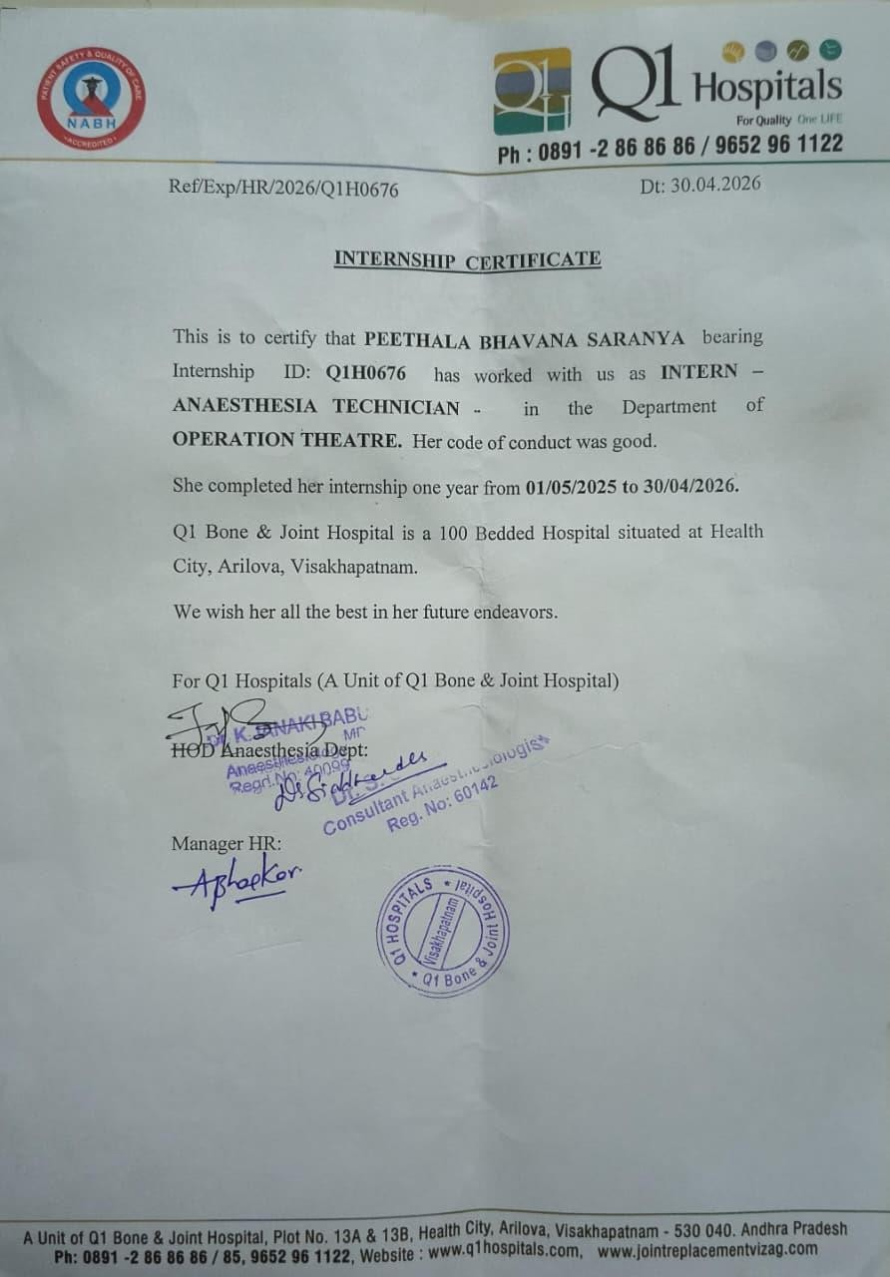

TABLE OF CONTENTS

CHAPTER. NO. | TITLE | PAGE.NO.
CHAPTER-1 | INTRODUCTION | 1-2
CHAPTER-2 | REVIEW OF LITRATURE | 3-4
CHAPTER-3 | AIMS AND OBJECTIVES | 5
CHAPTER-4 | MATERIALS AND METHODS | 6-8
CHAPTER-5 | RESULTS | 9-18
CHAPTER-6 | DISCUSSION | 19-20
CHAPTER-7 | CONCLUSION | 21
CHAPTER-8 | REFERENCES | 22
 | APPENDIX
 | ANNEXURES

S.NO. | TITLE | TABLE. NO | PG.NO
1 | Descriptive statistics | 5.1 | 9
2 | Normality test | 5.2 | 10
3 | Independent sample T- Tests HR, MAP | 5.3 | 10
4 | Independent sample T- Tests Spo2 | 5.3.1 | 10-11
5 | Independent sample T- Tests block recovery | 5.3.2 | 11
6 | Contingency tables hypotension | 5.4 | 11
7 | Within subject effects time vs group effect | 5.5 | 11-12

S.NO | TITLE | GRAPH.NO | PAGE.NO
1 | HR at 0 mins B, B+F | 5.1 | 13
2 | HR after 5 mins B, B+F | 5.2 | 13
3 | HR after 10 mins B, B+F | 5.3 | 14
4 | HR after 20 mins B, B+F | 5.4 | 14
5 | MAP at B, B+F | 5.5 | 15
6 | MAP after 5 mins B, B+F | 5.6 | 15
7 | MAP after 10 mins B, B+F | 5.7 | 16
8 | MAP after 20 mins B, B+F | 5.8 | 16
9 | Peak Block_min B, B+F | 5.9 | 17
10 | Sensory Duration min B, B+F | 5.10 | 17
11 | Ambulation hrs B, B+F | 5.11 | 18

S.No | Abbreviations
1 | MAP | Mean arterial pressure
2 | “SA”- | Spinal anesthesia
3 | “SF”- | Cerebro Spinal Fluid
4 | “TKR”- | Total Knee Replacement
5 | “HR”- | Heart rate
6 | “Spo2”- | Saturation.
7 | “ASA”- | American society of anaesthesiology
8 | “OT”- | Operation Theatre

ABSTRACT

Although spinal anesthesia is frequently utilized for total knee replacement (TKR) procedures, sympathetic blocking frequently results in major hemodynamic changes, including bradycardia and hypotension. The most used local anesthetic is bupivacaine, however using it by itself can cause significant hemodynamic instability. It has been suggested that adding intrathecal fentanyl will improve hemodynamic stability and increase analgesia. 32 patients (ASA I–II, ages 40–60) undergoing elective TKR under spinal anesthesia were included in this prospective comparative analysis. Patients were split into two groups: Group B+F (n=16) received bupivacaine plus fentanyl, while Group B (n=16) received 0.5% hyperbaric bupivacaine alone. Heart rate (HR), mean arterial pressure (MAP), and oxygen saturation (SpO₂) were among the hemodynamic parameters that were measured at baseline, five, ten, and twenty minutes following spinal anesthesia. Additionally assessed were the features of the block, the length of analgesia, and the frequency of complications. The bupivacaine plus fentanyl group showed considerably improved hemodynamic stability, according to the data, with a smaller decrease in HR and MAP at all observed intervals (p < 0.05). The bupivacaine group had a considerably higher incidence of hypotension (p < 0.001).The combination group also demonstrated a much longer duration of analgesia (250 ± 9.12 minutes vs. 159 ± 7.86 minutes) and a quicker start of sensory block. The fentanyl group had a longer time to ambulation, but there was no discernible change in SpO₂ between the groups. In conclusion, adding fentanyl to intrathecal bupivacaine enhances hemodynamic stability, prolongs postoperative analgesia, and lowers the risk of bradycardia and hypotension, making it a safer and more efficient option than bupivacaine alone for patients having TKR procedures.

CHAPTER-1

One of the most used regional anaesthetic methods for lower limb, pelvic, and lower abdominal procedures SA. Its quick onset, extensive neuronal blockage, potent analgesia, and avoidance of airway manipulation make it the preferable option. Spinal anaesthesia creates a reversible blocking of motor, sympathetic, and sensory nerve fibres by injecting medication into the subarachnoid area. Despite its benefits, it is linked to substantial haemodynamic alterations, mostly because of sympathetic blocking, which causes hypotension, reduced venous return, and vasodilation.

Blocking sympathetic outflow is the primary cause of spinal anesthesia's haemodynamic effects. As a result, blood pools in the peripheral circulation and systemic vascular resistance is reduced. As a result, mean arterial pressure (MAP) and occasionally heart rate (HR) fall, particularly if the cardiac accelerator fibres are compromised. Depending on the degree of block, the patient's traits, and the pharmacological qualities of the medication being taken, these alterations may be more noticeable. In anaesthetic practice, maintaining haemodynamic stability during spinal anaesthesia continues to be crucial.

Bupivacaine is a commonly used long-acting amide type local anaesthetic for spinal anaesthesia. It inhibits voltage gated sodium channels in the membranes of neurons, preventing the initiation and propagation of nerve impulses. The result is effective sensory and motor blockade. Bupivacaine is appropriate for longer treatments because of its potent nature and long duration of action. However bupivacaine has been linked with severe haemodynamic side effects such as bradycardia and hypotension due to its potent sympathetic blocking effect. The degree of these changes will depend on the dose given and the distribution of the drug within the CSF fluid. Despite these side effects, bupivacaine is still the drug of choice for spinal anaesthesia because of its reliability and effectiveness.

Bupivacaine has been used for decades in spinal anaesthesia for various surgical procedures. Its hyperbaric formulation is particularly favoured due to its predictable spread and consistent block characteristics. It provides sufficient muscle relaxation and long duration of sensory blockade which is helpful for intraoperative conditions as well as early postoperative analgesia.

However, adequate anaesthesia may require higher doses of bupivacaine alone with a greater risk of adverse hemodynamic effects. This has led to the search for different adjuvants to improve its efficacy with minimal side effects.

Fentanyl is a potent member of the phenylpiperidine class of synthetic opioids. It acts mainly on μ-opioid receptors in the central nervous system to block the transmission of nociceptive impulses and produces

analgesia. Intrathecally administered fentanyl acts directly on opioid receptors in the dorsal horn of the spinal cord, producing analgesia with relatively little effect on motor function.Fentanyl is very lipophilic, which translates into rapid onset of action and limited cephalad spread, thus reducing the risk of delayed respiratory depression. Used together with spinal anaesthesia it improves analgesia without markedly increasing sympathetic block.

Opioids have been studied extensively and are approved for use as adjuvants in spinal anesthesia. Fentanyl has gained particular notoriety due to its rapid onset of action, short duration of action, and few adverse effects when used as directed. Several studies have shown that combining fentanyl and bupivacaine leads to an additive effect for improved intraoperative analgesia and prolonged postoperative pain relief.In the past, anesthesiologists have been able to reduce the adverse effects of local anesthetics through the reduction of the dose of local anesthetic required with the addition of opioids to the local anesthetic . In many therapeutic settings, this combined approach has now become standard practice.

Bupivacaine and fentanyl combine in a synergistic manner to increase the total anesthetic efficacy through different pathways. Fentanyl changes how pain is perceived at the spinal level by activating opioid receptors
. Bupivacaine acts on sodium channels to block nerve conduction .This synergy provides sufficient anesthesia with reduced bupivacaine. This means there is less sympathetic blockade and this leads to better hemodynamic stability. In addition, the combination results in improved and prolonged analgesia.

There are several clinical advantages of fentanyl addition to intrathecal bupivacaine. It provides prolonged duration of surgical analgesia, better onset and quality of sensory block and better analgesia during surgery. Patients on the combination are often more comfortable and require less additional analgesics. Importantly, the use of fentanyl as an adjuvant reduces the dose of bupivacaine required and therefore the incidence and severity of bradycardia and hypotension. This leads to improved hemodynamic stability during surgery. In addition, fentanyl does not significantly prolong the motor block, thus enabling earlier ambulation and recovery. Despite the wide use of bupivacaine and fentanyl, the curiosity about the effect of both agents on hemodynamic parameters still exists. Bupivacaine alone is effective, but some patient groups may be at risk because of the hemodynamic changes it produces.Fentanyl has been suggested to improve analgesic results and have fewer adverse effects. Hence, it is essential to compare these two methods for their safety and effectiveness, especially in terms of hemodynamic stability.

CHAPTER-2

2003 – Korhonen et al
Korhonen et al. studied the efficacy of intrathecal hyperbaric bupivacaine with fentanyl in outpatient knee arthroscopy. The results of the study showed that addition of fentanyl allowed reduction of the dose of bupivacaine to provide adequate surgical anaesthesia. Patients receiving fentanyl recovered faster, were discharged earlier, and had stable hemodynamic parameters compared with those who received higher doses of bupivacaine alone. The authors concluded that intrathecal fentanyl enhances the quality of spinal anaesthesia without significant cardiovascular instability

2016 – Upadya et al
A randomized controlled trial comparing hyperbaric and isobaric bupivacaine with fentanyl during urological procedures was carried out by Upadya et al. Although both combinations generated adequate sensory and motor blockage, the study found that isobaric preparations improved hemodynamic stability. Fentanyl was added to extend analgesia and lessen intraoperative pain. The study emphasized how crucial opioid adjuvants are to raising the standard of spinal anesthesia.

2018 – Radhe Sharan et al.
For lower limb procedures, Radhe Sharan and colleagues assessed various intrathecal bupivacaine and fentanyl dosages. According to their research, fentanyl prolongs postoperative analgesia with little hypotension and intensifies sensory blockage. The combination enhanced patient comfort during surgery and decreased the need for extra analgesics.

2019 – Hussien and Abdel Halim
Regarding the administration of anaesthesia knee arthroscopy, the comparison of hyperbaric bupivacaine - fentanyl with hyperbaric levobupivacaine - fentanyl showed that hemodynamics was more stable in the levobupivacaine group. However adequate analgesia after surgery was achieved by both groups. This confirmed the use of fentanyl in intrathecal anaesthesia in knee surgeries.

2020 – Jethani et al.
In patients undergoing knee replacement surgery, jethani et al. Investigated the role of clonidine and fentanyl as adjuvants to hyperbaric spinal bupivacaine. The two adjuvants provided adequate sensory and motor blockade, along with stable hemodynamics, during the course of

their reasearch. As compared to clonidine, fentanyl had fewer sedative properties and excellent postoperative analgesic properties.

Neha Yadav et al., 2020
In their analysis of adjuvants in knee arthroscopy, Neha Yadav et al. Assessed the effect of hyperbaric bupivacaine, levobupivacaine and ropivacaine in combination with fentanyl. It was found out that the addition of fentanyl improved the quality and the period of action of the spinal anaesthesia in each groups. Hemodynamic changes were minimal. It was conducted that spinal anaesthesia in combination with fentanyl was effective and safe.

Mohanty et al., 2023.
When it comes to operations involving the lower limbs, Mohanty et al. Studied the effect of intrathecal tramadol and fentanyl When added to hyperbaric bupivacaine. It was found that fentanyl enhanced postoperative pain relief and improved sensory blockade without compromising hemodynamic stability. Patients experienced more satisfaction when intrathecal fentanyl was used.

Ashiq Kalam et al., 2024
A comparison between intrathecal and intravenous fentanyl administration for supplementation of spinal anaesthesia during abdominal surgery was done by Ashiq kalam et al. In the group that received intrathecal fentanyl, the authors found better analgesia and less hypotension, resulting in better hemodynamic stability.

Usha Shukla et al., 2024.
Usha shukla et al. Evaluated the efficacy of intrathecal bupivacaine with fentanyl and dexamedetomidine in orthopaedic surgery on the lower limbs. The patients who received fentanyl showed adequate sensory and motor blockade under stable hemodynamics and minimal side effects. In spite of the enhanced analgesia duration caused by dexamedetomidine, the later was comparatively safer in cardiovascular stability.

CHAPTER-3

AIM AND OBJECTIVE

Aim:
To assess hemodynamic modifications after delivering 0.5% bupivacaine heavy alone versus bupivacaine +fentanyl during TKR procedures

Objectives:

Primary:
To compare between the two groups regarding hemodynamic stability by monitoring MAP, HR, SpO2

Secondary objectives:
For evaluation of the onset and duration of sensory and motor blocks. To measure the duration of postoperative pain relief.

CHAPTER-4

Study design
A cross-sectional observational hospital-based study on patients undergoing elective surgery under spinal anaesthesia for a respective period of time.

Study area
Q1 hospitals, Vishakhapatnam

Study period
The study was conducted one year from May 2025 to May 2026.

Sample size
The sample size was set as 32 and divided into two groups, 16 per each group

Inclusion criteria
Undergoing elective surgery under SA ASA 1
ASA 2
Age limits -40 to 60

Exclusion criteria
ASA 3
ASA 4
Patient with chronic opioid use Revision TKR
Patient below 30 years old, 60 yrs

Methodology:
Preparation for Surgery
Every patient underwent preoperative evaluation. They adhered to standard fasting protocols. Heart rate (HR), mean arterial pressure (MAP), and SpO2 were among the baseline vital signs that were noted. Preloading with IV fluids was carried out in accordance with institutional practice and intravenous access was secured.

Protocol for Anaesthesia:
Patients were either seated or positioned laterally. A spinal needle was used to provide spinal anesthesia in the L3–L4 or L4–L5 interspace while adhering to stringent aseptic procedures.

Administration of Drugs:
Group B: 0.5% hyperbaric bupivacaine was administered.
Group B+F: Fentanyl (25 mcg) plus 0.5% hyperbaric bupivacaine Patients were put in the supine position right away following injection.

Intraoperative Observation (Information Gathering)
At predetermined intervals, hemodynamic parameters were recorded: Baseline (prior to spinal Anesthesia)
Five minutes Ten minutes Twenty minutes
Monitored Parameters:
Heart Rate (HR)
Oxygen Saturation (SpO₂) and Mean Arterial Pressure (MAP)

Evaluation of Block Features
Sensory block onset: Time required to reach the target dermatome level Level of peak sensory block
The length of the sensory block Regression time
Assessment of motor block (if applicable, using the Bromage scale) It’s time to walk.

Postoperative Evaluation
The length of analgesia following surgery was noted. Any issues like:
Bradycardia and hypotension
Vomiting and nausea were reported and treated appropriately.

Measures of Outcomes
Principal Result

Comparing the two groups' hemodynamic parameters (HR, MAP, and SpO₂) Secondary Results
The beginning and length of the sensory block Postoperative analgesia duration
Bradycardia and hypotension incidence It's time to walk.

CHAPTER-5

RESULTS
Descriptives statistics
 | Gr ou p | HR 0 | HR 5 | HR 10 | HR 20 | MA P0 | MA P5 | MA P10 | MA P20 | SpO 2 | PeakBlo ck_min | SensoryDu ration_min | Ambulat ion_hrs
N | B | 1  6 | 1  6 | 1  6 | 1  6 | 1  6 | 1  6 | 16 | 16 | 16 | 16 | 16 | 16
 | B+ F | 1  6 | 1  6 | 1  6 | 1  6 | 1  6 | 1  6 | 16 | 16 | 16 | 16 | 16 | 16
Miss ing | B | 0 | 0 | 0 | 0 | 0 | 0 | 0 | 0 | 0 | 0 | 0 | 0
 | B+ F | 0 | 0 | 0 | 0 | 0 | 0 | 0 | 0 | 0 | 0 | 0 | 0
Mea n | B | 8  6.  0 | 7  7.  4 | 7  3.  5 | 7  6.  4 | 9  6.  4 | 7  3.  5 | 71  .4 | 79  .4 | 98  .6 | 6.50 | 159 | 6.00
 | B+ F | 8  5.  8 | 7  9.  3 | 7  6.  3 | 7  8.  9 | 9  6.  3 | 7  9.  5 | 77  .5 | 85  .5 | 98  .8 | 4.25 | 250 | 7.97
Med ian | B | 8  6.  0 | 7  7.  5 | 7  3.  5 | 7  6.  5 | 9  6.  5 | 7  3.  5 | 71  .5 | 79  .5 | 99  .0 | 6.50 | 160 | 6.00
 | B+ F | 8  6.  0 | 7  9.  5 | 7  6.  5 | 7  9.  5 | 9  6.  5 | 7  9.  5 | 77  .5 | 85  .5 | 99  .0 | 4.00 | 250 | 8.00
Stan dard devi ation | B | 2.  4  2 | 1.  9  0 | 2.  0  0 | 1.  7  1 | 2.  1  3 | 1.  9  3 | 1.  90 | 1.  86 | 0.  51  2 | 0.516 | 7.86 | 0.408
 | B+ F | 2.  1  8 | 1.  7  8 | 1.  7  8 | 1.  5  3 | 1.  7  8 | 1.  5  1 | 1.  51 | 1.  51 | 0.  44  7 | 0.447 | 9.12 | 0.386
Mini mu m | B | 8  2 | 7  4 | 7  0 | 7  4 | 9  2 | 7  0 | 68 | 76 | 98 | 6 | 145 | 5.50
 | B+ F | 8  2 | 7  6 | 7  3 | 7  6 | 9  3 | 7  7 | 75 | 83 | 98 | 4 | 235 | 7.50
Max imu m | B | 9  0 | 8  0 | 7  7 | 7  9 | 1  0  0 | 7  6 | 74 | 82 | 99 | 7 | 172 | 6.50
 | B+ F | 8  9 | 8  2 | 7  9 | 8  1 | 9  9 | 8  2 | 80 | 88 | 99 | 5 | 265 | 8.50

NORMALITY TEST
Descriptives
 | Gr ou p | HR 0 | HR 5 | HR 10 | HR 20 | MA P0 | MA P5 | MA P10 | MA P20 | SpO 2 | PeakBlo ck_min | SensoryDu ration_min | Ambula tion_hrs
N | B | 16 | 16 | 16 | 16 | 16 | 16 | 16 | 16 | 16 | 16 | 16 | 16
 | B  +F | 16 | 16 | 16 | 16 | 16 | 16 | 16 | 16 | 16 | 16 | 16 | 16
Mis sin g | B | 0 | 0 | 0 | 0 | 0 | 0 | 0 | 0 | 0 | 0 | 0 | 0
 | B  +F | 0 | 0 | 0 | 0 | 0 | 0 | 0 | 0 | 0 | 0 | 0 | 0
Sha pir o-Wil k W | B | 0.  96  3 | 0.  94  4 | 0.  97  3 | 0.  92  6 | 0.  97  7 | 0.  93  5 | 0.  94  4 | 0.  94  4 | 0.  63  8 | 0.644 | 0.967 | 0.812
 | B  +F | 0.  95  7 | 0.  95  7 | 0.  95  7 | 0.  90  3 | 0.  95  7 | 0.  93  9 | 0.  93  9 | 0.  93  9 | 0.  54  6 | 0.546 | 0.961 | 0.819
Sha pir o-Wil k p | B | .7  14 | .3  95 | .8  80 | .2  07 | .9  30 | .2  88 | .3  95 | .4  00 | <. 00  1 | <.001 | .796 | .004
 | B  +F | .6  11 | .6  07 | .6  07 | .0  90 | .6  07 | .3  40 | .3  40 | .3  40 | <. 00  1 | <.001 | .686 | .005

Independent Samples T-Test HR, MAP
 |  | Statistic | p
HR0 | Mann-Whitney U | 120.5 | .790
HR5 | Mann-Whitney U | 62.0 | .013
HR10 | Mann-Whitney U | 38.5 | <.001
HR20 | Mann-Whitney U | 37.5 | <.001
MAP0 | Mann-Whitney U | 122.5 | .849
MAP5 | Mann-Whitney U | 0.0 | <.001
MAP10 | Mann-Whitney U | 0.0 | <.001
MAP20 | Mann-Whitney U | 0.0 | <.001
Note. Hₐ μB ≠ μB+F

Independent Samples T-Test SPO2
 |  | Statistic | p
SpO2 | Mann-Whitney U | 104 | .282

Independent Samples T-Test SPO2
Statistic | p
Note. Hₐ μB ≠ μB+F

Independent Samples T-Test BLOCK & RECOVERY
 |  | Statistic | p
PeakBlock_min | Mann-Whitney U | 0.00 | <.001
SensoryDuration_min | Mann-Whitney U | 0.00 | <.001
Ambulation_hrs | Mann-Whitney U | 0.00 | <.001
Note. Hₐ μB ≠ μB+F

Contingency Tables HYPOTENSION
 |  | Group
Hypotension |  | B | B+F | Total
No | Expected | 9.50 | 9.50 | 19.0
 | % within row | 15.8% | 84.2% | 100.0%
Yes | Expected | 6.50 | 6.50 | 13.0
 | % within row | 100.0% | 0.0% | 100.0%
Total | Expected | 16 | 16 | 32
 | % within row | 50.0% | 50.0% | 100.0%

χ² Tests
 | Value | df | p
χ² | 21.9 | 1 | <.001
N | 32

Within Subjects Effects TIME VS GROUP EFFECT
 | Sum of Squares | df | Mean Square | F | p
TIME | 2110.7 | 3 | 703.570 | 3748.9 | <.001
TIME ✻ Group | 45.6 | 3 | 15.216 | 81.1 | <.001
Residual | 16.9 | 90 | 0.188
Note. Type 3 Sums of Squares

Descriptives
Descriptives
 | Gro up | HR 0 | HR 5 | HR 10 | HR 20 | MA P0 | MA P5 | MAP 10 | MAP 20 | PeakBlock  _min | SensoryDurati on_min | Ambulatio n_hrs
N | B | 1  6 | 1  6 | 16 | 16 | 16 | 16 | 16 | 16 | 16 | 16 | 16
 | B+ F | 1  6 | 1  6 | 16 | 16 | 16 | 16 | 16 | 16 | 16 | 16 | 16

Plots HR0
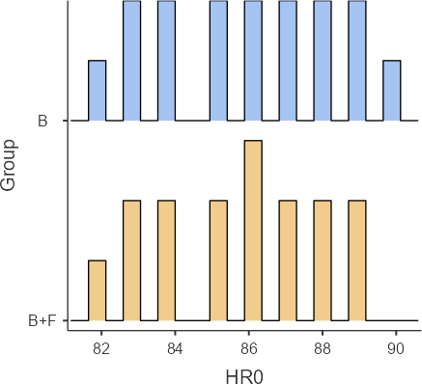

HR5
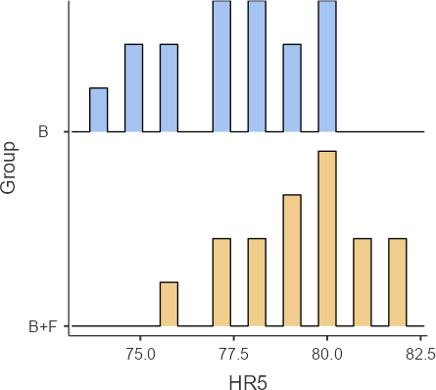

HR10
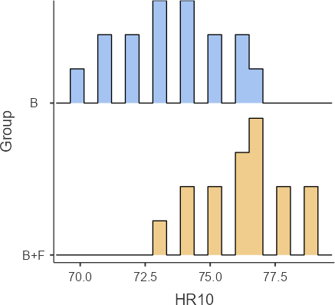

HR20
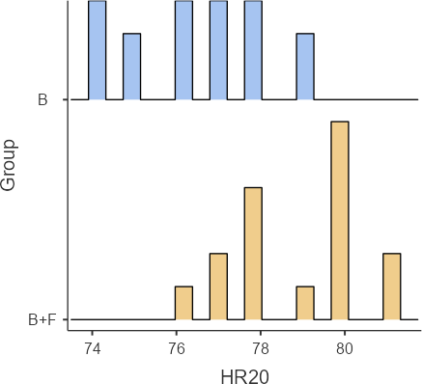

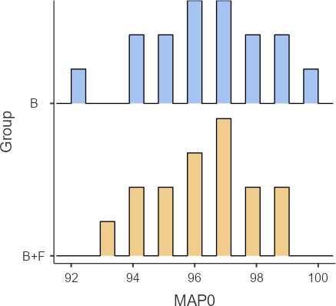

MAP5
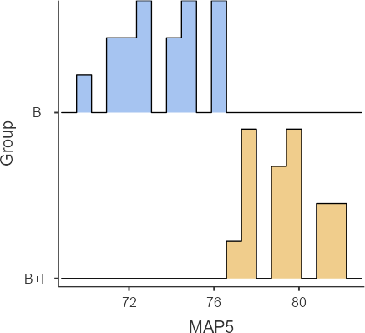

MAP10
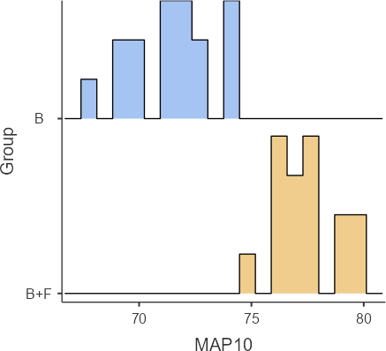

MAP20
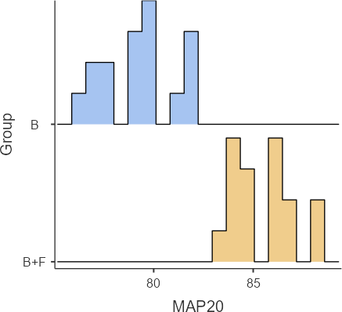

PeakBlock_min
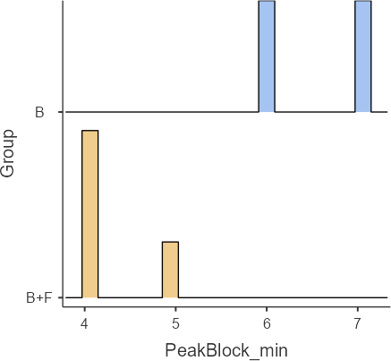
SensoryDuration_min
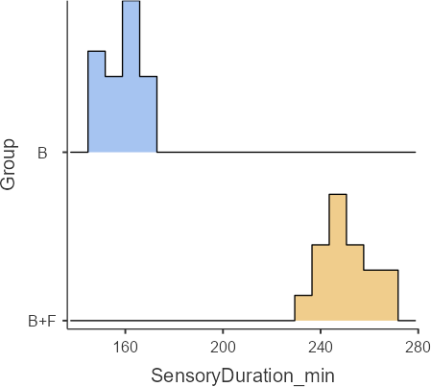

Ambulation_hrs
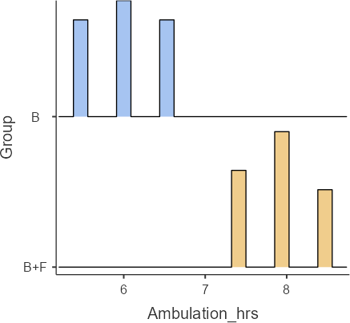

CHAPTER - 6

The current study found that during total knee replacement (TKR) procedures, patients who received intrathecal hyperbaric bupivacaine along with fentanyl showed more stable hemodynamic parameters than those who got bupivacaine heavy alone. Fentanyl seemed to lessen the degree of sympathetic blockage, which led to a smaller drop in mean arterial pressure, diastolic pressure and systolic blood pressure. Additionally, the combo group saw fewer bouts of bradycardia and hypotension that required medication. These results imply that fentanyl improves hemodynamic stability as an adjuvant without sacrificing the effectiveness of spinal anaesthesia.

Gupta et al. (2018)
By lowering the necessary dosage of local anaesthetic, intrathecal fentanyl as an adjuvant to bupivacaine enhances intraoperative hemodynamic stability. According to their research, patients who received the combo needed less vasopressor assistance and had fewer hypotensive episodes. Effective analgesia with a reduced sympathetic blockage is made possible by the synergistic action.

Ben - David et al. (2000)
The amount of bupivacaine needed is greatly decreased when opioids like fentanyl are added to spinal anaesthesia, which minimizes hemodynamic swings. Their results support extended analgesia with few side effects and enhanced cardiovascular stability.

Hunt et al. (2003)
Fentanyl improves intrathecal bupivacaine's analgesic profile without seriously impairing hemodynamics. According to the study , opioid augmentation, as opposed to local anaesthetic alone ,helps preserve superior perioperative hemodynamic parameters.

Prasad and Singh (2015)
Bradycardia and hypotension were less common in patients receiving bupivacaine and fentanyl. The authors explained this by pointing to a better controlled spread of spinal blockade and a decrease in the local anesthetic dose brought on by opioids

Choi et al. (2012)
According to a meta- analysis, instrathecal fentanyl lowers intraoperative stress reactions and improves haemodynamic stability. Additionally,it reduces the need for vasopressors and rescure analgesics.

Sharma et al. (2016)
Fentanyl as an adjuvant improves haemodynamic control and prolongs postoperative analgesia without increasing complications, according to their research on lower limb orthopedic operation, including TKR

Agarwal et al. (2009)
According to their research, fentanyl added to bupivacaine not only enhances analgesia but also facilitates better intraoperative hemodynamics, especially in older patients undergoing total knee replacement.

CHAPTER – 7

CONCLUSION

Patients treated with bupivacaine and fentanyl showed decreased bradycardia and hypotension, as well as less variation in mean, diastolic, and systolic arterial pressure. The synergistic impact of fentanyl, which improves analgesia and permits a more regulated and limited diffusion of local anaesthetic, eliminating excessive sympathetic blocking, is responsible for this increased stability. As a result, the combination group also required fewer vasopressors and other corrective measures.
Fentanyl’s usage as an adjuvant not only improves hemodynamic but also enhances intraoperative comfort and overall anesthesia quality without increasing side effects. These results are especially pertinent to TKR procedures, where preserving cardiovascular stability is essential, particularly for older patients and those with co - occurring disorders.

- Low Dose Bupivacaine - Fentanyl Vs. Conventional Dose Of Bupivacaine In Spinal Anesthesia for Orthopaedic Procedures In Elderly Patients- Shital Hardik, Halvadia, Hardik Bhikhalal Halvadia, Rachit M Joshi, Devanshi P Upadhyaya

- COMPARISON OF LOW-DOSE BUPIVACAINE WITH FENTANYL AND BUPIVACAINE ALONE
FOR SPINAL ANAESTHESIA FOR LOWER LIMB SURGERIES Karthi Vellakalpatti Mani 1 , Arunpandiyan Veerapandiyan, Shankar Radhakrishnan 3

- COMPARISON OF HYPERBARIC BUPIVACAINE AND FENTANYL MIXTURE AND HYPERBARIC BUPIVACAINE ALONE ON BLOOD PRESSURE AND HEART RATE AMONG PATIENTS UNDERGOING UNILATERAL SPINAL BLOCK FOR LOWER LIMB SURGERIES

- COMPARISON OF HEMODYNAMIC CHANGES BETWEEN INTRA-THECAL BUPIVACAINE AND BUPIVACAINE PLUS FENTANYL IN ELDERLY PATIENTS UNDERGOING DHS SURGERY
Original Research Abubakar Tariq 1 *, Leena Aziz 1 , Waqas Ashraf Chaudhary 1 *, Waseem Younis 1 , Maira Kaleem 1 , Kaneez Fatima 1 , Muhammad Umar 1

- Comparing the Analgesic Efficacy of Intrathecal Bupivacaine Alone with Intrathecal Bupivacaine Midazolam or Magnesium Sulphate Combination in Patients Undergoing Elective Infraumbilical Surgery, Amany Abo Elhussien, Mostafa Zaki

- A study of intrathecal low dose bupivacaine and fentanyl versus conventional dose of bupivacaine alone for elective caesarean section Rama Rao VM1 , Nageswara Rao Murupudi2*, Bharath Cherukuri3 , Shaik Ameena Bibi4

- A Comparison of Hemodynamic Changes Following Intrathecal Fentanyl with Low-dose Bupivacaine and Bupivacaine Alone. September 2002, The journal of Japan Society for Clinical Anesthesia 22(7):281-286, DOI: 10.2199/jjsca.22.281, Takeshi Anzai, Hirotsugu Okamoto, Eri Nakahara

APPENDIX

Case proforma

  - Patient Identification Information
is the patient ID.
is the name.
years of age
- Male ☐ Female Weight: kg Height: cm
BMI

  - Preoperative Evaluation ASA Grades: I and II
is the diagnosis. Surgery Type: ☐ Other ☐ Primary TKR Co-occurring conditions:
    - Heart disease ☐ Diabetes ☐ Hypertension ☐ None ☐ Others Allergies: ☐ Yes ☐ No If yes, specify:
Long-term opioid use: ☐ Sure ☐ No

  - Pre-Spinal Baseline Parameters

  - Allocation of Groups
    - Group B (Bupivacaine only)
    - Group B+F (Bupivacaine plus fentanyl)

  - Details of Anaesthesia
Level of the spine: L3–L4 ☐ L4–L5 Spinal position: ☐ Sitting ☐ Lateral Medication Given:
ml of bupivacaine (0.5% heavy) Fentanyl: mcg (if relevant)
is the spinal injection time.

  - Monitoring throughout surgery

Time Interval | HR(bpm) | MAP(mmHg) | SpO₂ (%)
Baseline
5min
10min
20mints

  - Block Features
Sensory block onset time: minutes
is the peak sensory block level. Peak block time: minutes Sensory block duration: minutes This is the motor block (Bromage scale).

  - Postoperative Information
Analgesic duration: minutes Walking time: hours

  - Issues
    - Yes ☐ No hypotension

Bradycardia: ☐ Yes ☐ No Vomiting and nausea: ☐ Yes ☐ No
Depres8sion of the respiratory system ☐ Sure ☐ No

MASTER CHART

Bupivacaine heavy

P  t | HR  0 | HR  5 | HR  10 | HR  20 | MA  P0 | MA  P5 | MAP  10 | MAP  20 | Sp  O2 | PeakBlock  _min | SensoryDuratio  n_min | Ambulation  _hrs | Hypotens  ion
1 | 84 | 76 | 72 | 75 | 95 | 72 | 70 | 78 | 99 | 6 | 150 | 5.5 | Yes
2 | 88 | 78 | 74 | 77 | 98 | 75 | 72 | 80 | 98 | 7 | 160 | 6 | Yes
3 | 82 | 74 | 70 | 74 | 92 | 70 | 68 | 76 | 99 | 6 | 145 | 5.5 | Yes
4 | 90 | 80 | 76 | 78 | 100 | 76 | 74 | 82 | 98 | 7 | 165 | 6.5 | Yes
5 | 85 | 77 | 73 | 76 | 96 | 73 | 71 | 79 | 99 | 6 | 155 | 6 | No
6 | 86 | 79 | 75 | 78 | 97 | 75 | 73 | 80 | 98 | 7 | 160 | 6 | Yes
7 | 83 | 75 | 71 | 74 | 94 | 71 | 69 | 77 | 99 | 6 | 150 | 5.5 | Yes
8 | 89 | 80 | 77 | 79 | 99 | 76 | 74 | 82 | 98 | 7 | 170 | 6.5 | Yes
9 | 87 | 78 | 74 | 77 | 97 | 74 | 72 | 80 | 99 | 6 | 160 | 6 | No
1  0 | 84 | 76 | 72 | 75 | 95 | 72 | 70 | 78 | 99 | 6 | 155 | 5.5 | Yes
1  1 | 86 | 77 | 73 | 76 | 96 | 73 | 71 | 79 | 98 | 7 | 162 | 6 | Yes
1  2 | 88 | 79 | 75 | 78 | 98 | 75 | 73 | 81 | 99 | 7 | 168 | 6.5 | Yes
1  3 | 83 | 75 | 71 | 74 | 94 | 71 | 69 | 77 | 99 | 6 | 150 | 5.5 | No
1  4 | 85 | 77 | 73 | 76 | 96 | 73 | 71 | 79 | 98 | 6 | 158 | 6 | Yes
1  5 | 87 | 78 | 74 | 77 | 97 | 74 | 72 | 80 | 99 | 7 | 165 | 6.5 | Yes
1  6 | 89 | 80 | 76 | 79 | 99 | 76 | 74 | 82 | 98 | 7 | 172 | 6.5 | Yes

BIPUVACINE + FENTANYL

P  t | HR 0 | HR 5 | HR 10 | HR 20 | MA P0 | MA P5 | MAP 10 | MAP 20 | Sp O2 | PeakBlock  _min | SensoryDuratio n_min | Ambulation  _hrs | Hypotens ion
1 | 84 | 78 | 75 | 78 | 95 | 78 | 76 | 84 | 99 | 4 | 240 | 7.5 | No
2 | 86 | 80 | 77 | 80 | 97 | 80 | 78 | 86 | 99 | 4 | 250 | 8 | No
3 | 82 | 76 | 73 | 76 | 93 | 77 | 75 | 83 | 99 | 5 | 235 | 7.5 | No
4 | 88 | 81 | 78 | 80 | 98 | 81 | 79 | 87 | 98 | 4 | 260 | 8.5 | No
5 | 85 | 79 | 76 | 78 | 96 | 79 | 77 | 85 | 99 | 4 | 245 | 8 | No
6 | 87 | 80 | 77 | 80 | 97 | 80 | 78 | 86 | 98 | 5 | 255 | 8 | No
7 | 83 | 77 | 74 | 77 | 94 | 78 | 76 | 84 | 99 | 4 | 240 | 7.5 | No
8 | 89 | 82 | 79 | 81 | 99 | 82 | 80 | 88 | 99 | 4 | 265 | 8.5 | No
9 | 86 | 79 | 76 | 79 | 96 | 79 | 77 | 85 | 99 | 4 | 250 | 8 | No
1  0 | 84 | 78 | 75 | 78 | 95 | 78 | 76 | 84 | 99 | 4 | 245 | 7.5 | No
1  1 | 87 | 80 | 77 | 80 | 97 | 80 | 78 | 86 | 98 | 5 | 252 | 8 | No
1  2 | 88 | 81 | 78 | 80 | 98 | 81 | 79 | 87 | 99 | 4 | 258 | 8.5 | No
1  3 | 83 | 77 | 74 | 77 | 94 | 78 | 76 | 84 | 99 | 4 | 240 | 7.5 | No
1  4 | 85 | 79 | 76 | 78 | 96 | 79 | 77 | 85 | 98 | 4 | 248 | 8 | No
1  5 | 86 | 80 | 77 | 80 | 97 | 80 | 78 | 86 | 99 | 5 | 255 | 8 | No
1  6 | 89 | 82 | 79 | 81 | 99 | 82 | 80 | 88 | 99 | 4 | 265 | 8.5 | No

CONSENT

Principal investigator:
P. Bhavana Saranya Department of anesthesiology Q1 hospitals

You are being invited to participate in a research study. With your consent you will undergo an All information collected during the study will be kept strictly confidential. Your identity will not be disclosed in any publication or report. I have read and understood the information provided above and all my questions have been answered satisfactorily. I voluntarily agree to participate in this study. You can participate or withdraw during the study. I have read and understood the above information. I have had the opportunity to ask questions, and my questions have been answered satisfactorily. I voluntarily agree to participate in this study.

Participant name:
Signature/ thumb impression: Date:

◻◻◻◻◻◻

◻◻◻◻◻◻ ◻◻◻◻◻◻◻◻◻◻:
◻◻◻◻◻ ◻◻◻◻ ◻◻◻◻◻
◻◻◻◻◻◻◻◻◻◻◻◻◻ ◻◻◻◻◻◻
◻◻◻◻ 1 ◻◻◻◻◻◻◻◻◻◻

◻◻ ◻◻◻◻◻◻◻ ◻◻◻◻◻◻◻◻◻ ◻◻◻◻◻◻◻◻◻◻◻◻◻ ◻◻◻◻ ◻◻◻◻◻◻◻◻◻◻◻◻◻◻◻◻.
◻◻ ◻◻◻◻◻◻◻◻, ◻◻◻◻◻◻ ◻◻◻◻◻◻ ◻◻◻◻◻◻◻◻◻ ◻◻◻◻◻◻ ◻◻◻◻◻◻◻ ◻◻◻◻◻◻◻◻
◻◻◻◻◻◻◻◻ ◻◻◻◻◻◻◻◻◻◻◻. ◻◻◻◻◻ ◻◻◻◻◻◻◻◻◻◻ ◻◻◻◻ ◻◻◻◻◻◻◻◻ ◻◻ ◻◻
◻◻◻◻◻◻◻◻◻ ◻◻◻◻◻◻◻◻◻◻◻◻◻. ◻◻◻ ◻◻◻◻◻◻◻◻ ◻◻◻◻◻◻◻◻◻◻◻ ◻◻◻◻
◻◻◻◻◻◻◻ ◻◻◻◻◻ ◻◻◻◻◻ ◻◻◻◻◻◻◻◻◻◻◻◻ ◻◻◻◻◻ ◻◻ ◻◻◻◻◻ ◻◻◻◻◻◻◻◻◻
◻◻◻◻◻◻◻◻◻◻◻◻◻ ◻◻◻◻◻◻◻ ◻◻◻◻◻◻◻◻◻◻. ◻ ◻◻◻◻◻◻◻◻◻ ◻◻◻◻◻◻◻◻◻◻◻◻◻
◻◻◻◻ ◻◻◻◻◻◻◻◻◻◻◻ ◻◻◻◻◻◻◻◻◻◻◻◻◻◻◻◻◻. ◻◻◻◻◻◻ ◻◻◻◻◻◻ ◻◻◻◻
◻◻◻◻◻◻◻◻◻◻◻◻ ◻◻◻◻ ◻◻◻◻◻◻◻◻◻◻◻◻◻◻◻◻◻. ◻◻ ◻◻◻◻◻◻◻◻◻◻◻ ◻◻◻◻
◻◻◻◻◻◻◻ ◻◻◻◻◻ ◻◻◻◻◻ ◻◻◻◻◻◻◻◻◻◻◻◻. ◻◻◻◻◻◻◻◻ ◻◻◻◻◻◻◻◻◻◻ ◻◻◻◻
◻◻◻◻◻◻ ◻◻◻◻◻◻◻◻◻ ◻◻◻◻◻ ◻◻ ◻◻◻◻◻◻◻◻◻ ◻◻◻◻◻◻◻◻◻◻◻◻◻ ◻◻◻◻◻◻◻
◻◻◻◻◻◻◻◻◻◻. ◻ ◻◻◻◻◻◻◻◻◻ ◻◻◻◻◻◻◻◻◻◻◻◻◻ ◻◻◻◻ ◻◻◻◻◻◻◻◻◻◻◻
◻◻◻◻◻◻◻◻◻◻◻◻◻◻◻◻◻.

◻◻◻◻◻◻◻◻◻◻◻◻ ◻◻◻◻:
◻◻◻◻◻/◻◻◻◻◻◻◻◻ ◻◻◻◻◻:
◻◻◻◻:

PLAGARISM REPORTS
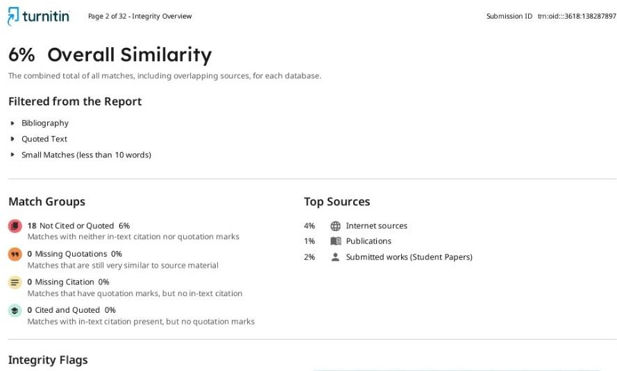

AI REPORTS

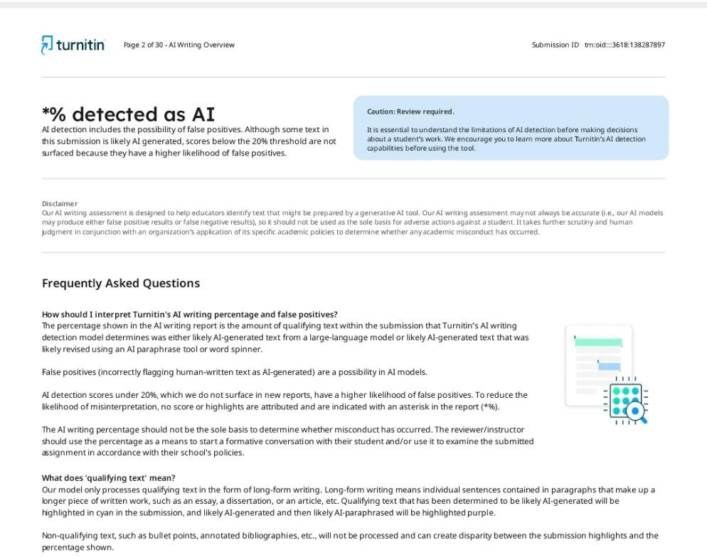

Seed article
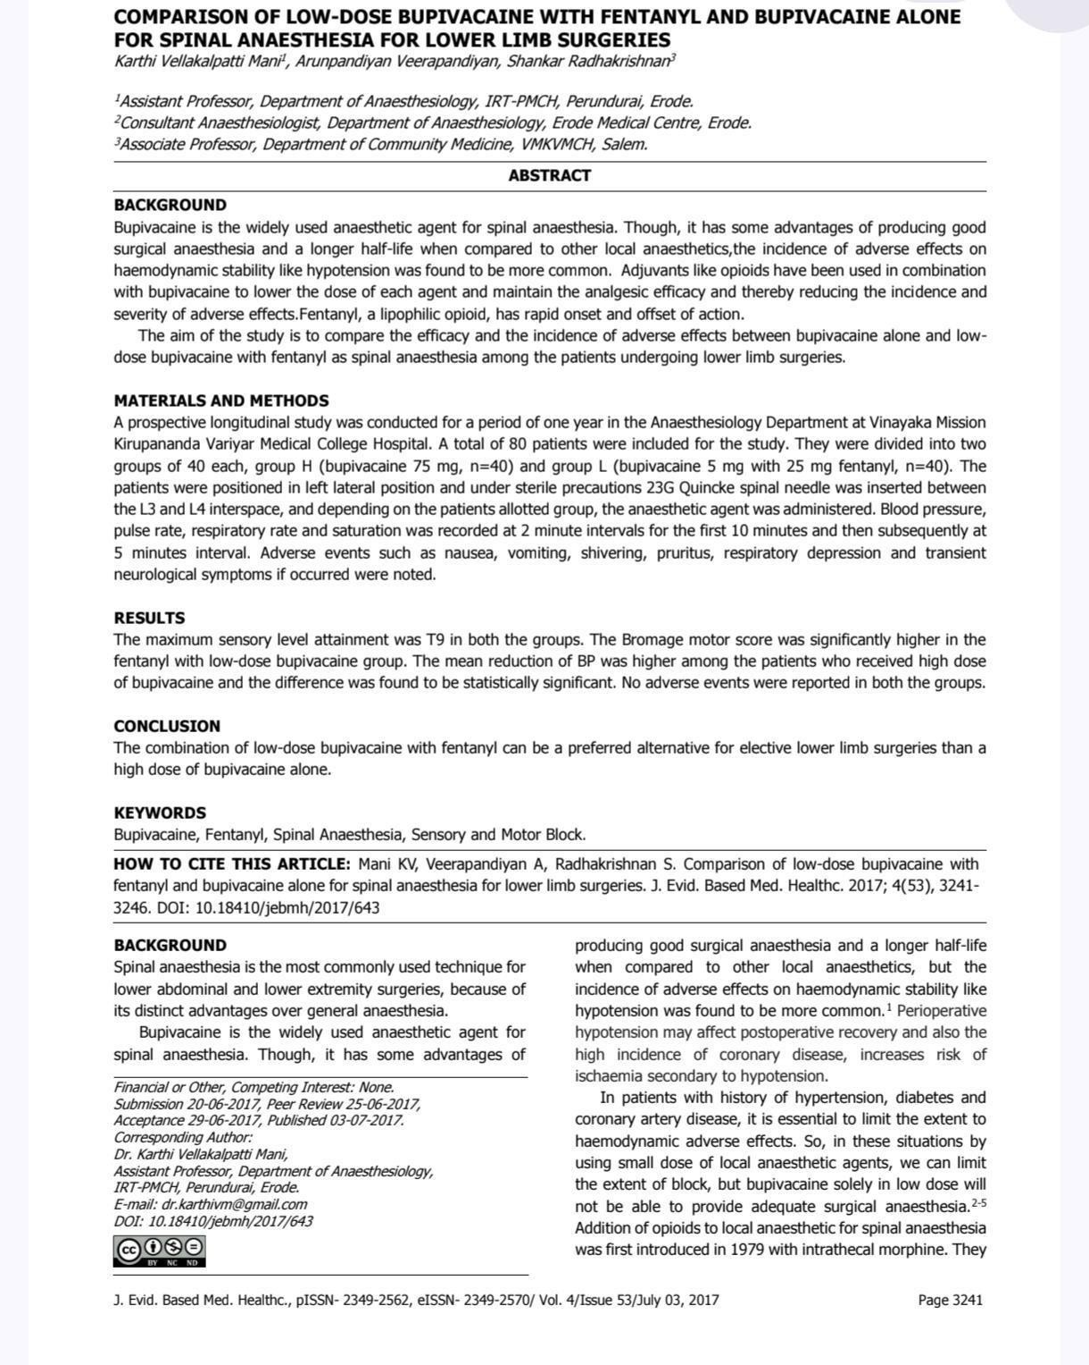

ASSESSMENT
Internal:

SL NO | RUBRICS | FULL MARK | MARKS OBTAINED | REMARKS
1 | Understanding the relevance, scope and dimension of the project | 10
2 | Methodology | 10
3 | Quality of Analysis and Results | 10
4 | Interpretations and Conclusions | 10
5 | Report | 10
 | Total | 50

Date: Signature of the Faculty

COURSE OUTCOME (COs) ATTAINMENT

- Expected Course Outcomes (COs):
(Refer to COs Statement in the Syllabus)

- Course Outcome Attained:
How would you rate your learning of the subject based on the specified COs?










1 2 3 4 5 6 7 8 9 10
LOW HIGH
- Learning Gap (if any):

- Books / Manuals Referred:

Date: Signature of the Student
- Suggestions / Recommendations:
(By the Course Faculty)

Date: Signature of the Faculty

