Provisioning Network Infrastructure in the Cloud
Deepika Agnihotri
CLCS 635 Networking Engineering for Cloud Computing
April 14, 2026

Introduction
Cloud computing has transformed the way organizations design, deploy, and manage network infrastructure by enabling scalable, flexible, and automated solutions. This practice focuses on provisioning network infrastructure in the cloud using AWS CloudFormation and the Infrastructure Composer tool. The primary objective is to demonstrate how a Virtual Private Cloud, along with public and private subnets, can be designed and deployed using a declarative Infrastructure as Code approach. By leveraging visual design tools and automated templates, the process simplifies complex configurations while ensuring consistency and reliability. This report highlights the importance of structured network design, automation, and best practices in building secure and efficient cloud environments.
Step 1: Explore CloudFormation dashboard and the Infrastructure Composer tool
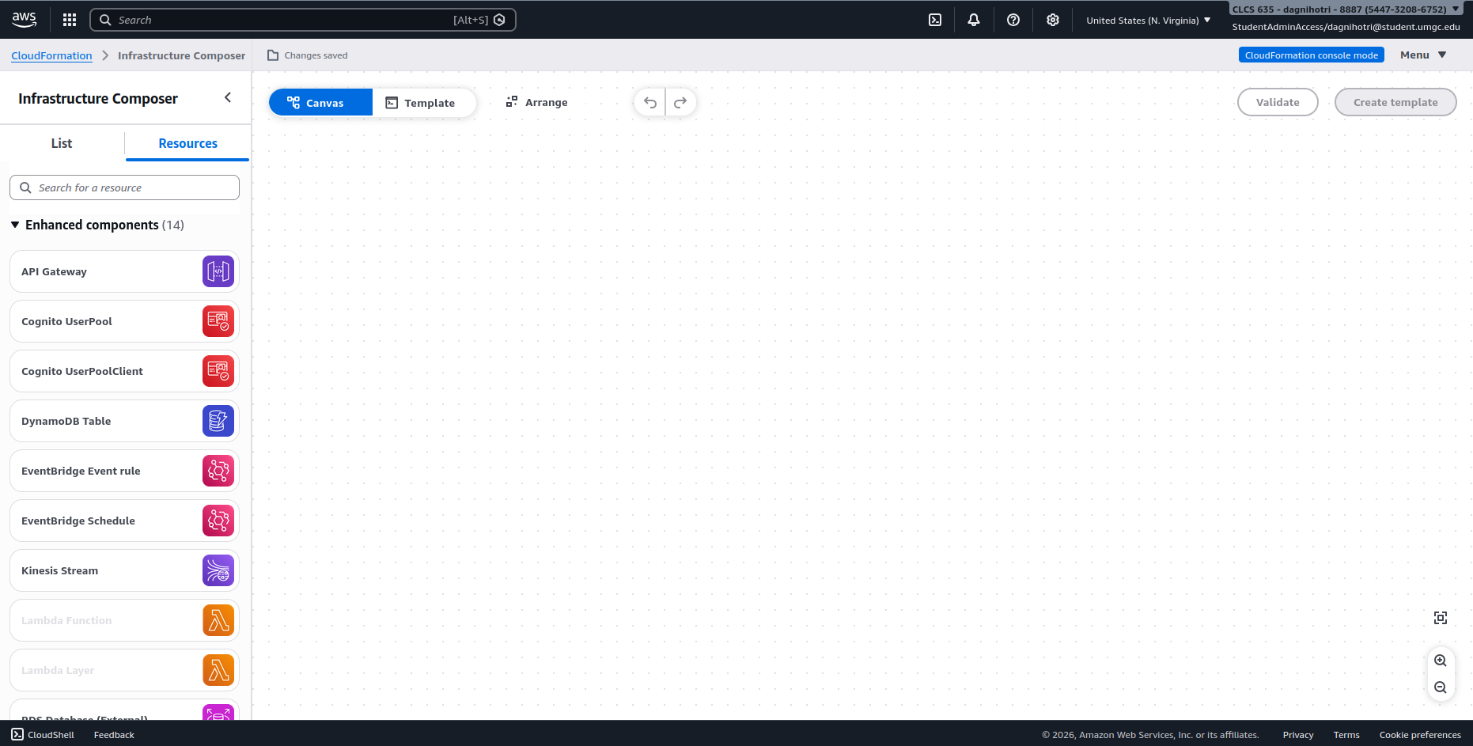
Above image shows the AWS CloudFormation console with the Infrastructure Composer tool. It provides a visual workspace where users can design cloud architecture using drag-and-drop components instead of writing code manually. It serves as the starting point for building infrastructure in a simple and visual way.

Step 2: Adding the VPC to Infrastructure Composer diagram
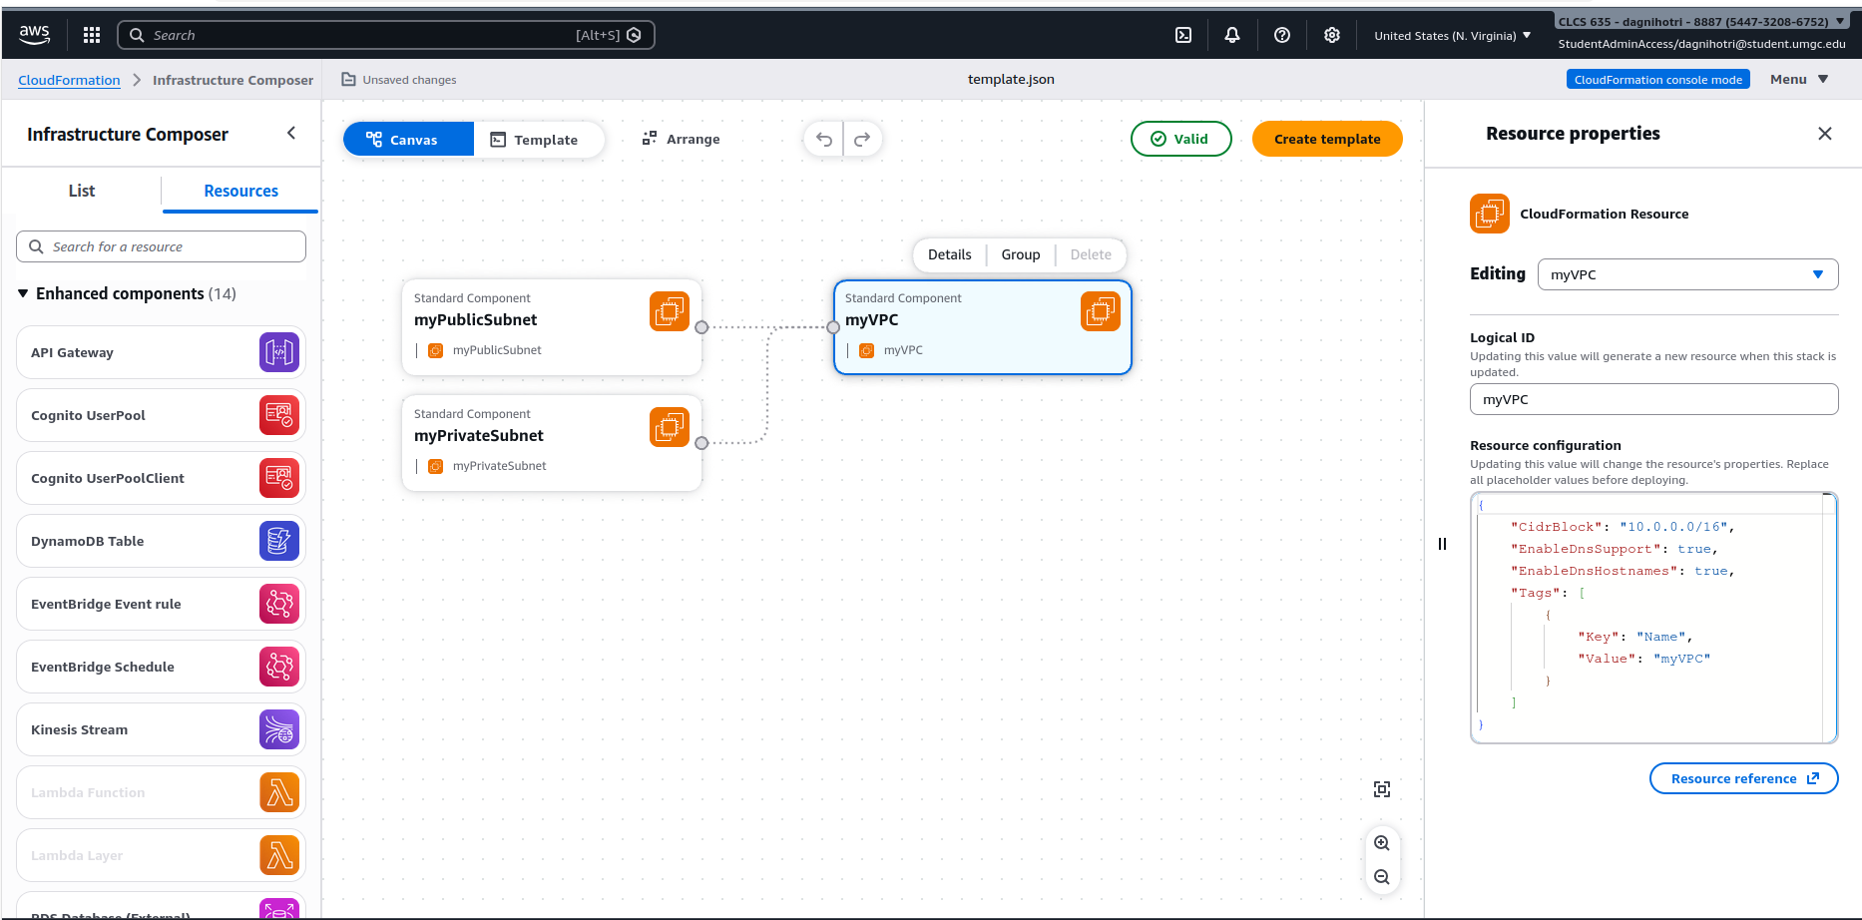
In this step, a VPC is added to the design canvas.
Configuration Details:
CIDR block: 10.0.0.0/16
DNS support: Enabled
DNS hostnames: Enabled
Name tag: myVPC
The VPC acts as the foundation of the cloud network. It allows to create an isolated environment where all resources will be placed. Using CloudFormation ensures the setup is automated and consistent.
Step 3: Adding two subnets to Infrastructure Composer diagram
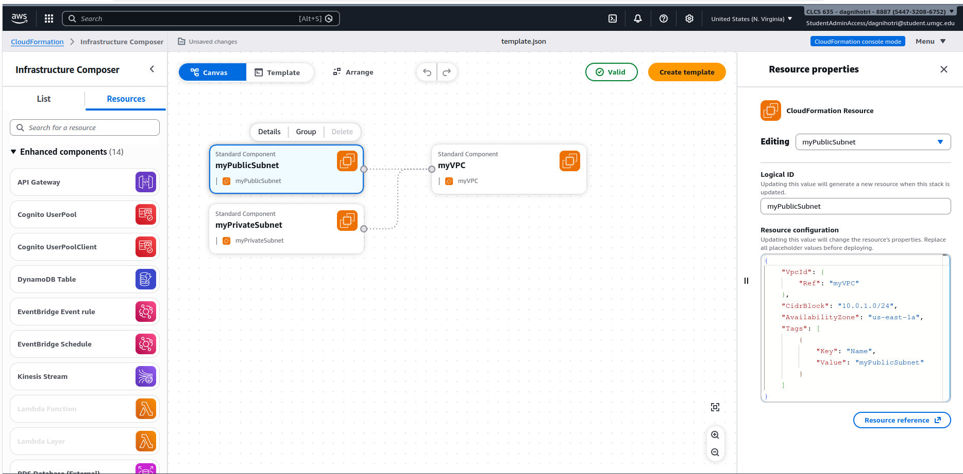
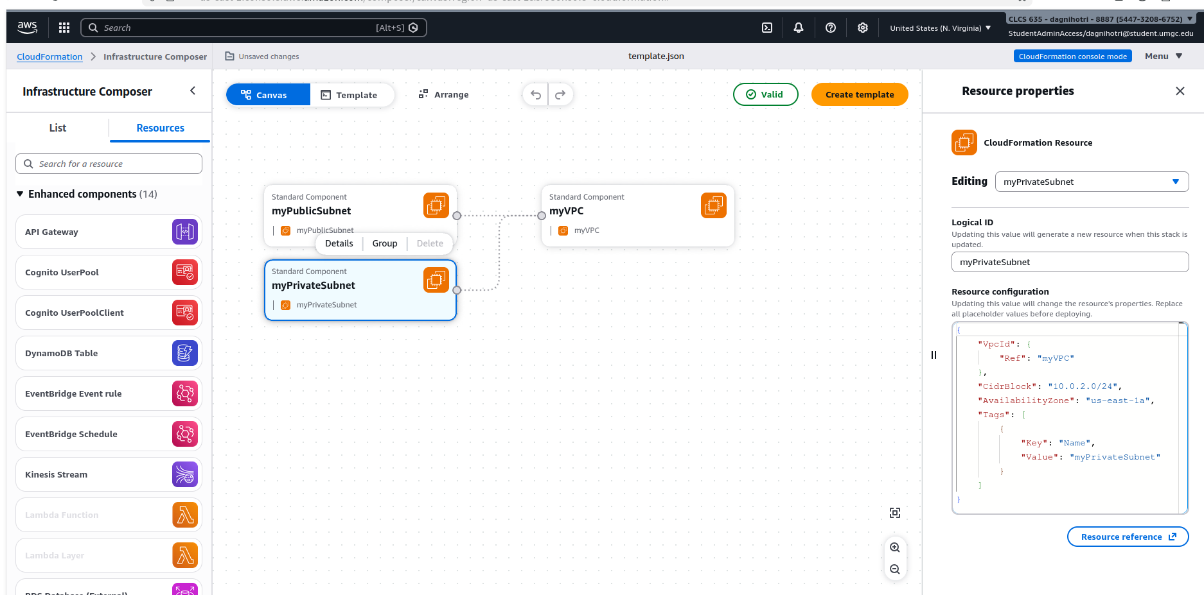
Above images show the completed network structure with subnets added inside the VPC.
Infrastructure component Created:
VPC: myVPC
Public Subnet: myPublicSubnet (10.0.1.0/24)
Private Subnet: myPrivateSubnet (10.0.2.0/24)
Both subnets are in the same Availability Zone
Description:
The network is divided into two parts:
Public subnet: Used for resources that need internet access
Private subnet: Used for secure internal resources
This separation improves security and follows best practices in cloud design.

Step 4: Create a CF template, run the resulting CF stack
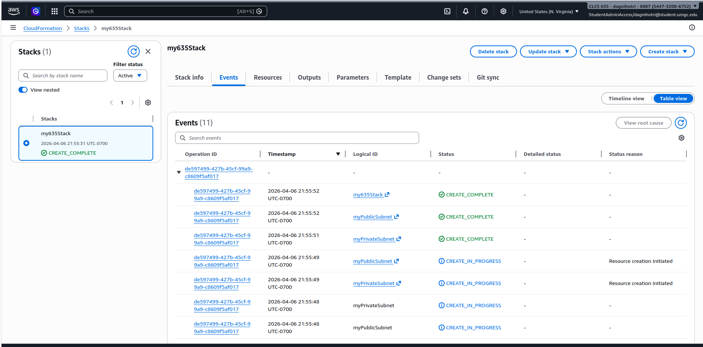This image shows the CloudFormation stack screen, where the stack named as my635Stack has been created successfully. The stack status shows that AWS has read the template and created all the resources automatically. This means the designed infrastructure was converted into a CloudFormation template and deployed using AWS automation. It also shows the declarative approach, where you define what you want, and AWS handles how to create it.

Step 5: Verify that VPC and subnets were provisioned
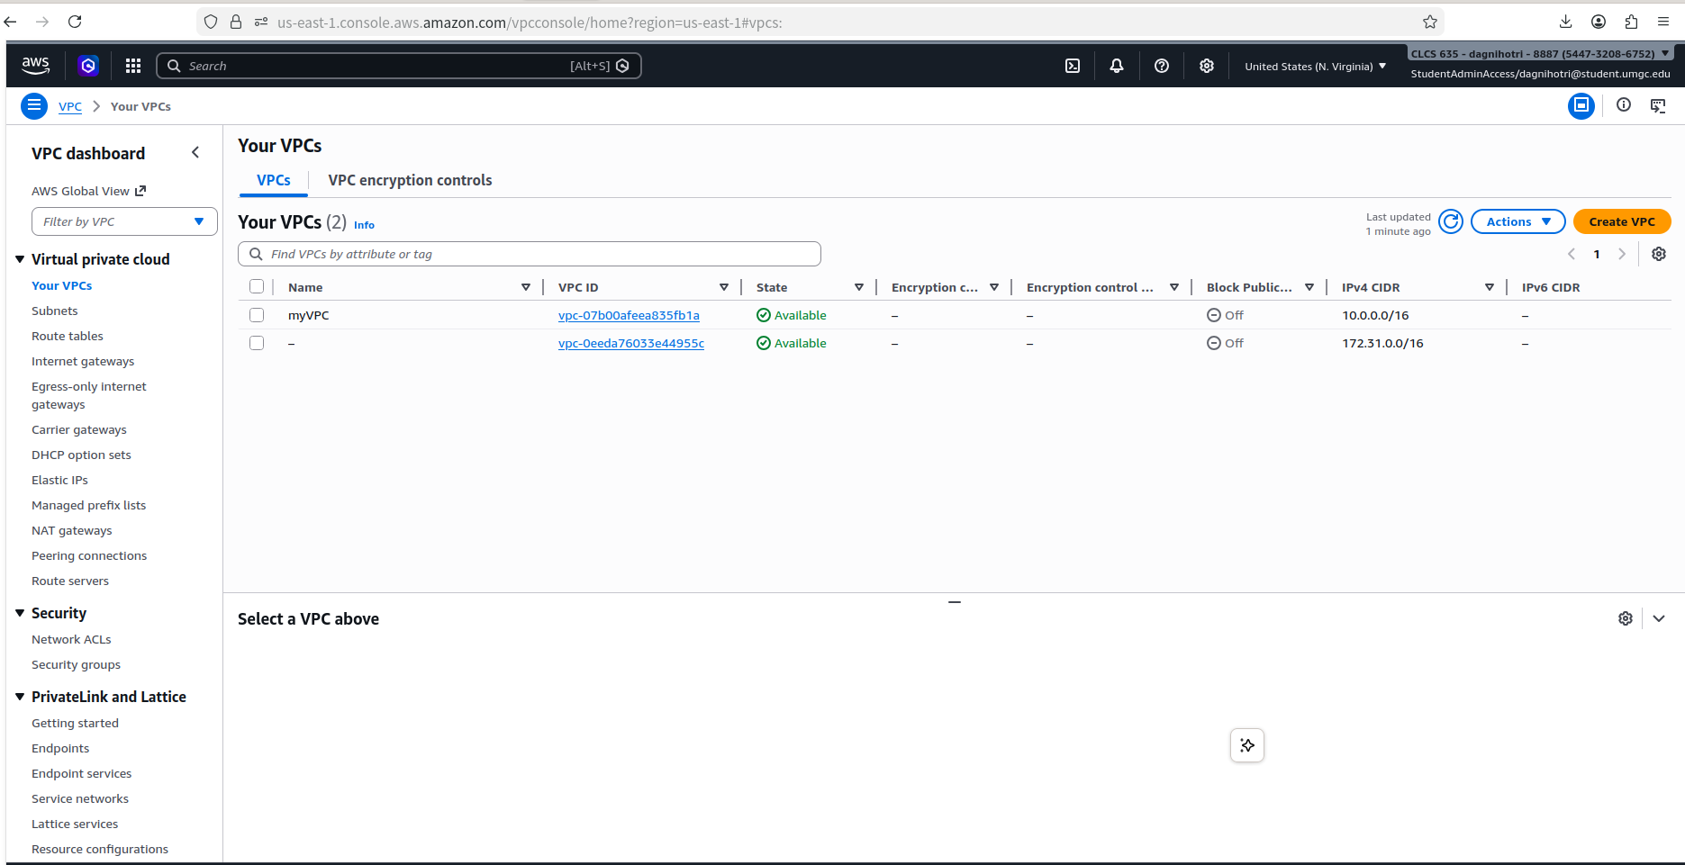
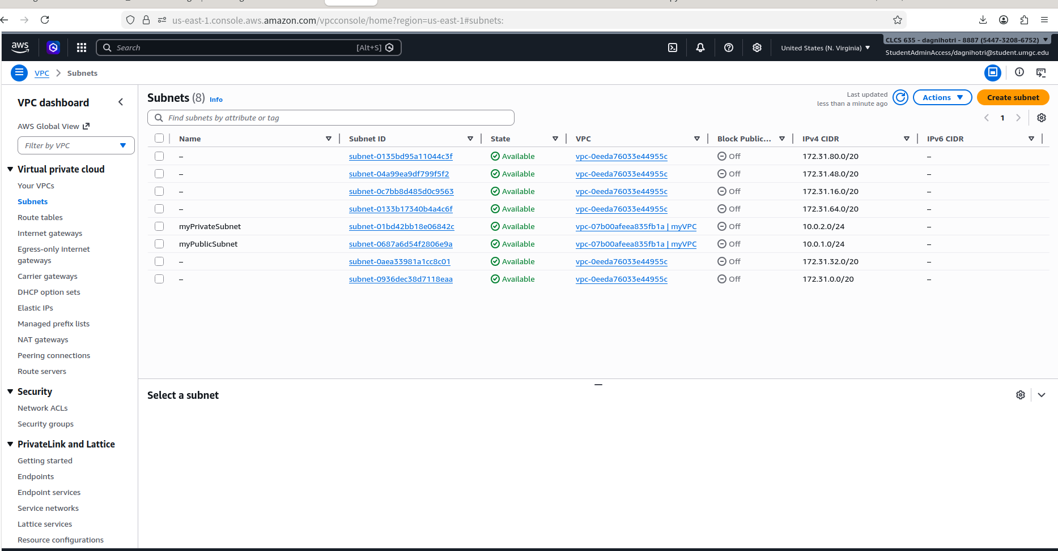
Above images show the AWS VPC Dashboard, listing the newly created myVPC along with its assigned VPC ID.
This verification step confirms that the VPC exists within the AWS environment and was correctly provisioned as defined in the CloudFormation stack.
Lessons Learned: This lab provides practical insight into the power and advantages of using a declarative approach in cloud infrastructure provisioning. Instead of manually executing step-by-step configurations, the process focused on defining the desired end state of the infrastructure. AWS CloudFormation then automatically determined and executed the necessary steps to achieve that state. This approach significantly reduces complexity and minimizes the risk of human error.
Another importance point is Infrastructure as Code in modern cloud environments. By representing infrastructure in a template, deployments become repeatable, and version controlled. This makes it simple to manage changes, replicate environments, and maintain reliability across deployments.
The use of the Infrastructure Composer also defined how visual tools can simplify the design process. It helped bridge the gap between conceptual architecture and implementation by allowing resources like VPCs and subnets to be modeled clearly before deployment.
Additionally, the lab reinforced best practices in network design, such as isolating resources using VPCs and separating workloads into public and private subnets. This improves both security and scalability in cloud environments.

Summary of Achievements:
In this assignment, a complete cloud network infrastructure was successfully designed and deployed using AWS CloudFormation and Infrastructure Composer. The desired architecture--including a VPC, public subnet, and private subnet was defined declaratively, allowing AWS to automatically provision all required resources.
The CloudFormation stack was created and executed successfully, confirming that the infrastructure definition was valid and functional. Verification through the AWS VPC Dashboard ensured that all components were provisioned correctly and aligned with the intended design.
Overall, this hands-on-lab demonstrates the effective use of a declarative Infrastructure as Code approach to achieve automated, consistent, and scalable cloud infrastructure deployment.
Conclusion:
This assignment demonstrates how AWS CloudFormation and Infrastructure Composer can be used to design and deploy cloud infrastructure efficiently. By using Infrastructure as Code, the process becomes automated, repeatable, and less error prone. The use of VPCs and subnets ensures a secure and well-structured network architecture.

