Api/v1/products (Express)Get
- Post create product
- Put Get product
- Delete delete
- Get + id Get one product

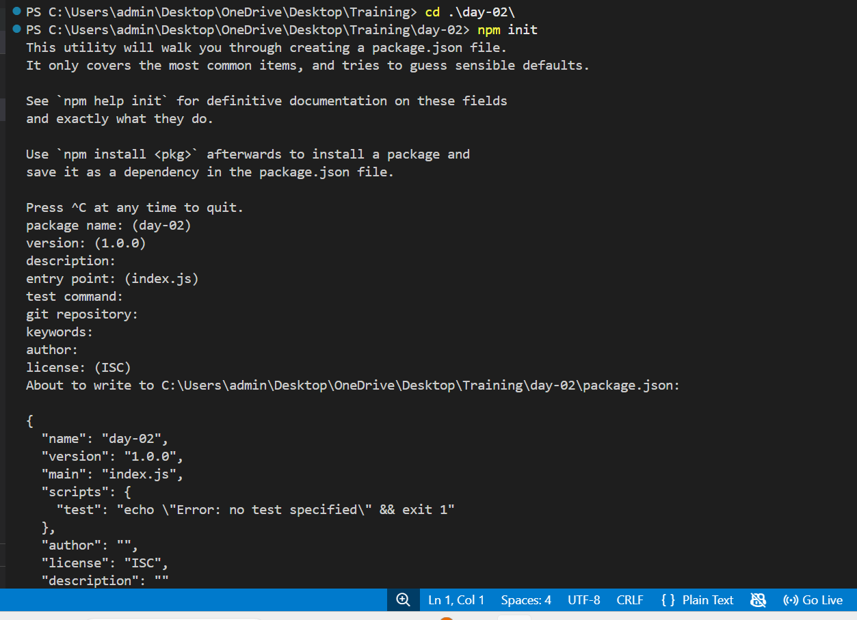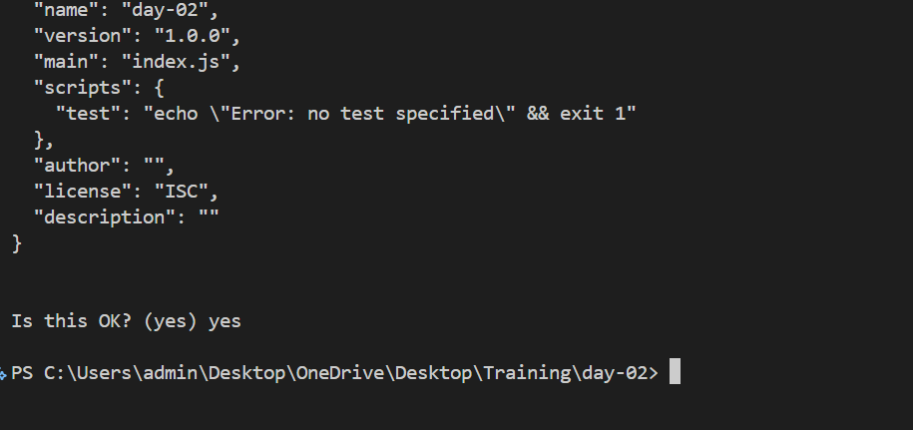
Dependency : library to run the application
Dev – dependency : to build the application
Nodemon: it does when we update the code then it automatically runs the code without manual intervention

Commands Used:
- npm init
- npm install express
- npm install nodemon –save-dev
- node nodemon index.js (to run the application)
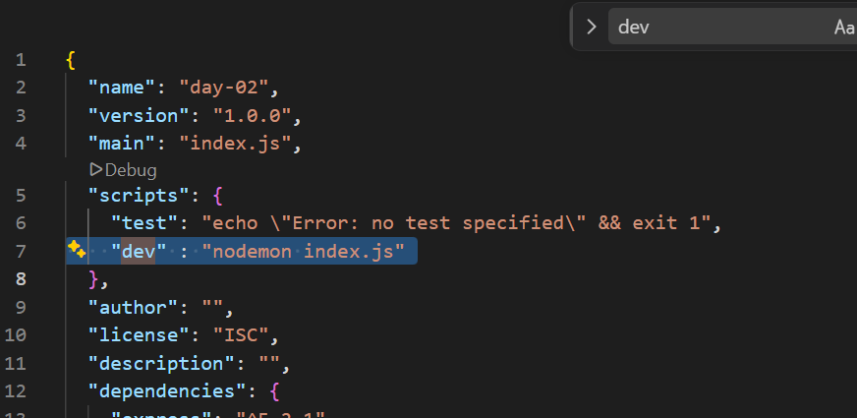
Add this script dev: nodemon index.js, in script to replace it with npm run dev
npm scripts are custom command shortcuts defined in the scripts section of package.json. They allow you to run frequently used commands with a simple npm run <script-name> command.
- Updating index.js file
const express = require("express"); // Import the Express framework into this file. 'require("express")' loads the Express module so we can create a web server.

const app = express(); // Create an Express application. 'app' is the main object used to configure routes, middleware, and the server.
const PORT = 3000; // Define the port number on which the server will listen for incoming requests.
function hello(req, res) { // Route handler (callback function). 'req' (request) contains information sent by the client. 'res' (response) is used to send a response back to the client. res.send("Hello world"); // Send "Hello world" as the HTTP response to the client.

}

// Register a GET route.
// "/" represents the root URL (http://localhost:3000/).
// When a GET request is made to "/", the 'hello' function is executed.
app.get("/", hello);

// Start the Express server and make it listen on port 3000.
// The server waits for incoming client requests.
app.listen(PORT, () => {
console.log(`Server is running at http://localhost:${PORT}`);
});

- function add(req ,res){
- const a = Number(req.query.a)
- const b = Number(req.query.b)
- const sum = a + b;
- res.json({
- result: sum
- });
- }
- app.get("/add",add);

and we give url as http://localhost:3000/add?a=10&b=10
(?-> Starts the query string which will be the input to the function name as add & used to separate query parameters, a=10 and b=10 are query parameters)
The URL https://localhost:3000/ fails because your local development server is only configured to listen for unencrypted HTTP traffic, not encrypted HTTPS traffic. [1, 2]
When you type http://, your browser talks to the server using standard text. When you type https://, your browser expects an SSL/TLS handshake and an encryption certificate. Because your local server does not have these security layers turned on by default, it rejects or fails to understand the request

- Purpose of PORT number: A port number is a virtual identifier used in computer networking to direct incoming data to the correct application or service running on a device (Don’t use multiple applications on the same port number in same system)
- app.use(express.json()) // this method automatically parses the input data into json format
- //POST localhost:/3000/names (JSON BODY) {"name: "Dharani}
function names(req ,res){
const {name} = req.body;
if(!name){
return res.json({
error: "Please add the names"
});

}
nms.push(name)
res.json({
message: "Success",
data: nms,
});
}
app.post("/names",names);
