**Report View:**

* Report view in Power BI Desktop provides a similar design experience to the report's editing view in the Power BI service.
* You can move visualizations around, copy and paste, merge, and so on.

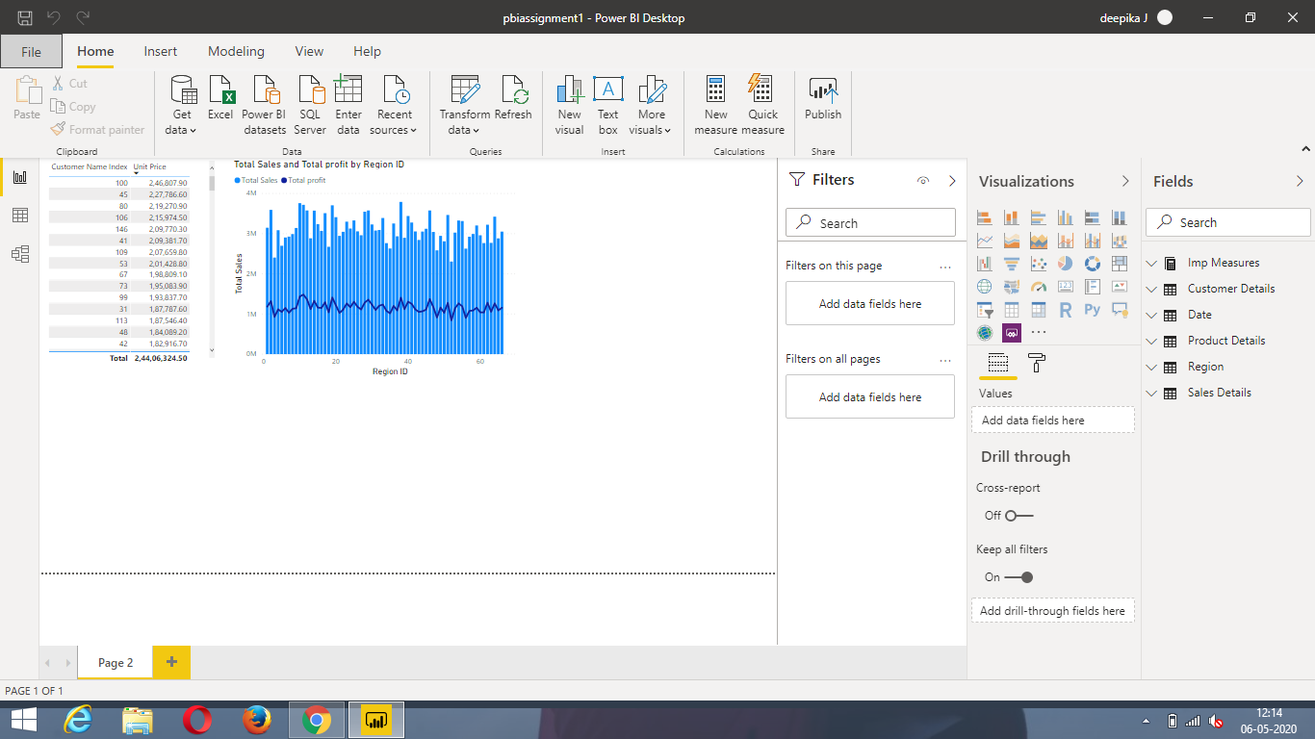

**Data View:**

* Data view helps you inspect, explore, and understand data in your Power BI Desktop model.
* It's different from how you view tables, columns, and data in Power Query Editor.
* With Data view, you're looking at your data after it has been loaded into the model.

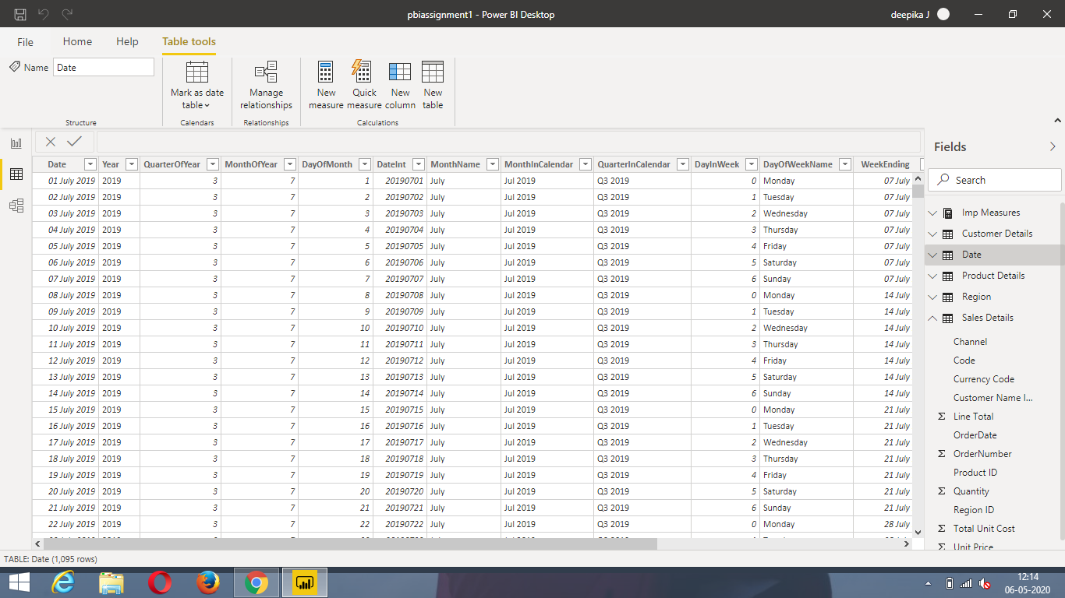

**Model View:**

* Model view shows all of the tables, columns, and relationships in your model.
* This view can be especially helpful when your model has complex relationships between many tables

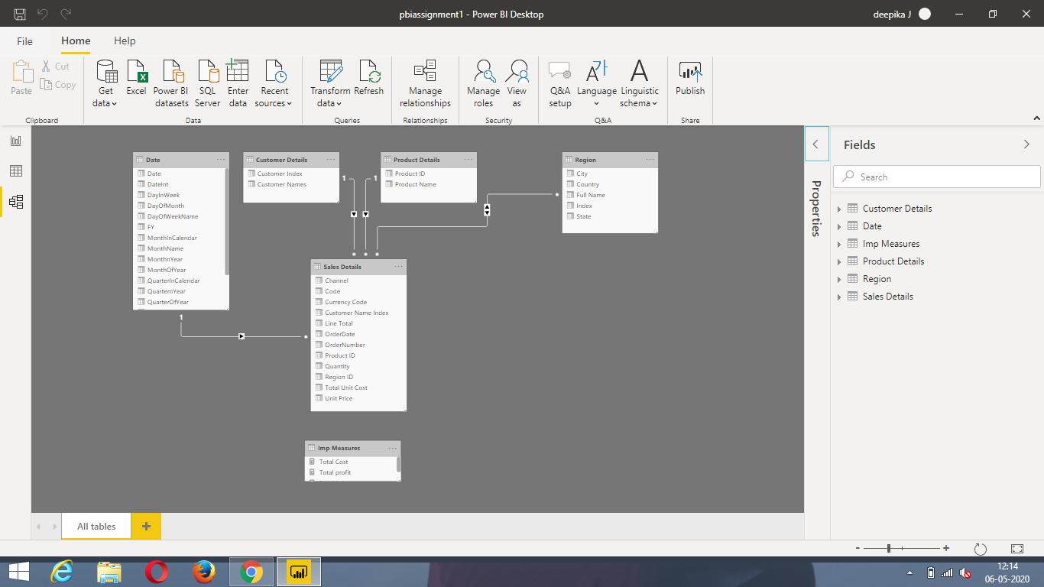

**Power Query Editor:**

* Power BI Desktop also comes with Power Query Editor.
* Use Power Query Editor to connect to one or many data sources, shape and transform the data to meet your needs, then load that model into Power BI Desktop.

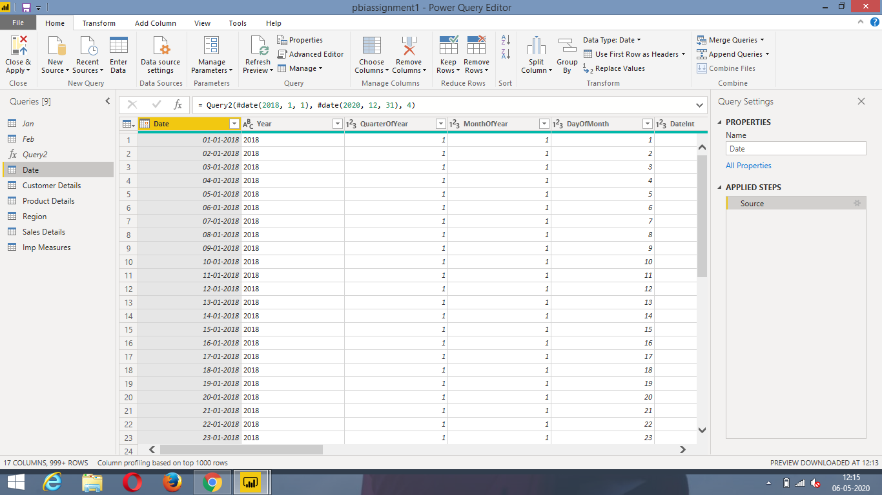

**Advanced Editor:**

* The **Advanced Editor** lets you see the code that Power Query Editor is creating with each step.
* It also lets you create your own shaping code.
* You can directly edit the code in the **Advanced Editor** window.

