**Week5_Handson_MicroServices**

**Creating Microservices for account and loan In this hands on exercises, we will create two microservices for a bank.**

**One microservice for handing accounts and one for handling loans. Each microservice will be a specific independent Spring RESTful Webservice maven project having it's own pom.xml.**

**The only difference is that, instead of having both account and loan as a single application, it is split into two different applications.**

**These webservices will be a simple service without any backend connectivity.**

Follow steps below to implement the two microservices:

Account Microservice

• Create folder with employee id in D: drive • Create folder named 'microservices' in the new folder created in previous step. This folder will contain all the sample projects that we will create for learning microservices.

• Open https://start.spring.io/ in browser

• Enter form field values as specified below: o Group: com.cognizant o Artifact: account

• Select the following modules o Developer Tools > Spring Boot DevTools o Web > Spring Web

• Click generate and download the zip file

• Extract 'account' folder from the zip and place this folder in the 'microservices' folder created earlier

• Open command prompt in account folder and build using mvn clean package command

• Import this project in Eclipse and implement a controller method for getting account details based on account number. Refer specification below: o Method: GET o Endpoint: /accounts/{number} o Sample Response. Just a dummy response without any backend connectivity.

• Launch by running the application class and test the service in browser Loan Microservice

• Follow similar steps specified for Account Microservice and implement a service API to get loan account details o Method: GET o Endpoint: /loans/{number} o Sample Response. Just a dummy response without any backend connectivity.

• Launching this application by having account service already running • This launch will fail with error that the bind address is already in use

• The reason is that each one of the service is launched with default port number as 8080. Account service is already using this port and it is not available for loan service.

• Include "server.port" property with value 8081 and try launching the application

• Test the service with 8081 port Now we have two microservices running on different ports.

**Implement Controller**

Create a class:  
src/main/java/com/cognizant/account/controller/AccountController.java

package com.cognizant.account.controller;

import org.springframework.web.bind.annotation.*;

@RestController

@RequestMapping("/accounts")

public class AccountController {

@GetMapping("/{number}")

public Account getAccountDetails(@PathVariable String number) {

return new Account(“🏦 Welcome to MicroBank! "

+ "Your account is as safe as gold in a dragon's vault. 💰🐉”);

}

static class Account {

private String number;

private String type;

private double balance;

public Account(String number, String type, double balance) {

this.number = number;

this.type = type;

this.balance = balance;

}

public String getNumber() { return number; }

public String getType() { return type; }

public double getBalance() { return balance; }

}

}

**Run and Test**

* Run the main class:  
  📄 AccountServiceApplication.java

package com.cognizant.account;

import org.springframework.boot.SpringApplication;

import org.springframework.boot.autoconfigure.SpringBootApplication;

@SpringBootApplication

public class AccountServiceApplication {

public static void main(String[] args) {

SpringApplication.run(AccountServiceApplication.class, args);

}

}

* Open browser

<http://localhost:8082/account>

Account Service:

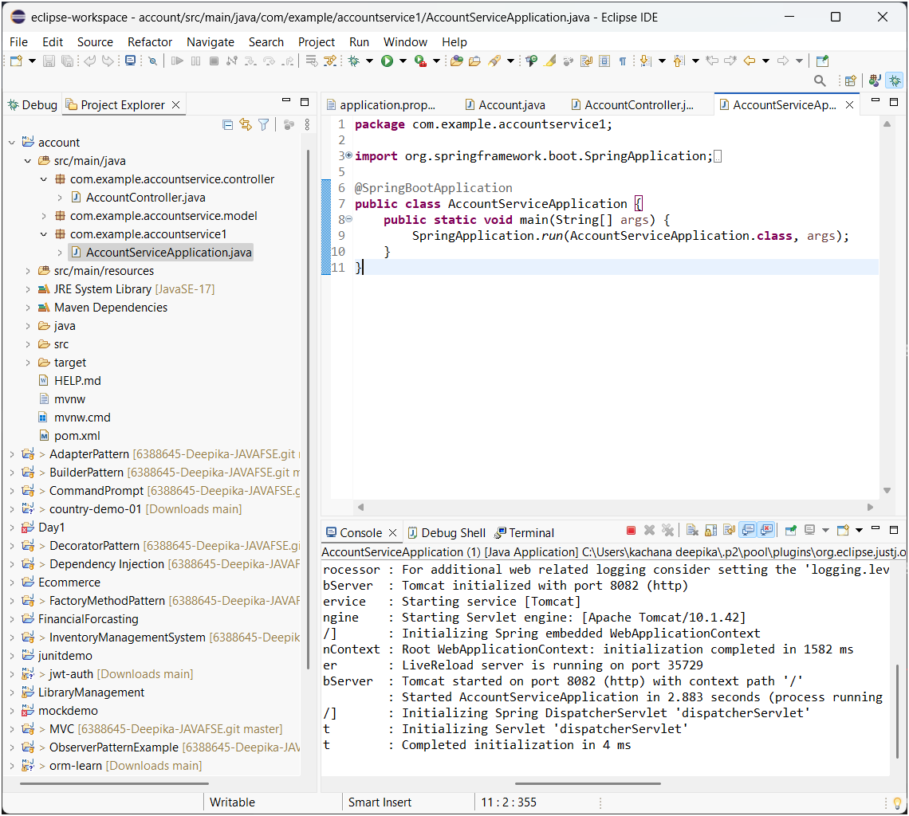

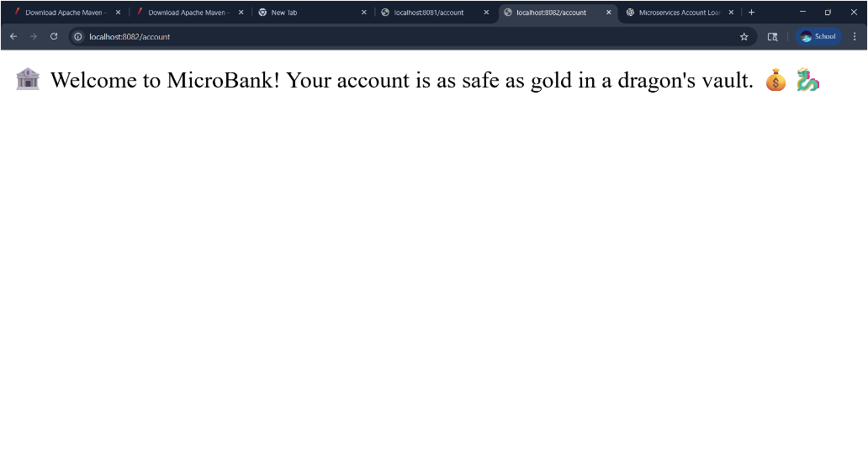

**Loan Microservice**

**Generate Spring Boot Project**

Repeat the steps in Spring Initializer:

* **Group**: com.cognizant
* **Artifact**: loan
* Dependencies:
  + Spring Boot DevTools
  + Spring Web
* Download, extract, and move it to:  
  D:\123456\microservices\loan

**Build and Import in Eclipse**

* Build:

mvn clean package

* Import into Eclipse like before

**Change Port Number**

Edit the file:

src/main/resources/application.properties

server.port=8083

**Implement Controller**

Create:  
src/main/java/com/cognizant/loan/controller/LoanController.java

package com.cognizant.loan.controller;

import org.springframework.web.bind.annotation.*;

@RestController

@RequestMapping("/loans")

public class LoanController {

@GetMapping("/{number}")

public Loan getLoanDetails(@PathVariable String number) {

return new Loan("H009879879723342", "car", 400000, 3258, 18);

}

static class Loan {

private String number;

private String type;

private double loan;

private double emi;

private int tenure;

public Loan(String number, String type, double loan, double emi, int tenure) {

this.number = number;

this.type = type;

this.loan = loan;

this.emi = emi;

this.tenure = tenure;

}

public String getNumber() { return number; }

public String getType() { return type; }

public double getLoan() { return loan; }

public double getEmi() { return emi; }

public int getTenure() { return tenure; }

}

}

**Run and Test**

Run:  
LoanServiceApplication.java

package com.cognizant.loan;

import org.springframework.boot.SpringApplication;

import org.springframework.boot.autoconfigure.SpringBootApplication;

@SpringBootApplication

public class LoanServiceApplication {

public static void main(String[] args) {

SpringApplication.run(LoanServiceApplication.class, args);

}

}

Test in browser :

<http://localhost:8083/loans>

Output of Loan Service:

