Struts2.0

Lab Book

Copyright © 2011 Patni Computer Systems, Akruti, MIDC Cross Road No. 21, Andheri (E), Mumbai 400 093. All rights reserved. No part of this publication reproduced in any way, including but not limited to photocopy, photographic, magnetic, or other record, without the prior agreement and written permission of Patni Computer Systems.

Patni Computer Systems considers information included in this document to be Confidential and Proprietary.



Document Revision History

|  |  |  |  |
| --- | --- | --- | --- |
| Date | Revision No. | Author | **Summary of Changes** |
| 30-Nov-2009 |  | Vaishali Kulkarni | Content Creation |
| 01-Dec-2009 |  | CLS team | Review |
| 10-Mar-2010 |  | Vaishali Kulkarni | Content Revamp |
| August 2012 |  | Vaishali Kulkarni | Content Revamp |

Table of Contents

Document Revision History 2

Table of Contents 3

Getting Started 5

Overview 5

Setup Checklist for Struts2.0 5

Instructions 5

Learning More (Bibliography if applicable) 5

Problem Statement/ Case Study (If applicable) 6

Overview 6

Functional requirements 6

1. Layout of Online Banking System 6

2. Login / Change Password 6

3. Account Opening Form 6

4. Fund Transfer 6

5. Views 7

6. Update Personal Details 7

7. Select a Language 7

Non-Functional Requirements 7

1. Security 7

2. Support 7

Lab 1. Developing Online Banking System (OBS) 8

1.1: Develop the Login feature for online banking system. 8

Lab 2. Developing Online Banking System (OBS) 10

2.1: Adding actions to the Login page 10

Lab 3. Developing Online Banking System (OBS) 12

3.1: UI creation and corresponding functionality for the options on ‘User Home Page’ 12

Lab 4. Developing Online Banking System (OBS) 13

4.1: Apply validations to all user inputs to the options on ‘User Home Page’ created in previous lab 13

4.2: Create functionality for the option ‘Select a language for page display’ using the I18N. 13

Lab 5. Review , Testing and Debugging Online Banking System (OBS) 15

Getting Started

## Overview

This lab book is a guided tour for learning Struts2.0. It comprises solved examples and ‘To Do’ assignments. Follow the steps provided in the solved examples and work out the ‘To Do’ assignments given.

## Setup Checklist for Struts2.0

Here is what is expected on your machine in order for the lab to work.

Minimum System Requirements

* Intel Pentium III or higher
* Microsoft Windows XP or 2003.
* Memory: 512MB of RAM (1 GB recommended)
* 1 GB hard disk space
* VGA or higher resolution monitor
* Mouse or other pointing device
* JDK version 1.5 with help, Netscape or IE
* Connectivity to Oracle database
* Eclipse3.3 IDE
* JBOSS 4.2 or equivalent Web Server.

## Instructions

* Create a directory by your name in drive <drive>. In this directory, create a subdirectory struts_assgn. For each lab exercise create a directory as lab <lab number>.

## Learning More (Bibliography if applicable)

* Struts2.0 In Action; by Donald Brown, Chand Davis, Scott Stanick
* Struts2 Black Book; by Kogent Solutions Inc

Problem Statement/ Case Study (If applicable)

## Overview

An online banking system has to be developed for a bank. This is an Intranet based application that is used by the bank customers to perform online activities. This system has internationalization feature that allows a user to select a language for all the UI (forms, reports) in this system.

## Functional requirements

## 1. Layout of Online Banking System

The online banking system application should have following facilities:

**For a customer:**

* + - * Login to the system or Open an account with the bank
      * Change the password after logging into the system
      * Transfer of funds from one account to another, of the same bank
      * View account details
      * Update the personal details
      * Select a language for the UI

## 2. Login / Change Password

Authenticate the user against an existing password. Password can be changed as per the password policy (assume a complexity level for password).

## 3. Account Opening Form

Following are the minimum details entered by the user to open an account:

* First Name, Last Name, Gender, Address, Upload Address proof and photograph, Account Type, occupation, office address, telephone numbers
* Password, Username

Account number is auto generated upon submission.

## 4. Fund Transfer

Authenticated user with an adequate balance (minimum balance is maintained after the transaction) can transfer funds to an account in the same bank.

The details like Date (System date captured), Account number (to which the funds are being transferred) are captured.

## 5. Views

* **Account Details:**

Following details have to be displayed for the account details report:

Account No. , Current Balance

## 6. Update Personal Details

The customer should be able to change the following details:

Address, Upload Address proof, Occupation, Office Address, Telephone Numbers

## 7. Select a Language

Home page should allow the user to choose a language for the UI.

## Non-Functional Requirements

## 1. Security

Application should be available to only authorized users.

## 2. Support

It is expected that company IT department should be able to support the application after implementation. It is recommended that application be developed on J2EE platform.

1. Developing Online Banking System (OBS)

|  |  |
| --- | --- |
| **Goals** | Developing the Login feature for Online Banking System (OBS)   * + Using Struts2.0 Framework   + Deploying the application in JBOSS 4.2 or equivalent Web Server |
| **Time** | 3 hrs |
| **Lab setup** | Windows OS with JDK1.5, Eclipse 3.0+ installed, JBOSS 4.2 Server |

## 1.1: Develop the Login feature for online banking system.

For the case study provided in the earlier section develop the Login feature for online banking system.

Solution:

**Step 1:** Create the index page as shown

**Index Page**

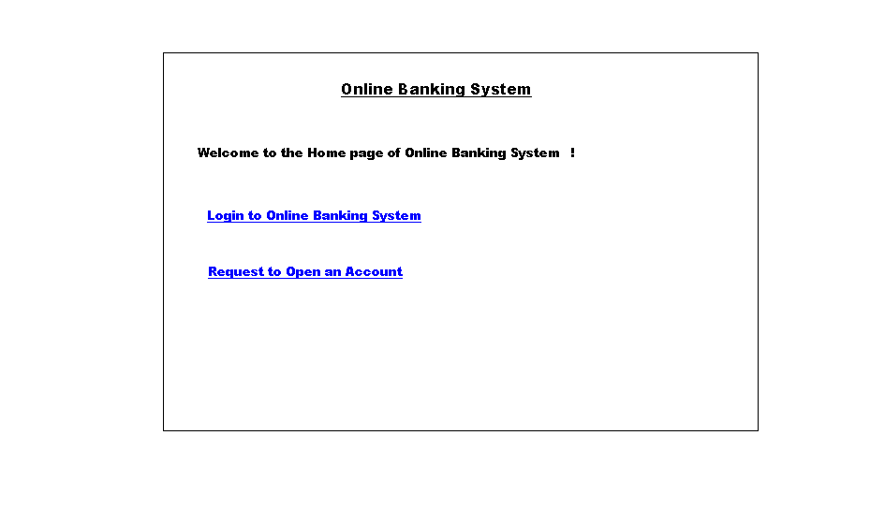

The first link connects to the Login Page as shown below.

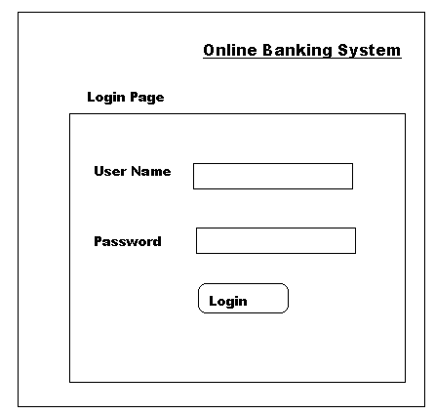

1. Developing Online Banking System (OBS)

|  |  |
| --- | --- |
| **Goals** | Developing the Login feature for Online Banking System (OBS)   * + Using Struts2.0 Framework   + Deploying the application in JBOSS 4.2 or equivalent Web Server |
| **Time** | 3 hrs |
| **Lab setup** | Windows OS with JDK1.5, Eclipse 3.0+ installed, JBOSS 4.2 Server |

## 2.1: Adding actions to the Login page

**Solution:**

**Step 1:**

* Login.java is the action class for the ‘Login Page’
* Validate the user inputs : Fields can not be left blank , authentication should be successful
* Display suitable error messages using the .property files.
* Incase authentication fails, the ‘Authentication Error Page’ should be displayed.

**Step 2:**

* **Login class** : The Login class has an object of User class as its member. To authenticate the user ,the user object is Login class is populated. Login class also has a method called ‘getBankingService()’ that returns an instance of ‘BankingService’ class. To authenticate the user its existence is checked using the userExists(userObject) method of BankingService
* **BankingService class :** Utility class that stores HashMap of valid User objects and corresponding Account Objects . BakingService provides a method ‘userExists(userObject)’ returning true if the such user exists in the HashMap.
* **User class :** Contains the Username, Password fields and its getter/setter methods

**Step 3:**

* On successful authentication the ‘User Home Page’ should be displayed as shown below.

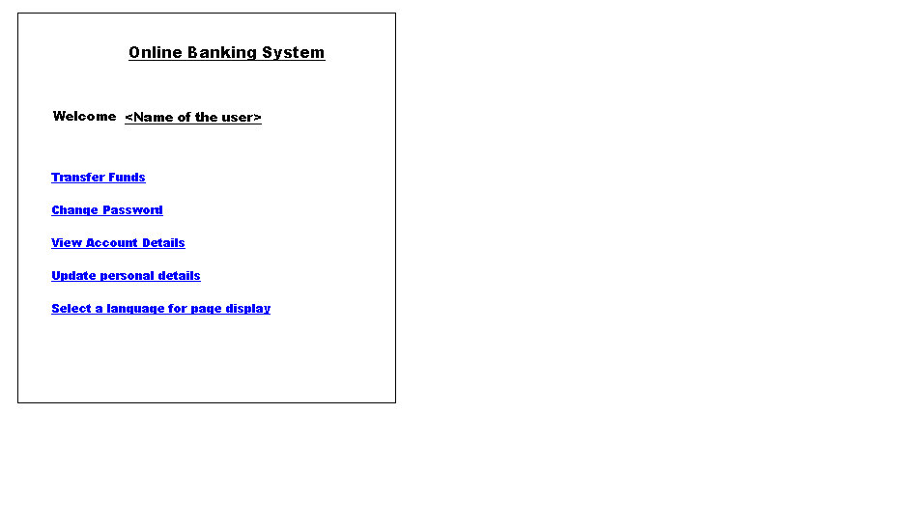

**Note:** A User may have more that one Account, but not Vice Versa.

1. Developing Online Banking System (OBS)

|  |  |
| --- | --- |
| **Goals** | Developing the Login feature for Online Banking System (OBS)   * + Using Struts2.0 Framework   + Deploying the application in JBOSS 4.2 or equivalent Web Server |
| **Time** | 4 hrs |
| **Lab setup** | Windows OS with JDK1.5, Eclipse 3.0+ installed, JBOSS 4.2 Server |

## 3.1: UI creation and corresponding functionality for the options on ‘User Home Page’

**Solution: Creating the functionality mentioned on the ‘User Home Page’**

**Step 1:** Create user interfaces for the following options

* 1. Account Opening Form (Hyperlink available on the index page)
  2. Change the password
  3. Transfer of funds (from one account to another, of the same bank)
  4. View account details
  5. Update the personal details

1. Developing Online Banking System (OBS)

|  |  |
| --- | --- |
| **Goals** | Developing the Login feature for Online Banking System (OBS)   * + Using Struts2.0 Framework   + Deploying the application in JBOSS 4.2 or equivalent Web Server |
| **Time** | 4 hrs |
| **Lab setup** | Windows OS with JDK1.5, Eclipse 3.0+ installed, JBOSS 4.2 Server |

## 4.1: Apply validations to all user inputs to the options on ‘User Home Page’ created in previous lab

## 4.2: Create functionality for the option ‘Select a language for page display’ using the I18N.

Review , Testing and Debugging Online Banking System (OBS)

|  |  |
| --- | --- |
| **Goals** | Review , Testing and Debugging the Online Banking System (OBS) |
| **Time** | 4 hrs |
| **Lab setup** | Windows OS with JDK1.5, Eclipse 3.0+ installed, JBOSS 4.2 Server |

**5.1:** **Peer-to-Peer Review**

Perform a code review of the solution created up to Lab3 and identify review defects. Use the checklist provided during the Software Reviews and Testing training.

Exchange your application with the person sitting next to you

and do the peer-to-peer review

Use the review form (xls) provided during the Software Reviews and Testing training for logging review defects.

**5.2:** **Peer Testing**

Perform a code testing (black box testing) for the solution up to Lab3. Use the UTP_Template.xls provided during the Software Reviews and Testing training for entering test cases.

**5.3:** **Writing** **Test Cases**

Write at least 3 test cases using JUnit framework for the BankingService Class.

**5.4:** **Debugging**

You have been provided with some application by your instructor. Debug those applications and make them working

**Hint:** Use the following technologies:



**User Interface:**

1. Servlets

2. JSP

3. Struts2.0

**Business Logic Components:**

1. Struts2.0 Actions

2. JDBC

**WebServer:**

1. JBOSS 4.2 or equivalent