Launch a t2.micro instance in Mumbai region where ssh can be done only from your IP address with docker and docker-compose installed in it.

Creating the ubuntu instance

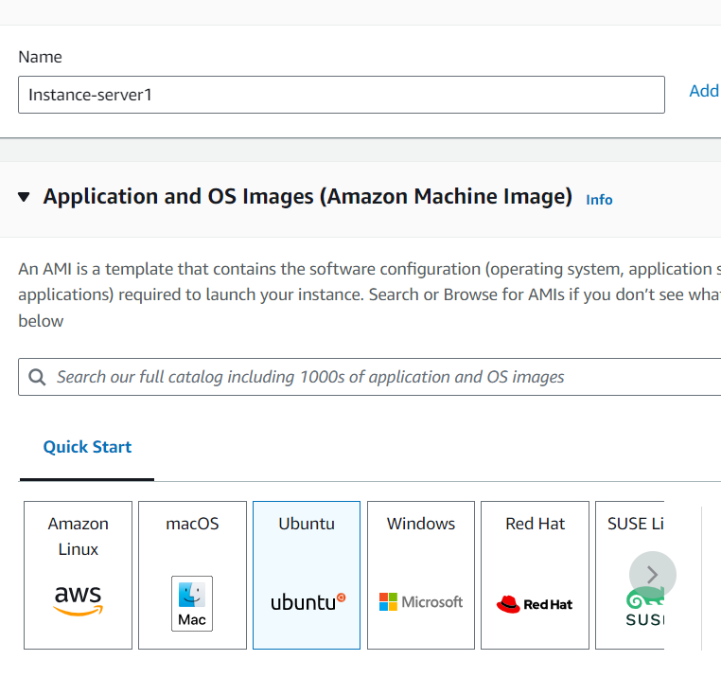

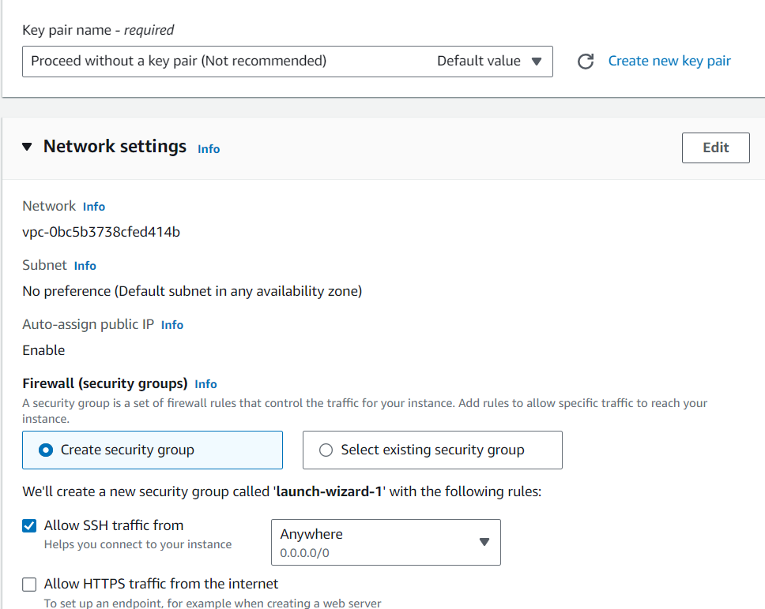

SSH into the server by downloading the key downloading both private & public key

In the session 🡪 Auth 🡪 Give the private key

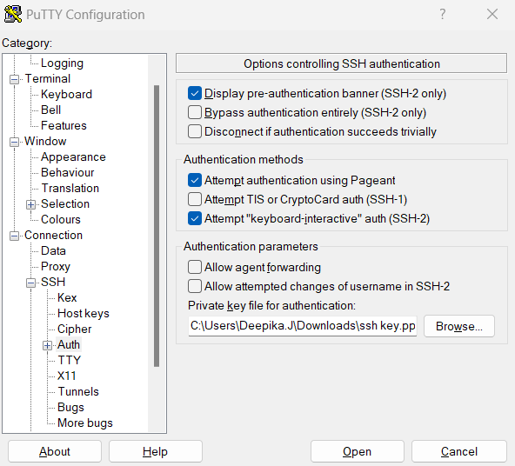

Login to the server with the username public DNS name

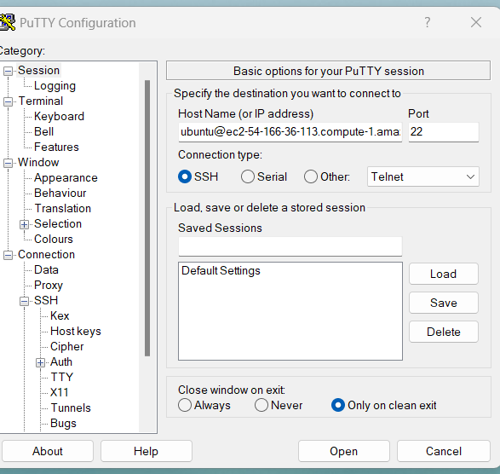

Install the Docker & docker-compose on it

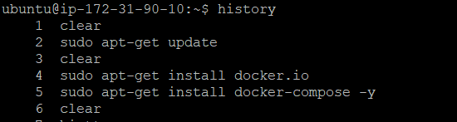

After SSH to the server, we can able to view the docker & docker-compose installed on it

