Write Terraform script to create highly available infrastructure in AWS. The infra should have1 vpc, 3 subnets setup in 3 different az and 2 instances setup in 2 different subnets

With the created terraform script the below had been created on the AWS console

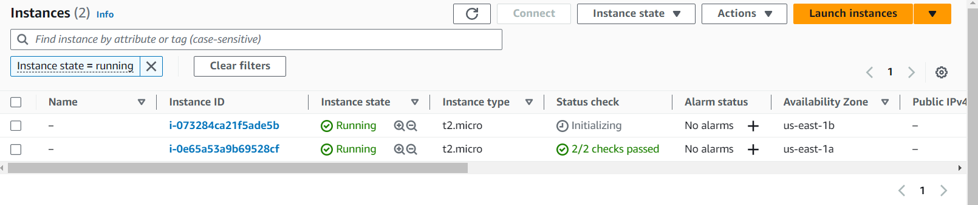

Server 1 Sg & Subnet :

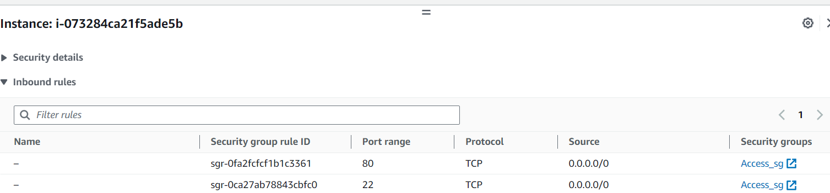

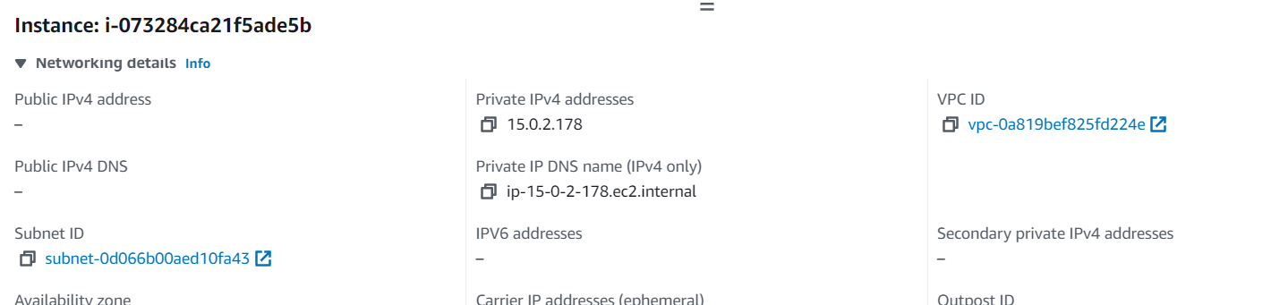

Server 2 Sg & Subnet:

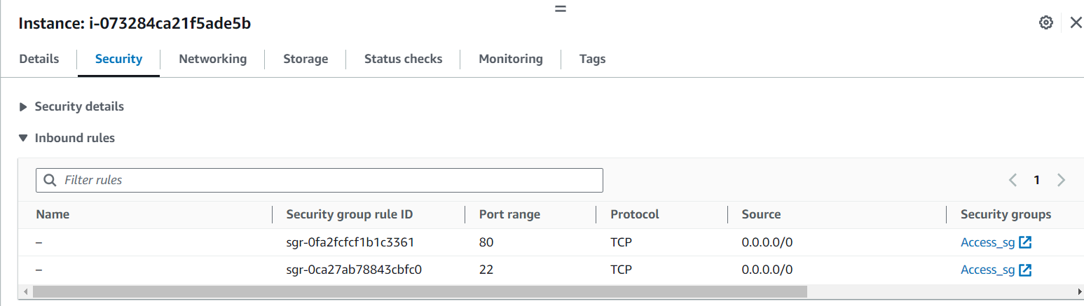

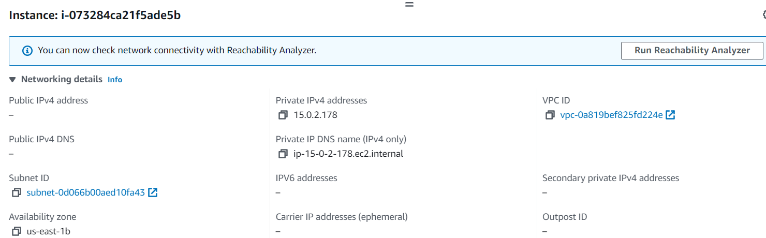

VPC & Associated public Subnet

