Installed Kubernetes on the EC2 instance with the below commands

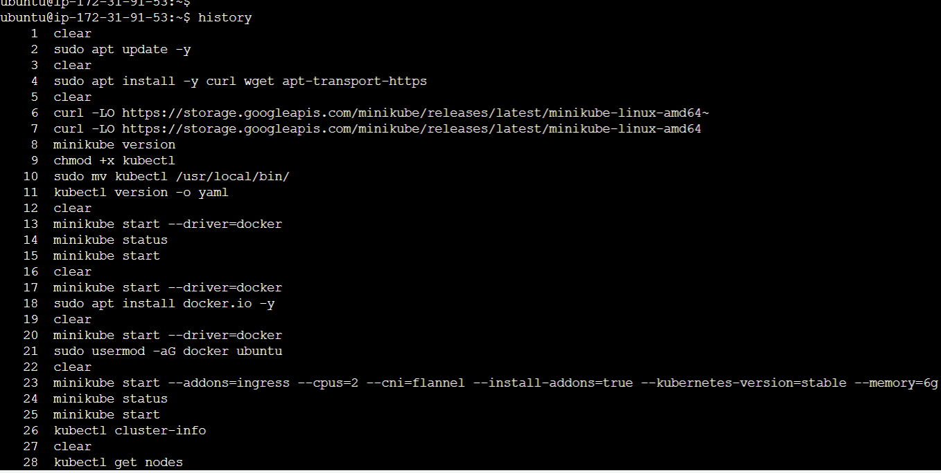

Checking the Kubernetes Nodes status

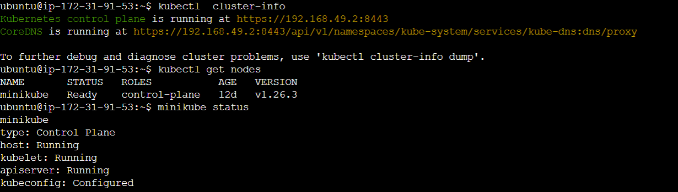

Getting the Namespace details in the Kubernetes

