**MOBILE BANKING SYSTEM**

**LOW LEVEL DESIGN**

**Overview of Mobile banking:**

The main objective of this project is to design an online mobile banking application that will allow the users to create an account, make transactions, open FD or RD without going to the bank the user can access it any time at any place.

**Procedure Flow:**

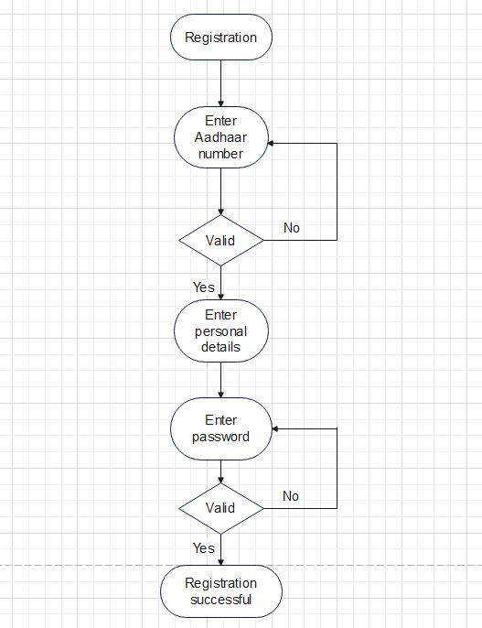

**User Registration:**

If a user wants to create a new account first the user has to register with 12 digits Aadhar number and personal details with a strong password.

**Password Validation:**

The password should be of at least 8 characters with combination of Upper Case Letters, Lower Case Letters, Numbers and Special character.

**Create Savings Account (SA) or Current Account (CA):**

On successful registration 8 digits account number will be generated. an account number with the user can create an SA or CA.

**Procedure Flow:**

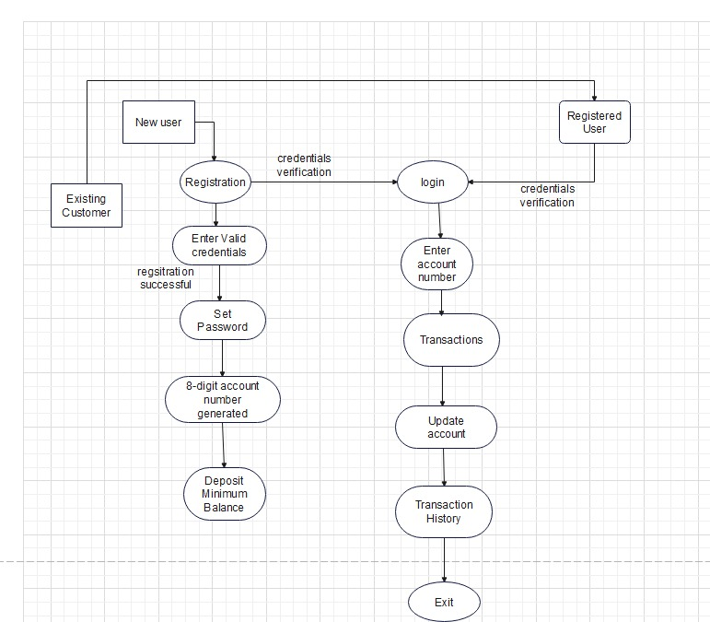

**Sequence Flow:**

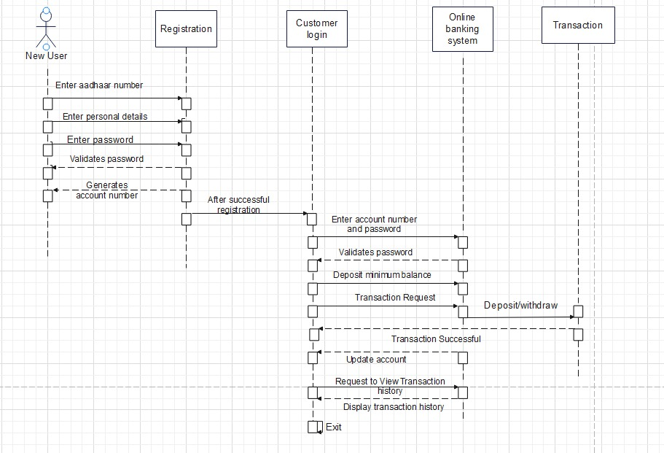

**Customer Login:**

Customer has to login with an account number and password, if the password is correct he/she can proceed further.

**Transaction:**

Customerrequests for transaction to credit or withdraw money from the respective bank account. After Successful transaction, the bank sends a message “Transaction is Successful”.