

**MOBILE BANKING SYSTEM**

**Software Requirement Specification (SRS) Document**

**Sprint 1 Implementation**

**Project Timeline: 20.10.2022 to 27.10.2022**

|  |  |  |
| --- | --- | --- |
| Sr.No | TOPIC | Page No |
| 1 | **Introduction**   * 1. Purpose   2. Intended Audience   3. Intended Use   4. Scope | 1 |
| 2 | **Overall Description**  2.1 Assumptions and Dependence | 2 |
| 3 | **System Features and Requirements**  3.1 Functionality  3.1.1 Registration_Process  3.1.2 Creating_Password  3.1.3 Minimum_Deposit  3.1.4 Transactions  3.1.5 Fund_Transfer  3.1.6 Available_Balance  3.1.7 Transaction_History  3.1.8 Open_RD_FD  3.1.9 Annual_Interest  3.1.10 Close_RD_FD  3.1.11 Request_checkbook  3.1.12 Change_Personal_Details  3.1.13 Close_SA_CA  3.1.14 Banker_Management  3.1.15 Daily_Transaction_Report  3.1.16 Low_Balance_Remainder  3.2 System Requirements  3.2.1 Tools Required  3.3 System Features | 3-5 |
| 4 | **Data Flow Diagrams**  4.1 DFD Level 0  4.2 DFD Level 1 | 6 |

### **INTRODUCTION :-**

Changing scenario has prompted customers to do banking from the safety of their home. Gone are the days when one needed to go to the bank, stand in long queues, waste valuable time and do transactions.  
The present day banking system is more home based/mobile based. The effort is to minimize the banking time and maximize the level of service.  
This mobile banking project is one that provides various banking functionality to a user with ease on his mobile phone. It allows the user to check his/her balance, view latest transactions, transfer funds, request for cheque book etc.

* 1. **Purpose :-**

The purpose of this document is to show the requirements for the Online Banking System, In which customers can access all the banking facilities under one roof.

* 1. **Intended Audience :-**

This document is intended to be read by Users of the system.

**1.3** **Intended Use :-**

* Development Team
* Bank Employees
* Customer

Since this is a General-Purpose Software any one can access it.

* 1. **Scope :-**

With the help of online banking, there are several indispensable services which are made available to customers, without them having to personally visit the bank. Customers can perform financial transactions like transfer funds online and open a savings account among various other transactions. Under non-financial transactions, customers can carry out several activities which may require going to the bank like applying for a new cheque book, getting account statements, update contact information, start/stop payment, etc.

**2. OVERALL DESCRIPTION :-**

Online Banking, also known as net banking, e-banking or online banking, is the facility provided by banks and financial institutions which allows customers to use banking services via the internet. This consists of a database which stores the information of the customer and employees of the bank. In this application we can create various types of bank accounts using Aadhar card as government id proof with password authentication. The customer can transfer funds from one account to any other account in the same bank. Using this application, the customer can check the last 10 transactions. It also gives updated information about annual interest percentage according to RBI guidelines. Customers can also request a check book by entering the required credentials. There is a separate section for editing the personal details in this application. Customers can also avail the benefits of Recurring Deposit (RD) and Fixed Deposit (FD) accounts. The main purpose of this project is to perform all the banking activities. This is an easy to understand and user-friendly application.

**2.1 Assumptions and Dependency :-**

* System should have Ubuntu Linux installed.
* · System should have either 4GB or more RAM.
* The service is used preferably on a desktop or laptop alternatively it can also be used from a mobile phone.

**3. SYSTEM FEATURES AND REQUIREMENTS :-**

**3.1 Functionality :-**

**3.1.1 MBS_01-> Registration_Process:** This is the first main menu level function that provides flexibility to enable the user to create a new account using Aadhar card and personal details. Here users can also select the type of account that the customer wants to open.

**3.1.2 MBS_02-> Creating_password** : After successful registration, the 8 digit account number is generated automatically and the user is required to set up a password which can be used for further transactions.

**3.1.3 MBS_03-> Minimum_Deposit** : This function asks user to deposit minimum amount while opening an account. User can also go for initial deposit which should be greater than minimum deposit.

**3.1.4 MBS_04->** **Transactions :**  As the name suggests, the job of this function is to deposit and withdraw amount from the respective account after successful validation of their credentials.

**3.1.4.1 MBS_04.1-> Deposit :** This function is used to deposit money to the respective bank account.

**3.1.4.2 MBS_04.2-> Withdraw :** This function is used to withdraw money from the respective bank account.

**3.1.5 MBS_05-> Fund_Transfer :** This function allow user to transfer funds from one account to another account within the same bank

**3.1.6 MBS_06-> Available_Balance :** This is a main menu level function that allows the customer to view current balance of Savings Account or Current Account.

**3.1.7 MBS_07-> Transaction_History :** This function allows user to get a view of last 10 transactions.

**3.1.8 MBS_08-> Open_RD_FD :** By using this function, customer can open an Recurring Deposit (RD) or Fixed Deposit (FD) account. The new account is linked with the existing account.

**3.1.8.1 MBS_08.1-> Open_RD:** This function is used to open a Recurring Deposit account. The customer can set installment amount which he have to pay on regular intervals.

**3.1.8.2 MBS_08.2-> Open_FD:** This function is used to open an Fixed Deposit account.while opening this account customer has to deposit a fixed amount for a fixed period of time.

**3.1.9 MBS_09-> Annual_Interest :** In this particular function, customers get an annual interest percentage according to RBI guidelines.

**3.1.10 MBS_10-> Close_RD_FD :** In this function, customers can request for closure of an RD or FD account and the amount is automatically transferred to its existing SA or CA.

**3.1.10.1 MBS_10.1-> Close_RD :** By calling this function ,the customer can close his recurring deposit and the money deposited will be transferred to the SA or CA with interest of that amount till date.

**3.1.10.2 MBS_10.2-> Close_FD:** By calling this function ,the customer can drop his fixed deposit and the money deposited will be transferred to the SA or CA with interest of that amount till date.

**3.1.11 MBS_11-> Request_Checkbook :** By using this function, the customer can request for the check book by entering the required details.

**3.1.12 MBS_12-> Change_Personal_Details :** In this section, customers can update password and personal details.

**3.1.13 MBS_13-> Close_SA_CA :** In this function, customers can request for closure of SA or CA.

**3.1.13.1 MBS_13.1-> Close_SA-** By choosing this function, customers can close the Saving account by filling the appropriate credentials.

**3.1.13.2 MBS_13.2-> Close_CA-** By choosing this function, customers can close the Current Account by filling the appropriate credentials.

**3.1.14 MBS_14-> Customer_Management :** This function is accessed by bank employees only by using their credentials. The bank employee can manage data (Add, Edit and Delete) according to requirements.

**3.1.14.1 MBS_14.1-> Add_data:** The bank employee can add the data of the new customer by using this function.

**3.1.14.2 MBS_14.2-> Edit_data:** The bank employee can edit the data of the existing customer by using this function.

**3.1.14.3 MBS_14.3-> Delete_data:** The bank employee can delete the data of the existing customer by using this function.

**3.1.14.4 MBS_14.4-> View_data:** The bank employee can view the data of the existing customer by using this function.

**3.1.15 MBS_15-> Daily_Transaction_Report :** This function will again be accessed by bankers only. The bank employee can produce a report of daily transactions by all customers.

**3.1.16 MBS_16-> Low_Balance_Remainder :** In this last section, the employee can generate a report of all accounts where the balance is very low. And a reminder can be sent to the customers for the same.

**3.2 System Requirements :-**

### **3.2.1. Tools to be used:**

* C file handling
* Vi Editor
* Splint
* Valgrind
* GDB

### **3.3 System Features :-**

* **Design Constraints:** The system is built using only C language.

### **Performance:** The system will work on the user’s terminal**.**

* **Reliability & Availability:** The system is available anywhere and anytime i.e. 24/7 that is it will be accessed by the user according to the need.

### **Supportability:** The system is easy to understand and it is user friendly.

**4. DataFlow Diagram:**

**4.1 DFD Level 0 -**

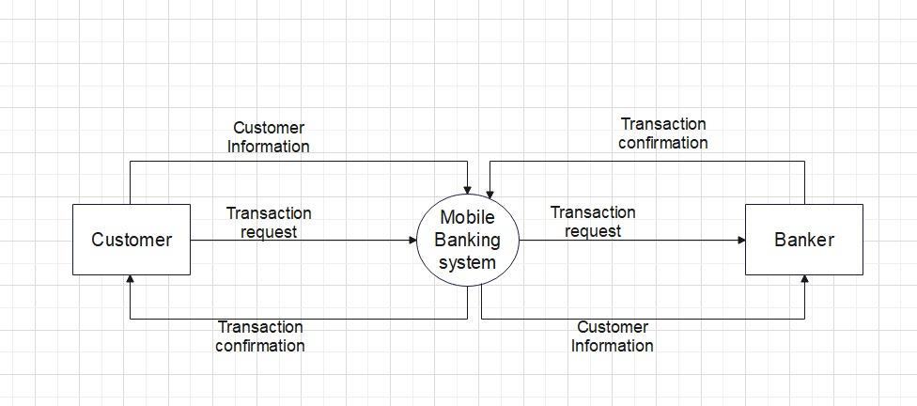

**4.1 DFD Level 1 -**

