**TEST CASES OF SERVICES DEPLOYED ON AWS AND TESTED USING POSTMAN**

**Prerequisites:**

1. Post Man installed on machine
2. Web browser**.**

**Access URL:** [**http://ec2-16-170-166-215.eu-north-1.compute.amazonaws.com:8080/tax**](http://ec2-16-170-166-215.eu-north-1.compute.amazonaws.com:8080/tax)

**Request type:** POST

**Description:** Below is the brief description of what steps were performed before performing test cases.

1. CongestionTaxCalculator jar is uploaded in S3 bucket.
2. Created EC2 instance
3. Installed Java11 version on EC2 instance
4. Fetched jar from S3 bucket to EC2 instance
5. Run CongestionTaxCalculator jar.

**Test Cases 1:** Random time

**Body:** {"vehicleType":"CAR","dateTimes":[[2022,10,14,17,0],[2022,10,14,17,30],[2022,10,14,18,0],[2022,10,14,18,28]]}

**Output:** 21

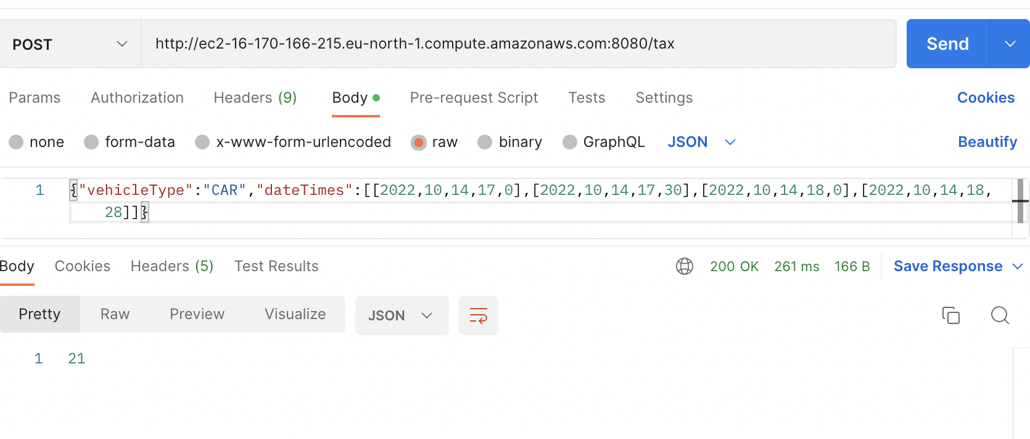

**Test Case 2:** Weekend Toll Test

**Body:** {"vehicleType":"CAR","dateTimes":[[2022,7,31,17,0]]}

**Output:** 0

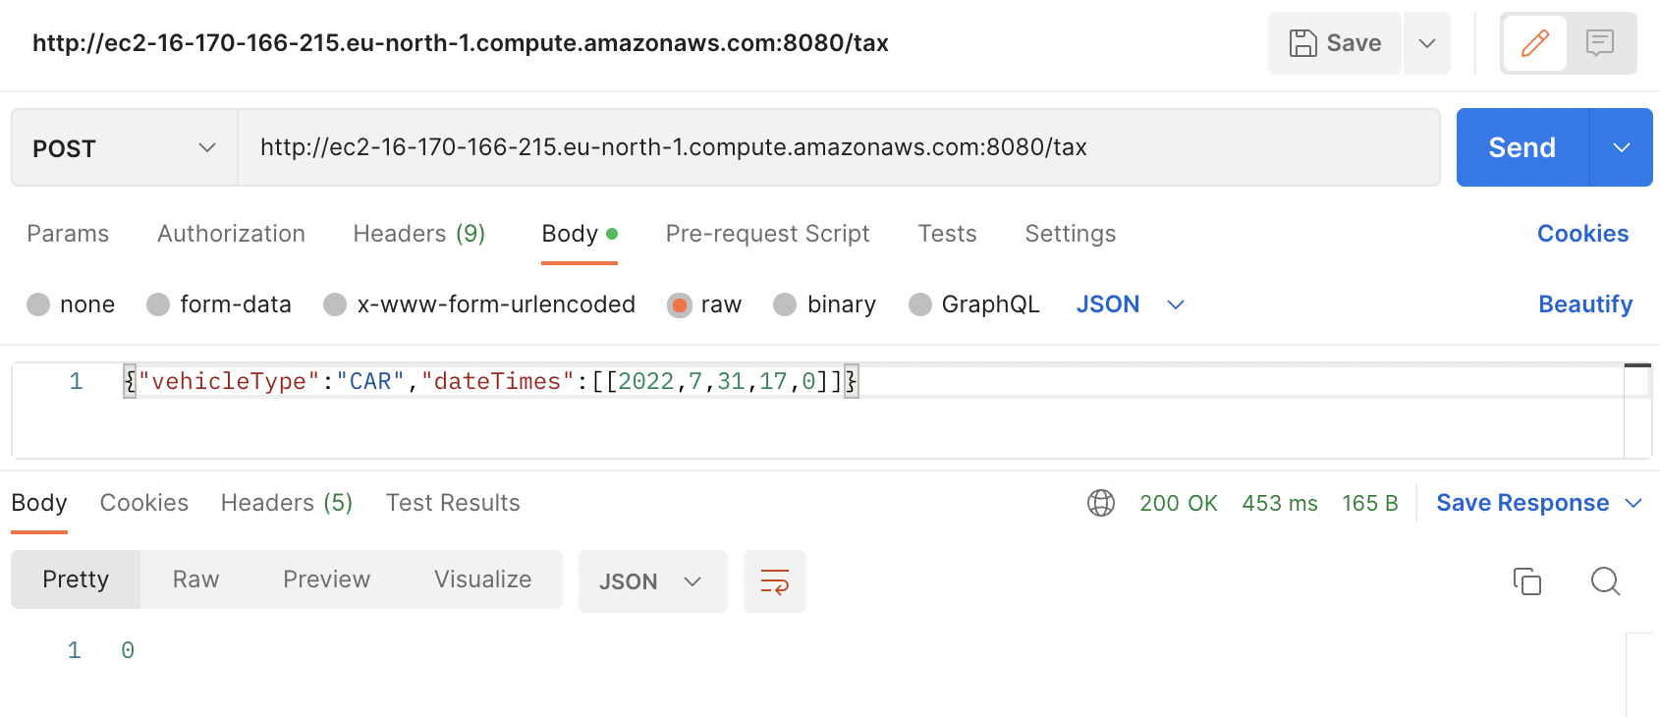

**Test Case 3:** Toll Free vehicle test

**Body:** {"vehicleType":"DIPLOMAT","dateTimes":[[2022,7,31,17,0]]}

**Output:** 0

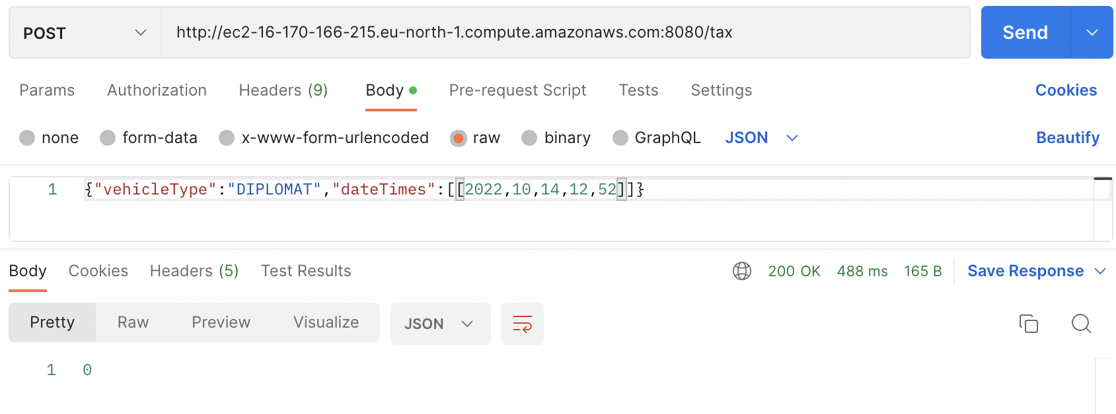

**Test Case 4:** Toll free date

**Body:** {"vehicleType":"CAR","dateTimes":[[2022,01,01,17,0]]}

**Output:** 0

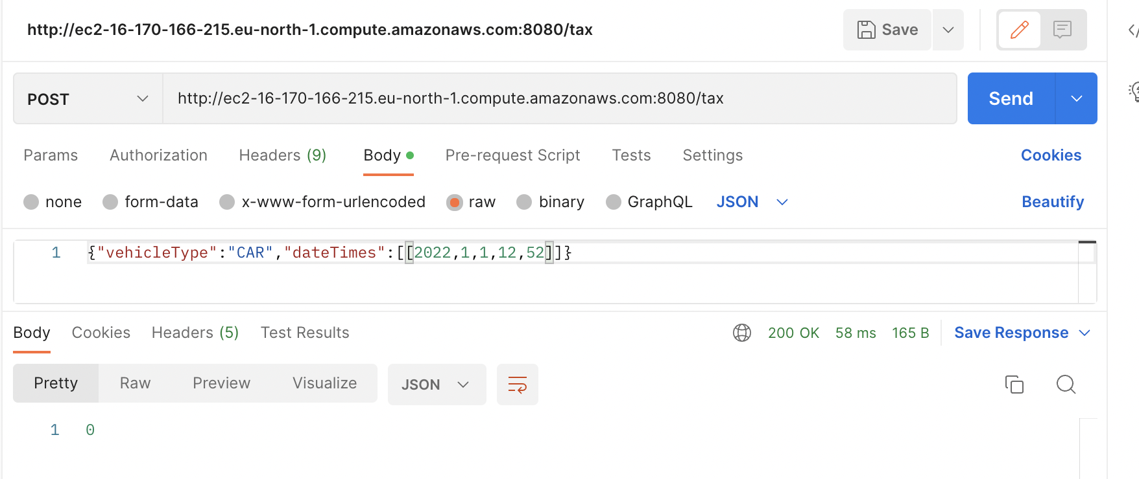

**Test Case 5:** Toll test for vehicles travelling from midnight till morning

**Body:** {"vehicleType":"CAR","dateTimes":[[2022,10,14,1,0],[2022,10,14,5,59],[2022,10,14,19,10]]}

**Output:** 0

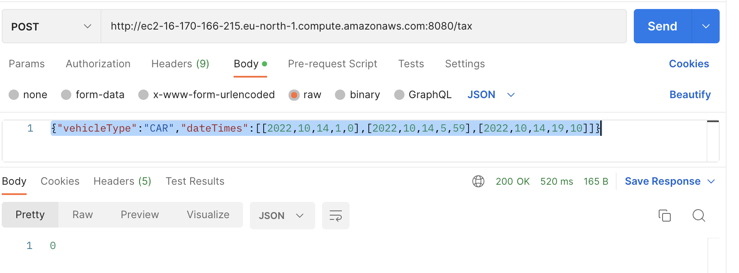

**Test Case 6:** Toll test for vehicles travelling in morning

**Body:** {"vehicleType":"CAR","dateTimes":[[2022,10,14,6,0],[2022,10,14,6,29]]}

**Output: 8**

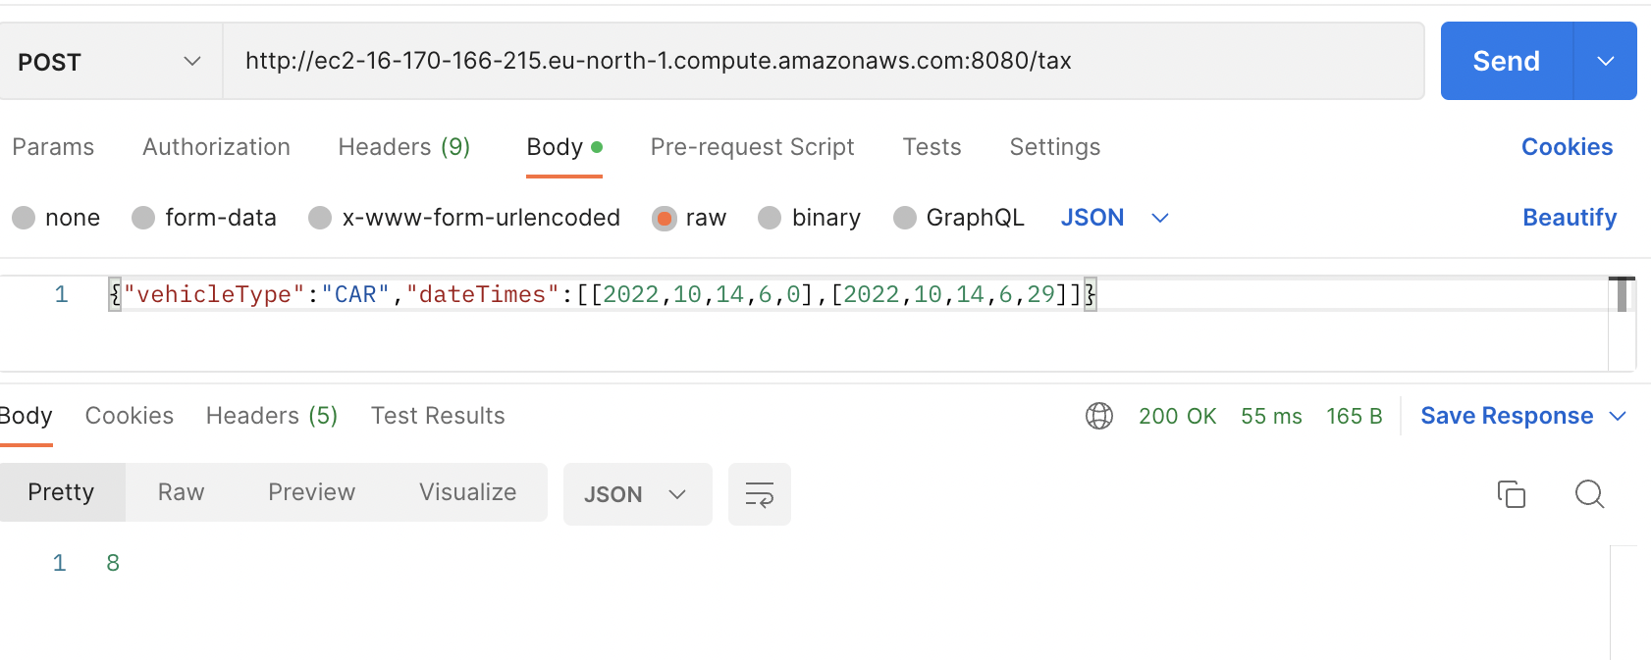

**Test Case 7:** Maximum toll calculation in one day

**Body:** {"vehicleType":"CAR","dateTimes":[[2022,10,14,6,0],[2022,10,14,11,35],[2022,10,14,12,35],[2022,10,14,14,35],[2022,10,14,16,0],[2022,10,14,17,0],[2022,10,14,18,0],[2022,10,14,15,35],[2022,10,14,14,35]]}

**Output: 60**

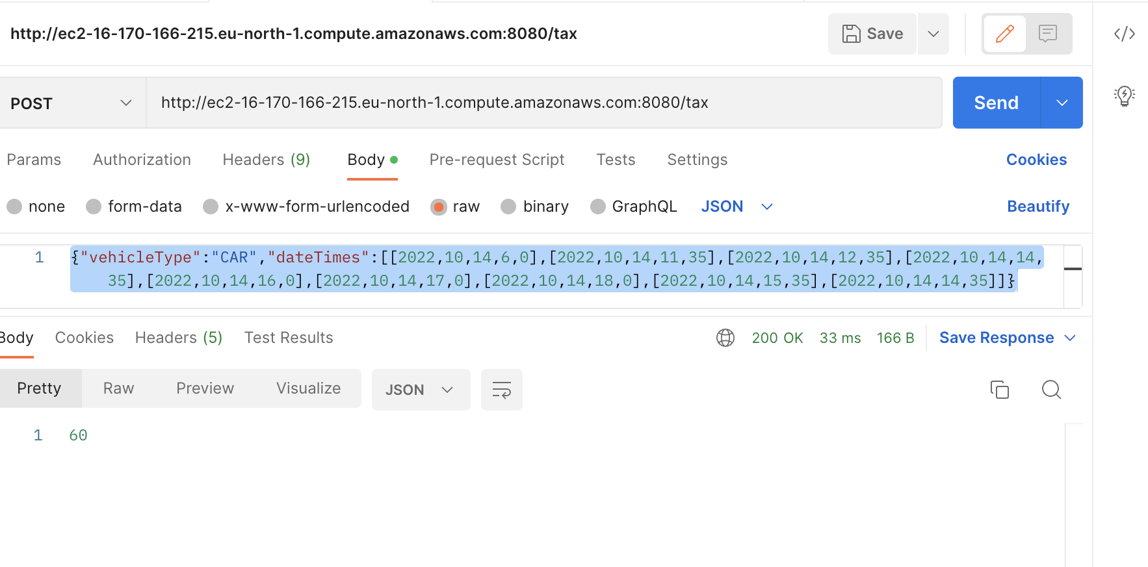

**Test Case 8:** Passing vehicle=null value

**Body:** {"vehicleType":null,"dateTimes":[[2022,10,14,17,0],[2022,10,14,17,30],[2022,10,14,18,0],[2022,10,14,18,28]]}

**Output:** Vehicle is marked null but it is non-null

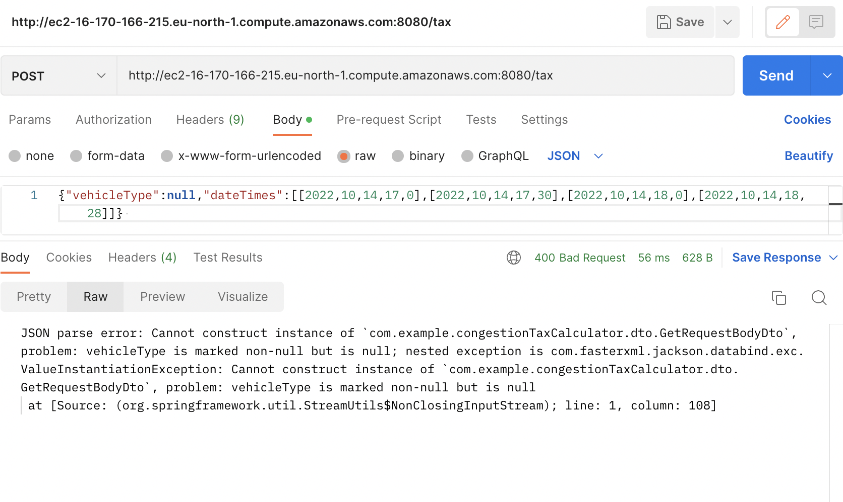

**EC2 console runtime message:** Vehicle cannot be null

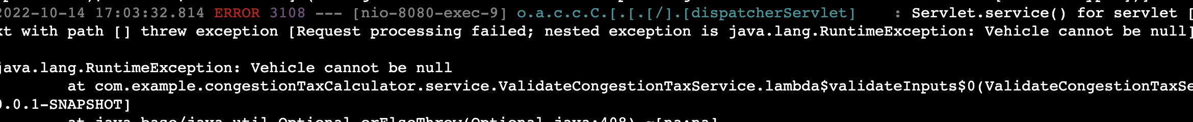

**Test Case 9:** Passing Date Time=null value

**Body:** {"vehicleType":”CAR”,"dateTimes":null}

**Output:** dateTime is marked non-null but is null

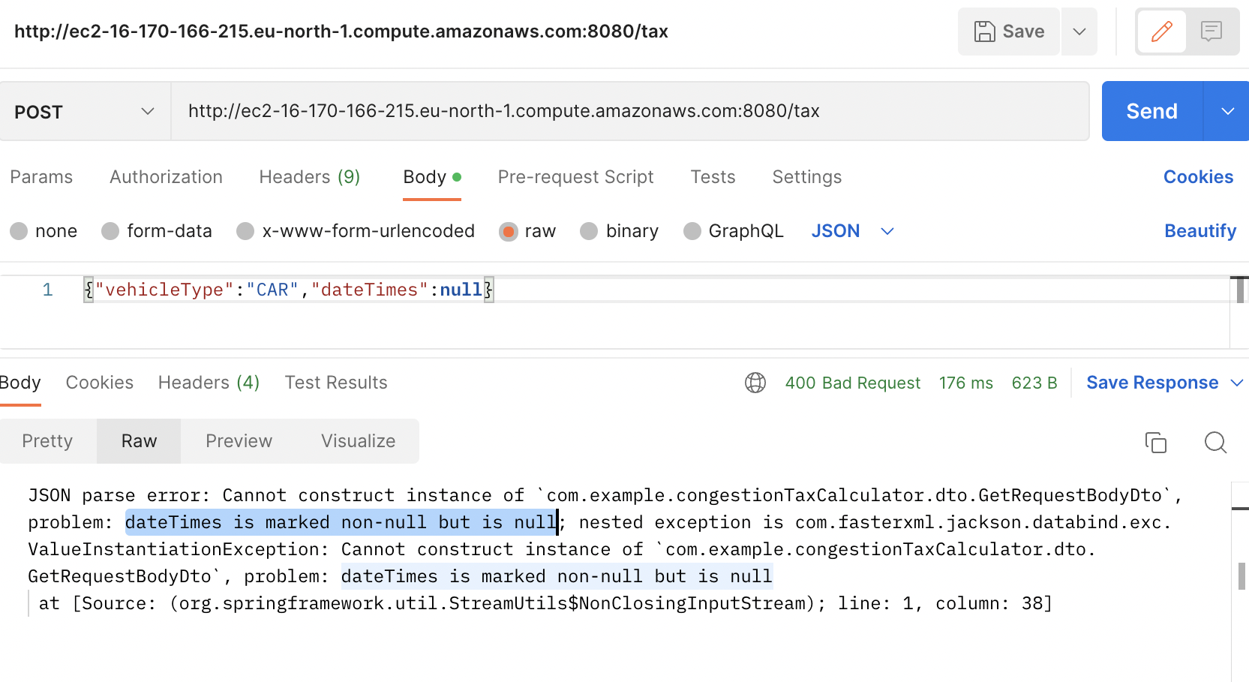

**Test Case 10:** Passing multiple date

**Body:** {"vehicleType":”CAR”,” dateTimes":[[2022,10,14,17,0],[2022,10,14,17,30],[2022,10,14,18,0],[2022,10,14,18,28]]}

**Output:** The time range cannot exceed more than one day

