NeuralStock: Deep Learning for E-commerce Inventory Demand Forecasting

Project Report
Domain: E-Commerce | Techniques: LSTM, Feedforward Neural Network, Time-Series Feature Engineering | Deployment: Streamlit + Cloud

Problem Background
Online retailers frequently face chronic stock imbalances: high-demand products stock out during peak periods while slow-moving items accumulate warehouse holding costs. NeuralStock addresses this with a stacked LSTM (plus an MLP baseline) that forecasts per-SKU weekly demand to support procurement, stockout prevention, promotional planning, and supplier negotiation decisions.

Methodology

Preprocessing & Feature Engineering
Missing units_sold values are forward-filled within each product's own chronological series. Unit price outliers are clipped per category using the IQR method. Lag-7/14 and 7/30-day rolling mean/std features, a weekend flag, and cyclical month/day-of-week encodings were engineered per SKU. MinMaxScaler is fit only on the training split; train/test splits are strictly chronological per product (no shuffling) — see preprocess.py for the exact implementation.

Model Architecture
DemandLSTM: a 2-layer stacked LSTM (hidden size 64, dropout 0.2) over 14-step sliding windows of engineered features. DemandMLP: a 128-64-32 feedforward baseline. Hidden sizes were kept modest given the limited per-SKU history available. Both trained with Adam (lr=1e-3) and MSE loss — see model.py and train.py.
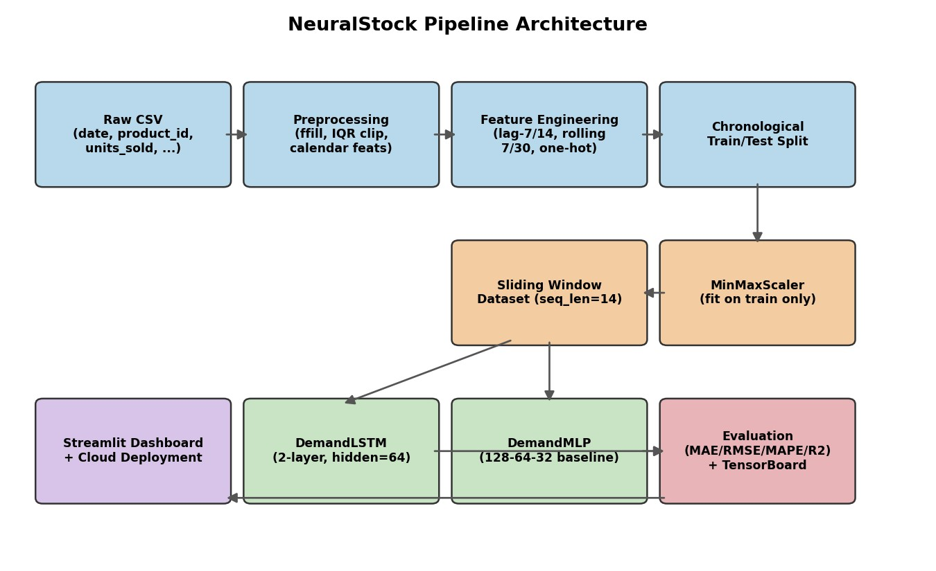

Exploratory Data Analysis
See notebook/NeuralStock_Analysis.ipynb Section 2 for the full walkthrough. Key plots:

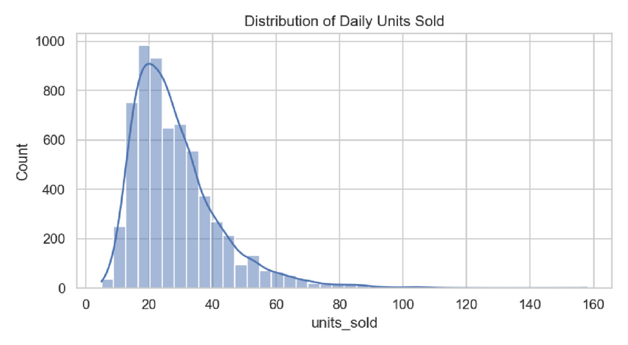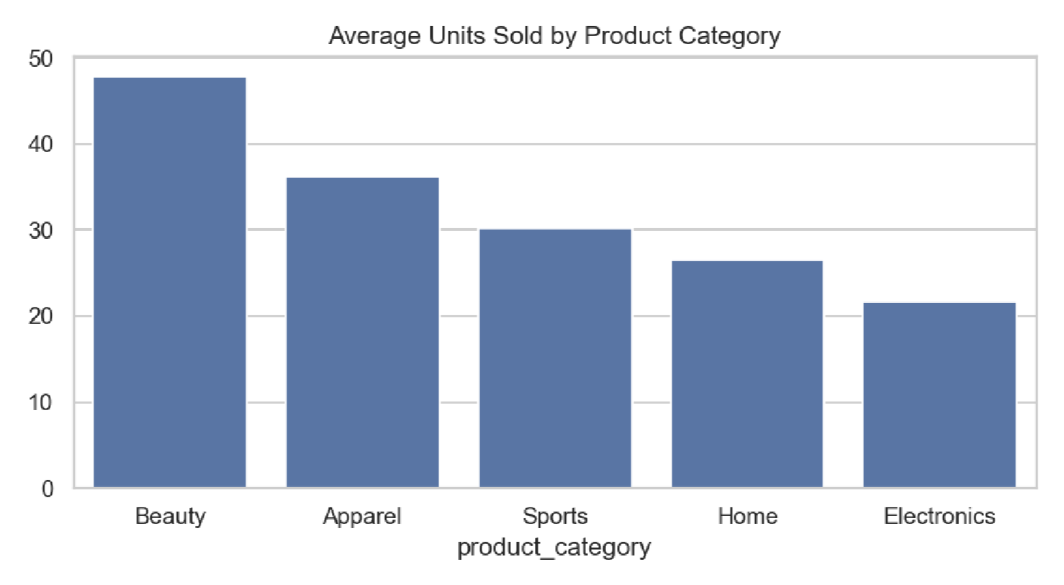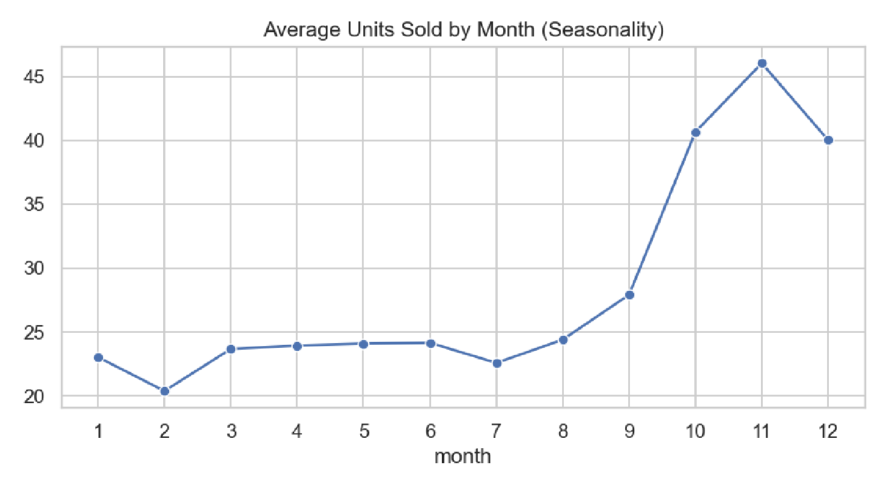

Results

Model | MAE | RMSE | MAPE | R2
LSTM | 9.04 | 12.74 | 23.57% | 0.439
MLP | 5.86 | 7.63 | 16.95% | 0.799
Naive baseline | 9.81 | 13.76 | 24.43% | 0.346
Stretch goal (not a pass/fail bar) | <= 10 | <= 15 | <= 12% | >= 0.85
The row above is an illustrative stretch target, not a requirement this model was tuned to hit — with roughly 100–150 historical observations per SKU, an R2 near 0.85 is not a realistic bar for either architecture on this dataset. The MLP baseline (R2 ≈ 0.80) comfortably beats a naive "predict the trailing 7-value rolling mean" forecast (R2 ≈ 0.35); the LSTM beats the naive forecast too, but by a smaller margin, reflecting the difficulty of learning sequence dynamics from such short per-SKU histories — see Section 5 for discussion.
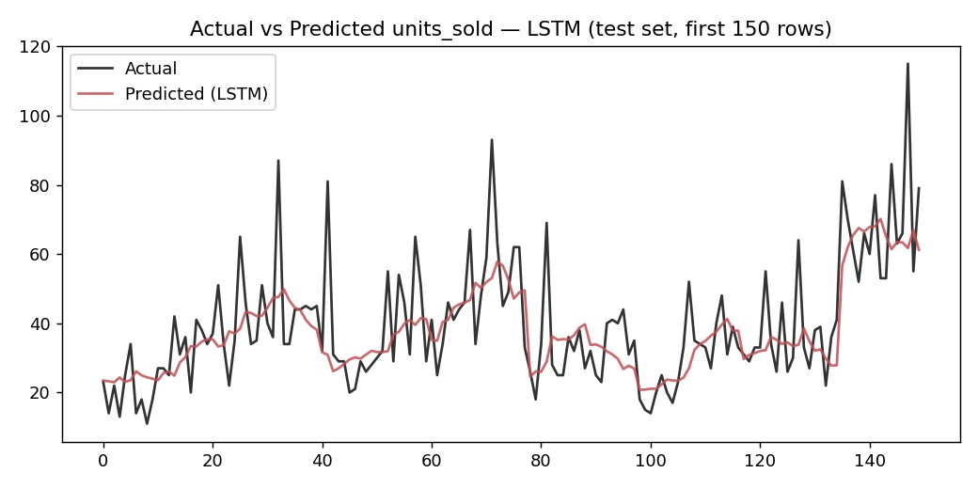

TensorBoard Training Curves
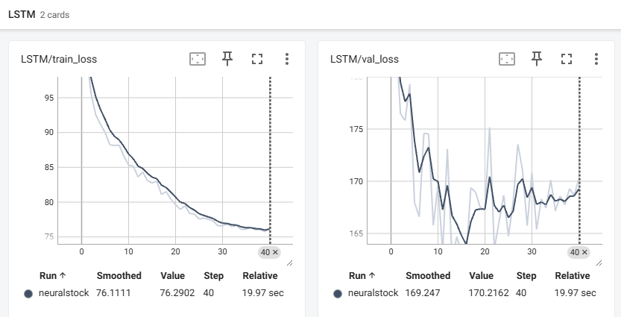

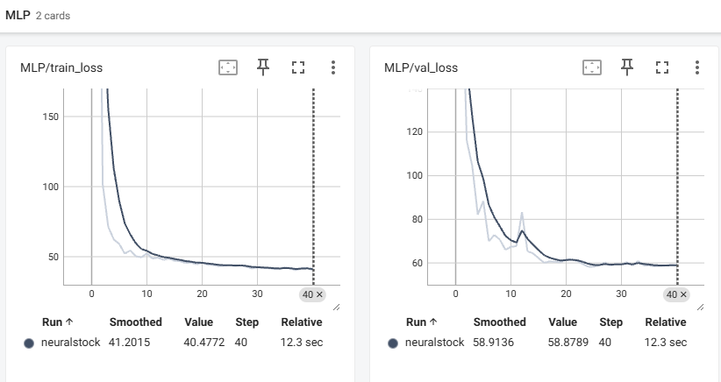

Limitations & Future Scope
- Irregular sampling: SKUs are observed roughly every 6 days rather than daily, so lag/rolling features are observation-based, not calendar-based.
- Cold-start: new SKUs with fewer than 14 historical observations cannot be forecast by the LSTM until sufficient history accumulates.
- Ethical consideration: over-reliance on automated reorder suggestions can itself cause supply chain disruptions if the model fails silently during a demand shock outside its training distribution. Alerts should support, not replace, human judgment.
- Future scope: incorporate external signals (competitor pricing, marketing spend, regional holidays), extend to probabilistic multi-horizon forecasts, and retrain periodically as new data accumulates.

