**SECURE AND WARNING SYSTEM IN HAIR PIN BENDS IN HILL STATIONS**

**A PROJECT REPORT**

***Submitted by***

**BENILA.Y (311615106023)**

**BHAVYA.S (311615106028)**

**DEEPIKA.J (311615106038)**

***in partial fulfillment for the award of the degree***

***of***

**BACHELOR OF ENGINEERING**

**IN**

**ELECTRONICS AND COMMUNICATION ENGINEERING**

**MISRIMAL NAVAJEE MUNOTH JAIN ENGINEERING COLLEGE**



**ANNA UNIVERSITY: CHENNAI 600 025**

**APRIL 2019**

**ANNA UNIVERSITY: CHENNAI 600 025**

**BONAFIDE CERTIFICATE**

Certified that this project report **“SECURE AND WARNING SYSTEM IN HAIR PIN BENDS IN HILL STATIONS”** is the bonafide work of “**BENILA.Y(311615106023),BHAVYA.S(311615106028),DEEPIKA.J (311615106038)”** who carried out the project work under my supervision.

**SIGNATURE SIGNATURE**

**Dr.N.JAISANKAR, M.E., Ph.D. MS.LAVANYA.P, M.E.**

**HEAD OF THE DEPARTMENT SUPERVISOR**

**PROFESSOR ASSOCIATE PROFESSOR**

Department of Electronics and Department of Electronics and

Communication Engineering Communication Engineering

M.N.M. Jain Engineering M.N.M. Jain Engineering

College, Thoraipakkam, College, Thoraipakkam,

Chennai-600 097 Chennai-600 097

Submitted for the project work and viva examination held on ...............................

**INTERNAL EXAMINER EXTERNAL EXAMINER**

**ACKNOWLEDGEMENT**

We express our gratitude and sincere thanks to our respected, Secretary (Admin)

**Dr.HARISH L METHA**, Secretary (Academic) **Shri.L. JASWANT MUNOTH** and our beloved principal **Dr.K.V.NARAYANAN,** for providing us with all kind of infrastructure for the successful completion of this project.

We are indebted to our Professor and Head, Department of Electronics and Communication Engineering, **Dr. N. JAISANKAR** and our project coordinator **Mrs. JAYABHARATHI,** Associate Professor, for their enthusiastic motivation and continuous encouragement which inspired us a lot in completing this project.

We would like to express my gratitude to my guide **MS.P.LAVANYA,** Associate Professor of ECE Department for his valuable suggestions and constant encouragement that led to the successful completion of this project.

Last but not least we are grateful to our parents and friends for this constant encouragement and support to complete project successfully.

**ABSTRACT**

Hill station have always been a favorite vacation spot, the often used mode of transportation is road ways. In these hilly regions are always filled with many hectic and endless curves. These curves provide either partial or no visibility of the incoming traffic to the drivers.

In every part of the bend the ultrasonic sensor fixed which is used to find the obstacle that is transmitted and the receiver section fixed in the every car receives the information and that is announced in speaker and if any abnormalities the buzzer will alert the driver and these are displayed in the LCD display. With the help of rain sensor and vibration sensor both rain and landslide can be detect. Temperature sensor is used to monitor and update the environment temperature or weather condition.

**TABLE OF CONTENTS**

**CHAPTER NO. TITLE PAGENO.**

**ACKNOWLEGMENT** iii

**ABSTRACT** iv

**LIST OF TABLES**  vii

**LIST OF FIGURES** viii

**LIST OF ABBREVATIONS** ix

**1. INTRODUCTION 1**

1.1 HILL STATION 1

1.2 OVERVIEW OF THE SYSTEM 1 1.3 EXSISTING SYSTEM 2

**2. LITERATURE SURVEY 3**

**3. SYSTEM DESIGN 7**

3.1 BLOCK DIAGRAM 6

3.2 CIRCUIT DIAGRAM 8

3.3 FLOW CHART 10

**4. HARDWARE DESCRIPTION 11**

4.1 Arduino UNO 11

4.1.1 Pin Diagram 12

4.1.2 Pin Description 12

4.1.3 Features 13 4.2 ATMega328 IC 13

4.2.1 Architecture 14

4.2.2 Pin Diagram 15

4.2.3 Pin Description 15

4.2.4 Features 17

4.3 POWER SUPPLY UNIT 19

4.3.1 Adapter 20

4.3.2 Features 20

4.4 LCD DISPLAY 20

4.4.1 Features 21

4.5 RF TRANSMITTER AND RECEIVER 22

4.5.1 RF Transmitter 22

4.5.2 RF Receiver 23

4.5.3 Need for encoder and decoder 26

4.5.4 Features 24

4.6 VOICE RECORDER 25

4.6.1 Block diagram 26

4.6.2 Features 26

4.7 ZIGBEE MODULE 27

4.7.1 Features 28

4.8 ULTRASONIC SENSOR 28

4.8.1 Pin diagram 29

4.8.2 Pin description 29

4.8.3 Features 30

4.9 RAIN SENSOR 30

4.9.1 Pin diagram 31

4.9.2 Features 32

4.10 TEMPERATURE SENSOR 32

4.10.1 Pin diagram 33

4.10.2 Features 33

**5. SOFTWARE IMPLEMENTATION 34**

5.1 ARDUINO IDE 34

5.1.1 Steps for Implementation Design 35

**6. CONCLUSION 37**

**APPENDIX 39**

**REFERENCES 51**

**LIST OF TABLES**

**TABLE NO. TITLE PAGE NO.**

4.1.2 Description of Arduino 13

4.8.3 Pin Description of Ultrasonic Sensor 29

4.9.1 Pin Description of Rain Sensor 31

4.10.1 Temperature Sensor 33

**LIST OF FIGURES**

**FIGURE NO. TITLE PAGE NO.**

3.1.1 Block Diagram of Transmitter 6

3.1.2 Block Diagram of Receiver 7

3.2.1 Circuit Diagram of Transmitter 8

3.2 .2 Circuit Diagram of Receiver 9

4.1.1 Arduino 12

4.1.2 Pin Diagram of Arduino 12

4.2.1 ATmega32IC 14

4.2.2 Pin Diagram of ATmegaIC 15

4.3.1 Power Supply 19

4.4.1 LCD Display 21

4.5.1 Circuit Diagram of RF Transmitter 23

4.5.2 Circuit Diagram of RF Receiver 23

4.6.1 Voice Recorder and Playback Module 25

4.6.2 Block Diagram of WTV-SK 26

4.7.1 ZigBee Module 27

4.8.1 Ultrasonic Sensor Interface with Arduino 28

4.8.2 Pin Diagram of Ultrasonic Sensor 29

4.9.1 Pin Diagram of Rain Sensor 31

4.10.1 Pin Diagram of Temperature Sensor 33

5.1.1 Arduino IDE 35

6.1 Screenshot of Transmitter section 37

6.2 Screenshot of Transmitter LCD Display 37

6.3 Screenshot of Receiver section 38

6.4 Screenshot of Receiver LCD Display 38

**LIST OF ABBREVATIONS**

MEMS Micro-Electro-Mechanical Systems

GSM Global System for Mobile communications

JTAG Joint Test Action Group

PCB Printed Circuit Board

UART Universal Synchronous and Asynchronous Receiver-Transmitter

MOSI Master Output Slave Input

TQFP Thin Quad Flat Package

ICSP In Circuit Serial Programming

PWM Pulse Width Modulation

TWI Two-Wire Interface

SDA Serial Data Line

MISO Master in Slave Out

LCD Liquid Crystal Display

IR Infrared

C C programming Language

**CHAPTER 1**

**INTRODUCTION**

**1.1 GENERAL INTRODUCTION**

A hill road may be defined as the one which passes through a terrain with a cross slope of 25% or more. There may be sections along hill roads with the cross slope less than 25%, especially when the road follows a river route. Even then these sections are also referred to as hill roads. Hence, to establish a hill road overall terrain must be taken into account. The hilly regions generally have extremes of climatic conditions, difficult and hazardous terrains, topography and vast high altitude areas. The region is sparsely populated and basic infrastructural facilities available in plain terrain are absent. Hence, a strong stable and feasible road must be present in hilly areas for overall development of other sectors as well. Hairpin bends are easier to climb - uphill or downhill. Without them, it would be extremely difficult and dangerous for a vehicle to make it to the top as the road starts to become steepish on the way up unless you have a powerful four wheel drive chain with a good power to weight ratio and a highly trained driver behind the wheel with all riding gears for protection.

The difficult part is for the vehicle the engine will struggle more and more as you ascend the slope, especially in higher gears. The worst part is at the hairpin bends ,the driver on his way up is unable to see the other side of the road near the bends . Also if you steer sideways or there's some sand on the road your vehicle could potentially go off road, which surely wouldn't be an enjoyable moment for you.

**1.2 OVERVIEW OF THE SYSTEM**

This project proposes a simplistic approach for the implementation of a Collision Avoidance System in hairpin bends on a hilly track, Ghats, or zero visibility turns using sensors and signals. It uses Ultrasonic sensors, which are placed on either side of the hairpin bend. The sensors are mutually exclusive and are connected to microcontroller through wires. Based on the output of sensors, position of vehicles on either side of the bend is detected which is provided as an input to the microcontroller. The microcontroller triggers the Zigbee transmitter to transmit the information to the receiver. The receiver gives the intimation to the driver regarding the distance of the vehicle coming on the other side. In addition to this, climatic condition and any other natural disaster such as landslide occurrence is displayed in the LCD display. The RF transmitter detects the potholes and transmits the information to the receiver.

**1.3 EXISTING SYSTEM**

The existing system contains a set of ultrasonic sensors, warning lights combined with a convex mirror is installed by the side of the road. It uses four ultrasonic sensors, which are placed on either side of the hairpin bend. The sensors are mutually exclusive and are connected by wires. The priority algorithm intelligently controls the movement of the vehicles at the hairpin bend based on the sensors values giving appropriate warnings on detection. For different conditions appropriate warning LED is triggered thereby prioritizing the vehicles movement. In case of a system breakdown a caution LED is triggered also sending a signal to notify the maintenance department about the same.

**1.4 ORGANISATION OF THE PROJECT**

In chapter 2 we will discuss about Literature survey.In chapter3, system design is discussed. In chapter 4 and 5 hardware and software is discussed. In chapter 6 result and conclusion is presented.

**CHAPTER 2**

**LITERATURE SURVEY**

With reference to the

1. **Hill Road Safety Assistance using Piezoelectric Sensor** by Anand Balaji P,  P Deepa Sharma (Volume 6, Issue 3,June 2018)

In the mountain roads there will be tight curves and the roads will be narrow. In these kinds of situations the driver of a vehicle cannot see vehicles coming from opposite side.The solution for this problem is alerting the driver about the vehicle coming from opposite side. This is done by keeping a specially designed piezoelectric sensor on the road before the curve and keeping a LED light.

2.**Landslide Pre-Warning System for Railway Track in Hill Station using** **WSN** by Anisha Begum.B, Harshini.S , Shobana.N, Bildass Santhosam.I (Vol. 4 Issue 03, March-2015)

The down sliding of rock, soil and organic material due to various parameters under the influence of the gravitational force causes a considerable hazard. Realtime monitoring of landslide is a very complex technology. A Disaster pre-warning system is being developed for the railway track in hill stations. Integrating MEMS, Flex, PIR and Moisture sensors forming a heterogeneous wireless network helps in identifying the abnormalities and data retrieval of the sensors information using WSN.

3.**AN ARDUINO BASED ACCIDENT PREVENTION AND IDENTIFICATION SYSTEM FOR VEHICLES by** Md. Sadad Mahamud ; Maliha Monsur ; Md. Saniat Rahman Zishan(Volume 1, Issue 3,April 2017)

In this paper an accident prevention system is being introduced with accident identification for vehicles.An accelerometer will also be used that will measure the velocity and the amount of the vehicle's tilting when it will struck over something whenever an accident will take place, the GPS will locate the geographical coordinates for that particular place, and using the GSM it will send an SMS.

4.**PRE-CRASH SENSING AND WARNING SYSTEM IN HILLY REGION** by R.Meena, R.Lavanya and K.Suresh Kumar (*Volume3Issue2- 2012)*

Accidents are commonly occurring in hilly regions. They are caused because of curve roads and speed breakers placed in mountain roads. The ve hicles from opposite side cannot be visible to the driver an idea is proposed to avoid those types of accidents by implementing the crash sensing and warning system.It will sense the vehicle from the opposite side ,starting the condition of the tyre used, if air pressure is decreased. Visible mirror of the vehicles observe the high intensity of opposite vehicles that will automatically reduce intensity of light in our vehicle by using dim and dip sensor.

5.**Sensor Based Accident Prevention System** by Aravinda B1, Chaithralakshmi C1, Deeksha1, Ashutha K2 (Volume 4, Issue 3,April 2016)

Since we are talking about mountain roads here other side might be lead to a cliff. The solution for this problem is alerting the driver about the vehicle coming from opposite side. This is done by keeping an ultrasonic sensor in one side of the road before the curve and keeping a LED light after the curve, so that if vehicle comes from one end of the curve sensor senses and LED light glows at the opposite side. By looking at the LED light on/off criteria driver can become alert and can slow down the speed of the vehicle.

**6.ACCIDENT AVOIDANCE AND DETECTION** **ON HIGHWAYS** by S.P. Bhumkar, V.V. Deotare, R.V.Babar(*Volume3Issue2- 2012)*

Technological approaches for detecting and monitoring fatigue levels of driver fatigue continue to emerge and many are now in the development, validation testing, or early implementation stages.The purpose of such a model is to advance a system to detect fatigue symptoms in drivers and control the speed of vehicle to avoid accidents.The main components of the system consist of number of real time sensors like gas, eye blink, alcohol, fuel, impact sensors and a software interface with GPS

7**.IMPLEMENTATION OF COLLISION AVOIDANCE SYSTEM** **FOR HAIRPIN BENDS IN GHATS USING PROXIMITY SENSORS** by Chitransh Srivastava1, Nikhil Acharya2, Fervez Jaffer B.M. 3, Sachin Bhat4 (VOLUME-3, ISSUE-11, 2016)

In this paper, the implementation of the Collision Avoidance System is aimed to reduce the risks of collisions at the hairpin bend on a Hilly track, Ghats, or other Zero visibility turns. The proposed system contains a set of proximity sensors, warning lights combined with a convex mirror is installed by the side of the road. It uses four IR sensors. Based on the output of sensors, position of vehicles on either side of the bend is detected.

**CHAPTER 3**

**SYSTEM DESIGN**

**3.1 BLOCK DIAGRAM**

**TRANSMITTER:**

**LCD DISPLAY**

**POWER SUPPLY**

**MICRO CONTROLLER**

**ULTRASONIC SENSOR**

**RF TRANSMITTER**

**RAIN SENSOR**

**VIBRATION SENSOR**

**ZIGBEE TXM**

**TEMPERATURE SENSOR**

Fig 3.1 Block diagram of transmitter

The Ultrasonic sensor calculate the time and send it to the Arduino. It will calculate the distance. The Arduino get all other sensors output and give this information to the ZigBee module. The ZigBee module transmits the data wirelessly. LCD display is used to display all the climatic conditions.

**RECEIVER:**

**POWER SUPPLY**

**ARDIUNO**

**UNO**

**RF RECEIVER**

**ZIGBEE RECEIVER**

**LCD DISPLAY**

**BUZZER**

**VOICE PLAY BACK**

**SPEAKER**

Fig 3.2 Block diagram of receiver

The ZigBee module in the receiver collects the data and give it to the Arduino. Based upon that data, the Arduino instructs the voice recorder and play back module to play the appropriate audio. If the vehicle is too near, it will intimate the driver through buzzer sound. The RF receiver detects the potholes. LCD display displays the distance between the vehicles and climatic conditions such as temperature. It also indicates whether the landslide has occurred.

**3.2 CIRCUIT DIAGRAM**

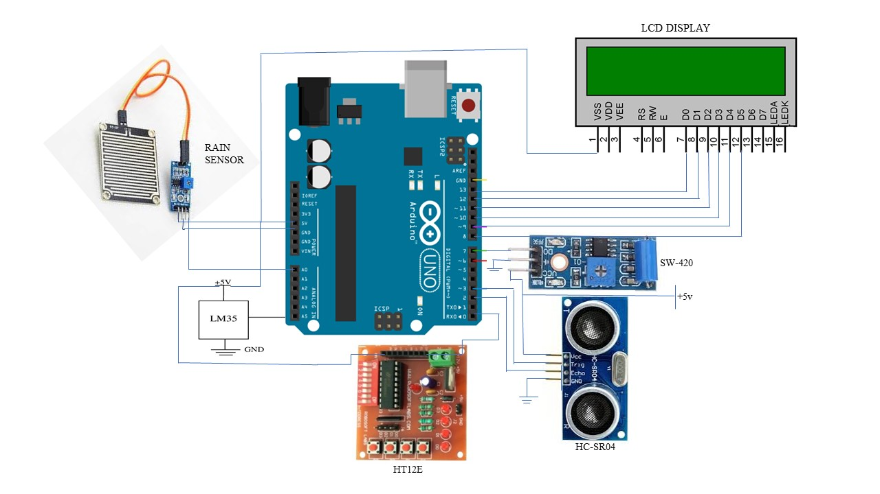

Fig.3.2.1 Circuit Diagram of Transmitter

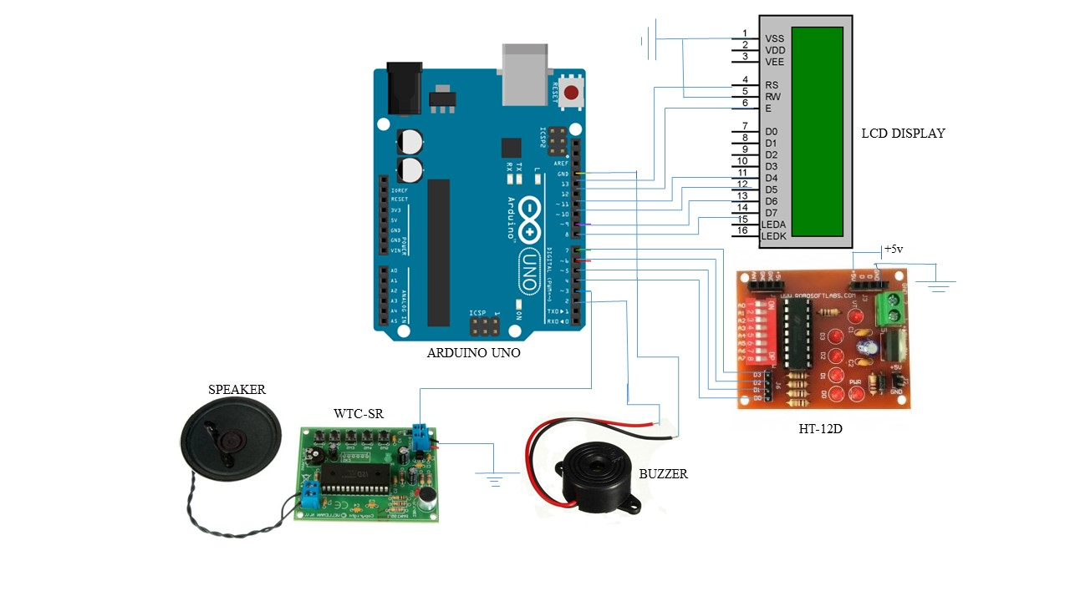

Fig. 3.2.2 Circuit Diagram of Receiver

**3.3FLOW DIAGRAM**

IS VEHICLE IS COMING

MEASURE THE VEHICLE DISTANCE AND GIVES INFORMATION TO THE DRIVER

YES

NO

NO BUZZER

SENSE THE TEMPERATURE,CLIMATIC CONDITION AND LANDSLIDE

DISPLAY IT TO THE DRIVER

CHECK THE POTHOLE AND INTIMATE THE DRIVER

**CHAPTER 4**

**HARDWARE DESCRIPTION**

**4.1 ARDUINO UNO DEVELOPMENT BOARD**

Arduino is an open source, computer hardware and software company, project, and user community that designs and manufactures Single-board microcontrollers and microcontroller kits for building digital devices and interactive objects that can sense and control objects in the physical world. Arduino is an open-source electronics platform based on easy-to-use hardware and software. Arduino boards are able to read inputs - light on a sensor, a finger on a button, or a Twitter message - and turn it into an output - activating a motor, turning on an LED, publishing something online.

The Arduino Uno is a microcontroller board based on the ATmega328 (datasheet). It has 14 digital input/output pins (of which 6 can be used as PWM outputs), 6 analog inputs, a 16 MHz crystal oscillator, a USB connection, a power jack, an ICSP header, and a reset button. For programming the microcontrollers, the Arduino project provides an integrated development environment (IDE) based on a programming language named Processing, which also supports the languages C and C++.

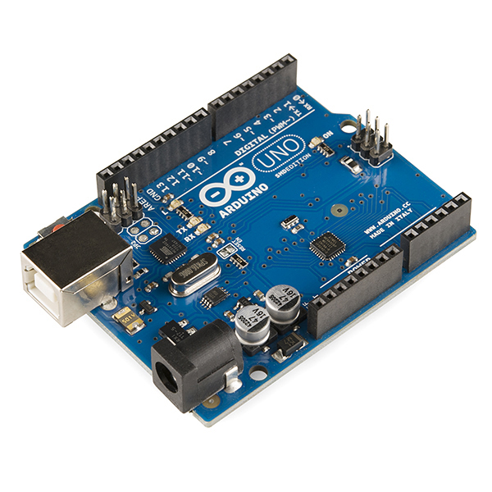

Fig.4.1 Ardino UNO

**4.1.1PIN DIAGRAM**

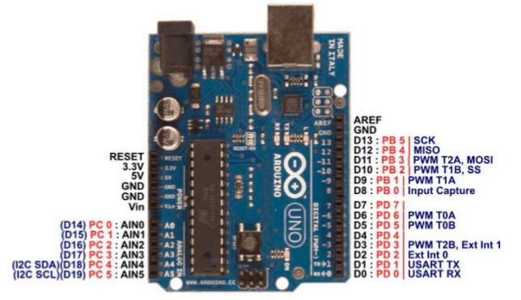

Fig.4.1.1 Pin diagram of Arduino UNO

**4.1.2 PIN DESCRIPTION**

|  |  |  |
| --- | --- | --- |
| **Pin Category** | **Pin Name** | **Details** |
| Power | Vin, 3.3V, 5V, GND | Vin: Input voltage to Arduino when using an external power source.  5V: Regulated power supply used to power microcontroller and other components on the board.  3.3V: 3.3V supply generated by on-board voltage regulator. Maximum current draw is 50mA.  GND: ground pins. |
| Reset | Reset | Resets the microcontroller. |
| Analog Pins | A0 – A5 | Used to provide analog input in the range of 0-5V |
| Input/Output Pins | Digital Pins 0 – 13 | Can be used as input or output pins. |
| Serial | 0(Rx), 1(Tx) | Used to receive and transmit TTL serial data. |
| External Interrupts | 2, 3 | To trigger an interrupt. |
| PWM | 3, 5, 6, 9, 11 | Provides 8-bit PWM output. |
| SPI | 10 (SS), 11 (MOSI), 12 (MISO) and 13 (SCK) | Used for SPI communication. |
| Inbuilt LED | 13 | To turn on the inbuilt LED. |
| TWI | A4 (SDA), A5 (SCA) | Used for TWI communication. |
| AREF | AREF | To provide reference voltage for input voltage. |

Table no.4.1.2 Description of Arduino UNO

**4.1.3 FEATURES**

* Operating voltage: 5V
* Input voltage: 7-12V
* Flash memory: 32KB
* SRAM: 2KB
* EEPROM: 1KB

**4.2 ATMEGA 328P IC**

The ATmega328 is a single-chip microcontroller created by Atmel in the mega AVR family. The Atmel 8-bit AVR RISC-based microcontroller combines 32 kB ISP flash memory with read-while-write capabilities, 1 kB EEPROM, 2 kB SRAM, 23 general purpose I/O lines, 32 general purpose working registers, three flexible timer/counters with compare modes, internal and external interrupts, serial programmable USART, a byte-oriented 2-wire serial interface, SPI serial port, 6-channel 10-bit A/D convertor (8-channels TQFP and QFN/MLFpackages), programmable watchdog timer with internal oscillator, and five software selectable power saving modes. The device operates between 1.8-5.5 volts. The device achieves throughput approaching 1 MIPS per MHz.

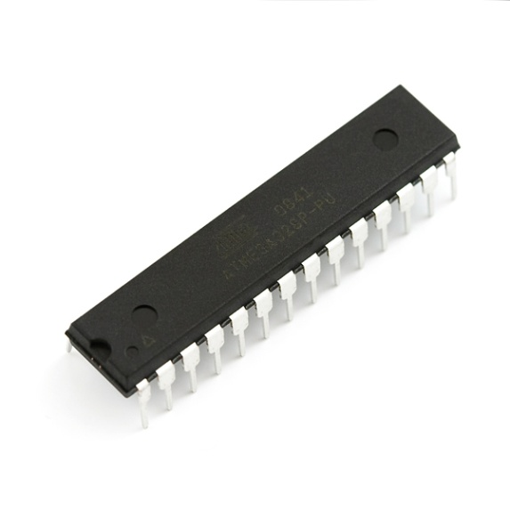

Fig.4.2 ATmega328P IC

**4.2.1ARCHITECTURE**

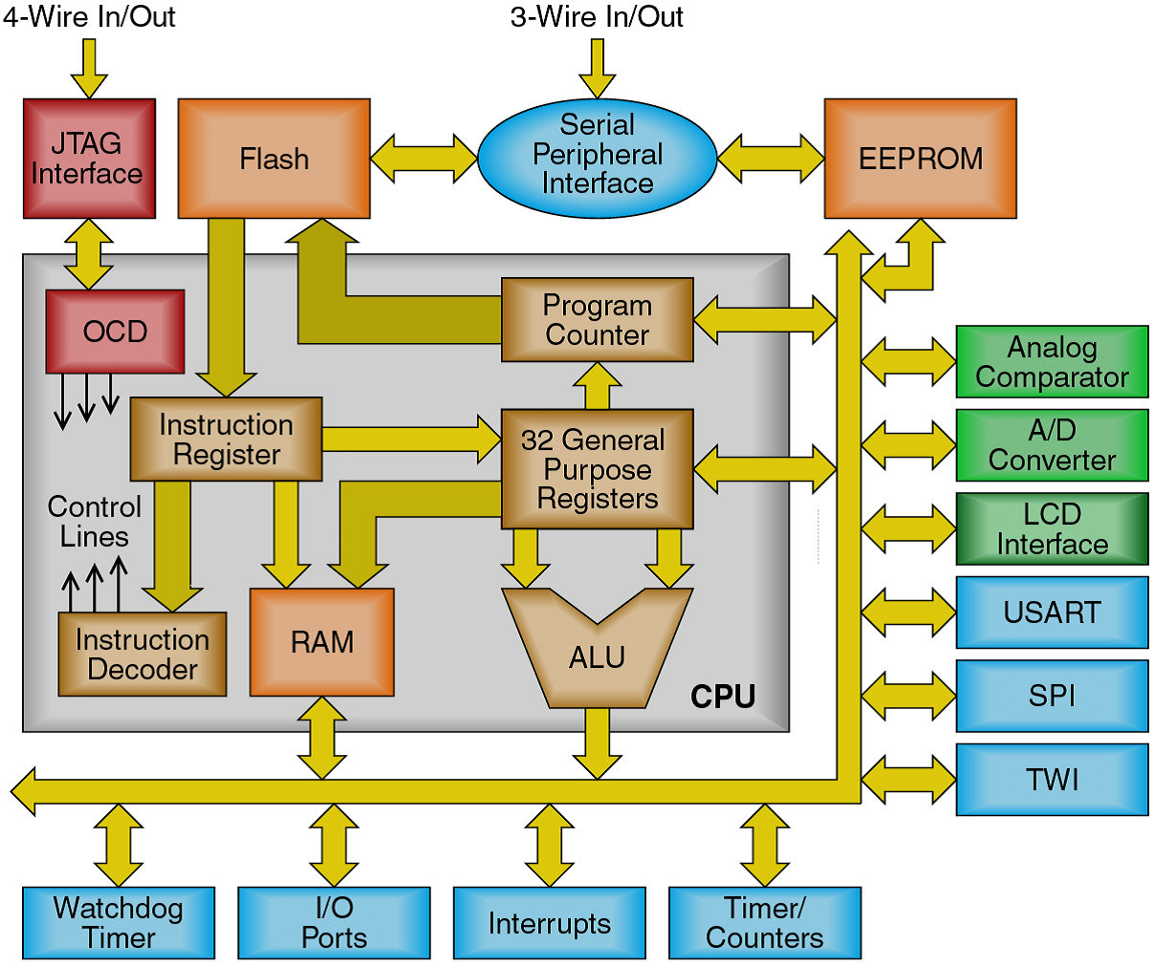

Fig.4.2.1 Architecture of AtMega328 IC

**4.2.2 PIN DIAGRAM**

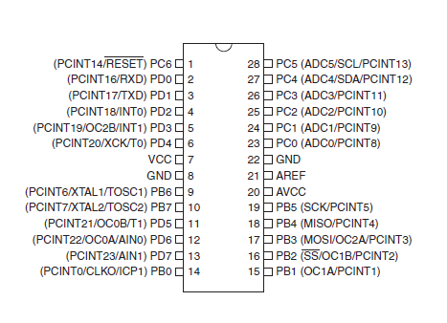

Fig.4.2.2 pin diagram of ATmega328P IC

**4.2.3 PIN DESCRIPTION**

**VCC**  Digital supply voltage

**GND** Ground.

**Port B (PB7:0) XTAL1/XTAL2/TOSC1/TOSC2**

Port B is an 8-bit bi-directional I/O port with internal pull-up resistors (selected for each bit). The Port B output buffers have symmetrical drive characteristics with both high sink and source capability. As inputs, Port B pins that are externally pulled low will source current if the pull-up resistors are activated. The Port B pins are tri-stated when a reset condition becomes active, even if the clock is not running. Depending on the clock selection fuse settings, PB6 can be used as input to the inverting Oscillator amplifier and input to the internal clock operating circuit. Depending on the clock selection fuse settings, PB7 can be used as output from the inverting Oscillator amplifier. If the Internal Calibrated RC Oscillator is used as chip clock source, PB7..6 is used as TOSC2..1 input for the Asynchronous Timer/Counter2 if the AS2 bit in ASSR is set.

**Port C (PC5:0)**

Port C is a 7-bit bi-directional I/O port with internal pull-up resistors (selected for each bit). The PC5 0 output buffers have symmetrical drive characteristics with both high sink and source capability. As inputs, Port C pins that are externally pulled low will source current if the pull-up resistors are activated. The Port C pins are tri-stated when a reset condition becomes active, even if the clock is not running.

**PC6/RESET**

If the RSTDISBL Fuse is programmed, PC6 is used as an I/O pin. Note that the electrical characteristics of PC6 differ from those of the other pins of Port C. If the RSTDISBL Fuse is unprogrammed, PC6 is used as a Reset input. A low level on this pin for longer than the minimum pulse length will generate a Reset, even if the clock is not running. The minimum pulse length is given in Table 28-3 on page 308. Shorter pulses are not guaranteed to generate a Reset.

**Port D (PD7:0)**

Port D is an 8-bit bi-directional I/O port with internal pull-up resistors (selected for each bit). The Port D output buffers have symmetrical drive characteristics with both high sink and source capability. As inputs, Port D pins that are externally pulled low will source current if the pull-up resistors are activated. The Port D pins are tri-stated when a reset condition becomes active, even if the clock is not running.

**AVCC**

AVCC is the supply voltage pin for the A/D Converter, PC3:0,and ADC7:6. It should be externally connected to VCC, even if the ADC is not used. If the ADC is used, it should be connected to VCC through a low-pass filter. Note that PC6..4 use digital supply voltage, VCC

**AREF**

AREF is the analog reference pin for the A/D Converter It allows us to feed the Arduino a reference voltage from an external power supply. For example, if we want to measure voltages with a maximum range of 3.3V, we would feed a nice smooth 3.3V into the AREF pin – perhaps from a voltage regulator IC. Then the each step of the ADC would represent 3.22 millivolts.

**ADC7:6 (TQFP and QFN/MLF Package Only)**

In the TQFP and QFN/MLF package, ADC7:6 serve as analog inputs to the A/D converter. These pins are powered from the analog supply and serve as 10-bit ADC channels.

**4.2.4 FEATURES**

* High Performance, Low Power Atmel®AVR® 8-Bit Microcontroller Family
* Advanced RISC Architecture
  + - 131 Powerful Instructions
    - Most Single Clock Cycle Execution
    - 32 x 8 General Purpose Working Registers
    - Fully Static Operation
    - Up to 20 MIPS Throughput at 20MHz
    - On-chip 2-cycle Multiplier
* High Endurance Non-volatile Memory Segments
* 4/8/16/32KBytes of In-System Self-Programmable Flash program memory
  + - 256/512/512/1KBytes EEPROM
    - 512/1K/1K/2KBytes Internal SRAM
    - Write/Erase Cycles: 10,000 Flash/100,000 EEPROM C(1)°C/100 years at 25°̶ Data retention: 20 years at 85
    - Optional Boot Code Section with Independent Lock Bits In-System Programming by On-chip Boot Program
    - True Read-While-Write Operation
    - Programming Lock for Software Security Atmel® QTouch® library support
    - Capacitive touch buttons, sliders and wheels ̶ QTouch and QMatrix® acquisition
    - Up to 64 sense channels
* Peripheral Features
* Two 8-bit Timer/Counters with Separate Prescaler and Compare Mode
* One 16-bit Timer/Counter with Separate Prescaler, Compare Mode, and Capture Mode
* Real Time Counter with Separate Oscillator
* 8-channel 10-bit ADC in TQFP and QFN/MLF package
* Temperature Measurement
* 6-channel 10-bit ADC in PDIP Package
* Programmable Serial USART ̶ Master/Slave SPI Serial Interface
* Programmable Watchdog Timer with Separate On-chip Oscillator
* On-chip Analog Comparator
* Special Microcontroller Features
  + - Power-on Reset and Programmable Brown-out Detection
    - Internal Calibrated Oscillator
    - External and Internal Interrupt Sources
    - Six Sleep Modes: Idle, ADC Noise Reduction, Power-save, Power-down, Standby, and Extended Standby
* I/O and Packages
* 23 Programmable I/O Lines
* 28-pin PDIP, 32-lead TQFP, 28-pad QFN/MLF and 32-pad QFN/MLF
* Operating Voltage: 1.8 - 5.5V
* Temperature Range: -40 C°C to 85°
* Speed Grade: 0 - 4MHz@1.8 - 5.5V, 0 - 10MHz@2.7 - 5.5.V, 0 - 20MHz @ 4.5 - 5.5V C°
* Power Consumption at 1MHz, 1.8V, 25
* Active Mode: 0.2Ma
  + - Power-down Mode: 0.1µA
    - Power-save Mode: 0.75µA (Including 32kHz RTC)

**4.3 POWER SUPPLY UNIT**

A power supply unit (or PSU) converts mains AC to low-voltage regulated DC power for the internal components of a computer. Modern personal computers universally use switched-mode power supplies. Some power supplies have a manual switch for selecting input voltage, while others automatically adapt to the mains voltage.

A power supply is used to reduce the mains electricity at 240 volts AC down to some thing more useable, say 12 volts DC. A linear power supply uses a transformer to reduce the voltage. The AC signal is rectified and regulated to produce a high DC voltage.

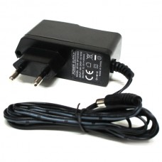

Fig.4.3 Power supply

**4.3.1 ADAPTER (12V 1AMP)**

An adapter is a device that converts attributes of one electrical device or system to those of an otherwise incompatible device or system. Some modify power or signal attributes, while others merely adapt the physical form of one electrical connector to another. In a computer, an adapter is often built into a card that can be inserted into a slot on the computer's motherboard. The card adapts information that is exchanged between the computer's microprocessor and the devices that the card supports.

An electric power adapter may enable connection of a power plug, sometimes called, used in one region to a AC power socket used in another, by offering connections for the disparate contact arrangements, while not changing the voltage. An AC adapter, also called a "recharger", is a small power supply that changes household electric current from distribution voltage) to low voltage DC suitable for consumer electronics.

**4.3.2 FEATURES**

* Output current:1A
* Supply voltage: 220-230VAC
* Output voltage: 12VDC
* Reduced costs
* Increased value across front-office and back-office functions
* Access to current, accurate, and consistent data
* It generates adapter metadata as WSDL files with J2CA extension.

**4.4 LCD DISPLAY**

LCD (liquid crystal display) is the technology used for displays in notebook and other smaller computers. Like light-emitting diode (LED) and gas-plasma technologies, LCDs allow displays to be much thinner than cathode ray tube (CRT) technology.

Flat screen LCD and plasma screens work in a completely different way. In a plasma screen, each pixel is a tiny fluorescent lamp switched on or off electronically. In an LCD television, the pixels are switched on or off electronically using liquid crystals to rotate polarized light

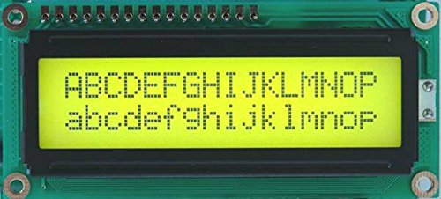

Fig.4.4.1 16X2 LCD DISPLAY

This is an LCD Display designed for E-blocks. It is a 16 character, 2-line alphanumeric LCD display connected to a single 9-way D-type connector. This allows the device to be connected to most E-Block I/O ports. The LCD display requires data in a serial format, which is detailed in the user guide below. The display also requires a 5V power supply. Please take care not to exceed 5V, as this will cause damage to the device. The 5V is best generated from the E-blocks Multi programmer or a 5V fixed regulated power supply.

The 16 x 2 intelligent alphanumeric dot matrix displays is capable of displaying 224 different characters and symbols. A full list of the characters and symbols is printed on pages 7/8 (note these symbols can vary between brand of LCD used). This booklet provides all the technical specifications for connecting the unit, which requires a single power supply (+5V).

**4.4.1 FEATURES**

* Input voltage: 5v
* E-blocks compatible
* Low cost
* Compatible with most I/O ports in the E-Block range
* Ease to develop programming code using Flow code icons

**4.5 RF TRANSMITTER & RECEIVER**

The main application of RF module is an embedded system to communicate with another device wirelessly. This communication may be accomplished through radio frequency communication. For various applications the medium of choice is radio frequency since it does not need line of sight. The applications of RF modules mainly involve in low volume and medium volume products for consumer applications like wireless alarm systems, garage door openers, smart sensor applications, wireless home automation systems and industrial remote controls.

RF modules typically communicate with an embedded system, such as a microcontroller or a microprocessor. The communication protocols include UART, used in Digi International’s X-Bee modules, Serial Peripheral Interface Bus used in Anaren’s AIR modules and Universal Serial Bus used in Roving Networks' modules. Although the module may use a standardized protocol for wireless communication, the commands sent over the microcontroller interface are typically not standardized as each vendor has its own proprietary communications format. The speed of the microcontroller interface depends on the speed of the underlying RF protocol used: higher speed RF protocols such as Wi-Fi require a high-speed serial interface such as USB whereas protocols with a slower data rate such as Bluetooth Low Energy may use a UART interface.

**4.5.1 RF TRANSMITTER**

An RF transmitter and receiver are small electronic devices used to transmit and receive radio signals between them. They are desirable to communicate with another device wirelessly. This wireless communication is done through Radio Frequency (RF) communication. An RF transmitter module (HT12E) is capable of transmitting a radio wave and modulating that wave to carry data.

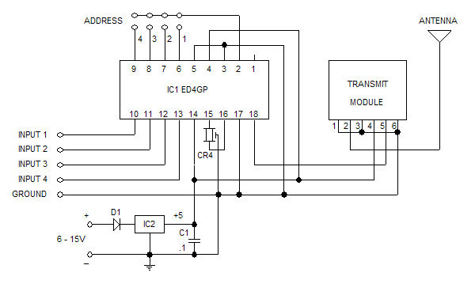Fig.4.5.1 CIRCUIT DIAGRAM OF RF TRANSMITTER MODULE

**4.5.2 RF RECEIVER**

An RF transmitter module is a small PCB sub-assembly capable of transmitting a radio wave and modulating that wave to carry data. Transmitter modules are usually implemented alongside a micro controller which will provide data to the module which can be transmitted. RF transmitters are usually subject to regulatory requirements which dictate the maximum allowable transmitter power output, harmonics, and band edge requirements.

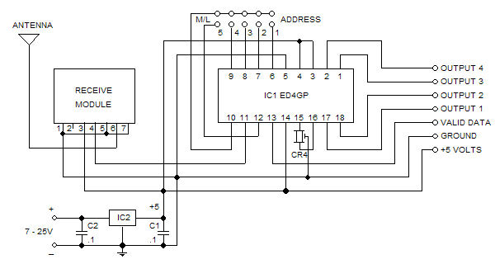

Fig.4.5.2 CIRCUIT DIAGRAM OF RF RCECIVER MODULE

An RF receiver module receives the modulated RF signal, and demodulates it. There are two types of RF receiver modules: super heterodyne receivers and super-regenerative receivers. Super-regenerative modules are usually low cost and low power designs using a series of amplifiers to extract modulated data from a carrier wave. Super-regenerative modules are generally imprecise as their frequency of operation varies considerably with temperature and power supply voltage. Super heterodyne receivers have a performance advantage over super-regenerative, they offer increased accuracy and stability over a large voltage and temperature range.

**4.5.3 NEED FOR ENCODER AND DECODER**

The RF modules can also function without the need of Encoder and Decoder modules. Simply power on both the modules with the corresponding voltage. Now, make the Din pin on transmitter high and you will find the Dout pin on receiver also goes high. But, there is a big drawback in this method. You can have only one button on the sender side and one output on the receiver side. This will not help in building better projects, so we employ the encoder and decoder modules.

The HT12D and HT12E are 4-data bit encoder and decoder modules. This means that we can make (2^4 = 16) 16 different combinations of inputs and outputs. These are 18 pin IC’s which can operate between 3V to 12V input power supply.

**4.5.4 FEATURES**

* Receiver frequency: 434 MHz
* Receiver typical sensitivity: 105Dbm
* Receiver current supply: 3.5mA
* Receiver operating voltage: 5V
* Low power consumption
* Transmitter frequency range: 433.92MHz
* Transmitter supply voltage: 3V~6V
* Transmitter output power: 4~12Dbm
* 4 -Switch Option at transmitter side
* 4 digital outputs at receiver side.
* Transmission rate: 1kbps - 10kbps
* Reliability

**4.6 VOICE RECORDER & PLAYBACK**

In a digital recording system, sound is stored and manipulated as a stream of discrete numbers, each number representing the air pressure at a particular time. The numbers are generated by a microphone connected to a circuit called an ANALOG TO DIGITAL CONVERTER, or ADC.

WTV-SR is one of the members of recording serial products. WTV-SR module can record as well as fixed voice playback, recording content uploaded and a variety of control modes can be chosen. With the master chip and plug-in SPI-FLASH, it has a great advantage in the duration time of recording and cost performance.

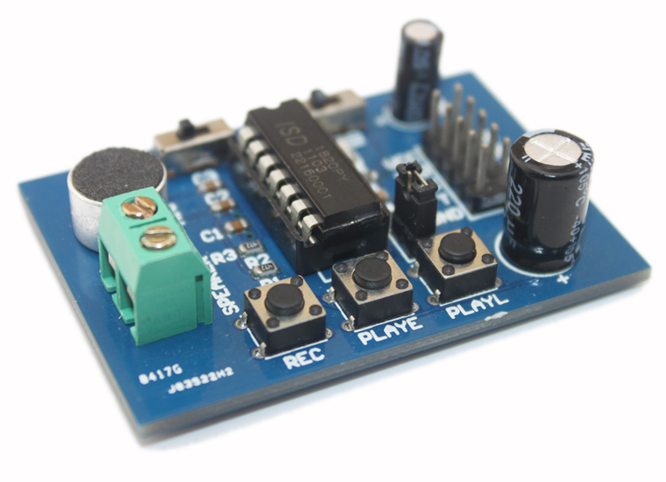

Fig 4.6.1 VOICE RECORDER & PLAYBACK MODULE

WTV-SR is provided with mp3 mode, Key control one by one, parallel interface, one-line serial interface, three-line serial interface. Therefore, WTVSR module is suit for many occasions. It can be changed different control modes by setting I/O, which on the bottom of WTV-SR. It gives a Flexible power supply by either supply module or supply solution, so it is a effective recording solution.

The recorded voice can be uploaded to the system. It also supports download voice from PC and play recorded voice with high quality. It can record up to 252 segment voice (including fixed voice) and recording time up to 1600 seconds. It supports audio recording at 10 KHz or 14 KHz sample rate.

**4.6.1 BLOCK DIAGRAM**



Fig.4.6.2 Block diagram of WTV-SR

**4.6.2 FEATURES**

* Operating voltage: 3.3v DC
* Recording Time: 12 minutes
* 8-level adjustable volume
* Support MIC
* & LINE-IN recording Support USB with programmer
* With power down memory to retain

**4.7 ZIGBEE MODULE**

ZigBee is a wireless technology developed as an open global standard to address the unique needs of low-cost, low-power wireless M2M networks. The ZigBee standard operates on the IEEE 802.15.4 physical radio specification and operates in unlicensed bands including 2.4 GHz, 900 MHz and 868 MHz. The RF transceiver is integrated with a highly configurable baseband modem.

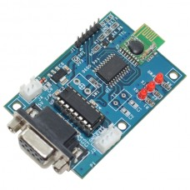

Fig.4.7.1 ZIGBEE MODULE

ZigBee is an IEEE 802.15.4-based specification for a suite of high-level communication protocols used for wireless networking. It is a wireless technology developed as an open global standard to address the unique needs of low-cost, low-power wireless M2M networks. ZigBee (CC2500) is a low cost true single chip 2.4 GHz transceiver designed for very low power wireless applications.

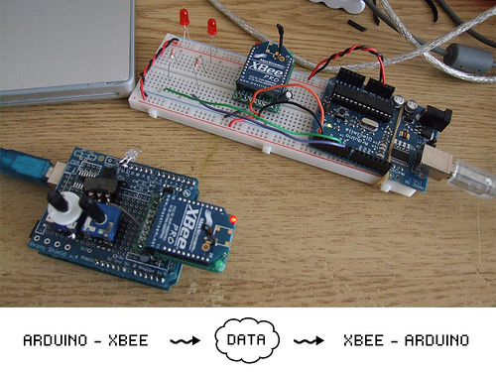

Fig.4.7.2ZIGBEE MODULE INTERFACE WITH ARDUINO

ZigBee devices are required to conform to the IEEE 802.15.4-2003 LowRate Wireless Personal Area Network (LR-WPAN) standard. The standard specifies the lower protocol layers are the physical layer (PHY), and the Media Access Control portion of the data link layer (DLL). The technology defined by the ZigBee specification is intended to be simpler and less expensive than other wireless personal area networks (WPANs), such as Bluetooth or Wi-Fi. Its low power consumption limits transmission distances to 10–100 meters line-of sight, depending on power output and environmental characteristics.ZigBee has a defined rate of 250 kbit/s, best suited for intermittent data transmissions from a sensor or input device.

**4.7.1 FEATURES**

* Supply voltage: 5v DC
* Detection range: (10-30) m
* RS232 Output
* TTL uart also provided
* Frequency: 2.4GHz
* Tx and Rx Status LEDs

**4.8 ULTRASONIC SENSOR**

An Ultrasonic sensor is a device that can measure the distance to an object by using sound waves. It measures distance by sending out a sound wave at a specific frequency and listening for that sound wave to bounce back. By recording the elapsed time between the sound wave being generated and the sound wave bouncing back, it is possible to calculate the distance between the sonar sensor and the object.

Ultrasonic sensor emit ultrasonic pulses, and by measuring the time of ultrasonic pulse reaches the object and back to the transducer. The sonic waves emitted by the transducer are reflected by an object and received back in the transducer. After having emitted the sound waves, the ultrasonic sensor will switch to receive mode. The time elapsed between emitting and receiving is proportional to the distance of the object from the sensor.

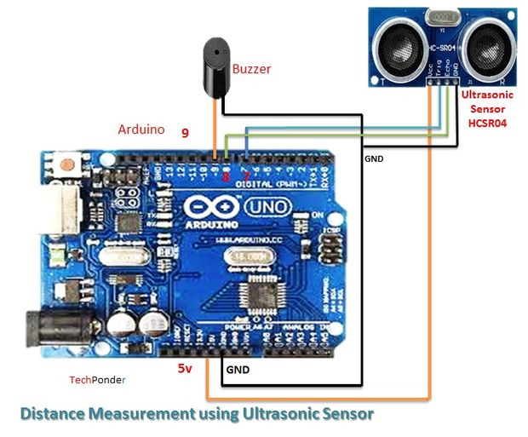

Fig.4.8.3ULTRASONIC SENSOR INTERFACE WITH ARDUINO

**4.8.1 PIN DIAGRAM**

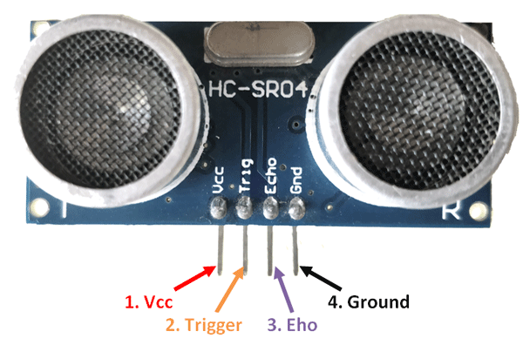

Fig.4.8.2 ULTRASONIC SENSOR

**4.8.2 PIN CONFIGURATION**

|  |  |  |
| --- | --- | --- |
| **Pin Number** | **Pin Name** | **Description** |
| 1 | Vcc | The Vcc pin powers the sensor, typically with +5V |
| 2 | Trigger | Trigger pin is an Input pin. This pin has to be kept high for 10us to initialize measurement by sending US wave. |
| 3 | Echo | Echo pin is an Output pin. This pin goes high for a period of time which will be equal to the time taken for the US wave to return back to the sensor. |
| 4 | Ground | This pin is connected to the Ground of the system. |

Table no.4.8.3 Description of ultrasonic sensor

Ultrasonic transmitter emitted an ultrasonic wave in one direction and started timing when it launched. Ultrasonic spread in the air and would return immediately when it encountered obstacles on the way. At last the ultrasonic receiver would stop timing when it receives the reflected wave. The distance of sensor from the target object is calculated. It offers excellent non-contact range detection with high accuracy and stable readings in an easy-to-use package. It operation is not affected by sunlight or black material. The supply voltage to the sensor is 5VDC. The sensor has two pins namely trig and echo which is connected to the controller to give digital input.

**4.8.3 FEATURES**

* Working Voltage: 5VDC
* Operating Frequency: 40Hz
* Working Current: 15mA
* Detecting Range: 2cm – 80cm
* Trigger Input Pulse width: 10uS

**4.9 RAIN SENSOR**

This rain detector will give you a heads-up the instant it starts to rain, hopefully giving you time to close windows and bring in possessions. The battery powered circuit draws virtually no current when the sensor is dry and the current consumption is low when the buzzer is activated so a couple of AA cells will last a long time. A rain sensor or rain switch is a switching device activated by rainfall.

A slower, longer beep may be had by increasing the 1 uF capacitor. The 10 k resistor may be increased for a longer beep time without decreasing the beep rate but at some point the circuit will cease to function properly, depending on the gain of the transistors.

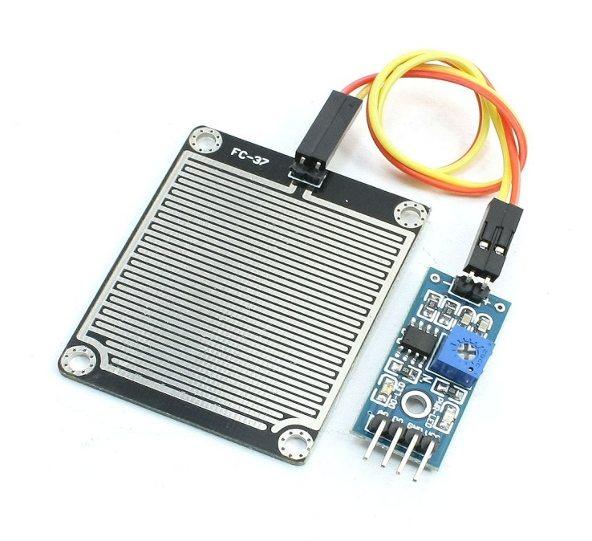

Fig.4.9.1RAIN SENSOR

**4.9.1 PIN DIAGRAM**

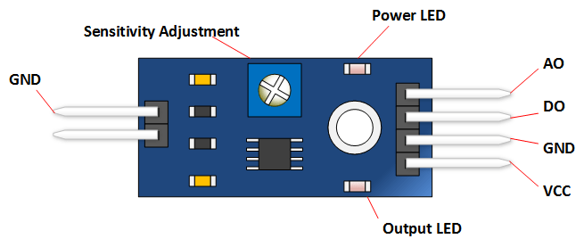

Fig.4.9.2 pin diagram of rain sensor

Alternately, a molded power supply with a simple voltage regulator to drop the voltage to 3 volts could be used. The circuit is basically a handy flasher circuit that operates well on only 3 volts using ordinary silicon transistors. When the circuit is triggered, the buzzer is pulsed about once per second for a very short time, giving it a "dripping water" sound which seems appropriate.

|  |  |
| --- | --- |
| **Pin, Control, or Indicator** | **Description** |
| VCC | +5 Volts Power Source |
| GND | Ground or negative power source |
| DO | Digital Output. Goes low when moisture exceeds set threshold. |
| A0 | Analog Output - Zero to five volts. The lower the voltage, the greater the moisture. |
| Power LED | Indicates that power is applied |
| Output LED | Illuminates when moisture has exceeded threshold set by sensitivity adjustment. |
| Sensitivity Adjustment | Clockwise is more sensitive. Counterclockwise is less sensitive. |

Table no.4.9.1 description of rain sensor

**4.9.2 FEATURES**

* Uses reliable electrolyte measurement principle.
* Detects both rain and snow.
* Operating voltage: 5V DC.
* Output voltage: 5v
* Output: Analog
* Adjustable sensitivity and switching behavior.

**4.10TEMPERATURE SENSOR**

A temperature sensor is a device, typically, a thermocouple or RTD, that provides for temperature measurement through an electrical signal. A thermocouple (T/C) is made from two dissimilar metals that generate electrical voltage in direct proportion to changes in temperature.

The LM35 series are precision integrated-circuit temperature devices with an output voltage linearly-proportional to the Centigrade temperature. The LM35 device has an advantage over linear temperature sensors calibrated in Kelvin, as the user is not required to subtract a large constant voltage from the output to obtain convenient Centigrade scaling.

The LM35 device does not require any external calibration or trimming to provide typical accuracies of ±¼°C at room temperature and ±¾°C over a full −55°C to 150°C temperature range. The low-output impedance, linear output, and precise inherent calibration of the LM35 device makes interfacing to readout or control circuitry especially easy.

**4.10.1 PIN DIAGRAM**

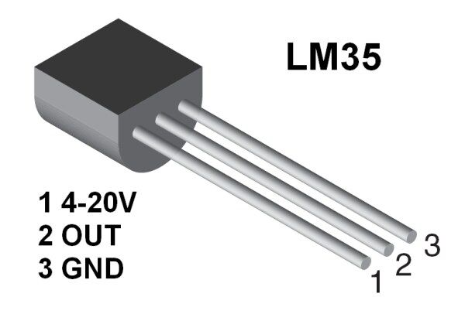

Fig.4.10.1 TEMPERATURE SENSOR

|  |  |  |
| --- | --- | --- |
| **Pin Number** | **Pin Name** | **Description** |
| 1 | Vcc | Input voltage is +5V for typical applications |
| 2 | Analog Out | There will be increase in 10mV for raise of every 1°C. Can range from -1V(-55°C) to 6V(150°C) |
| 3 | Ground | Connected to ground of circuit |

Table.no.4.10.1 description of temperature sensor

**4.10.2 FEATURES**

* Calibrated Directly in Celsius (Centigrade)
* Linear + 10-mV/°C Scale Factor
* 0.5°C Ensured Accuracy (at 25°C)
* Rated for Full −55°C to 150°C Range

**CHAPTER 5**

**SOFTWARE IMPLEMENTATION**

* 1. **ARDUINO IDE**

The Arduino Integrated Development Environment - or Arduino Software (IDE) - contains a text editor for writing code, a message area, a text console, a toolbar with buttons for common functions and a series of menus. It connects to the Arduino and Genuino hardware to upload programs and communicate with them.

Programs written using Arduino Software (IDE) are called **sketches**. These sketches are written in the text editor and are saved with the file extension .ino. The editor has features for cutting/pasting and for searching/replacing text. The message area gives feedback while saving and exporting and also displays errors. The console displays text output by the Arduino Software (IDE), including complete error messages and other information. The bottom righthand corner of the window displays the configured board and serial port. The toolbar buttons allow you to verify and upload programs, create, open, and save sketches, and open the serial monitor.

The Arduino platform has become quite popular with people just starting out with electronics, and for good reason. Unlike most previous programmable circuit boards, the Arduino does not need a separate piece of hardware (called a programmer) in order to load new code onto the board – you can simply use a USB cable. Additionally, the Arduino IDE uses a simplified version of C++, making it easier to learn to program. Finally, Arduino provides a standard form factor that breaks out the functions of the micro-controller into a more accessible package.

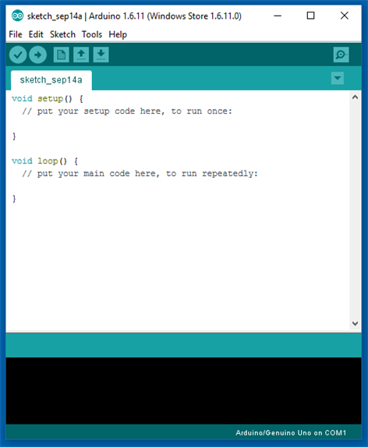

Fig 5.1.1 Arduino IDE

* + 1. **Steps For Implementing Design**

Step 1 − Download Arduino IDE Software.

You can get different versions of Arduino IDE from the Download page on the Arduino Official website. You must select your software, which is compatible with your operating system (Windows, IOS, or Linux). After your file download is complete, unzip the file and install the Arduino software in your computer.

Step 2 − Power up your board.

Connect the Arduino board with your computer using the USB cable. A green color LED will glow indicating the power is on. Now you should install the drivers which will allow your computer to interact with your board through USB port.

Step 3 − Launch Arduino IDE.

Open the Arduino software you have downloaded by double clicking on the Arduino icon to start the IDE.

Step 4 − Open your first project.

Once the software starts, you have two options

* Create a new project.
* Open an existing project example.

To create a new project, select File → New.

To open an existing project example, select File → Example → Basics → Blink.

Here, we are selecting just one of the examples with the name Blink. It turns the LED on and off with some time delay. You can select any other example from the list.

Step 5 − Select your Arduino board.

To avoid any error while uploading your program to the board, you must select the correct Arduino board name, which matches with the board connected to your computer.

Go to Tools → Board and select your board.

Here, we have selected Arduino Uno board according to our tutorial, but you must select the name matching the board that you are using.

Step 6 − Select your serial port.

Select the serial device of the Arduino board. Go to Tools → Serial Port menu. This is likely to be COM3 or higher (COM1 and COM2 are usually reserved for hardware serial ports). To find out, you can disconnect your Arduino board and re-open the menu, the entry that disappears should be of the Arduino board. Reconnect the board and select that serial port.

Step 7 − Upload the program to your board.

Compile the Blink led program after it click the upload button Wait a few seconds - you should see the RX and TX leds on the board flashing. If the upload is successful, the message "Done uploading." will appear in the status bar. A few seconds after the upload finishes, you should see the pin 13 (L) LED on the board start to blink (in orange).

**CHAPTER 6**

**CONCLUSION**

The purpose of this project is to decrease the number of accidents in curve roads. This is done by alerting the driver by means of a voice playback when vehicle comes from the other side of the curve. The vehicle is detected by the help of Ultrasonic sensor which is interfaced to the microcontroller Arduino UNO. In order make the journey comfortable and safe, the climatic condition or any other discrepancy in the path along they travel is detected by the sensors and intimation is given to the driver .By this we can save thousands of lives in the curve roads.

**RESULT**

In transmitter section, the microcontroller i.e. Arduino collects the output of all sensors and transmit these information wirelessly through ZigBee module.

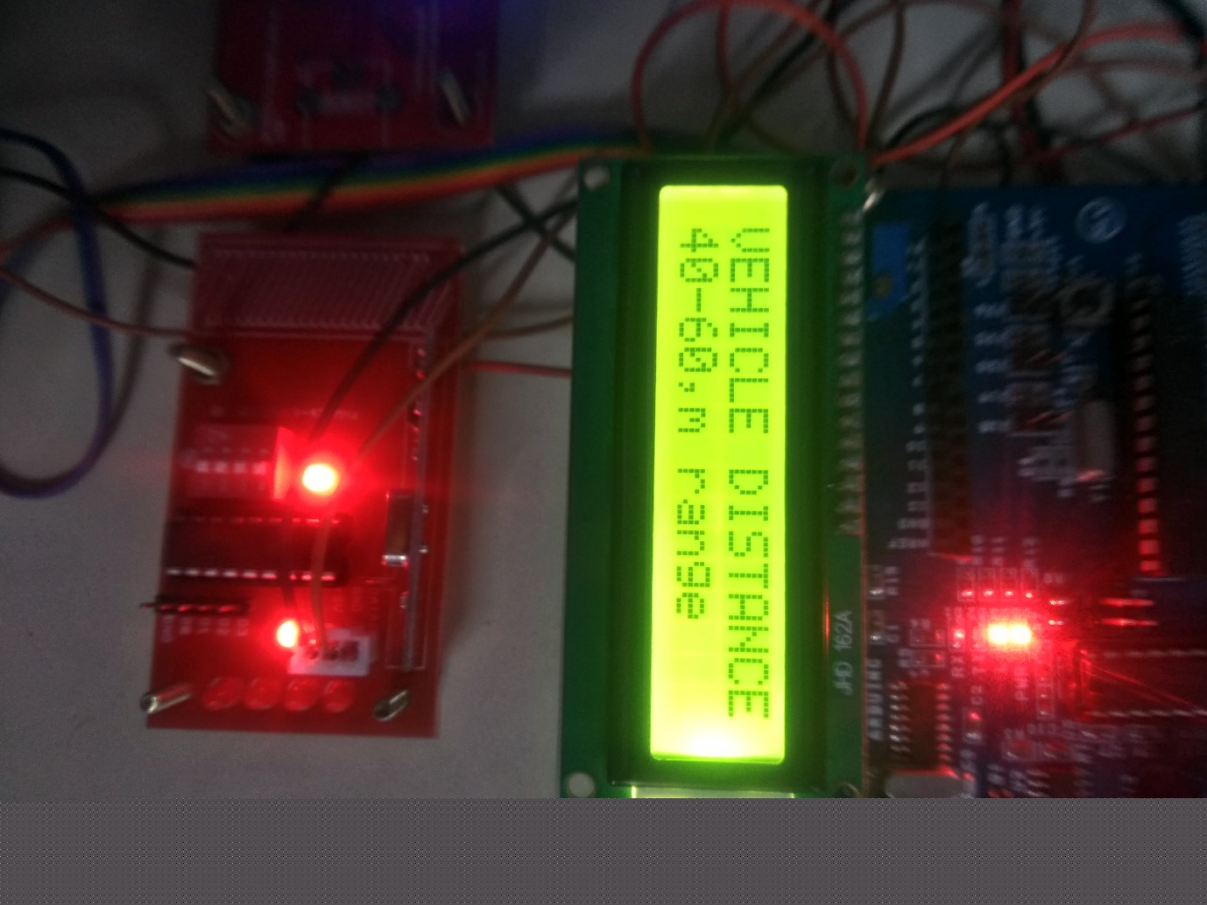

Fig.6.2 Screenshot of transmitter LCD display

With the help of Ultrasonic Sensor we can calculate the distance between the vehicle.The Vibration sensor will sense whether landslide has occurred or not.

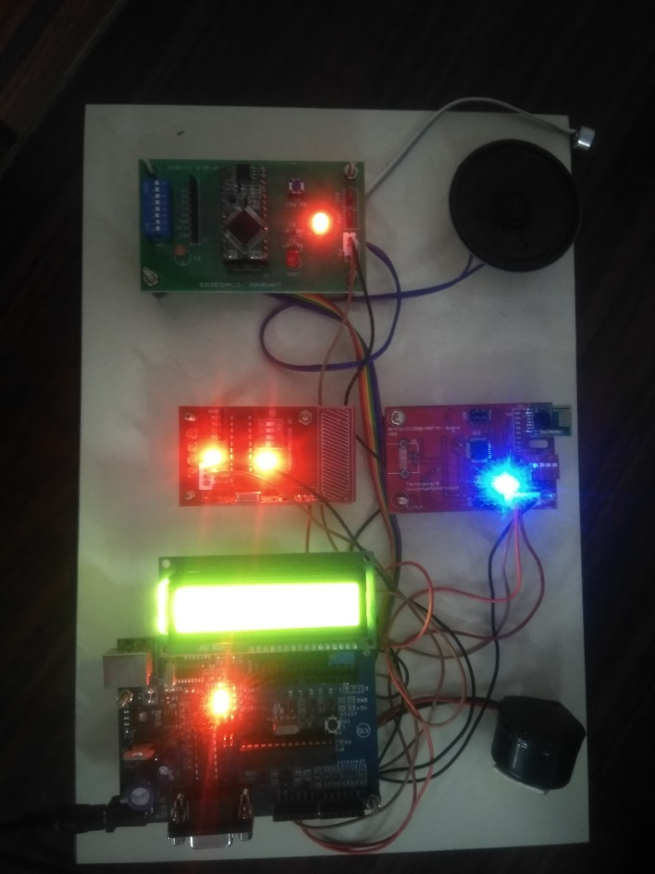  
Fig.6.2 Screenshot of receiver

In receiver section, zigbee module get the data from transmitter and deliver that information to arduino.Based upon the distance the corresponding voice will be played.

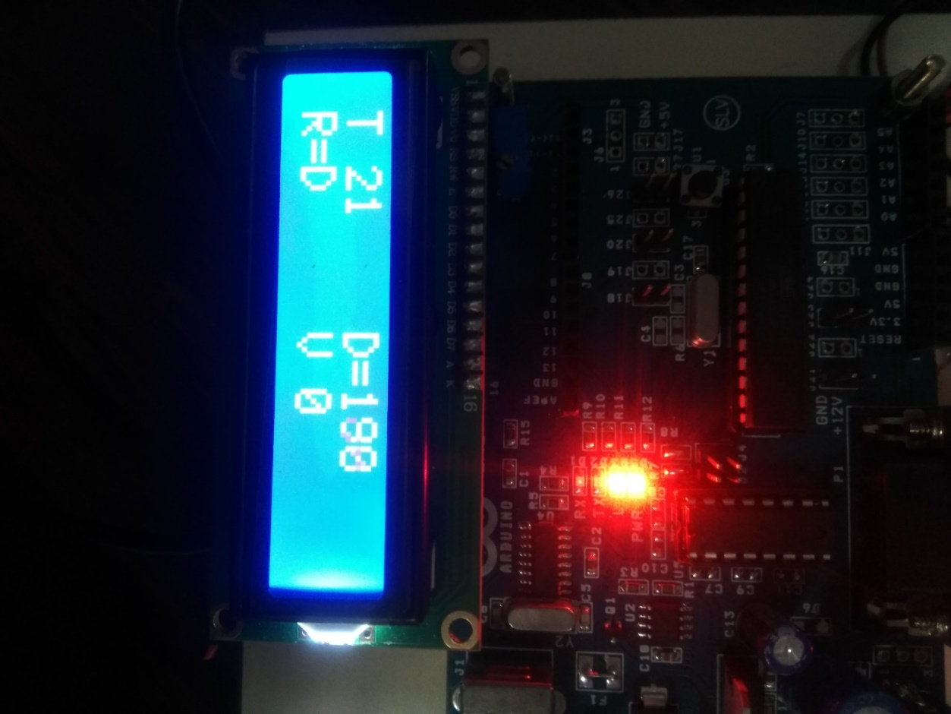

Fig.6.4 Screenshot of receiver LCD display

The LCD display in the receiver displays the temperature of that area, information about the rainfall and the landslide.

**APPENDIX**

**TRANSMITTER PROGRAM**

#include <LiquidCrystal.h>

LiquidCrystal lcd(13, 12, 11, 10, 9, 8);

int temp=A0;

int vib=A5;

int r=7;

int data=6;

int trigPin=4;

int echoPin=5;

long duration, distance, sensor;

void setup()

{

Serial.begin(9600);

lcd.begin(16,2);

pinMode(temp,INPUT);

pinMode(vib,INPUT);

pinMode(r,INPUT);

pinMode(data,OUTPUT);

digitalWrite(data,LOW);

pinMode(trigPin, OUTPUT);

pinMode(echoPin, INPUT);

}

void loop()

{

temp=analogRead(A0);

temp=temp-35;

//Serial.print('T');

//Serial.print(' ');

//Serial.print(temp);

lcd.setCursor(0,0);

lcd.print("T");

lcd.setCursor(2,0);

lcd.print(temp);

delay(500);

vib=analogRead(A5);

//Serial.print('V');

//Serial.print(' ');

//Serial.print(vib);

lcd.setCursor(8,1);

lcd.print('V');

lcd.setCursor(10,1);

lcd.print(" ");

lcd.setCursor(10,1);

lcd.print(vib);

r=digitalRead(7);

//Serial.print('R');

//Serial.print(' ');

//Serial.println(r);

lcd.setCursor(0,1);

lcd.print("R=");

delay(500);

if(r==1)

{

lcd.setCursor(2,1);

lcd.print('D');

//Serial.print('O');

}

else if(r==0)

{

lcd.setCursor(2,1);

lcd.print('N');

//Serial.print('N');

}

Sensor(trigPin,echoPin);

if(distance<=10)

{

Serial.print('A');

delay(500);

}

else if((distance>=11)&&(distance<=20))

{

Serial.print('B');

delay(500);

}

else if((distance>=21)&&(distance<=30))

{

Serial.print('C');

delay(500);

}

else if((distance>=31)&&(distance<=40))

{

Serial.print('D');

delay(500);

}

else if((distance>=41)&&(distance<=50))

{

Serial.print('E');

delay(500);

}}

void Sensor(int trigPin,int echoPin)

{

digitalWrite(trigPin, LOW);

delayMicroseconds(2);

digitalWrite(trigPin, HIGH);

delayMicroseconds(10);

digitalWrite(trigPin, LOW);

duration = pulseIn(echoPin, HIGH);

distance = (duration/2) / 29.1;

lcd.setCursor(8,0);

lcd.print("D=");

lcd.setCursor(10,0);

lcd.print(" ");

lcd.setCursor(10,0);

lcd.print(distance);

//Serial.print('D');

//Serial.print(' ');

Serial.print(distance);

delay(1000);

}

**RECEIVER PROGRAM**

#include <LiquidCrystal.h>

LiquidCrystal lcd(13, 12, 11, 10, 9, 8);

char data;

int play=2;

int a1=3;

int a2=4;

int a3=5;

int a4=6;

int a5=7;

int i;

int d=A0;

int buzz=A1;

void setup() {

Serial.begin(9600);

lcd.begin(16,2);

pinMode(play,OUTPUT);

pinMode(a1,OUTPUT);

pinMode(a2,OUTPUT);

pinMode(a3,OUTPUT);

pinMode(a4,OUTPUT);

pinMode(a5,OUTPUT);

pinMode(d,INPUT);

pinMode(buzz,OUTPUT);

digitalWrite(buzz,LOW);

digitalWrite(play,HIGH);

digitalWrite(a1,HIGH);

digitalWrite(a2,HIGH);

digitalWrite(a3,HIGH);

digitalWrite(a4,HIGH);

digitalWrite(a5,HIGH);

lcd.setCursor(0,0);

lcd.print("VEHICLE DISTANCE=");

}

void loop() {

d=analogRead(A0);

//Serial.print(d);

//delay(500);

if(d<=200)

{

digitalWrite(buzz,HIGH);

}

else

{

digitalWrite(buzz,LOW);

}

if(Serial.available()>=0)

{

data=Serial.read();

//delay(500);

if(data=='A')

{

lcd.setCursor(0,1);

lcd.print("20-40,m range");

one();

delay(500);

digitalWrite(play,LOW);

delay(5000);

refresh();

delay(1000);

}

else if(data=='B')

{ lcd.setCursor(0,1);

lcd.print("40-60,m range");

two();

delay(500);

digitalWrite(play,LOW);

delay(5000);

refresh();

delay(1000);

}

else if(data=='C')

{ lcd.setCursor(0,1);

lcd.print("60-80,m range");

three();

delay(500);

digitalWrite(play,LOW);

delay(5000);

refresh();

delay(1000);

}

else if(data=='D')

{ lcd.setCursor(0,1);

lcd.print("80-100,m range");

four();

delay(500);

digitalWrite(play,LOW);

delay(5000);

refresh();

delay(1000);

}

else if(data=='E')

{ lcd.setCursor(0,1);

lcd.print("ABOVE 100 range");

five();

delay(500);

digitalWrite(play,LOW);

delay(5000);

refresh();

delay(1000);

}}}

void one()

{

digitalWrite(a1,LOW);

}

void two()

{

digitalWrite(a2,LOW);

}

void three()

{

digitalWrite(a3,LOW);

}

void four()

{

digitalWrite(a4,LOW);

}

void five()

{

digitalWrite(a5,LOW);

}

void refresh()

{

digitalWrite(play,HIGH);

digitalWrite(a1,HIGH);

digitalWrite(a2,HIGH);

digitalWrite(a3,HIGH);

digitalWrite(a4,HIGH);

digitalWrite(a5,HIGH);

}

**REFERENCE**

* R. S. Rakul S. Ravia K. N. Thirukkuralkani(2016), “Implementation of Vehicle Mishap Averting System Using Arduino Microcontroller”, International Journal of Engineering Research & Technology, pp Vol. 5 Issue 04
* Varat, Michael S., and Stein E. Husher (2000)Vehicle impact response analysis through the use of accelerometer data. No. 2000-01-0850. SAE Technical pp 421-425.
* Hussain, Aini, et al. "Vehicle crash analysis for airbag deployment decision."Int. J. Automotive Technology 7.2 (2006): pp179-185.
* Xu, N., Rangwala, S., Chintalapudi, K.K., Ganesan, D., Board, A., Govindan, R. and Estrin, D. (2004) A wireless sensor network for structural monitoring, Proc ACM Conference on Embedded Networked Sensor Systems, Baltimore, USA, November, 12p.
* Chung, H.C., Enomoto, T., Shinozuka, M., Chou, P., Park, C., Yokoi, I., and Morishita, S. (2004), Real time visualisation of structural response with wireless MEMS sensors, Proc. 13th World Conference on Earthquake Engineering, Vancouver, Canada, Aug. 1-6, Paper 121, 10 p.
* Kim, S., Pakzad, S., Culler, D.E., Demmel, J., Fenves, G., Glaser, S. and Turon, M. (2006) Health Monitoring of Civil Infrastructures Using Wireless Sensor Networks, EECS Department, University of California, Berkeley Tech. Report No. UCB/EECS-pp 2006-121,.
* Mascarenas, D., Flynn, E., Todd, M., Park, G. and Farrar, C. (2008) Wireless Sensor Technologies for Monitoring Civil Structures, Sound and Vibration Magazine, April, pp16-20.
* Jessen Joseph Leo, R. Monishaz, (2014 )“Vehicle Movement Control Andaccident Avoidance in Hilly Track”, International Conference on Electronics and Communication System JCECS.
* EiEiThwe, Theingi, (2015)“Design And Implementation Of Data Logger For Vehicle Safety”, International Journal of Engineering and Techniques - Volume 1 Issue 4.