1.C++ program for class implementation

#include<iostream.h>
#include<conio.h>
class date
{
private:
int day;
int month;
int year;
public:
void getdata()
{cout<<"\n enter date (dmmyy):"<<endl;
cin>>day>>month>>year;
}
void display()
{
cout<<"today date="<<day<<"/";
cout<<month<<"/"<<year<<endl;
}
};
void main()
{
clrscr();
class date today;
today.getdata();
today.display();
getch();
}

Output: -

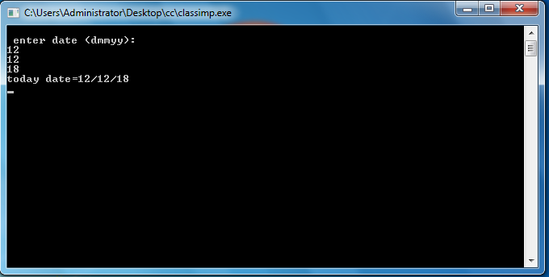

2.C++ program for array of class object
#include<iostream.h>
#include<conio.h>
const int max=100;
class student
{
private:
long int rollno;
int age;
char gender;
float height,weight;
public:
void getinfo()
{
cout<<"rollno :";
cin>>rollno;
cout<<"age :";
cin>>age;
cout<<"gender(m for male::f for female):";
cin>>gender;
cout<<"height :";
cin>>height;
cout<<"weight :";
cin>>weight;
}
void disinfo()
{
cout<<endl;
cout<<"rollno= "<<rollno<<endl;
cout<<"age= "<<age<<endl;
cout<<"gender= "<<gender<<endl;
cout<<"height= "<<height<<endl;
cout<<"weight= "<<weight<<endl;
}
};
void main()
{
clrscr();
student object[max];
int i,n;
cout<<"how many students?\n";
cin>>n;
cout<<"enter information \n";
for(i=0;
i<=n-1;++i)
{
int j=i;
cout<<"record= "<<(j+1)<<endl;
object[i].getinfo();
}
cout<<"\n content of class \n";
for(i=0;i<=n-1;++i)
{
object[i].disinfo();
}
getch();
}

Output: -

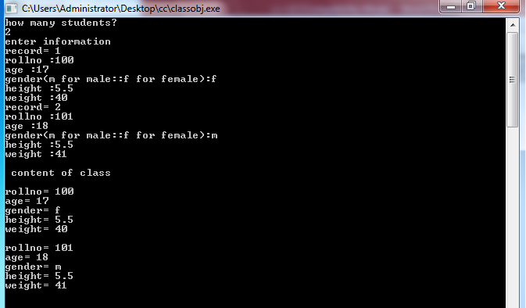

3.C++ program for friend function
#include<iostream.h>
#include<conio.h>
class box
{
double width;
public:
friend void printwidth(box b);
void setwidth(double wid);
};
void box::setwidth(double wid)
{
width=wid;
}
void printwidth(box b)
{
cout<<"\nOUTPUT \n\n"<<"width of box= "<<b.width<<endl;
}
void main()
{
box b;
b.setwidth(10.0);
printwidth(b);
getch();
}

Output: -

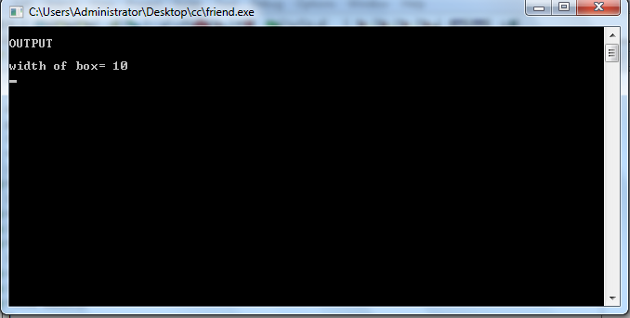

4.C++ program for string
#include<iostream.h>
#include<conio.h>
#include<string.h>
void main()
{
char str1[10]="hello";
char str2[10]="world";
char str3[10];
int len;
//copy strl into str3
strcpy(str3,str1);
cout<<"strcpy(str3,str1):"<<str3<<endl;
//concatenates str1&str2
strcat(str1,str2);
cout<<"strcat(str1,str2):"<<str1<<endl;
//total length of str1 after concatenation
len=strlen(str1);
cout<<"strlen(str1):"<<len<<endl;
getch();
}

Output: -

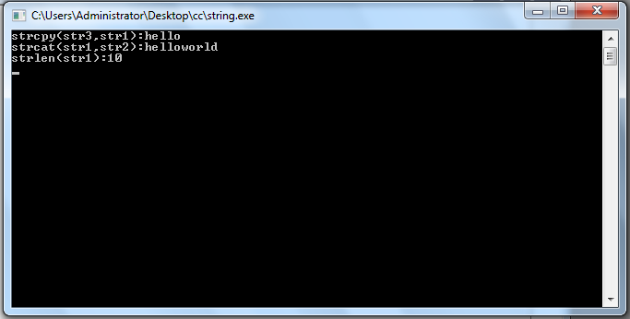

5.C++ program of virtual function
#include<iostream.h>
#include<conio.h>
class person
{
public:
virtual void print()
{
cout<<"\n Name of the person is BOB"; }
};
class student:public person
{
public:
void print()
{
cout<<"\n Name of the student is Tom";
}
};
void main()
{
person x,*p;
student y;
p=&x;
p->print();
p=&y;
p->print();
getch();
}

Output: -

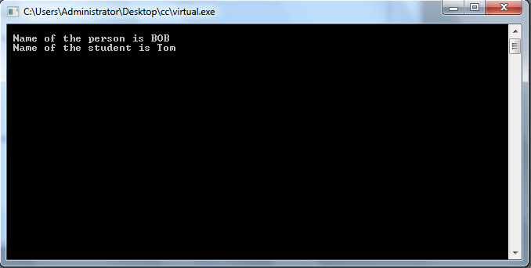

6.C++ program of array of pointer
#include<iostream.h>
#include<conio.h>
void main()
{
clrscr();
static int a[4]={11,12,13,14};
int i,n,temp;
n=4;
cout<<"content of array"<<endl;
for(i=0;i<=n-1;i++)
{
temp=*((a)+(i));
cout<<"value="<<temp<<endl;
}
getch();
}
Output:
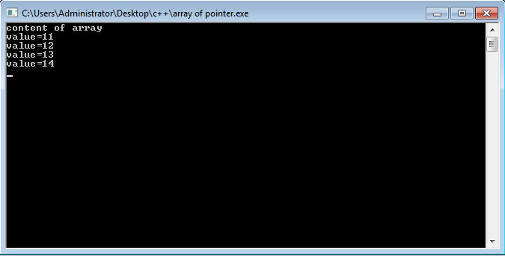

7.C++ program for constructor
#include<iostream.h>
#include<conio.h>
class fibonacci
{
private:
int f0,f1,fib;
public:
fibonacci();
void increment();
void display();
};
fibonacci::fibonacci()
{
f0=0;
f1=1;
fib=f0+f1;
}
void fibonacci::increment()
{
f0=f1;
f1=fib;
fib=f0+f1;
}
void fibonacci::display()
{
cout<<fib<<"\n";
}
void main()
{
fibonacci number;
for(int i=1;i<=15;i++)
{
number.display();
number.increment();
}
getch();
}
Output: -

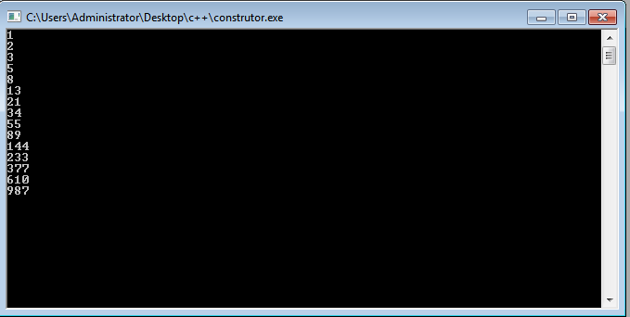

8.C++ program for operator overloading
#include<iostream.h>
#include<conio.h>
class space
{
int x;
int y;
int z;
public:
void getdata(int a,int b,int c);
void display(void);
void operator-();
};
void space::getdata(int a,int b,int c)
{
x=a;
y=b;
z=c;
}
void space::display(void)
{
cout<<x<<" ";
cout<<y<<" ";
cout<<z<<" \n ";
}
void space::operator -()
{
x=-x;
y=-y;
z=-z;
}
void main()
{
space s;
s.getdata(10,-20,30);
cout<<"s:= ";
s.display();
-s;
cout<<"s:= ";
s.display();
getch();
}

Output: -
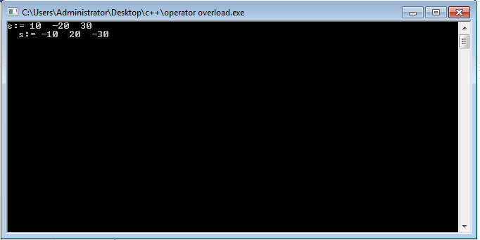

9.C++ program for single inheritance
#include<iostream.h>
#include<conio.h>
#include<string.h>
class staff
{
private:
char name[50];
int code;
public:
void getdata();
void display();
};
class typist:public staff
{
private:
int speed;
public:
void getdata();
void display();
};
void staff::getdata()
{
cout<<"name:";
cin>>name;
cout<<"code:";
cin>>code;
}
void staff::display()
{
cout<<"name:"<<name<<endl;
cout<<"code:"<<code<<endl;
}
void typist::getdata()
{
cout<<"speed";
cin>>speed;
}
void typist::display()
{
cout<<"speed:"<<speed<<endl;
}
void main()
{
typist t;
cout<<"enter data"<<endl;
t.staff::getdata();
t.getdata();
cout<<endl<<"display data"<<endl;
t.staff::display();
t.display();
getch();
}

Output: -

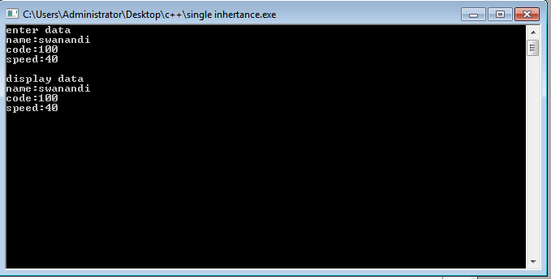

10.C++ program for single file operation

#include<iostream.h>
#include<conio.h>
#include<fstream.h>
#include<string.h>
main()
{
char string[80];
cout<<"enter a string\n";
cin>>string;
int len=strlen(string);
fstream file;
file.open("TEXT",ios::in | ios::out);
for(int i=0;i<=len;i++)

file.put(string[i]); //put character to file
file.seekg(0);//go to start
char ch;
while(file)
{
file.get(ch);//get character from file
cout<<ch;//display it on screen
}

getch();
return 0;
}

Output:

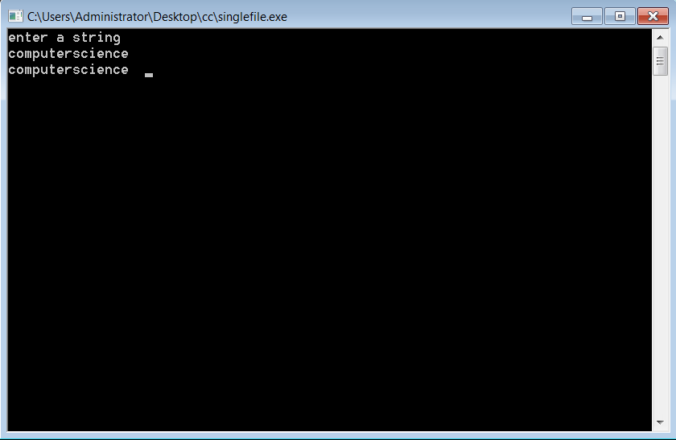

11.C++ program for of two number GCD
#include<iostream.h>
#include<conio.h>
void main()
{
int n1,n2;
cout<<"enter any two integer";
cin>>n1>>n2;
while(n1!=n2)
{
if(n1>n2)
{
n1=n1-n2;
}
else
{
n2=n2-n1;
}
}
cout<<"GCD ="<<n1;
getch();
}

Output: -

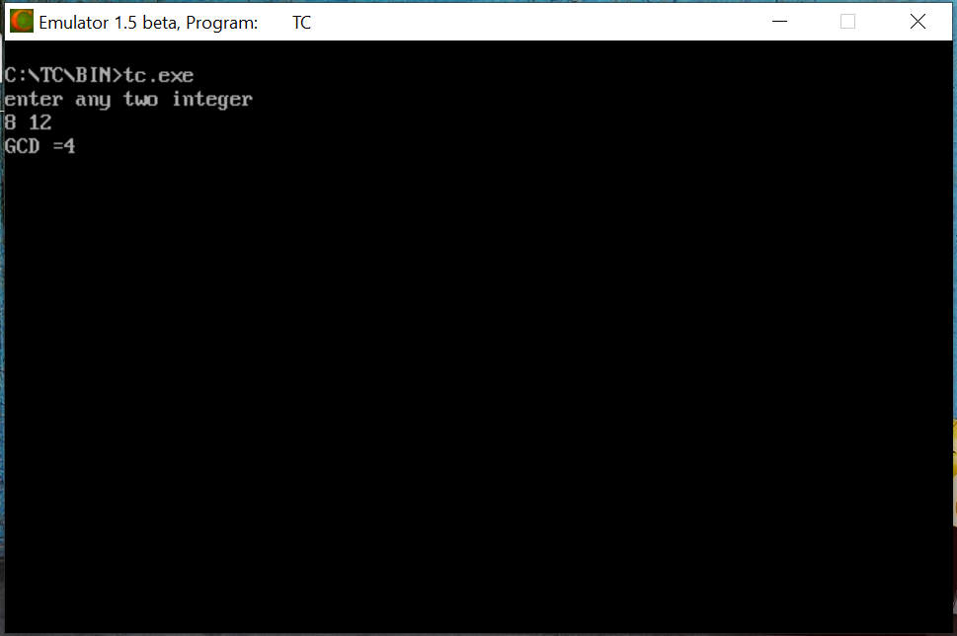

12.C++ program of prime number
#include<iostream.h>
#include<conio.h>
void main()
{
int p,c=0;
cout<<"enter the number";
cin>>p;
for(int i=2;i<p;i++)
{
if(p%i==0)
{
c=1;
}
}
if(c==0)
{
cout<<"prime number"<<p;
}
else
{
cout<<"not prime number"<<p;
}
getch();
return 0;
}

Output:-

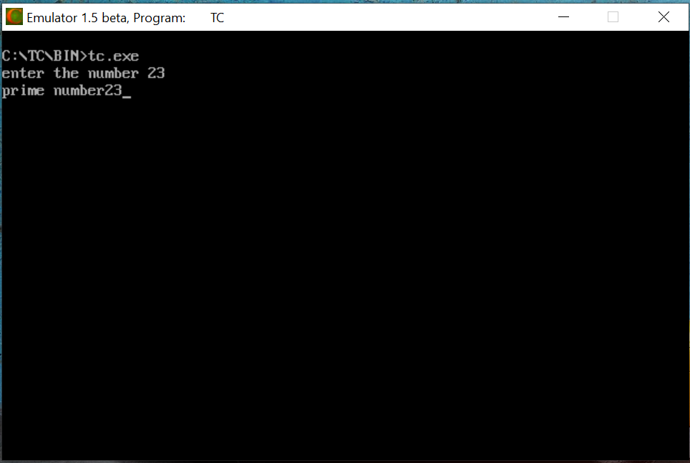

13.C++ program of sum of digit of integer
#include<iostream.h>
#include<conio.h>
class digit
{
private:
int num;
public:
void display();
void sum();
};
void digit::display()
{
cout<<"enter the number";
cin>>num;
}
void digit :: sum()
{
int rem,add=0;
while(num>0)
{
rem=num%10;
add=add+rem;
num=num/10;
}
cout<<"sum of all digit of number:"<<add;
}
void main()

{
digit s;
s.display();
s.sum();
getch();
}
Output:

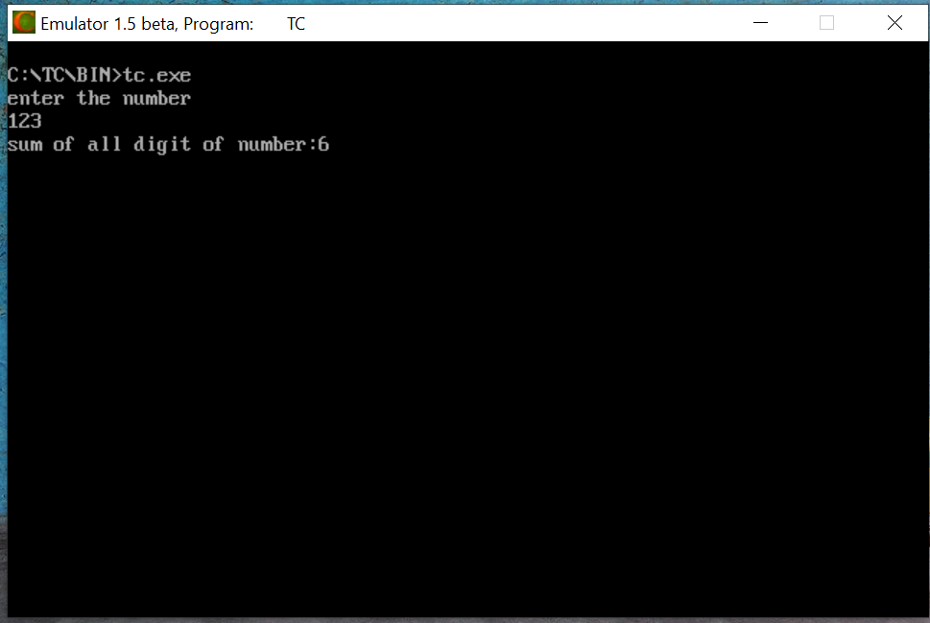

14.C++ program of count total number of blank spaces
#include<iostream.h>
#include<conio.h>
void main()
{
char s[80];
int c=0,i=0;
cout<<"enter any text line"<<endl;
cin.getline(s,80);
while(s[i]!='\0')
{
if(s[i]==' ')
{
c++;
}
i++;
}
cout<<"count of blank spaces="<<c;
getch();
}

Output: -

