Task1 layout
1. Top KPI Header Section
This top section includes three fixed Fiori standard KPI cards, showing core financial overview metrics: Total Gross Revenue, Total Gross Profit and Gross Margin Percentage. All values dynamically switch between normalized USD and original local currency following the toggle setting, and refresh automatically once users adjust filters or select chart items.
Purpose: Give users instant high-level financial performance overview at first glance, complying with ALP’s native restriction of maximum three headline KPIs.
2. Revised Filter Bar Area (Left-to-right adjusted order: Currency Toggle → Donut Visual Filter → Country Dropdown → Date Range Dropdown)
Four functional filter components are arranged sequentially from left to right as revised:
Far-left Custom Currency Toggle Switch: The global currency control button, toggles all dashboard data between unified USD for global comparison and original local currency for local store managers. It unifies currency unit for all charts, KPIs and table in one single switch.
Visual Filter: Sales Channel Donut Chart: Interactive donut chart for online & physical store channel split; clicking any donut segment filters the whole dashboard to the selected sales channel directly.
Compact Country Dropdown Filter: Standard dropdown box to pick single or multiple target countries, supporting precise regional data screening.
New Compact Date Range Dropdown: Custom start & end month selector, lets users lock specific analysis period to limit revenue calculation time scope flexibly.
Purpose: All filters synchronize data across the entire page, enabling flexible customized data exploration as required in Task1’s exploratory sales analysis rule.
3. Middle Three Parallel Chart Area
Three independent interactive charts are placed side by side horizontally, with full cross-page link & table highlight enabled for all of them; the left bar chart supports native ALP drill-down function:
Left Horizontal Bar Chart: Displays revenue grouped by continent. After clicking one continent bar, the chart refreshes in-place and expands to show detailed country-level revenue of that selected continent. Any bar selection triggers full-page data filtering and matched table row highlight.
Middle Monthly Line Chart: Visualizes continuous 24-month revenue fluctuation and marks seasonal sales peak values, designed for time-series trend analysis required by coursework. Clicking a certain month filters all page data to this month only.
Right Vertical Bar Chart: Tracks average monthly delivery delay days; bars for delayed months are marked in red to highlight supply chain issues as Task1 required. Selecting any month bar also activates global dashboard filtering.
4. Bottom Analytical Table Section
Raw Transaction Table: Displays granular row-level data including order numbers, dates, locations, revenues, and original currency.

Framework
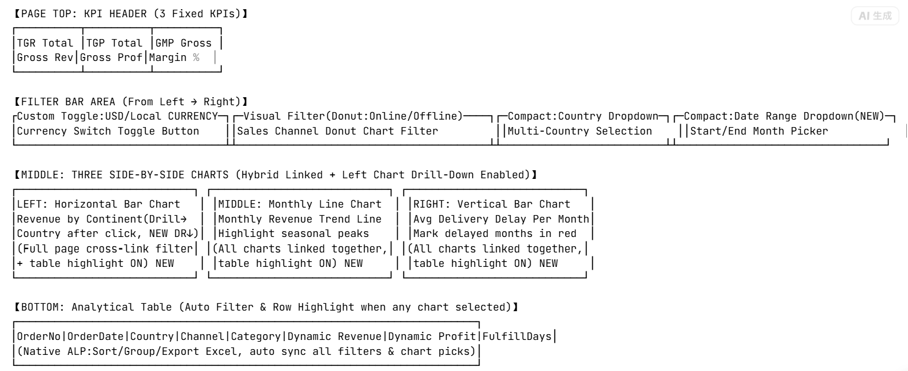
Prototype
