
K.R. Mangalam University
School of Engineering and Technology
Task -3 Generate visualizations and comparative charts
Program: BCA (AI & DS) Course Code - ENCA351 (2026-27)

Submitted by:
Submitted To: Name: Deepika Rani
Dr. Aarti Sangwan
RollNumber: 2401201131
Faculty, SOET
Course: BCA (AI & DS) - Section A

A. Search algorithms
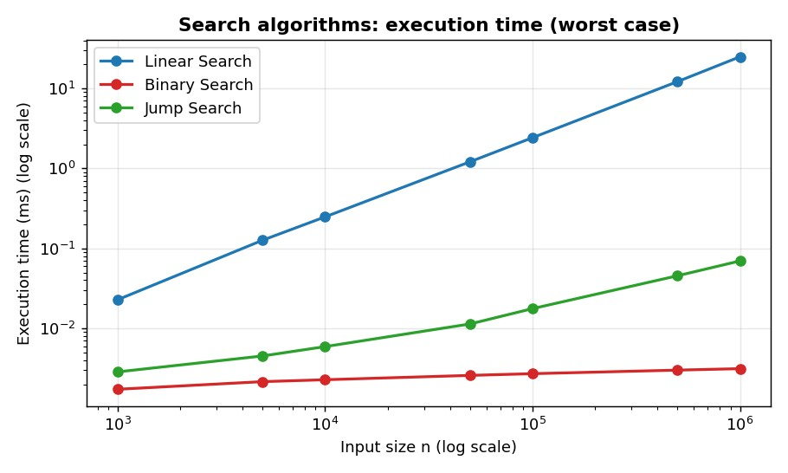
Figure 2: Execution time of linear, binary and jump search (worst case).
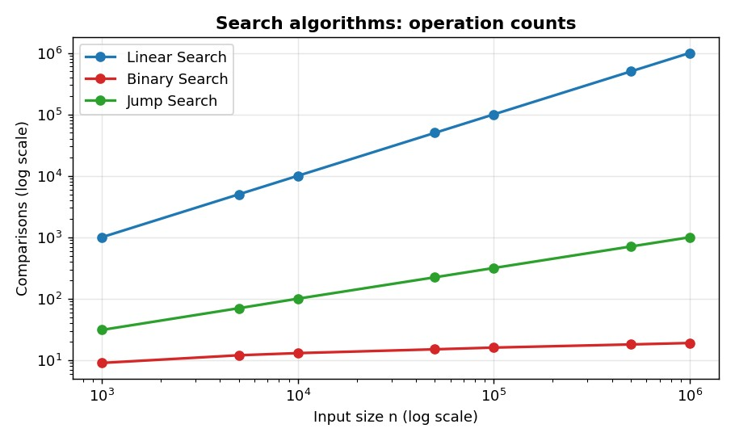
Figure 3: Number of comparisons performed by each search algorithm.

Performance observations
- Linear search scales linearly. Comparisons grew exactly with n (1,000,000 comparisons for n = 1,000,000) and the time slope was 1.01. At n = 1,000,000 it took 24.911 ms.
- Binary search is almost flat. It needed only 19 comparisons for one million elements (≈ log2 n) and 0.0031 ms, about 7,942× faster than linear search at that size.
- Jump search sits in between. 1,000 comparisons (= √n) and 0.070 ms, with a measured slope of 0.47, which matches the theoretical 0.5.
- Memory is constant for all three. Each uses only a few index variables (peak ≈ 0.2 KB), confirming O(1) auxiliary space.
- Trade-off. Binary and jump search need sorted data; for a one-off search of unsorted data, linear search avoids the cost of sorting.

B. Factorial implementations
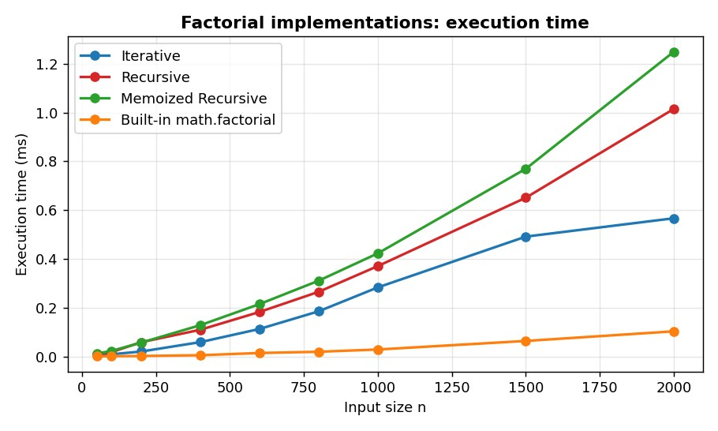
Figure 4: Execution time of the four factorial implementations.
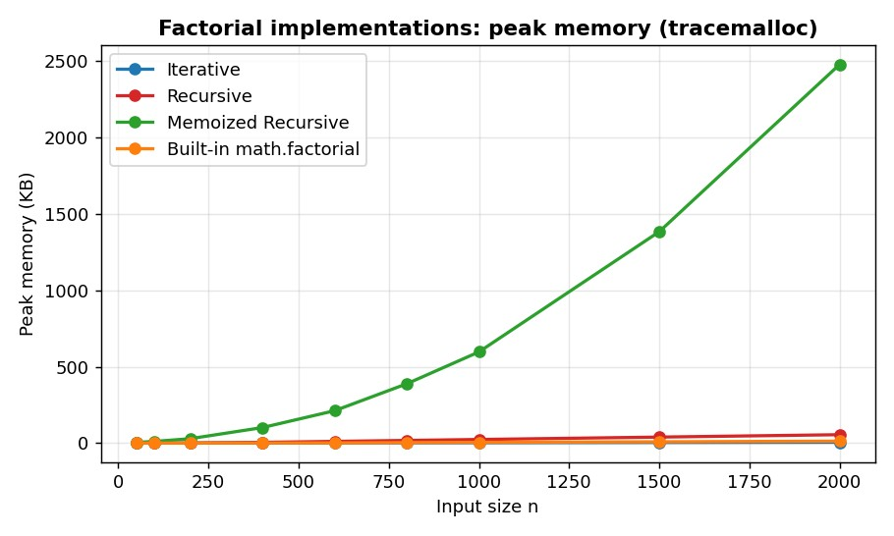
Figure 5: Peak memory allocated by each factorial implementation.
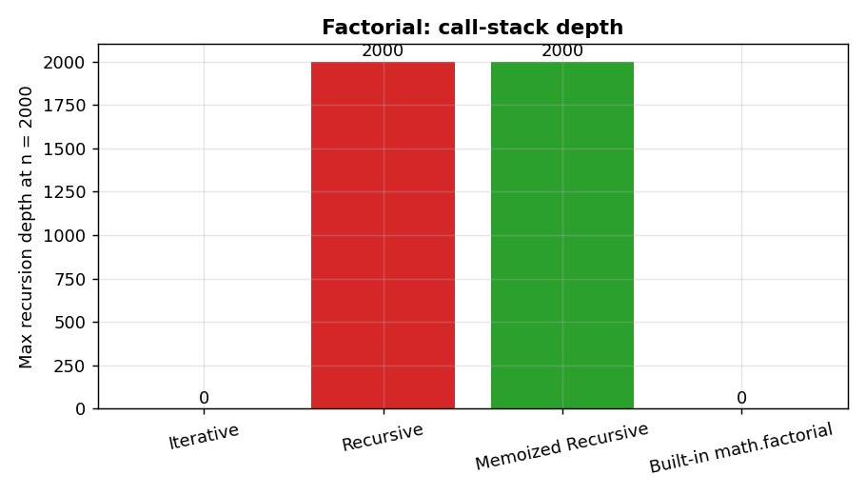
Figure 6: Maximum call-stack depth at n = 2000.

Performance observations
- Same operation count, different cost. Iterative, recursive and memoized versions all perform exactly n − 1 multiplications, yet at n = 2000 they took 0.567 ms, 1.015 ms and 1.249 ms respectively. Function-call overhead makes recursion slower than a loop.
- Built-in is fastest. math.factorial took 0.103 ms at n = 2000, about 5.5× faster than the iterative loop, because the whole loop runs in optimised C code.
- Time is slightly super-linear. Observed slopes were 1.41 (iterative), 1.28 (recursive) and 1.27 (memoized) rather than 1.0: factorial values become huge integers, and multiplying big integers costs more than multiplying small ones.
- Space differs the most. Recursion reaches a call-stack depth of 2,000 at n = 2000 while the iterative version needs none (O(n) vs O(1) stack). The memoized version stored every intermediate factorial and used 2.42 MB at n = 2000; doubling n from 1000 to 2000 multiplied its memory by 4.2, i.e. roughly quadratic growth because the cached numbers are themselves growing.
- Memoization did not help here. Each top-level call starts with an empty cache and every sub-problem is visited once, so memoization only adds overhead. It pays off only when the same function is called repeatedly, e.g. computing many factorials in sequence.

C. Loop-based programs
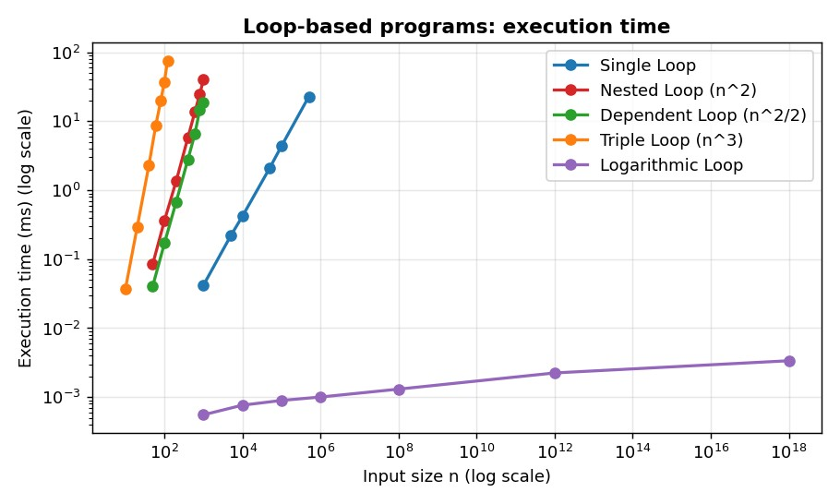
Figure 7: Execution time of loop-based programs (log-log scale).
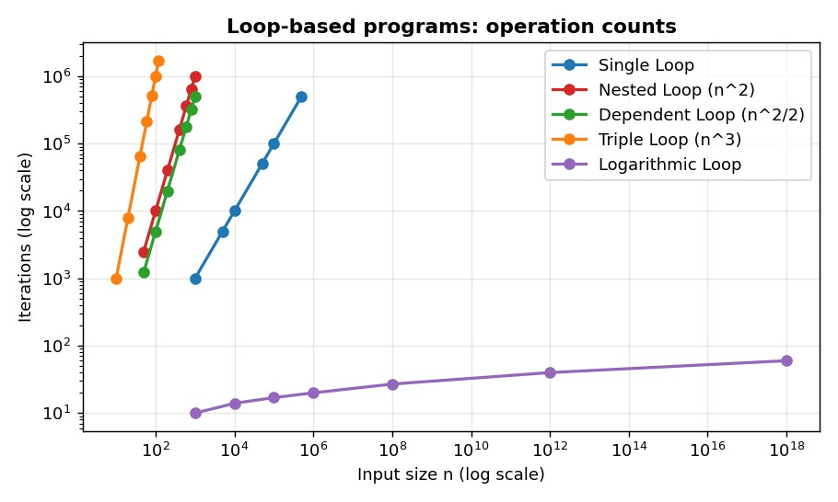
Figure 8: Iteration counts of loop-based programs.

Performance observations
- Operation counts match theory exactly. Single loop = n, nested = n², dependent = n(n−1)/2 and triple = n³ iterations (ops/f(n) = 1.000 for all). The logarithmic loop ran only 60 iterations even for n = 10^18.
- Time follows the same exponents. Observed log-log slopes were 1.01, 2.05, 2.07, 3.05 and 0.05 for single, nested, dependent, triple and logarithmic loops, against theoretical 1, 2, 2, 3 and ≈0.
- Constant factors matter. The dependent loop does half the iterations of the nested loop at n = 1000 (499,500 vs 1,000,000) and ran in 19.0 ms vs 40.4 ms. Both are O(n²), but the constant differs.
- Practical impact. The triple loop at only n = 120 (1.7 million iterations) took 76.2 ms, longer than a single loop of 500,000 iterations (22.8 ms), showing how fast polynomial growth overtakes linear growth.
- Memory is constant. All loop programs use O(1) extra space (peak < 0.4 KB).

D. Overall comparison
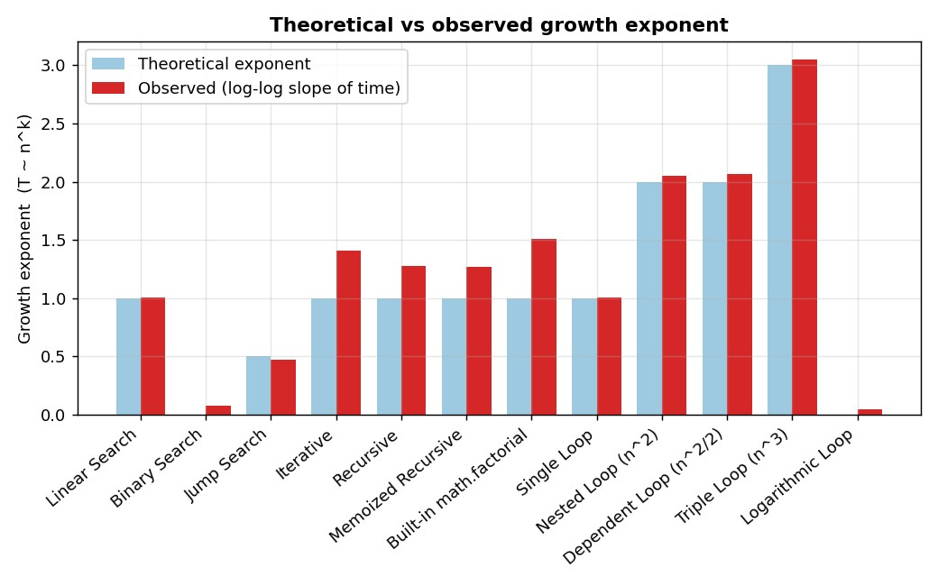
Figure 9: Theoretical growth exponent vs observed log-log slope for all 12 algorithms.
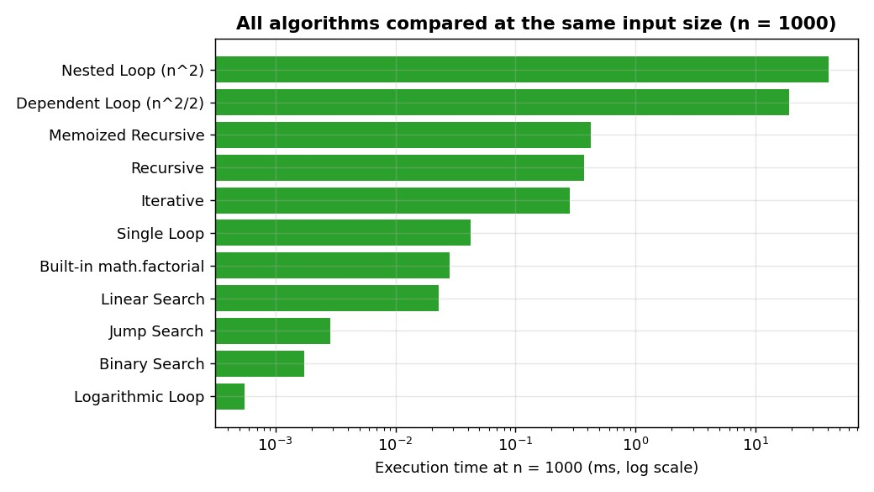
Figure 10: All algorithms measured at the same input size (n = 1000).

Overall observations
- Observed exponents track the theoretical ones closely; the only systematic deviation is the factorial group, caused by big-integer arithmetic.
- At the same n, algorithm choice changes running time by several orders of magnitude (compare binary search and the nested loop in Figure 10).
- Choosing a better algorithm (binary vs linear search, built-in vs hand-written factorial) gives bigger gains than any constant-factor tuning.

Github link =

