
K.R. Mangalam University
School of Engineering and Technology
Task -1 Record execution time, memory usage, and operation counts.
Program: BCA (AI & DS) Course Code - ENCA351 (2026-27)

Submitted by:
Submitted To: Name: Deepika Rani
Dr. Aarti Sangwan
RollNumber: 2401201131
Faculty, SOET
Course: BCA (AI & DS) - Section A

Objective
Implement an Automated Benchmarking Engine that executes algorithms and code snippets for multiple input sizes and records execution time, memory usage and operation counts. The engine is written in Python 3 (file: benchmark_engine.py) and is fully automated: one command runs every suite, prints a live log and saves the results to CSV and JSON.

Design of the engine
Component | Purpose / technique
OpCounter | Lightweight object passed into every algorithm. The algorithm increments counter.ops at each basic operation (comparison, multiplication, loop iteration) and counter.max_depth tracks recursion depth.
Algorithms under test | Linear, binary and jump search; iterative, recursive, memoized and built-in factorial; single, nested, dependent, triple and logarithmic loops (12 in total).
BenchmarkEngine.run() | For each input size: builds the input, measures time, measures memory, counts operations and stores a Record.
Time measurement | time.perf_counter(). Each sample is repeated 7 times and the median is reported (min and standard deviation are also stored). Very fast calls are batched (inner loop) so the timer resolution does not dominate.
Memory measurement | tracemalloc: peak bytes allocated during one call minus the baseline. Run as a separate pass because tracing slows execution.
Operation counts | Instrumented counter in a separate pass, so counting does not affect the memory pass.
Persistence | save() writes results.csv and results.json for later analysis and plotting.

Test configuration
Suite | Algorithm | Input sizes tested | Input type
Search | Linear / Binary / Jump | 1,000; 5,000; 10,000; 50,000; 100,000; 500,000;  1,000,000 | Sorted list, target absent (worst case)
Factorial | Iterative / Recursive / Memoized / Built-in | 50; 100; 200; 400; 600; 800; 1000; 1500; 2000 | Integer n
Loops | Single | 1,000 – 500,000 | Integer n
Loops | Nested, Dependent | 50 – 1,000 | Integer n
Loops | Triple | 10 – 120 | Integer n
Loops | Logarithmic | 10^3 – 10^18 | Integer n

Sample output (console)
Running python benchmark_engine.py produces a live log for every algorithm and input size (excerpt below; 91 measurements in total):
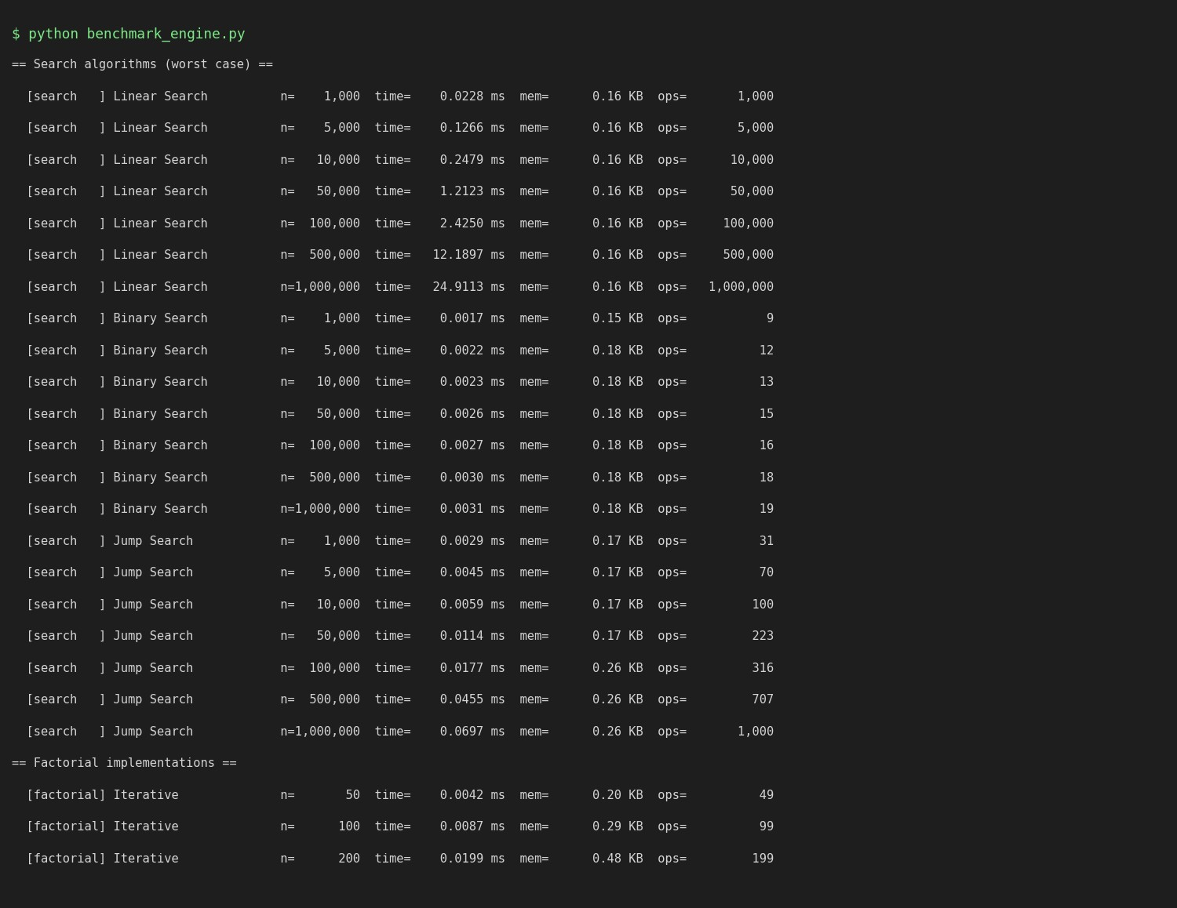
Figure 1: Console output of the benchmarking engine (excerpt).

Summary of recorded measurements (largest input of each algorithm)
Algorithm | n | Time (ms) | Memory (KB) | Operations | Max depth
Linear Search | 1,000,000 | 24.9113 | 0.16 | 1,000,000 | 0
Binary Search | 1,000,000 | 0.0031 | 0.18 | 19 | 0
Jump Search | 1,000,000 | 0.0697 | 0.26 | 1,000 | 0
Iterative | 2,000 | 0.5665 | 5.17 | 1,999 | 0
Recursive | 2,000 | 1.0148 | 55.11 | 1,999 | 2000
Memoized Recursive | 2,000 | 1.2492 | 2,477.52 | 1,999 | 2000
Built-in math.factorial | 2,000 | 0.1029 | 13.18 | 1 | 0
Single Loop | 500,000 | 22.7978 | 0.23 | 500,000 | 0
Nested Loop (n^2) | 1,000 | 40.3517 | 0.34 | 1,000,000 | 0
Dependent Loop (n^2/2) | 1,000 | 18.9793 | 0.34 | 499,500 | 0
Triple Loop (n^3) | 120 | 76.2457 | 0.28 | 1,728,000 | 0
Logarithmic Loop | 1,000,000,000,000,000,000 | 0.0034 | 0.16 | 60 | 0

Appendix: complete source code (benchmark_engine.py)
"""
Lab 2: Algorithm Performance Measurement and Benchmarking Tool
===============================================================

An automated benchmarking engine that runs algorithms / code snippets for multiple input sizes and records:

- execution time (time.perf_counter, median of several repeats)
- memory usage (tracemalloc peak allocation during the call)
- operation counts (instrumented comparisons / iterations / calls) * recursion depth (extra "space" indicator for recursive code)

Results are written to CSV + JSON and later turned into charts / tables.
Usage: python benchmark_engine.py # runs every suite, saves results/ """
import csv import json import math import os import statistics import sys import time import tracemalloc
from dataclasses import dataclass, field, asdict from typing import Callable, Dict, List

sys.setrecursionlimit(10_000)

# ----------------------------------------------------------------------
# 1. Instrumentation: operation counter
# ---------------------------------------------------------------------- class OpCounter:
"""Counts basic operations (comparisons, iterations, calls).""" __slots__ = ("ops", "depth", "max_depth")

def __init__(self): self.ops = 0 self.depth = 0 self.max_depth = 0

# ----------------------------------------------------------------------
# 2. Algorithms under test
# ---------------------------------------------------------------------- # ---- Search algorithms (worst case: target is absent) ----------------- def linear_search(arr, target, c: OpCounter): for x in arr:
c.ops += 1 # one comparison per element if x == target: return True return False

def binary_search(arr, target, c: OpCounter): lo, hi = 0, len(arr) - 1 while lo <= hi:
mid = (lo + hi) // 2
c.ops += 1 # one comparison per halving step if arr[mid] == target:
return True if arr[mid] < target:
lo = mid + 1 else:
hi = mid - 1 return False

def jump_search(arr, target, c: OpCounter):

n = len(arr)
step = int(math.sqrt(n)) prev = 0 while prev < n and arr[min(prev + step, n) - 1] < target: c.ops += 1 prev += step for i in range(prev, min(prev + step, n)): c.ops += 1 if arr[i] == target:
return True return False

# ---- Factorial implementations ---------------------------------------- def fact_iterative(n, c: OpCounter):
result = 1 for i in range(2, n + 1):
c.ops += 1 # one multiplication per iteration result *= i return result

def fact_recursive(n, c: OpCounter): c.depth += 1
c.max_depth = max(c.max_depth, c.depth) if n <= 1:
c.depth -= 1 return 1
c.ops += 1 # one multiplication per call r = n * fact_recursive(n - 1, c) c.depth -= 1 return r

def fact_memoized(n, c: OpCounter, _cache=None): if _cache is None:
_cache = {0: 1, 1: 1} # fresh cache for every top-level call c.depth += 1
c.max_depth = max(c.max_depth, c.depth) if n in _cache:
c.depth -= 1 return _cache[n] c.ops += 1
_cache[n] = n * fact_memoized(n - 1, c, _cache) c.depth -= 1 return _cache[n]

def fact_builtin(n, c: OpCounter):
c.ops += 1 # one call into optimised C code return math.factorial(n)

# ---- Loop-based programs ---------------------------------------------- def loop_single(n, c: OpCounter):
total = 0 for i in range(n): c.ops += 1 total += i return total

def loop_nested(n, c: OpCounter):
total = 0 for i in range(n): for j in range(n): c.ops += 1 total += 1 return total

def loop_dependent(n, c: OpCounter):
total = 0 for i in range(n): for j in range(i):

c.ops += 1 total += 1 return total

def loop_triple(n, c: OpCounter):
total = 0 for i in range(n): for j in range(n): for k in range(n): c.ops += 1 total += 1 return total

def loop_logarithmic(n, c: OpCounter):
i, total = 1, 0 while i < n:
c.ops += 1 total += i i *= 2 return total

# ----------------------------------------------------------------------
# 3. Benchmark engine
# ----------------------------------------------------------------------
@dataclass class Record: suite: str algorithm: str n: int time_ms: float time_min_ms: float time_std_ms: float memory_kb: float operations: int max_depth: int

@dataclass class BenchmarkEngine: repeats: int = 7
records: List[Record] = field(default_factory=list)

def _measure_time(self, call: Callable[[], None]) -> List[float]: """Median-of-N timing; fast calls are batched for timer accuracy.""" t0 = time.perf_counter() call()
single = max(time.perf_counter() - t0, 1e-9)
inner = max(1, int(2e-4 / single)) # aim for >= ~0.2 ms per sample samples = [] for _ in range(self.repeats): s = time.perf_counter() for _ in range(inner):
call() samples.append((time.perf_counter() - s) / inner) return samples

def run(self, suite: str, name: str, fn: Callable, sizes: List[int], build_input: Callable[[int], tuple]):
"""Benchmark `fn` for every input size in `sizes`.""" for n in sizes: args = build_input(n)

# --- time ------------------------------------------------- samples = self._measure_time(lambda: fn(*args, OpCounter()))

# --- memory (separate pass; tracing slows execution) ------- tracemalloc.start() tracemalloc.reset_peak() base, _ = tracemalloc.get_traced_memory() fn(*args, OpCounter())
_, peak = tracemalloc.get_traced_memory() tracemalloc.stop()

# --- operation count ---------------------------------------- c = OpCounter() fn(*args, c)

self.records.append(Record( suite=suite, algorithm=name, n=n, time_ms=statistics.median(samples) * 1e3, time_min_ms=min(samples) * 1e3,
time_std_ms=(statistics.pstdev(samples) * 1e3), memory_kb=max(peak - base, 0) / 1024, operations=c.ops, max_depth=c.max_depth,
))
r = self.records[-1]
print(f" [{suite:9s}] {name:22s} n={n:>9,d} "
f"time={r.time_ms:10.4f} ms mem={r.memory_kb:10.2f} KB " f"ops={r.operations:>12,d}")

# ---- persistence --------------------------------------------------- def save(self, folder: str): os.makedirs(folder, exist_ok=True) rows = [asdict(r) for r in self.records] with open(os.path.join(folder, "results.json"), "w") as f: json.dump(rows, f, indent=2) with open(os.path.join(folder, "results.csv"), "w", newline="") as f:
w = csv.DictWriter(f, fieldnames=list(rows[0].keys())) w.writeheader()
w.writerows(rows)

# ----------------------------------------------------------------------
# 4. Benchmark configuration
# ---------------------------------------------------------------------- def sorted_input(n):
return (list(range(n)), -1) # absent target => worst case

def int_input(n): return (n,)

def run_all(out_dir="results"):
eng = BenchmarkEngine(repeats=7)

print("\n== Search algorithms (worst case) ==") search_sizes = [1_000, 5_000, 10_000, 50_000, 100_000, 500_000, 1_000_000] eng.run("search", "Linear Search", linear_search, search_sizes, sorted_input) eng.run("search", "Binary Search", binary_search, search_sizes, sorted_input) eng.run("search", "Jump Search", jump_search, search_sizes, sorted_input)

print("\n== Factorial implementations ==")
fact_sizes = [50, 100, 200, 400, 600, 800, 1000, 1500, 2000]
eng.run("factorial", "Iterative", fact_iterative, fact_sizes, int_input) eng.run("factorial", "Recursive", fact_recursive, fact_sizes, int_input) eng.run("factorial", "Memoized Recursive", fact_memoized, fact_sizes, int_input) eng.run("factorial", "Built-in math.factorial", fact_builtin, fact_sizes, int_input)

print("\n== Loop-based programs ==")
eng.run("loops", "Single Loop", loop_single,
[1_000, 5_000, 10_000, 50_000, 100_000, 500_000], int_input) eng.run("loops", "Nested Loop (n^2)", loop_nested, [50, 100, 200, 400, 600, 800, 1000], int_input) eng.run("loops", "Dependent Loop (n^2/2)", loop_dependent, [50, 100, 200, 400, 600, 800, 1000], int_input) eng.run("loops", "Triple Loop (n^3)", loop_triple, [10, 20, 40, 60, 80, 100, 120], int_input) eng.run("loops", "Logarithmic Loop", loop_logarithmic,
[10**3, 10**4, 10**5, 10**6, 10**8, 10**12, 10**18], int_input)

eng.save(out_dir) print(f"\nSaved {len(eng.records)} records to '{out_dir}/'") return eng

if __name__ == "__main__":

run_all()

Github link =

