**SCREENSHOTS OF THE DESIGN:**

1. **SMALL** screen – 320px x 511px

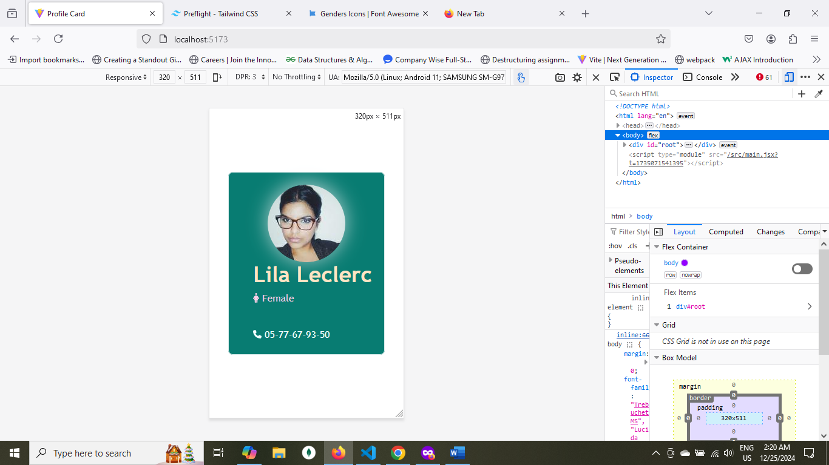

1. **Medium** screen – 768px x 511px

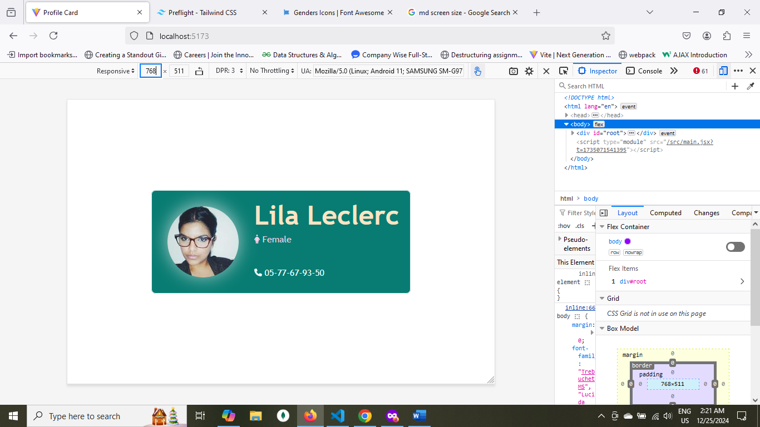

1. **Large screen** 902px x 511px

